
Assignment Cover Sheet

Student Name: | Annur Zara Liyana
Student Number: | 1227
Course: | Diploma of Fashion Design
Assignment NO: | 10

Student Statement:

By submitting this assignment, I confirm that this is my own work.

Student Signature | 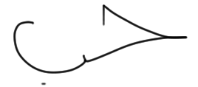 | Date | 8th July 2014

For Tutor / Assessor Use Only
Total Marks
Marks Obtained
Percentage / Grade

Fashion Sketching

Assessment 10
Q: 1: Multiple Choice Questions:

a) A fashion figure is about;
Answer - Eight to ten heads tall

b) The best rule to follow in sketching the face is to;
Answer - Omit as much detail as possible

c) The fashion artist exaggerates the;
Answer - Length of the figures and maximises the width of the hand

2. What is most important thing to consider when sketching for dressing the figure?
When dressing a figure, the artist should be familiar with human body. This is because the garment will be wearing on a real body that will move and stretch. Not only flat like in the hanger. When the sample garment is ready, designer will make a live model wear it to see it better. The artist should bring out the interesting part of the design which can make the women especially like it. The well-modeled and well-pictured will give an imagination that the garment will be look good too in consumer body.
When sketching the design, artist should be careful with the line because after the cloth design be drawn on the figure sketch, some line should be erase to expose design of the cloth. The artist should know how to contour the body under the dress to show the all dimension and the thickness. The design should be flow together with the body.
A few points to bear in mind when sketching a dress on a figure are:
Where is the neckline – high or low?
Does the costume have a collar? Which shape?
What is the style of sleeves - short? long? tight?
Does it have a normal shoulder line? Exaggerated? Slanting? Where is the waist line? Above or below the normal
Does it have a belt? Tight or loose?
Which type of skirt is it - circular? Pleated? Straight?
How long is the skirt?
What type of trimming does the garment have?
Which type of fabric it is?

The material of the fabric also one of the most important thing while sketching the design. The harmonious between the fabric and the feel can be found when the design be sketch nicely. From that designer will know if the combination of the chosen fabric match or not.
The body position of the sketching figure should be sketch according to style of the design. For example if the woman is presented in sports clothes, she should be depicted actually engaged in some sport. If the woman presented the evening dress, she should be sketch in the graceful sketching figure.

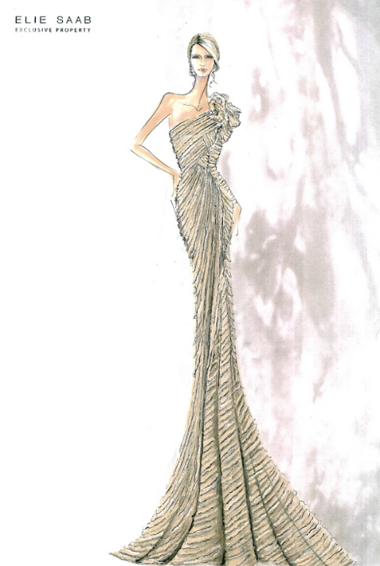

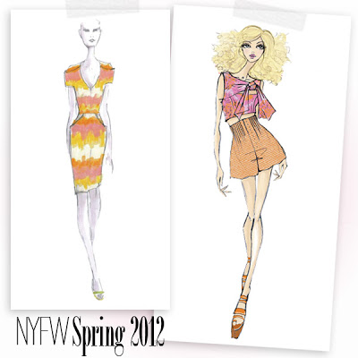
The examples of fashion sketching that be sketched attractively and show the deminsion and thickness on the design.

2. How does fashion design sketch help a fashion designer?
Fashion design sketches help us paint the picture we have in your mind. Before one can actually designs a good dress, he must visualise it first, and once it is done, he can slowly try recreating the image using pen and paper. The designer usually have the rough idea in her/him mind and by sketching it on the paper it allow designer see if the idea look good on the figure.
At first the designer will draw out the rough idea and soon if she/he think it look good the detail will be sketch together to give the design looking more interesting. By sketching also designer can find out the certain colour tones match or not in the whole design. Even though we have the colour guide in order to harmonize the design, still the balance, or the other factor in designing will effect the colour usage.
The material match is also can be show in the fashion sketching. To see how good the match of two different fabric can be use in one design, designer have to sketch it in detail. Also the decoration that design wish to add in the design such as pockets or some other things also can be arrange by sketching it outBe it shoes, tops, belts, pants, shorts, dresses, skirts, coats or whatever it is, it must start with a sketch or two. Besides that, the fashion design sketches are what you will submit to your manufacturing companies to produce your design

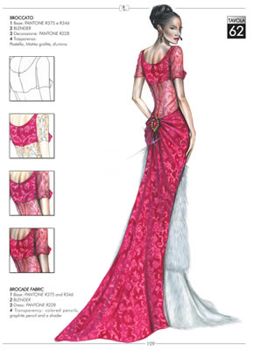
Example of a fashion sketch that show the detail in the design.

4. How should bottom of the skirt be sketched? Why is it important to harmonise the mood and action of the figure with the clothes in which artist draws her. Explain giving at least one example.
When sketching a design on a paper, its really important to show the full illustration of the dress by sketch it lively like in real body. The dress should be looking gracefully according to the fashion figure sketched. For the bottom of the skirt, it should not be sketch just straight across the edge. It should be in rectangle shape so it can show the shape when it will be wear in real body. This is because if we sketch just straight it will give a flat look while rectangle shape will give the thinkness lok in the design. Curve the rectangle at the sides to lend the appearance of going around the figure. The hemline will appear to be longer over the leg in the foreground or the foot nearer the artist.
In order to show the real look in the fashion sketching, the position of fashion figure should be sketch to match the dress design. Designer should pay attention for the fabric that they will use and sketch the bottom of the skirt according to the type of fabric.
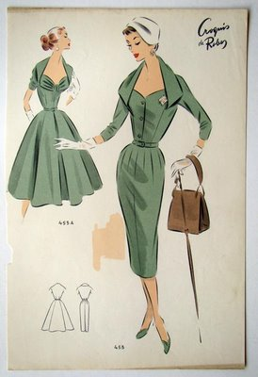
Example of the bottom of the skirt be sketched in rectangle effect to show the thickness like on the real body.

Activity
Sketch a fashion dress for a female showing all the details required in that garment. Then sketch a fashion figure dressed in same outfit.

I choose to create two pieces of dress. The balance is the informal balance. The colours are white and black which is so popular in use. The emphasis probably the long hemisphere skirt. The cut give the grace effect to the skirt. Also I created the open up part in the shoulder match the skirt design. This dress in suitable for a skinny and tall body shape.

Picture A
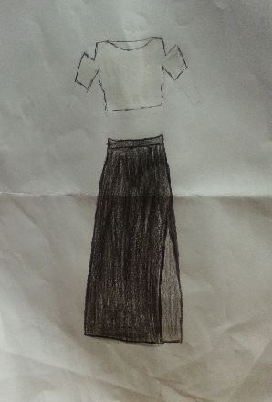
The sketch of a dress design

Picture B
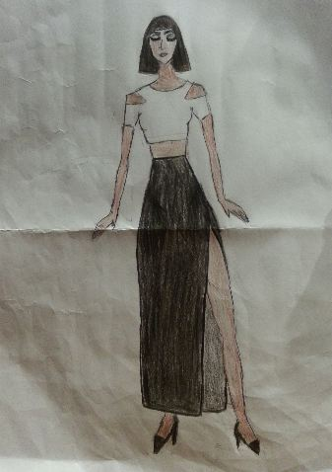
The sketch of a dress design on a figure sketching.

Reference
Information: BOLC Unit 10 note, Fashion textile Lecturer at Hongik University South Korea- Miss. JooEun Park, Fashion, website, Fashion blog.
Picture: Fashion magazines offline and online, Fashion books, Google Images.

