
Assignment Cover Sheet

Student Name: | Asabi Beckles
Student Number: | 1217
Course: | Diploma in Event Management (Level 4)
Assignment NO: | 14
Assessment 14 Total Marks: 30

Q.1. Short Questions: (18)
i. Which type of waste is usually accumulated at most large events?
At most large events there are a wide range of waste generated depending on the type of event:
- Fun fairs - i.e. excess/scrap food, drink containers and ticket stubs, etc.
- Music events/festivals – i.e. construction byproducts from the creation of stages/stall (nails/screws, timber, paint); sanitation accumulation (liquid and solid waste); camping waste (broken tents, torn sleeping bags); medical waste (bandages, latex gloves, protective clothing).
- Exhibitions/conferences – i.e. menus, cutlery and disposable dishes, etc.

ii. Outline the main hazards posed by waste at events.
At events, the main hazards posed by waste to staff/workers and attendees resulting from the accumulation, collection or removal of waste are:
- Injuries or accidents
- Cuts, scrapes and bruises from broken glass or ill-used equipment;
- Slips, trips and falls from blocked passage ways, deliberate or poor/inappropriate behaviour;
- Strains and other physical/emotional affects from periods of long standing, tiredness, fatigue overexertion or heavy lifting.
- Exposure to infections and viruses
- Pricks from used syringes;
- Insect stings or bites (including allergic reactions);
- Food poisoning;
- Contamination from vermin.
- Fire or intentional harm to cause hysteria
- Accidental or purposeful igniting of trash bins/skips;
- Bombs or other exploding material;
- Missile throwing and assaults from bottles, cans, physical altercations

iii. If you are to manage workers and equipments at a large outdoor event, which areas will you pay special attention for waste collection when appointing staff?
At a large outdoor event, it is important to pay special attention to the following areas when dealing with waste collection:
- Venue entrances and exits (including street or land pathways) - to prevent blockages, accidents or hazards allowing maximum crowd flow;
- Stages or activity stations – ensure these areas are clutter free allowing performers and crew to operate safely as well as maintain a sturdy perimeter for audiences. This also ensures the audience are a safe distance from sources noise, i.e. sound system;
- Sanitation areas – ensure restrooms, chemical toilets and water sources are functioning well, with any issues reported to the appropriate authorities so they can be fixed/replenished as soon as possible;
- First-aid and emergency areas – ensure medical waste is disposed of effectively, sharps receptacles with needles are kept separate from used dressing, etc;
- Catering and concession areas – ensure litter and waste food/drinks are regularly collected to prevent the attraction of vermin and other pest;
- Camping area (if available/accessible) – ensure provisions are made to contained fire pits, reduce the amount of ignitable litter and maintain areas that contain gas canisters that can be fire hazards.

Q.2. Prepare a waste management plan for an outdoor event that will contain food stalls and will be attended by approximately 10,000 people. (6)
See page 3

Q.3. According to the personal protective equipment Regulation 1992 what are the suitable protective clothing and equipments for people working on waste removal? And who is responsible for providing these items to the staff? (6)

The 1992 Personal Protective Equipment Regulation (amended in 2002) states that it is an employer’s responsibility to ensure workers are supplied with the necessary clothing and aids to ensure work is completed to the highest standard of safety. Before these are provided, it is essential risk assessments have been conducted to exactly determine the hazards and suitability of the equipment for the specific tasks involved. Once chosen, sufficient training, storage and maintenance of the protective clothing/equipment must be provided.

The following are examples of clothing and equipment for waste removal workers. It is important to note some individuals are allergic to latex or oils used for maintenance so keeping a range of material available for use is always handy:

- Eyes - safety glasses/goggles or face shields, visors, etc protect against chemical splashes, dust, flying debris, gas and fumes.
- Head/neck – helmets/hard hats, scarves, hair nets, collared jackets/overalls, etc reduce/prevent the impact of falling/flying articles like lose screws, injury resulting from hair entangled in machinery.
- Breathing – air filters, respirator or other breathing apparatus control exposure to dust, chemical and naturally occurring fumes/vapours, gas such as ethanol.
- Body – conventional/disposable overalls or boiler suits that are either flame-retardant, water-proof or chemically impermeable, high-visibility vests or equipment, and occasionally safety harnesses. These protects against chemical splashes and temperature variations.
- Hands and arms: a range of gloves assists in the reduction and control of infections, diseases or contamination from cuts and punctures, exposure to chemicals, possible electric shock, etc.
- Feet and legs: boots/shoes with metal toe caps, oil/chemical-resistant soles penetration-resistant mid-soles, protective trousers/leggings reduce the chances of slips, cuts and punctures, impact from falling objects, chemical splashes, etc.

Q.2. Abridged 2015 Barclaycard British Summer Time Waste Management Plan

Name of Event: | Barclaycard British Summer Time (2015)
Date(s) & Time: | - Thurs 18th June - Priority Entry: 14:30, General Admission: 15:30  - Sat 20th June - Priority Entry: 12:00, General Admission: 13:00  - Sun 21st June - Priority Entry: 12:00, General Admission: 13:00  - Fri 26th June - Priority Entry: 13:00. General Admission: 14:00  - Sat 27th June - Priority Entry: 14:30, General Admission: 15:30
Address of venue: | Hyde Park - London
Anticipated crowd size: | 7000 -15 000 (total per day)
Event activities: | - Live music/performance from popular artists and bands  - Funfair rides  - Attraction  - Games
Venue description: | One of the largest Royal Parks in London which has hosted many rock famous concerts  Measuring 142 hectares (350 acres) with access to 2 river ways  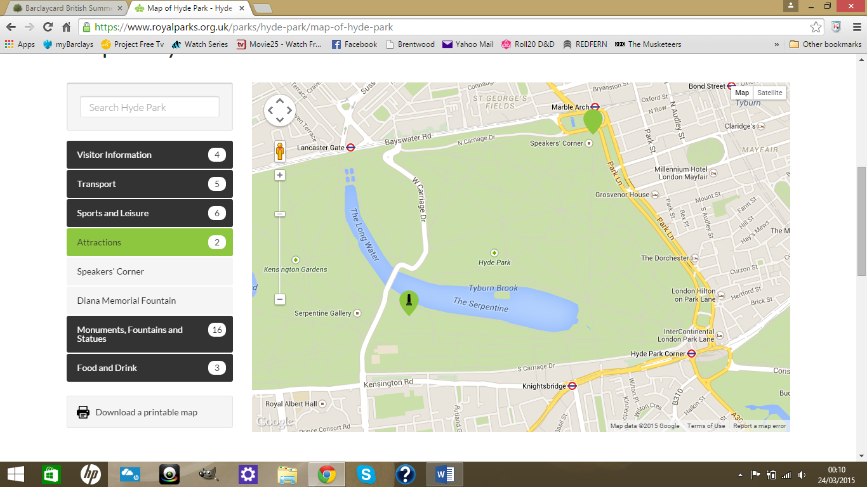
Venue crowd capacity: | 150 000 - 500 000 people
Existing facilities: | Transport - Surrounded by 5 Underground stations:  - Hyde Park Corner (Piccadilly line)  - Knightsbridge (Piccadilly line)  - Queensway (Central line)  - Lancaster Gate (Central line)  - Marble Arch (Central line)  Water-based activities include:  - Swimming  - Boating  - Cycling  - Tennis  - Horse riding  Food and drink:  - Serpentine Bar & Kitchen  - Lido Cafe Bar  - Refreshment points
Other relevant information: | Areas of interest:  - Speakers' Corner  - Diana Princess of Wales memorial  - London's Holocaust Memorial  - 7 July Memorial commemorating the victims of 7 July 2005 London bombings  - The Weeping Beech known locally as "the upside-down tree"  - Art and culture - sculptures including the Drinking Horse, a family of Jelly Babies, Broom Broom, etc.
- Event Details
In 2013 Barclaycard signed up for the 5 year concert series British Summer Time Hyde Park with promoters AEG and the Royal Parks Agency, which saw the launch of:

- Live music, comedy acts and film
- Cafes, bistros and independent food stalls
- Themed pubs and cocktail bars

The 10 day line up sees British & international music/comedy stars entertaining guests as well as providing a host of food and drinks from around the world, free health & wellbeing advice, access to an outdoor cinema and live cookery demonstrations.

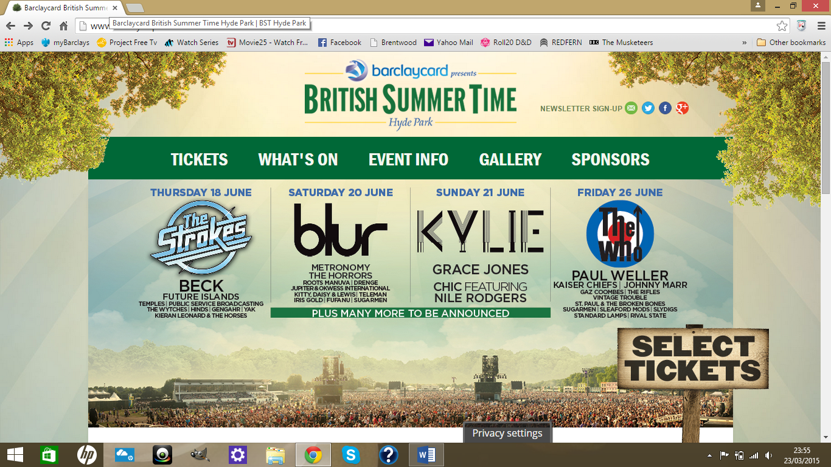

Facilities:
- ATMs – north east side of the park
- Toilets and baby changing rooms
- Disabled parking and facilities
- First Aid post
2 Catering
Food or drink type | Packaging or tableware | Material type
- Hot food  e.g. Street food from Mexico, Asia, America, Europe, etc  - Cold food  e.g. Jellied eels, crab, lobster, etc  - Sandwiches  - Salads  - Alcohol  - Soft drink  - Freshly pressed juices  - Fresh fruit/veg  - Sweets and confectionery  - Desserts | - Cups  - Bottles  - Cutlery/utensils  - Serving containers  - Serviettes | - Glass  - Plastic  - Paper  - Aluminum  - Cardboard

- Activity Wastes
Activity | Waste Types
- Novelty goods  - Sweets and Confectionery making  - Fun fair rides | - Cardboard boxes  - Plastic housing  - Cling film  - Machinery parts and lubricant

4 Catering Wastes
Stall Type | Waste Types
- Traditional chip and burger  - Street food – Mexican, Asian, Caribbean  - Smoked and grilled seafood  - Sweets and confectionery | - Cardboard boxes  - Food scraps and leftovers  - Plastic wrapping  - Used utensils/cutlery  - Aluminum containers  - Wooden pallets  - Empty drink cans/bottles  - Water  - Energy, e.g. gas, heat, light

5 Waste Generation and Quantities - What, where, when, how much?
What – as in section 4 above
Where – stage areas, food and drink stalls, toilets, etc
When – before, during and after set dates but also at rehearsals, set up, testing sessions
How much – quantities will be measured in tonnes, litres and kilowatt hours

Despite searching online for news reports, articles, annual reports, I was unable to find exact figures from past or present information. However, I was able to locate the following from the Royal Parks Agency, AEG and City of Westminster 2013/14 annual reports:

- Energy supply – mobile generators and bottled gas for stalls
- Water consumption -
- Sustainable products – recycled materials, timber, locally sourced food and drink
- Waste Stations (what for, how many)
- Clearly labelled bins – recyclable materials, food, etc
- Energy efficient lighting

In 2013 British Summer Time achieved zero waste to landfill by achieving a recycling rate of 22% by using clearly sign-posted colour-coded bins for the public and clear plastic bags traders. They aimed increase this to 25% in 2014 target and will likely seek to surpass this percentage in 2015.
7. Promotion of waste system/handling (how announced, by whom)
ACTION | WHO/HOW | DONE (tick)
- Write media release & issue to local media  - Arrange for signage (translations if necessary)  - Educate stallholders of waste system via presentation/flyer/phone  - Script announcements for PA or Master of Ceremonies  - Arrange for local Council, community group, waste board stall to promote recycling at event/public education | - AEG Marketing dept  - Royal Parks staff  - Event coordinator  - BST, Barclaycard, AEG Live websites

8 Activities required before the event (by whom, by when)
ACTION | WHO | DONE (tick)
Order additional bins in various sizes, e.g. dumpsters, etc | - AEG Event Coordinator  - Royal Park staff  - Waste contractors
Empty existing bins before event
Set up waste stations at predetermined location

9 Waste management during the event (by whom, by when)
ACTION | WHO | DONE (tick)
Monitor set up waste performance | - AEG Event Coordinator and team  - Royal Parks staff  - Waste contractors
Remind stall holders about recycling
Master of Ceremonies read announcements re waste
Monitor waste & recycling bin content quantities
Monitor bin cleaning/collection schedule
Link/bind waste station bins together

Bibliography

Websites
Accessed: 22/3/15:
- https://www.royalparks.org.uk/press-and-media/press-releases/barclaycard-presents-british-summer-time-hyde-park-2015-q-and-a

- http://www.bst-hydepark.com/event-info/faqs/general-info-faqs

Accessed: 23/3/2015:
- http://en.wikipedia.org/wiki/List_of_concerts_in_Hyde_Park

- http://en.wikipedia.org/wiki/Hyde_Park,_London

- https://www.royalparks.org.uk/parks/hyde-park

- http://www.barclaycard.co.uk/personal/customer/altogetherbetter/entertainment/british-summer-time

- http://www.theguardian.com/media/2013/jan/22/barclaycard-deal-hyde-park

Accessed: 25/3/2015
- http://www.bateauxlondon.com/news/Barclaycard-British-Summer-Time-Hyde-Park/

Annual Reports
- The Royal Parks Annual Report and Accounts 2013-14
- City of Westminster Annual Accounts 2013/14
- Active Energy Group PLC Interim Report and unaudited condensed financial statements for the six months ended 30 June 2014

Student Statement:

By submitting this assignment, I confirm that this is my own work.

Student Signature | Asabi Beckles | Date | 26/03/2015

For Tutor / Assessor Use Only
Total Marks
Marks Obtained
Percentage / Grade

