
Assignment Cover Sheet

Student Name: | Coenrad Adolph Groenewald
Student Number: | 1382
Course: | Hotel Management Dip
Assignment NO: | Assessment 8 – Managing the Food and Beverage Department

Managing Food and Beverage Operations

Assessment 8 Total Marks: 30

1. Give short answers for the following questions: (12)

I. What is the importance of hygiene for a restaurant?

Hygiene plays an important part in the reputation of a restaurant and how patrons perceive the restaurant.

Bad hygiene could have a devastating effect on the ROI and could also lead to fines and eventual closure of the restaurant, while good hygiene can increase sales as more patrons would want to experience the product and facilities.

II. What is ROL in the hotel industry and how is ROL calculated?

ROL is the formula for Record Level

The formula for ROL is:

(W x L) + S

W = Maximum Stock
L = Lead Time
S = Safety Stock (buffer or minimum stock)

To calculate the W (maximum stock) you need to use the following formula

M = W (T+L) + S

W = average usage rate
T = Review period (i.e. 2 weeks, 4 weeks, etc)
L = Lead time
S = Safety Stock

III. Which factors should be considered when purchasing equipment for food and beverage service?

Factors to consider when buying equipment for the F&B department should include
- Flexibility of use; (can the item be used in more than one way)
- Type of service being offered;
- Type of customer;
- Design;
- Colour;
- Durability; (Important on cost saving before replacement)
- Ease of maintenance; (Important for cleaning)
- Stakability; (This is important for saving space)
- Costs and funds available;
- Availability in the future – replacements;
- Storage;

IV. What are the three menu types?

The three menu types are

1. Static or Fixed Menu

A fixed menu is a menu with the same dishes that is used over and over. This is also known as a A-la-Carte menu and can be found in places like steakhouses, etc.

2. Cycle Menu

This is a menu that offers certain items within a certain time frame.

3. Single use Menu

This covers a once of menu and can be used during a special occasion like a Easter menu or Christmas menu.

V. How does the use of computer help in Food and Beverages operations?

The use of computers for the F&B operation is beneficial in that

1. It streamlines the speed which orders is place and delivered and billed to the client
2. It minimizes errors when billing the guest and is neat
3. It keeps record of transactions
4. It gives accurate access to reports like, the sales report, negative postings, voids, etc
5. It can be used for payroll as a staff member can sign in and out.
6. It can show which product is a high seller or low seller
7. It can automatically calculate F&B cost
8. It can calculate wastage
9. Recipes can be input and food cost can be calculated including Meas (how many portions) wastage, etc.

VI. What factors should be considered when planning a menu?

Factors that should be considered when planning a menu should include but not limited to:

- The future users or customers age, sex, physiological and psychological influence affect of the food a consumer chooses. This is important as it shows the target market or segment of the market that will be targeted.

- “Factors like appetite, personality, mood and emotions and also the influence of other people,”
When you consider the above statement one needs to decide on whether to concentrate on a specialized menu or a A-la-Carte menu

- “Economic conditions and social or prestige issue of the guest,”
This is an important as factors like the area, suspend able capital, etc will all play part of achieving your goals and ROI.

- The appearance, texture, quality, odor and flavor of the prepared food, and
People tend to follow their noses, literally. Therefore it is vital to ensure good odours are present, both during preparation and presentation as well as the textures and taste. People use all senses when they eat

- Finally, religious and cultural constraints as many people don’t try some food due to their set views.
This is a vital point as you do not want to offend the community. Living in a Muslim country you need to understand and respect both religion and tradition. In other words do not service non-halaal food items in this scenario as well as preparation techniques for non contamination

2. Describe various aspects of managing food service operations. (9)

There is three major aspects for managing food service operations:

2.1 Introduction

I will identify and discuss the three aspects for managing the food service operation. The three aspects are Food purchasing, food production systems and food hygiene.

2.2 Food purchasing

Food purchasing include the following
- developing specifications;
- preparing an approved suppliers list;
- determining the appropriate order size; and
- establishing appropriate receiving and storage procedures

It can therefore be summarized that it is the responsibility of the F&B manager to develop specifications which should include a list of suppliers and quality and pricing of items purchased for the production of goods in the kitchen. The task will also fall on the F&B manager to ensure the correct calculations was made to determine the size of the order so that there is not access stock and money is tied up in stock. Lastly the F&B manager will ensure that the correct receiving procedure and storage procedures are uses, I.E FIFO (first in first out) to ensure stock turnover. If the F&B manager understands ratio analysis he/she could do a stock ratio to ensure stock turnover is at a healthy rate

2.3 Food production systems
Food production can be divided into three categories

- No Choice
This is a fixed type menu and is normally used by airlines.

- Limited Choice
This type of menu is normally used in self service or quick service restaurants like at schools, etc.
- Choice
This type of menu is normally used in full service restaurants and is also referred to as A-la-Cart menus with a wide range of items to choose for the patron.

Example of a recipe card that I made

I have added a copy of a standardized recipe card as an example of what the production department and F&B manager would look at when either preparing or ordering the food

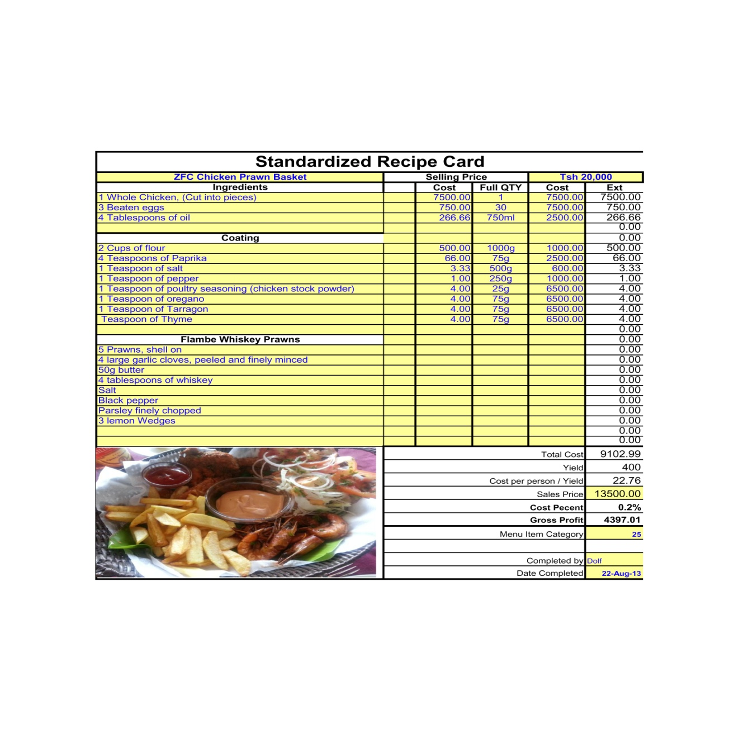

2.4 Food hygiene

Food hygiene is absolutely important for any restaurant.
If a restaurant is not hygienic or does not appear to be clean than patrons will not return and work of month will spread having a impact on business.
It is important to ensure the following:
- The staff is conscience of personal hygiene, items are normally made available like hair nets, gloves, shoe covers and uniform to ensure ultimate hygiene when working with food
- The cleaning area should be kept clean and disinfected. If possible certain pieces of equipment should be sterilized
- Pots and pans should be kept clean and stacked separately
- Crockery and cutlery should be kept clean and packed and covered not to be in contact with dust.
- The preparation areas should be demarcated properly

3. Discuss traditional stages of food delivery system. (9)
Introduction
There are eight stages in the traditional food delivery system/cycle. I will identify and discuss these
1) Storage – refrigerated or ambient storage of material

Items or stock is normally ordered and delivered and than kept in storage. There should be sufficient space provided and correctly marked for goods. Items like detergents or chemicals should not be mixed with food items, i.e. dry goods. There should be a proper system in place for first in first out to ensure there is no wastage. Bin cards should also be added to ensure stock control procedure is followed.

2) Preparation – activities such as peeling, cutting and so forth

The prep area is normally setup behind the production or main kitchen area. It is important to have a prep list available and up to date according to occupancy or expected business. The importance of prepping food is that it speeds up service delivery and getting the food faster to the guest. This area should be kept clean and hygienic to ensure that there is no contamination of the raw product to reach the production area.

3) Production (cooking) – methods such as frying, roasting and so forth

In the production area the recipe cards should be followed as this indicates which method should be used. It is vitally important to follow the health and safety rules when it comes to production to avoid any possible injuries. The head chef, executive chef need to check the order and do proper planning for production.

4) Holding – storage between production and consumption

This area needs to be very clean and organized. This is where the attendant or waiter will fetch the food from production and deliver it to the guest for consumption.

5) Service – style of delivering dishes/meals to consumers

It is important that the waiter ensure that the order is correct and as per standard before accepting it from the production department. The waiter will deliver the order and normally serve it from the guest right hand side.

6) Dining – consumption of meal by consumer in setting

The customer will know consume the order and all senses will be used, smell or aroma, taste and texture and visual. Therefore it is extremely important that the standard of presentation and quality of the final product produced by the kitchen/production is as per the kitchens recipe cards as this is their set standards.

7) Clearing – removal of equipment/food debris

Waiters should be attentive and clear tables as soon as the guest is done. The clearing normally takes place from the left for the customer. If cutlery falls on the floor the waiter should be attentive and replace such an item with a fresh one. If breakage occurs, then it needs to be cleaned up by following the proper cleaning procedure. All dishes cleared from the table should be placed in the dish washing or clearing area

8) Dish wash – cleansing of soiled equipment
It is important that the dishwashing area is kept clean and hygienic at all times. The dishwasher or kitchen attendant will collect the dirty dishes and start cleaning them and ensure they are dried and placed on a holding rack or area. Pots are cleaned last and needs to be placed in a separate area, easy accessible for the production department.

Student Statement:

By submitting this assignment, I confirm that this is my own work.

Student Signature | Coenrad Adolph Groenewald | Date | 16 March 2015

For Tutor / Assessor Use Only
Total Marks
Marks Obtained
Percentage / Grade

