
Assignment Cover Sheet

Student Name: | Omnia Rafiq
Student Number: | 1343
Course: | Diploma in interior Design
Assignment NO: | 15

Student Statement:

By submitting this assignment, I confirm that this is my own work.

Student Signature | Omnia Rafiq | Date | 8-5-2015

For Tutor / Assessor Use Only
Total Marks
Marks Obtained
Percentage / Grade

Q.1.i. When visiting the client for the first time how the survey is started?
The survey, which is the most important part of the fact gathering process, consists of two stages. The first, relates to the thorough analysis of the space - the detailed measurements of the space; and the second, relates to the information about the space which is non -measureable.
The space needs to be measured so that the scale drawings can be produced as a basis for spatial planning and subsequent layout. The detailed measurements are then recorded on the rough floor plan, which is done by working systematically all the way around the site. This includes information about any existing fitted furniture. It is important to allow enough space around the plan for the inclusion of dimensions. The designer would also mark the position of any existing services, such as soil pipe, gas pipes, radiators, television, electrical sockets and switches. Also added to the plan are, heights of the windows from the floor, as well as depth of the sills. The doors of the windows and cupboards are also included in the measurements for the survey. The way a room faces would also need to be indicated on the survey plan, because the decisions on design and decoration are affected by the quality and strength of the sunlight.
But First of all there might be some tips we as designers should take into consideration to get the ideal client – interior designer relationship:

1. Decide how you will and won’t work before you have your next conversation with a prospective client. Add the qualifying questions to your telephone interview list so you determine the deal-breakers before you spend time meeting in person. There are a few professions that are difficult to deal with. Questions should include demographics (age, income level, profession), psychographics (likes, dislikes and values), personality characteristics, techno graphics (their knowledge and affinity toward email, the Internet, etc.), and I also suggest you include specific personality traits or other attributes you don’t want to work with. If someone has worked with more than one designer and they are critical of all of them, run the other way. You’ll save yourself a tremendous amount of stress, time and money by avoiding difficult clients.
2. Create a script for your questions and for your initial conversations with your prospects and your clients. Establish your professionalism, process and dialogue from the very beginning. Practice in front of a mirror if you aren’t comfortable practicing with your friends.
3. Compile a list of issues or questions that you’ve encountered with previous clients and turn that into a Frequently Asked Questions About Working With An Interior Designer report. Offer this FAQ to your prospective clients prior to your first meeting. You’ll have an entirely different conversation if you surface the issues early.
4. Work on your courage and self-esteem. Many of the biggest problems that arise with clients are due to the fear of asking questions that may appear nosy such as how much they’ve budgeted or decided to invest for fear of how a client or prospect will react. How do you handle this? Be proactive. Think about what can and has gone wrong in previous client relationships. How can you address this in the beginning part of your relationship with your clients? Having the difficult decisions before you begin your client relationship ensures that it will be much smoother, or you will at least you will have a means to address the problems when they arise.
5. Ask your clients how they prefer to work. Do they want to do their own purchasing? Do they want you to purchase some items for them? Do they want you to purchase everything for them? Explain the benefits of you managing the process for them as well as the problems that occur when you don’t manage the entire process. If you don’t want to allow your clients to do their own purchasing, then you need to address this before signing a contract and becoming upset when a new piece of furniture arrives without your assistance.
6. Almost 70% of all consumers prefer a fixed fee. How do you work? Are you billing by the hour with a mark-up? This puts you in a position of providing design services that are a commodity. I’ve lost jobs to designers who have a lower hourly fee. It doesn’t matter that I’m more efficient and my business is more automated than less expensive designers. You’re also limited to how many hours you or your staff can bill. Even the most affluent clients are often stunned when they receive large time bills. When this happens, you lose trust, and potentially, a lot of money. Your clients might choose to trim your scope of work, and then you lose control of your project, future referrals, and your profits.

What clients want is a result that is based on emotional benefits.

7. Discuss in advance how you will both handle X when it occurs:
· When they find a product for less money on the Internet that you quoted at a higher price
· When a problem occurs with a product or service provided by you
· When they add to the scope of work and it isn’t included in your contract
· When they change their minds after the order is placed
· When you don’t receive payments for your services as agreed in your contract
· When they don’t discuss the amount they are willing to invest and your design exceeds the amount they had established in their mind
· When the client receives your early time bills if you are billing this way
· For instance – do you remember when we discussed X at the beginning of the relationship and that this might occur? This is what we agreed and now this is how we need to handle this situation
8. Allow your clients the option to purchase some items on their own. Wouldn’t you prefer to control the custom furnishings orders that require your expertise, problem-solving skills and detail management? If a client has a secondary room such as a basement recreation area that is used by their children, why encourage them to spend money on custom furnishings when using retail items is more appropriate. Your relationship with the client changes to one of a trusted advisor when you aren’t trying to make them purchase everything through you with your mark-up. The exception might be the ultra-affluent clients that don’t want to deal with the headaches of purchasing, managing deliveries and installations.
9. Discuss deadlines before you sign a contract. This is one of the biggest reasons interior designers are sued. If a client’s deadline is unrealistic, you must address this and decide how to handle it before you start a project. You need a clear contract and I recommend professional liability insurance for every designer. Just one lawsuit could lead to business failure and even bankruptcy.
10. Explain your process. Our work as interior designers is misunderstood by most consumers, so again, be proactive and explain very clearly how you work and the benefits you bring to them.

Q.1.ii. If the client is not clear about what he wants. What would you do as a designer?
If they are not clear on what they want, We must ask questions, Designer should work hard on knowing the client’s life style, personality, his likes & dislikes, and his taste in the field of interiors. As our design will be reflecting their personalities, after all they are the ones who are going to live with the created designs.

Here are some questions we may ask the clients who aren’t clear about what they want:

The first question a designer should ask his uncertain client, after showing him some already made designs, is, “What do you love in this room?” This question is important because it assures you the designer is interested in what you want — what your tastes are — and is not determined to impose his or her tastes on you.

The second question follows fairly obviously. “What do you hate in this room?” That will help the designer understand the client’s taste better, and will let him or her know things that might need to be replaced.

The third thing the designer needs to ask is, “What colours do you love?” For instance, if this is your living room, you definitely like cool neutrals with just a touch of colour.

Number four is, obviously, “What colours do you hate?” If this is your dining room, and you love Grandma’s buffet but hate orange, then we’ll have a little tweaking to do.

Question five is one that really helps in giving direction to a design process. “Is there something you have, or have seen, that you want to serve as your colour inspiration?”

The sixth question the designer should ask is, “Do you have a favourite look or style that you want to create?”

Q.1.iii. How is a commercial brief different from the residential one?
The process of gathering information from the client regarding requirements and life style is usually referred to as “taking the brief”. Consideration of life style is of great importance; what is the point of using up valuable space as a formal dining room, for example, if it is to be used only once or twice in the whole year. The designer will have to build up a detailed picture of the client’s life style. For instance, a designer would like to know what the client needs in terms of storage are, working spaces, comfortable seating and up-to-date technology, in the style he is happy with. Taking the brief is a logical process and some designers work with a prepared questionnaire to help establish the number of people in the household, how much time they spend at home, how and where they like to relax, eat, watch television, work, listen to music, cook and entertain. There might be an elderly relative living in the family, raising all sorts of Safety and access considerations, or pets, necessitating a particularly practical approach to the final choice of materials and finishes. The designer can take note of the existing decorations, which can prove helpful in indicating the client’s taste, style and the way they live. While, The commercial brief will need to take into account the market factors also. It would be required for the designer to know the commercial area, in order to understand exactly how the operation works and any particular requirements that the proposed project might raise. Designing for public Spaces can be extremely exciting and challenging also. Although not always the easiest area to discuss, it will be important for the designer to get some idea from the client about the budget that is available. Inevitably, some clients may have fixed ideas about their requirements, which are not viable within the budget, they are suggesting, while others may set any form of budget figure for the fear of the designer’s reaction. However, it is such an important area that needs early agreement, if the project is to reach a satisfactory conclusion.

When acting as the interior designer in a design team or when acting as lead consultant, the designer will carry out all of the following tasks:

- Receive from the client a detailed description of the functions that the project is to accommodate and prepare a room schedule
- Collect information concerning the precise requirements of each room, interviewing key staff as necessary, and prepare a room requirements schedule for each space
- When space relationships are complex, prepare an adjacency relationships matrix
- From the adjacency relationships matrix, develop planning diagrams
- As appropriate, collaborate with other consultants in the preparation of a design brief
- Present the design brief (incorporating the above deliverables) to, and review options with, the client.

Initial brief
A crucial statement (which ideally should be prepared before the designer is appointed to design the Concept stage) is the initial brief. This should set out, in as much detail as the client is able, his/her requirements for the project and should be attached to the appointment letter. If the client has not formulated a detailed brief at the beginning, this should be noted in the appointment letter, perhaps together with a general statement of the client's intent.
Brief preparation
For large, complex projects, clients often have not carried out a detailed analysis of their requirements. In such situations, the designer can perform a useful service by carrying out such an analysis. This usually involves interviewing key staff, determining what spaces are required, ascertaining the requirements of each space and how it should relate to other spaces, analyzing these 'adjacency' relationships and preparing diagrams that show the ideal relationships of the spaces to each other. From the latter, floor plan(s) can then be developed in the next stage.

Budget, timetable
The client should be encouraged to state at the beginning what the desired budget and timetable are and, if they are unable to do so, then this should be noted in the appointment letter.

Q.1.iv. What is the fact finding process? Which sort of information is included in it?
The fact finding process, consists of two stages. The first part is starting a survey when visiting a client for the first time as mentioned before in question one. While, The second part of the fact finding process for the designer is to carry out an analysis of the existing space. This would include all the information relating to the space involved that is non-measureable. The use of video or digital camera can be a valuable additional add but before using any such source you will need to take permission from the client. It is also important that fabric of the building is in a decent state of repair. Older properties may have been built without a proper damp proof course, for example, and there may be some other hidden problems also, which obviously have to be remedied before carrying out any decorative work. Any such work would need to be built into the castings and schedule of a project. In some cases the existing problems may not be immediately obvious and the designer might need to bring in specialists to inspect the range of items such as roof timbers or floor joints.
To complete an analysis of a space for a domestic interior, a designer would provide a checklist for each room:

1. Ceiling
Does the ceiling have any beautiful mouldings or any other details which need to be restored? Is it too big for volume of a room? Are there unsightly beams or bulks which could be lost by introducing a suspended ceiling area?
2. Walls
Are the walls built of bricks, stone, concrete or building block, traditional lath, plaster, modern plaster board or timber studding? Is there any decorative plaster work or picture rail? And what is the condition and style of skirting board?
3. Flooring
Does it suit the client’s life- style and is it practical choice for the function of the room? Is it wooden suspended floor, concrete, stone or quarry tiles? If carpeted, are there loose of squeaky boards, and what is the sub floor under the carpet?
4. Fireplace
If a gas fire is to be installed, is there a gas supply, or if coal fire is required, is there space to store the fuel? Does the fireplace need cleaning, restoration or replacement?
5. Electrics
What is the position of fittings, switches and the quality of sockets? What types of switches are there? Where are the computer terminals, telephone and television aerial points situated?
6. Heating
Is the property heated by oil, gas, electric storage heaters, solid fuel boiler with water filled radiators, or combination boiler or mega- flow system?
7. Joinery
What is the quality and adequacy of the storage already provided? What is the height of any existing joinery? Are there any kind of new joinery, or example bookshelves, cupboards, radiator casing and other boxing in, that might be required?
8. Doors
Is there any need for enlarging the width of the doorways or raising their height? Are the doors plain, polished, flush, stained or in need of refurbishment?
9. Windows
Are the windows worthy of attention? Or are they unsightly and need screening or removing? Are they difficult to operate? Are there any trees in view or how they affect the light and view in summer and winter? What is the condition of fitting? And is there any double glazing? How do the
Windows open?

Q.1.v. What is pre-liminary research? Is this required for a residential project or not?
Some element of research is always required in an interior design project. In the case of hotel or restaurant for example, a valuable part of the process of formulating ideas would be to visit other similar establishments to look at the space, the layout, the style so on. Even for a residential
Project some form of research may be required on the period of architecture or a specific theme or style that the client has requested. Nearly all projects require some research into materials and finishes and a design practice will have a trade reference library to help support this function. The contents of the library will depend to some extent on the type of work under taken by a particular practice but it may also include catalogues of companies supplying items such as lighting, furniture, glass, kitchen, bathroom equipment, mirrors, suspended ceilings, partitioning, wallcoverings, floor coverings and accessories. There will also be lots of pattern books and samples. Most of the designers depend upon the publications and seminars of market research because trends and styles change so fast. Another important resource for interior designer could be the trade fairs and exhibitions, which offer the largest technology for interiors, new collection
Of furniture, materials, finishes accessories and inspirational room sets. Many suppliers update their collections seasonally and a designer may visit the showrooms to see the latest products and can discuss with the sales representatives how these can best be used. Another source of new
Ideas and styles can be the show houses and flats.

Q.1.vi.What does a design analysis consist of?
After you have collected all this information in the form of the client brief and survey, begin the process of formulating a creative response. To do this you will need to write a design analysis, in which you can include all the available facts in details about the client and the project. This record
Forms a basis for producing ideas and concepts. Finally, a decision would then need to be made as to which are the best ideas and concepts to meet the brief and this would then be worked up to the presentation stage.

Activity
- Prepare a briefing questionnaire.

NEW CLIENT QUESTIONNAIRE

Please take a few moments to complete the information requested below.
Brief answers are fine. Use the back of these sheets if you would like to provide more information.
Involve your entire household. Have fun telling us about your wants and needs.
We would like to take full advantage of the time we share together and your input is essential.
Thank you for your cooperation. All information will be kept confidential.

PRIMARY CONTACT INFORMATION: Date: Address:
City:

CONTACT #1: CONTACT #2:
Name: | Name:
Day Phone: | Day Phone:
Evening Phone: | Evening Phone:
Fax: | Fax:
Cell: | Cell:
E-Mail: | E-mail:

How would you prefer to be contacted? (Check all that apply)
Work Phone Home Phone E-mail Cell Day Eve

Part I HOUSEHOLD INFORMATION

House square footage:
# Bedrooms:
Age of house:
# Baths:

How long have you lived in your home and how long do you plan to live in your home?

Do you have plans for the future use of your residence? (Will your rooms need to serve different functions in the future for any household members?)
Household Members:
Please provide us with the names of the members of your household and
What needs they have for space, work, study or special needs? Please
Include ages of each child.

Name | Work, Study, Space, Special Needs | Birthday
Example:  Stacy, 10 | Will soon need own room or study space, needs better lighting in  bedroom | May 15

Do you anticipate changes for any Household Members: (i.e. College, retirement, etc.) within the next 2-3 years? (Please explain)

Do you have pets in household? Please list type, age, special needs:

Special Considerations – Check any that apply:

Disabled, elderly or young children in the home?
Are occupants daytime sleepers?

ENTERTAINING:
Our entertaining style is:
LIFESTYLE

Formal Informal Combination or both
We entertain:
1-2 times/week 1-2 times/month 1-2 times/year
Average # guests:
1 – 6 7 – 12 More than 12
Average guests ages:
Adults Teenagers Children All ages
Entertaining Type:
Meals Music Games
Watching TV Other
MEALS:
What cooking facilities are required? Circle one
Average above Average Elaborate

Does more than one person cook at a time? Yes / No

Where do you eat your meals?
Dining Table Kitchen Counter
Kitchen Table Family Room

MAINTENANCE:
How many hours per week will be devoted to cleaning and/or
Maintenance of your home?

Do you have professionals clean your home? Yes / No
If yes, how often?

HOBBIES:
Do the household members share common time around the home?
Together? Yes / No

If yes, is an area needed to accommodate you? Yes / No
Explain:

Do you have any collections? Yes / No
If yes, please list-

Are any collections on display? Yes / No
If you circled yes, would you like to display your collection? Where?

Hobbies:
Reading | T.V. / Home Theater | Crafts/ Sewing
Entertaining | Music | Sports
Cooking

What are your technical needs?
Computers Surround Sound Other
Wireless DSL/Satellite Home Theater

Are you looking to create a children’s play area? Yes / No
HOME OFFICE:

Does any household member work from home? Yes / No
If yes, are there any special needs (i.e., lighting, soundproofing, computers,
Etc.)?

Is there a designated area for working in your home? Yes / No

LIGHTING

Is additional lighting needed? If yes, locations:
Bathroom Office Living Room Family Room
Bedrooms Kitchen/nook other

STORAGE

Multipurpose Furniture
Hidden Storage (for clutter issues)
Closet Storage/ Organizers

VACATION TIME:

We stay at home for our rest/relaxation:
All the time some of the time rarely

We travel for our vacations:
All the time some of the time rarely

Part II PROJECT INFORMATION

Person(s) responsible for project decisions:

What is the budget for your project?
□ $5,000 – 10,000 □ $10,000 - $30,000
□ $40,000 - $90,000 □ $100,000 – $200,000
□ Other

The project is to be done: All at one time in stages
Will occupants be home during project/construction for access?
‰If not, will you authorize neighbors or designee to provide access?
Priorities:

.

Please “X” the rooms to be included in the project. If the project will be done in stages, please indicate the order of the work by writing a number in the box to show the order (1= first, 2= second, etc.)

Entry Hall / Foyer | Formal  Living Room | Formal  Dining Room | Family / Great Room
Kitchen | Nook | Office/Study | Laundry Area
Master  Bedroom | Master  Bathroom | Hall  Bathroom | Guest  Bathroom
Bedroom #2 | Bedroom #3 | Bedroom #4 | Other
Home Theater/ Media Room | Outdoor  Kitchen | Outdoor Living  Area | Other

What kind of enhancements are you considering? (Please check all that apply))

‰Furniture | ‰Flooring | ‰Reupholster
‰Remodel Kitchen | ‰Window  Treatments | ‰Remodel Bathroom
‰Window replacements  or changes | ‰Artwork,  mirrors, etc. | ‰Appliances
‰Interior paint | ‰Accents | ‰Plumbing fixtures
‰Exterior paint | ‰Space planning | ‰Room addition
‰Wallpaper | ‰Murals | ‰Lighting
‰Wall finishes | ‰Color scheme/  Paint | ‰

What is your favorite room in the house? Why?

What don’t you like about your current home?
Why?
What part of your house do you use the most?

What part of your house do you use the least?

Are there any pieces of furniture, window, wall or floor coverings that must stay, and be worked into the new plan?
Please explain:

Are there any items that MUST GO? Please explain:

How involved do you wish to be in this project: (Please Check?)
Very involved (Call you with details and updates daily or weekly)
Involved – KPSID to act as project manager (Keep you updated with
Install dates, deliveries, work schedule etc.)
Minimally involved – don’t call until everything is ready to install
Other:

What is your “ideal” timeline for your project?
Within 3 months
3 – 6 months
Other

Design Goals

PART III DESIGN PREFERENCES

Prioritize the following personal design goals for your home from 1-3, with 1 being your most important quality.

I am interested in achieving a more stylish/beautiful appearance for my home
I want my home to function more effectively for my household.
I want my home to better reflect our personal tastes.
Other

Would you like to include “green products” when possible?
Yes No what do you mean?
What “feeling” are you seeking to achieve?

Casual Formal Spacious Clean lines Warm/ cozy
Light/airy Elegant Sophisticated “Lived in” Welcoming
Romantic Contemporary

What style are you seeking to achieve? [See Style Photos on pages to follow]

Tuscan | Mediterranean | French Country | Mission style
Beach Cottage | Country Cottage | Asian | Southwestern
Old World | Art Deco | Early American | Industrial

Do you and your partner’s style preferences agree? Circle Yes / No

Comments:

The following questions are designed to provide us with a general description of your likes and dislikes regarding your personal style:

Select from the following to describe your preference in fabric: (Check all that apply)

‰Paisley | ‰Stripe | ‰Plaid | ‰Toile | ‰Silk
‰Sheer | ‰Leather | ‰Bold pattern | ‰Suede | ‰Velvet
‰Subtle pattern | ‰Satin | ‰Cotton | ‰ | ‰

Preferences of Color: (Check all that apply)

Whites | Oranges | Blues | Pastels
Blacks | Reds | Jewel Tones | Grays
Burgundies | Navy Blue | Neutrals | Beiges
Pinks | Powder Blue | Earth tones | Tans
Aquas | Warm Colors | Pale yellows | Eggplant
Mint Greens | Cool Colors | Yellows | Lavenders
Olive Greens | Subtle | Peach | Purples
Forest Greens | Bright | Bold | Greens
Teals

Colors you dislike?
Do you have a color theme in mind? Yes No

Please Describe:
Are there types of flooring you prefer? (Please check all that apply)

‰Hardwood | ‰Carpet | ‰Laminate
‰Natural Stone | ‰Concrete | ‰Tile
‰Combination | ‰Bamboo | ‰Cork

Are there types of window treatment you prefer? (Please check all that apply)

Custom Draperies | Blinds | ‰Sheers
Shutters | Room Darkening | Curtains
All Fabrics | Natural Materials | Metal
Shades | Other | Combination

Do you need sun control or privacy with your window treatments?
Yes No

Additional information regarding preferences:

Have you ever hired an interior designer before? Circle Yes / No
If yes, when did this take place, and were you pleased with the experience
And the results:

The following pages include style photos you can reference when answering the second question on page 7.

Thank you for your input. We look
Forward to serving you with your design needs. You may fax or mail us
…………………………..

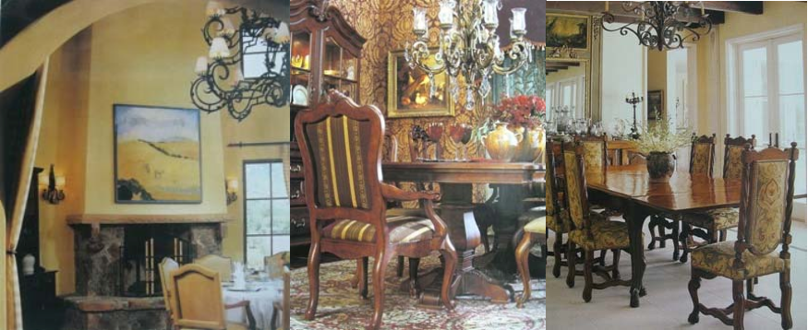

BEACH COTTAGE:

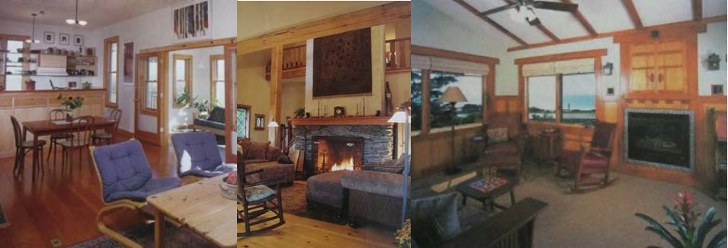

OLD WORLD:

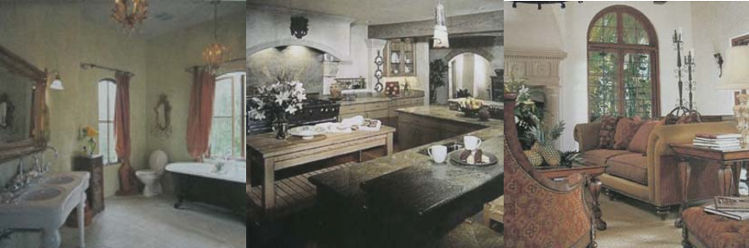
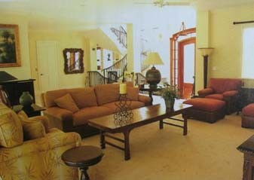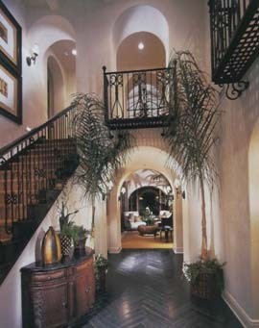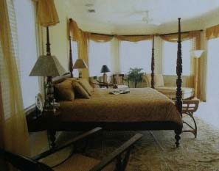MEDITERRANEAN:

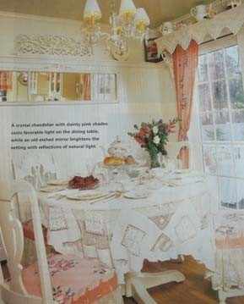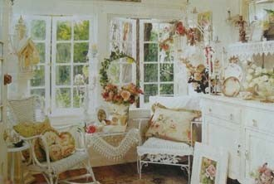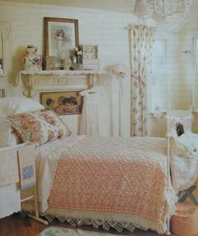COUNTRY COTTAGE:

ART DECO:

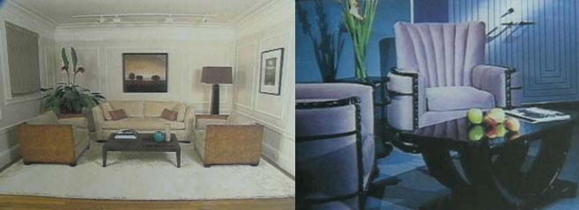

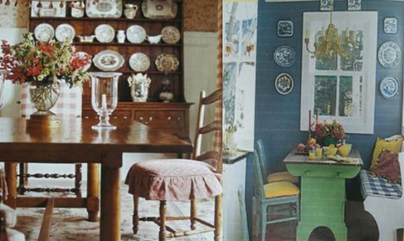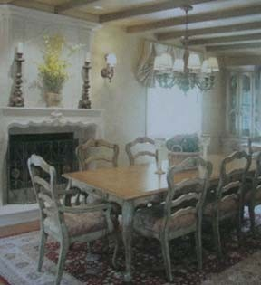FRENCH COUNTRY:

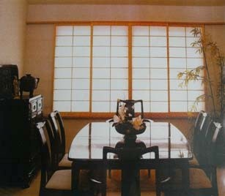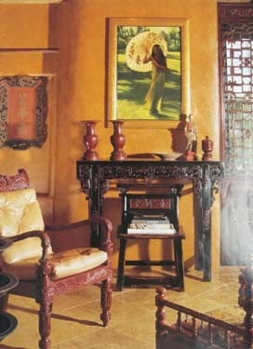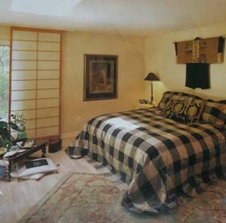ASIAN:

EARLY AMERICAN:

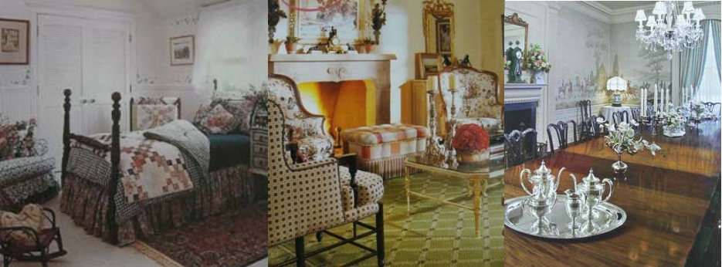
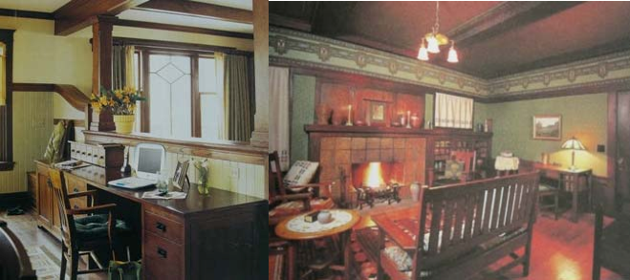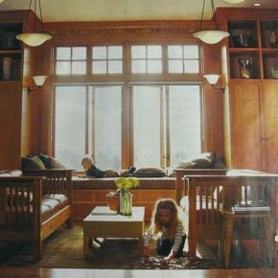MISSION:

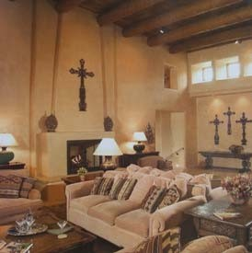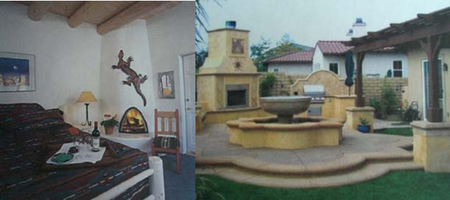SOUTHWESTERN:

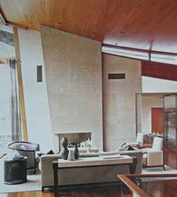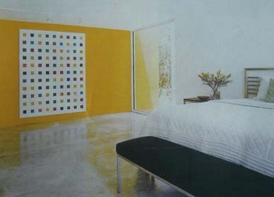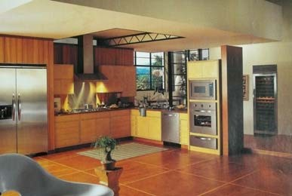INDUSTRIAL:

