
Catherine Richardson
1427
Diploma in Public Relations
Production of Public Relations Materials
Assessment 6
Page 1
Assignment Cover Sheet

Student Name: | Catherine Jane Richardson
Student Number: | 1427
Course: | Diploma in Public Relations
Assignment NO: | Production of Public Relations Materials - Assessment 6

Marking Criteria:
We expect the learners to write minimum one well expressed point in three lines against each allocated mark. This means one needs to write 15 lines with 5 well expressed points to get high grades for a 5 marks question.
For high grades use examples and illustrations where appropriate.
Please insert your completed assignment (in word format) here:
- Give short answers to the following questions:
- What are the advantages and limitations of the printed word as Public Relations material?
Branding Advantage
One advantage of printed materials is that they give the organisation an opportunity to saturate the market with the brand message (Harris 2011). Corporate organisations external and internal design and advertising studios to create logos and illustrations to identify the firm. Larger organisations tend to have a graphics and marketing department to produce in-house brandings. They can also use proprietary font styles and colors to identify further the company's image and branding. Consumers identify the branding image with the business when consumers observe this consistent message on printed materials, such as flyers, leaflets, letters, etc. The branded message of an organisation or business is reinforced by the use of such printed materials (Balmer 2001).
Accessing the Consumer Advantage
Another advantage of print materials is that they connect with the consumer without having to wait for the consumer to initiate action (Schultz 2008). Websites, email and social networking are all the rage in a global scale. This method of communication is effective. However, the user is required to log onto the website, open the email and participate in social networking. There are some points to consider with users blocking pop-up advertising. On another note, some users do not have access to the internet. Billboards offer the consumer the message without them having to access the information. Direct mail postcards and brochures delivered right to the home of a targeted demographic audience can feature high-quality graphics that entice the recipient to read the marketing message (Donnelly 2011).
Catherine Richardson
1427
Diploma in Public Relations
Production of Public Relations Materials
Assessment 6
Page 2
Staying Power Advantage
Printed materials have some influence in the home or office. An informational brochure or catalog can be on hand for reference, even when online options are not available (Palacios 2010).
Updating Disadvantage
Updating or modifying printed material, in general, takes more time than modernising other media. Changing a leaflet to include new or different information can take time to modify, especially paying particular attention to the layout and printing. Updating information on a website or an email message tends to be quick and accessible. . Also, updating a website is generally less expensive than changing, printing and mailing out a new brochure.
Length Disadvantage
With longer documents costs tend to increase to print and send out. Websites and emailing methods are easier to store and compress when archiving such information.

- List the steps involved in planning of corporate publication.
The layout for corporate publications needs to be designed and planned to attract a wide readership with an immediate impact on the reader. The corporate image and corporate ideology must also be prevalent throughout the publication to enlighten the reader such concepts Kirhenstein 2013). The information presented must also be factual, clear, concise and easy to comprehend (Fekete 2003). As well as the latter, the information needs to be error free. How many times has there been information with simple grammatical errors within publicized text? The steps involved are:
Copy preparations
Full editorial instructions
Size of publication and numbers of copies
Choice of paper
Catherine Richardson
1427
Diploma in Public Relations
Production of Public Relations Materials
Assessment 6
Page 3
Selection type for composing
Estimation of size of composing matter
Preparing illustration / images / visuals / photography
Layout
Binding style and cover for booklet / souvenirs etc.
Distribution of printed literature
When executing corporate publications drafts are often composed to ensure that the publications are produced with the correct corporate message. In some corporate organisations where products and services are the main functions, those with direct client contact i.e. Sales Persons, may provide feedback regarding the publication and how this may be interpreted by their clients.

- What are annual reports?
Annual reporting is used to present an overall perspective of corporate results such as, profits and losses, assets and liabilities, productivity and inefficiencies and growths and trends (Frantz 1950).
When laypersons think about annual reports, normally one may think of a booklet format. According to Epic Public Relations blog, (2013) https://epicpr.wordpress.com/2013/04/25/annual-reports-dont-have-to-be-boring/, the suggestion of using social media, such as Calgary Zoo (2012) releasing their annual report on Instagram. The annual report copy was structured to fit Instagram's style sheet, and the result is a unique, shareable and environmentally-conscious overview into zoo life.
The on-screen structure permits for a much richer media experience with interactivity and eye-catching images. This organization was able to establish the Zoo's message about conservation.
This is an example of how an annual report can be a chance to express an organization's achievements and vision in a clear and appealing way to internal and external publics.
This example shows how forward thinking and innovative communicators can use annual reports as a public relations opportunity to summarize a client's yearly activity. The usual information of statistics and facts are presented alongside corporate culture, community relations and social activities.
Another tool used was the Amazon Conservation Association releasing their annual report as a comic strip. The comic strip was produced with a media application that changes photos into illustrations.
Catherine Richardson
1427
Diploma in Public Relations
Production of Public Relations Materials
Assessment 6
Page 4
Lastly, incorporating a video message into an annual report where the information is summed up in a more engaging and concise way. Unlike most printed annual reports, video does not use much text; it's a medium that can translate quick and concise messages to emphasise the key themes and highlights. An example of this is the CEO of The Waterfront Development group's introducing their annual report.
In summary, the above examples suggest that the composition of annual reports report quantitative information as well as the cultural backbone of an organisation.

- What is the purpose of house journals?
There are two types of house journals, internal and external. Internal journals are for internal employees. These journals issue information to its employees as methods of in-house communication (Wood 2009). Internal journals serve the purpose to encourage and reinforce the relationship between management and employees (Wilcox & Nolte, 1995).
External journals are published specifically for external publics such as shareholders, suppliers, dealers and customers who take an interest in the given organisation (Copley 2007).
Larger organisations tend to focus on external house journals to keep their stakeholders informed with the organisations services and products. The belief tends to focus on external investment rather than internal public relations, the reason being that the higher the investment with stakeholders develop and enhances these relationships (Bourne, 2007). Bearing in mind the philosophy of global or holistic public relations (Ledingham – 2015), investment in relationship building should be for both internal publics as well as external publics. Regarding investment and relationship building as well as organisational transparency, quality of information and delivery of information should be equal to reap the investment with both publics. Points to consider are time constraints in producing such information as well as the expense in producing separate publications. Nevertheless, if this is a constraint, one publication could be issued to both internal and external publics. This will limit bias in information giving and sharing.

- What are the legal formalities to be observed for bringing out a journal?
Catherine Richardson
1427
Diploma in Public Relations
Production of Public Relations Materials
Assessment 6
Page 5
Legal formalities can rise through breaches of the codes of conduct when publishing work. This can apply to both self-publishing and non-self-publishing work.
According to COPE (Committee on Publications Ethics) their code of conduct for journal editors addresses ethical issues:
Data fabrication or data falsification
Duplicate submission / publication and redundant publication
Duplication of text and / or figures (plagiarism)
Authorship Issues
Undeclared conflict of interest
COPE takes into consideration the above issues by looking at preventive measures when journals or published materials are released. They provide practical guidelines to manage the repercussions potentially arising from publishing work that could be in breach of policies or codes of conduct.
Hawkins (2013) suggests that there are five issues that could have potential legal repercussions when publishing.
Copyright of images and graphics.
Copyright of text and music lyrics
Registration of your copyright
Use of brand names and trademarks
Your copyrights with your publications
Self-publishing for organisations prove to have challenging consequences regarding the legal issues, especially if publishing experiences are new to the organisation.
A self-published author's credibility is secured into more than just the words of their publications. When taking into consideration an organisation's reputation, credibility and relationships with stakeholders, stakes are high if preparation to publicize information is potentially liable.

Activity
Collect a few publications like folders, brochures, house journals, manuals, annual reports, etc, and examine them critically. How each is different from the other. Produce the finding in a report.

INTRODUCTION
Written publications offer distinct methods of communication directed at specific audiences with information about a service or product, and at times relating to an organization. When examining different types of publications they often have different characteristics. The following report will examine some publications from Toyota Gibraltar Stockholdings Ltd. The publications are documents which are either printed or downloaded from the TGS website “media centre”. The following four publications will provide detailed evidence regarding the differences between the four documents presented.
Catherine Richardson
1427
Diploma in Public Relations
Production of Public Relations Materials
Assessment 6
Page 6

PUBLICATIONS to be examined
Catherine Richardson
1427
Diploma in Public Relations
Production of Public Relations Materials
Assessment 6
Page 7
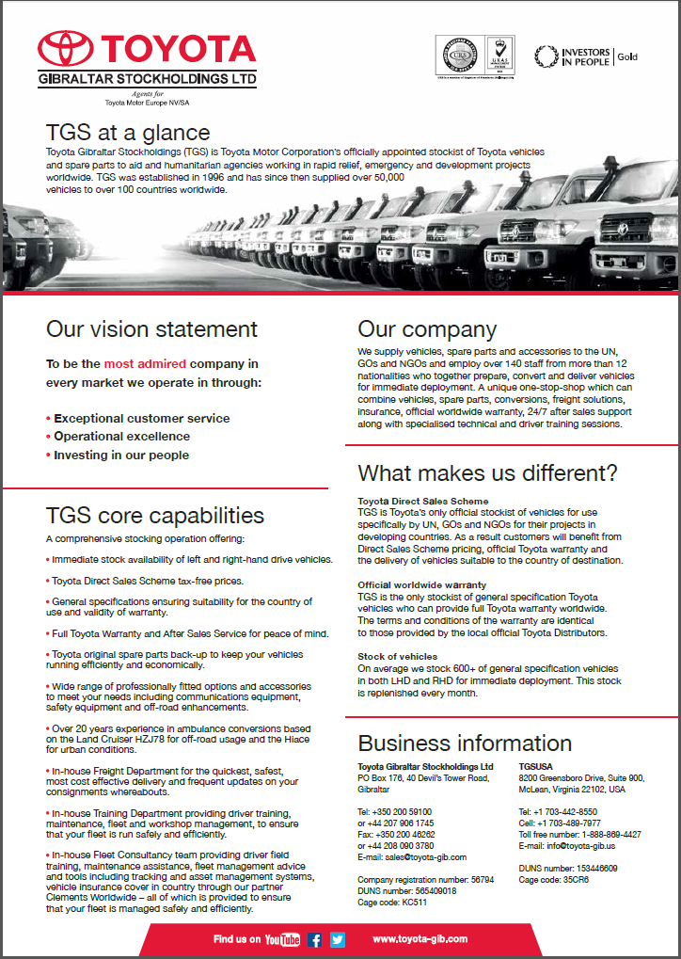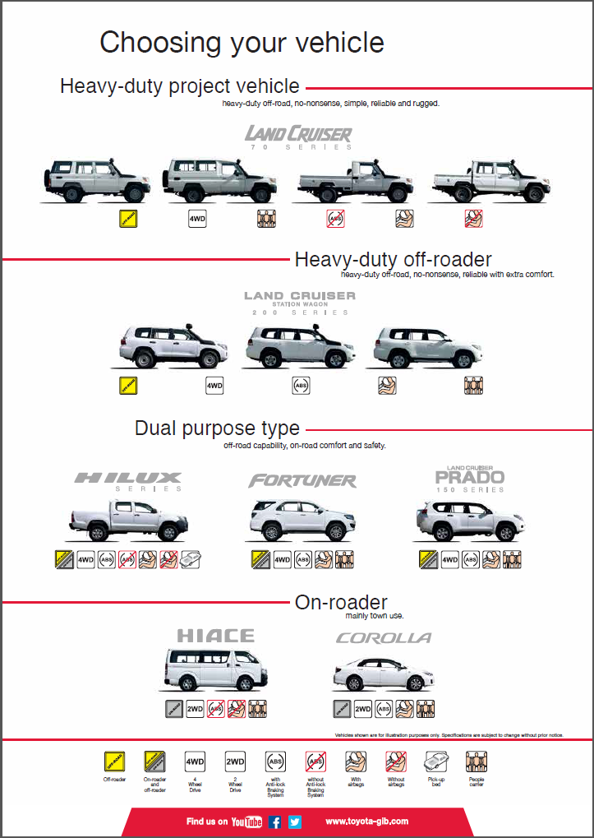
- TGS at a glance brochure

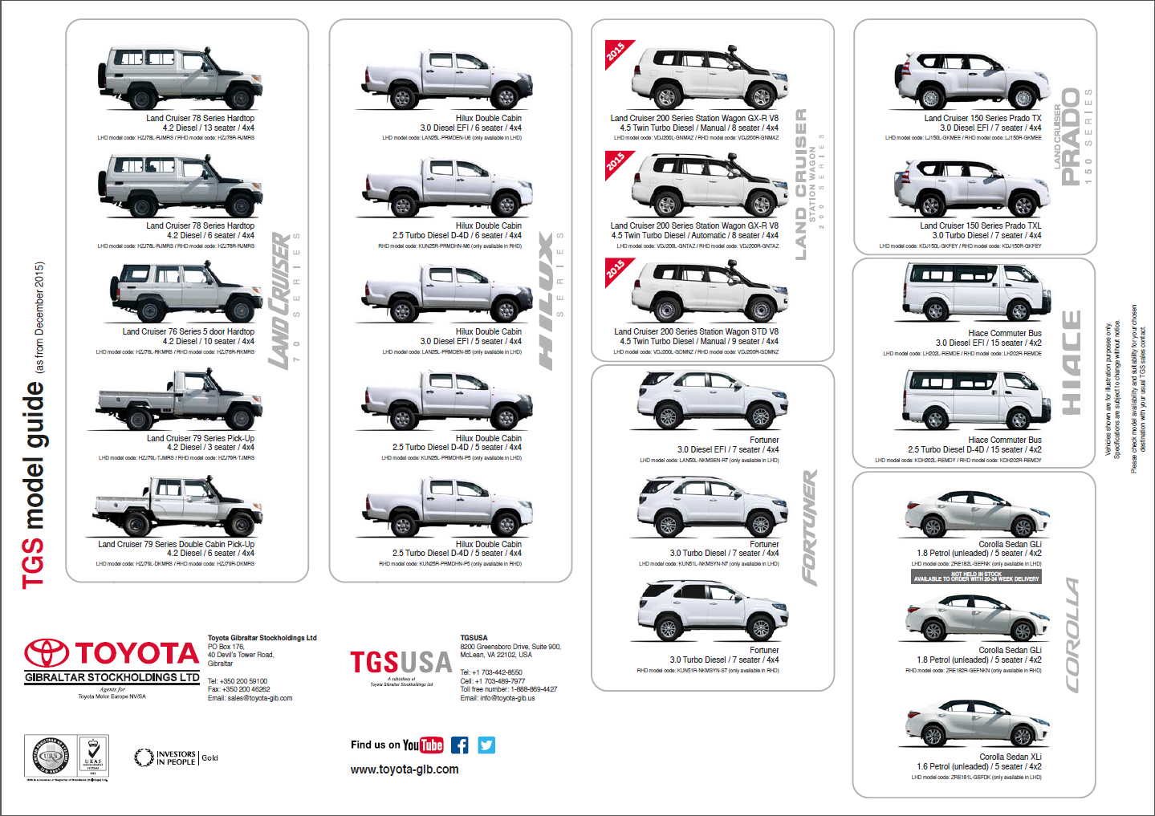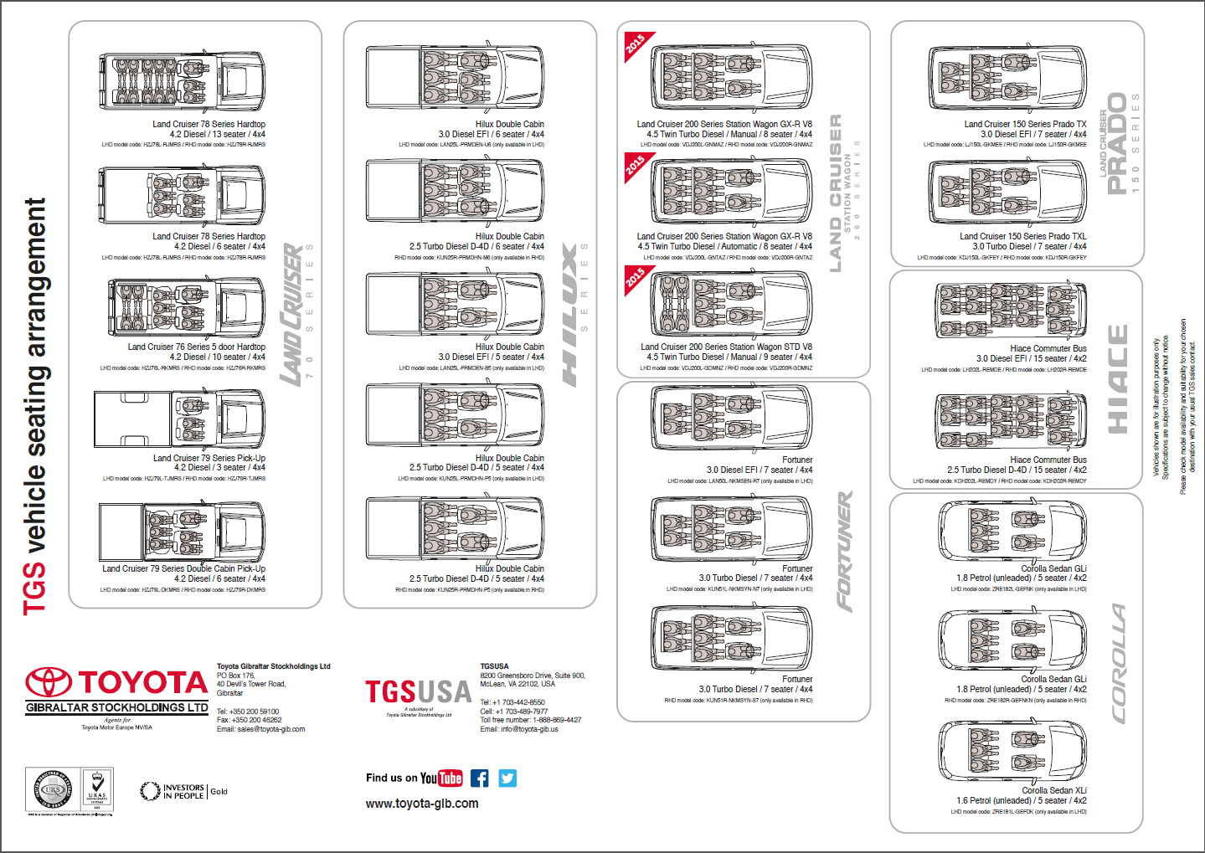
- TGS model guide

- TGS Fleet Management Booklet
Catherine Richardson
1427
Diploma in Public Relations
Production of Public Relations Materials
Assessment 6
Page 8
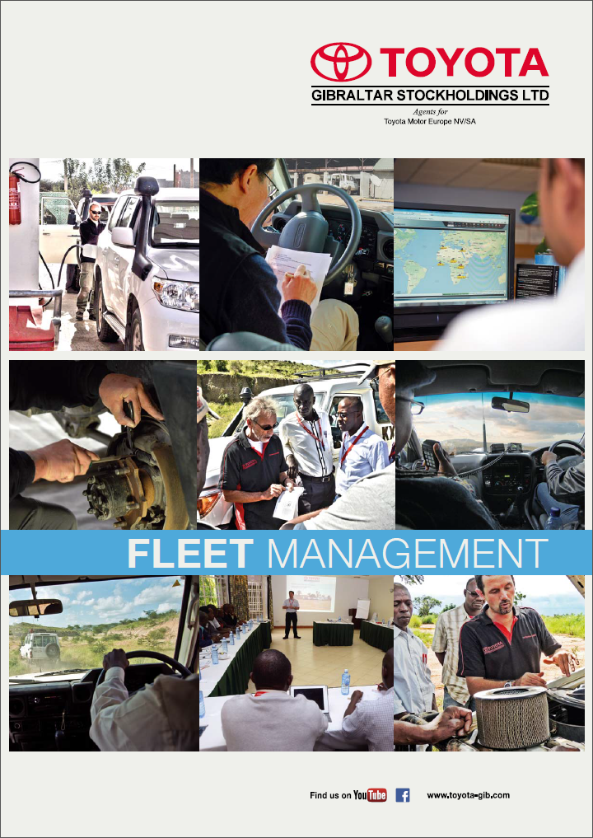 (page 1)
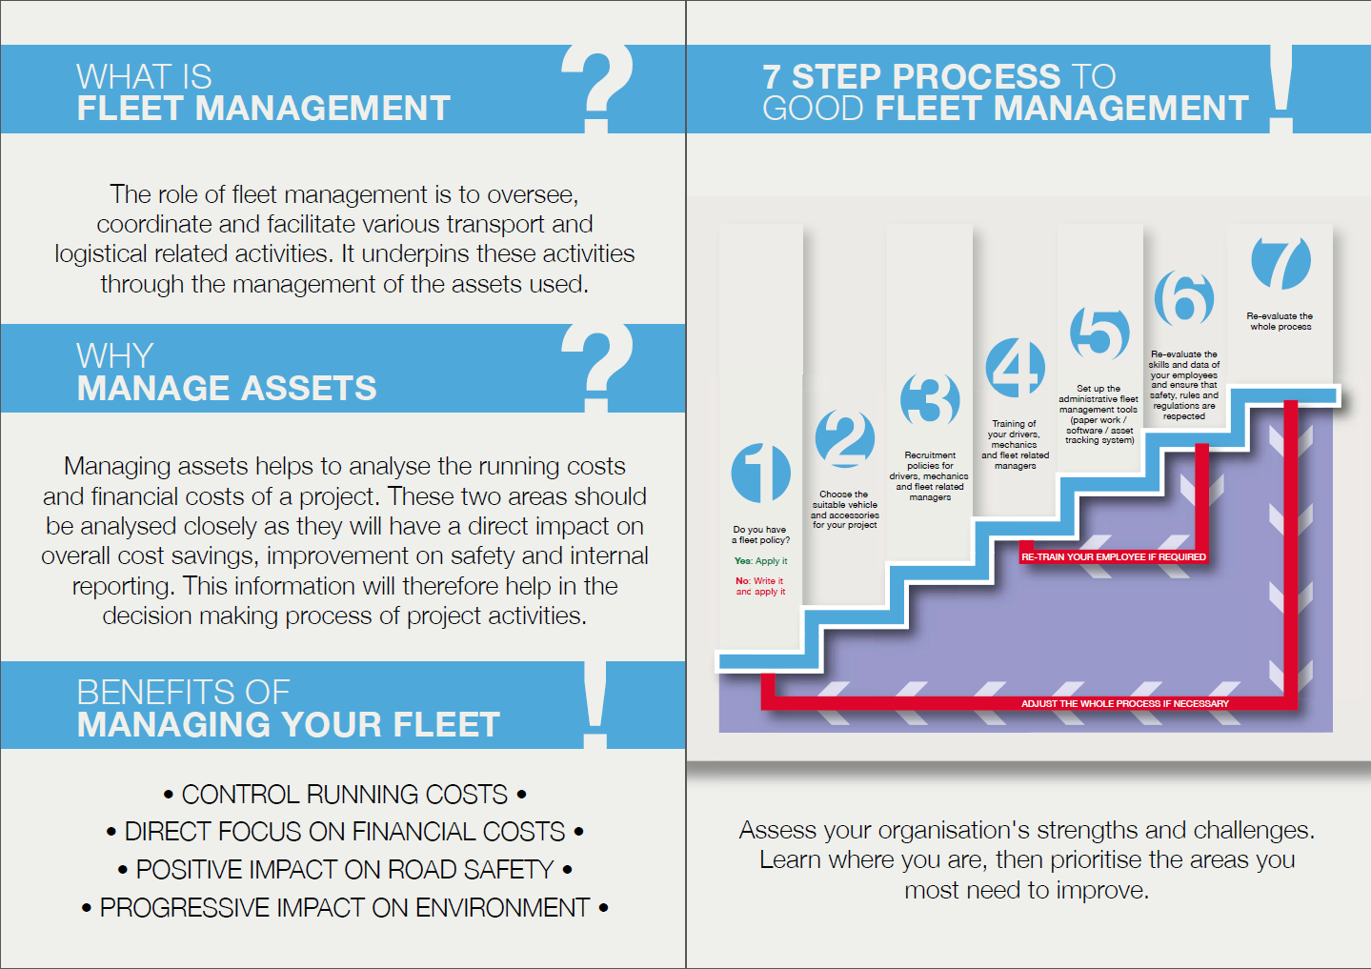 (page 2 – 3)
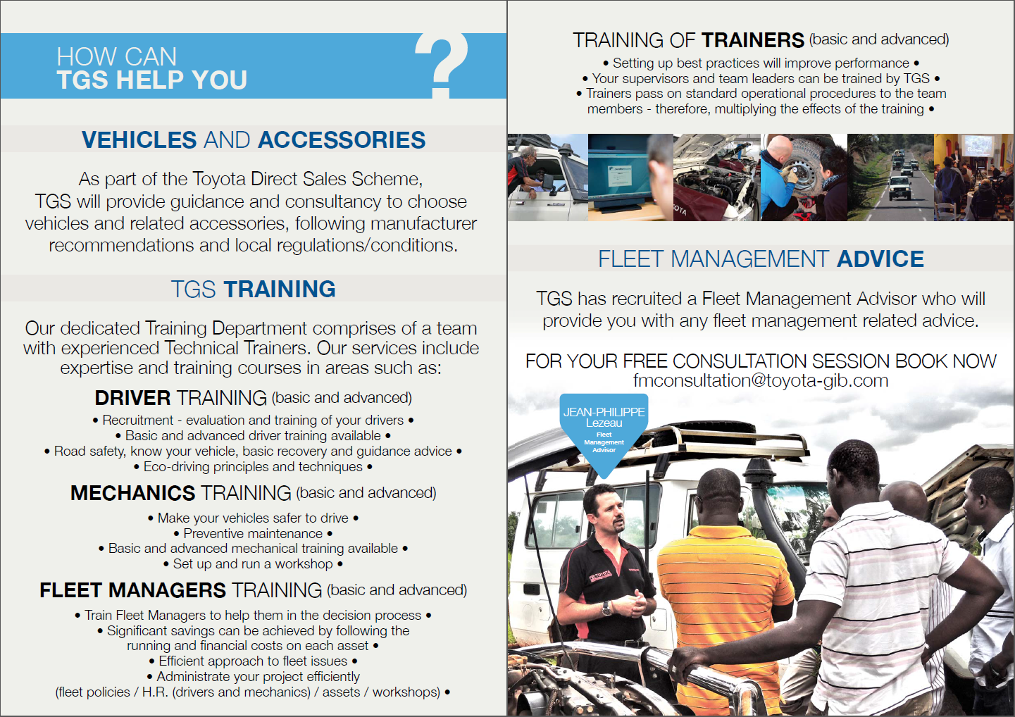 (page 4 – 5)
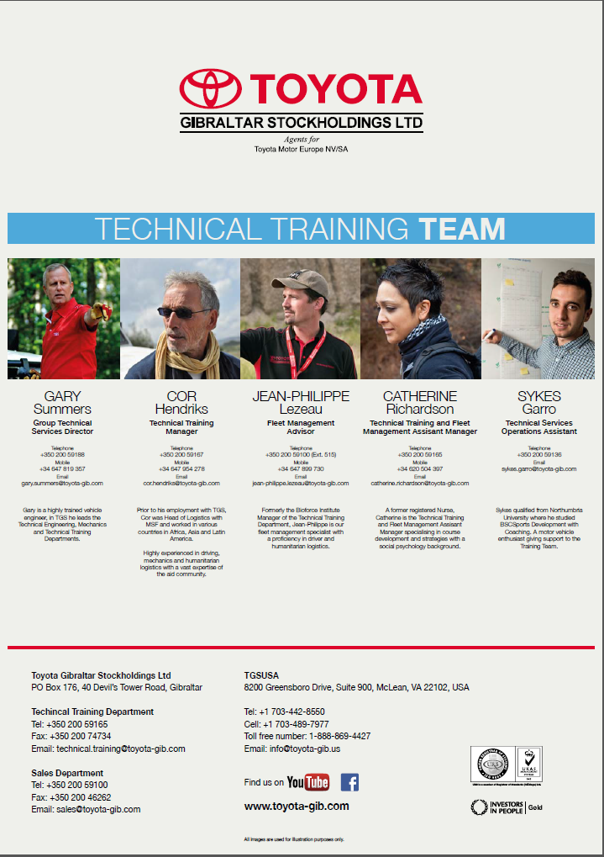 (page 6)
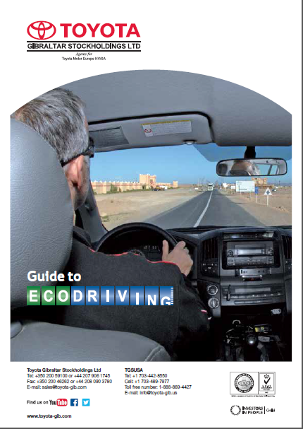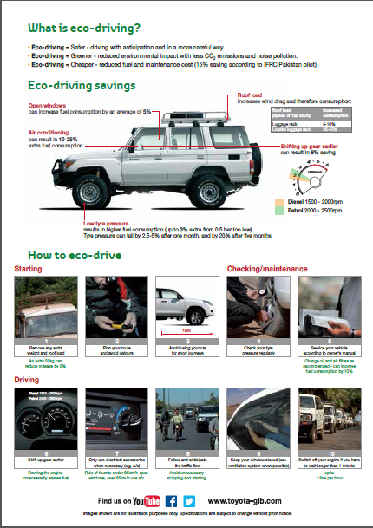
Catherine Richardson
1427
Diploma in Public Relations
Production of Public Relations Materials
Assessment 6
Page 9
- TGS Guide to ECODRIVING

Brochures, leaflets and booklets can be one of the most effective marketing techniques but the success of this type of tool depends primarily on the design. A brochure of leaflet must grab the recipient’s attention, make them interested in the product or service, and finally induce some action, whether that’s phoning a number, visiting a website, or placing an order. The above mentioned publications will be examined using the criteria below:
Paper layout (folds or flips)
Images
Colour or Black & White
Paper quality
Headline
Text
Text Layout and Spacing
Order (Beginning, middle, end.)
Font
Contact Information
 | TGS at a glance brochure | TGS model guide | TGS Fleet Management Booklet  Catherine Richardson  1427  Diploma in Public Relations  Production of Public Relations Materials  Assessment 6  Page 10 | TGS Guide to ECODRIVING
Paper Layout | Flips | Flips | Booklet (6 pages) | Flips
Images | Photos Icons  Illustrations | Photos  Icons  Illustrations | Photos  Icons  Illustrations | Photos  Icons  Illustrations
Colour | Colour (dominant black, grey, white and red) | Colour (dominant black, grey, white and red) | Colour | Colour
Paper Quality | Glossy | Mat Card | Glossy | Glossy
Headline | Top Left | Left Middle | Top Middle | Centre Middle
Text | Yes | Yes | Yes | Yes
Order | What?  About? | Product Information | What?  Benefits  How to/ | What?  Benefits  How to?
Font | Corporate | Corporate | Corporate / | Corporate
Contact Information | Both sides | Both sides | Last 2 pages | Both sides
Size | A4 portrait | A4 Landscape | A4 portrait booklet | A5 portrait

The above table summarizes the differences (highlighted in red) between the publications. The areas in which the publications remained the same were the text, images and font. All of the publications had some text within the publication and the font remained the same type throughout. All four publications also presented photographs, icons and illustrations throughout.
The areas that differed were the categories of paper layout, Images, Colour, Paper Quality, Headline, Oder, Contact information and Size.

Paper layout (folds or flips)
3 out of 4 publications were double sided documents in comparison with a booklet style format.

Colour or Black & White
Both the “TGS at a glance” and the “TGS model guide” displayed the same colour choices of black, grey, white and red. The icons in the second page of the “TGS at a glance had a few added touches of yellow and pink in their icons.
Both the “ECO driving” and the “Fleet Management” displaced the same branding more colour choices in the photographs. Specifically the ECO driving displayed green coloured text to highlight the message of environmental concerns. The Fleet Management booklet was dominant with blues and greys. According to Ciotti (2013) the colour psychology of blue corresponds to Trust, Dependable and Strength, and in combination with grey; Balance, Neutral and Calm. This was a new concept and service that TGS were branching out into, so it would make sense to utilize such colours of choice.
Catherine Richardson
1427
Diploma in Public Relations
Production of Public Relations Materials
Assessment 6
Page 11

Paper quality
The TGS model guide was the only publication that was printed on matt card, the other 3 publications were produced on glossy paper.

Headline
All publications had a heading(s) on their documents. The location differed for all 4 of these publications. The similarities were that they were is bold.

Text Layout and Spacing

Order (Beginning, middle, end.)
All publications presented a “what” question. Primarily the content of all publications offered a service or a product(s) to their intended audience.
TGS at a glance focuses on the services it can provide. The TGS model guide specifically focuses on the products. TGS Fleet Management booklet focuses on the service and also provides benefits as well as advice (page 3- 4).
The TGS Guide to ECO driving clarifies the meaning of ECO driving and advice how to achieve it.

Contact Information
3 out of 4 publications provided contact details on both sides. These publications were double sided leaflets. The TGS Fleet Management booklet introduced the key person to contact with a specific email address (page 5). On page 6 there is an introduction to the whole team that focuses on fleet management and training. This follows to the end of page 6 with a selection of contacts; Head Office, USA office, Technical Training Department (relates to the booklet contents) and Sales Department.
The publications mentioned above are primarily used by Toyota Gibraltar Stockholdings to offer information about some of their products and services. The design is brief enough to offer some information, most importantly each publication offers their contact details so the reader can contact for more information.
These leaflets tend to circulated by either as hand outs in exhibitions, posted along side other documents such as invoices and also downloaded from the business website. The main aim is to circulate the information to a wide readership. Areas to measure however are the effectiveness of obtaining a larger readership and whether an increase in product sales and services is a result of such marketing activities.
Catherine Richardson
1427
Diploma in Public Relations
Production of Public Relations Materials
Assessment 6
Page 12

Student Statement:

By submitting this assignment, I confirm that this is my own work.

Student Signature | Catherine Jane Richardson | Date | 15th Jan 2016

For Tutor / Assessor Use Only
Total Marks
Marks Obtained
Percentage / Grade

