
Assignment Cover Sheet

Student Name: | Sukhwinder kaur
Student Number: | 1282
Course: | Fashion design
Assignment NO: | 11

Answer 1.
Designers use their perception of the relationship between garments, styles and the state of fashion not just to evaluate their designs but also to selectively generate only designs. They also actively control their context the sources of inspiration in their immediate elements for these designs


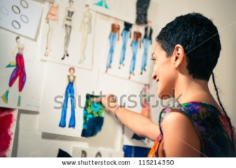
a) Designer`s memories for other designs they have seen, as well as other objects and images, provide the building blocks for the creation of new designs. Designer`s pattern synthesis actions, that create or modify new designs, combine, manipulate and transform the objects, features and properties they have available in memory. Thus creative thinking is powerfully influenced by recent experiences, and helps designers to produce their creative works.
b) Strategies for guiding idea generation in the course of designing, the sources of inspiration in combination with the designers` earlier memories help them in the generation of new ideas and concepts. Many designers appear to apply these strategies to generate very large numbers of ideas for designers as mental images which they perceptually evaluate .
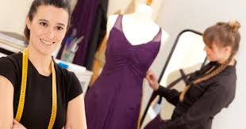
c) Before designing for a new season, designers need to gain an understanding about what will be fashionable for that season. They need to learn the constraints of the fashion space by understanding what looks dated is not yet right for their market sector, as well as the key looks and features that define a particular fashion.
Answer 2.
Once the story board is created, which talks of fashion drawings of human forms with garments rendered on them is done. This rendering of garments on the figure sketches create an element of interest. Illustration could be hand rendered or worked on the computer using latest software like adobe photoshop. Different types of figure formats are in use. Single, double or multiple figure formats can be selected by the designers depending on the intricacy of the designs. Generally both the front and back view of the illustration is done for complete of the garment design.
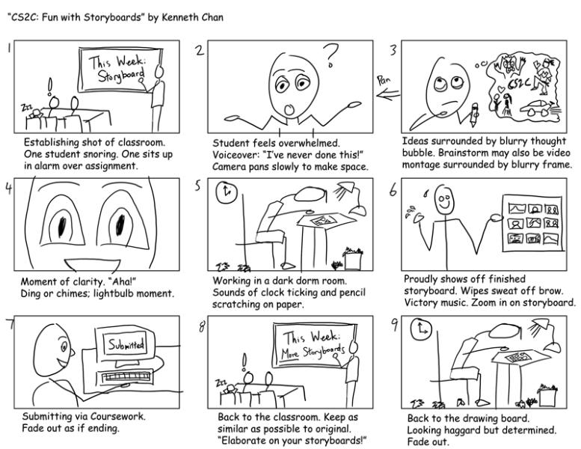
Flats are miniature drawings of garments when drawn flate on table on the design sheets.
Client board this board gives the details of age group, season, target market and exact or approximate costing of the line. The layout of these sheets could be changed as desired by the designer.
Tag designing tags are designed with theme, colour board,
Logos/labels company`s name can be designed and attached along with tags for fixing on the garments. Size tag may be attached with the label or may be separate.
Answer 3.
The story boards designers generate design sheets or design boards with in depth study of the fashion forecast services. Story board is visual form of expression. These boards take start from a source of inspiration. This board comprises the visual pictures in the form of cut-outs, photographs or natural items that are collected and pasted in the form of story on the board. Along with the name of collection a brief write up indicating the mood of the collection line given in forcast later, key words are generated to formulate the styling of garments. Continuing with one of the above exemple key world like curvaceous,smooth, feminine elegant,bell shape, fit the line.
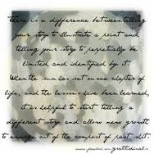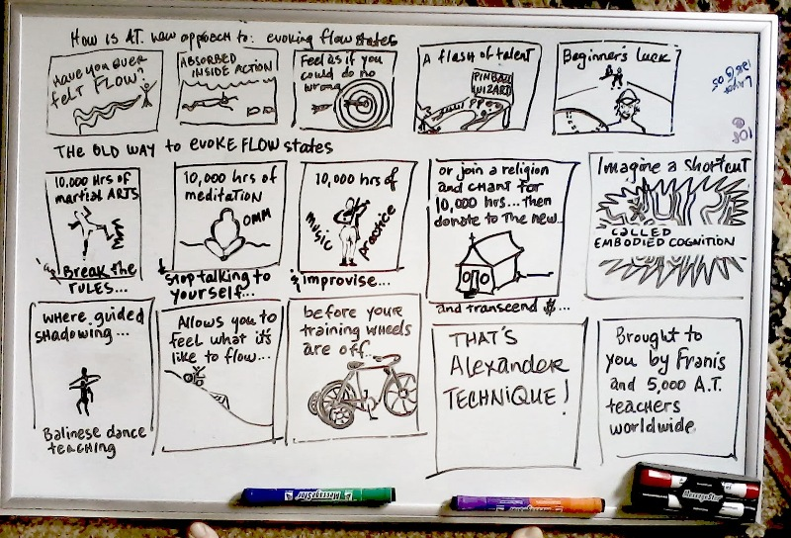
Colour board after the story board has been formulated, a visual presentation of colours in the form of swatches, write up pantone chips etc is done. Pantone contains the standard colours, which are numbered. This number is indicated along with the colour for accuracy in colour shade and tone

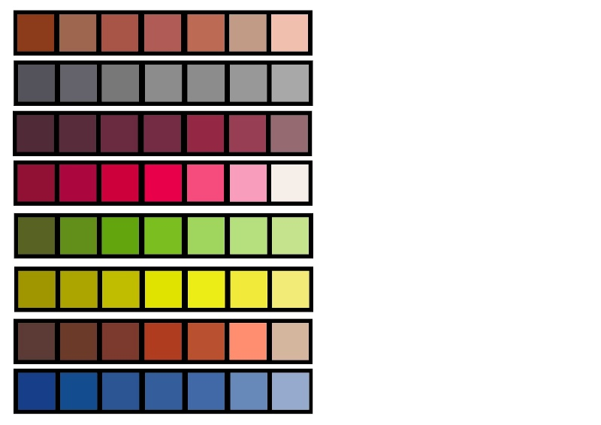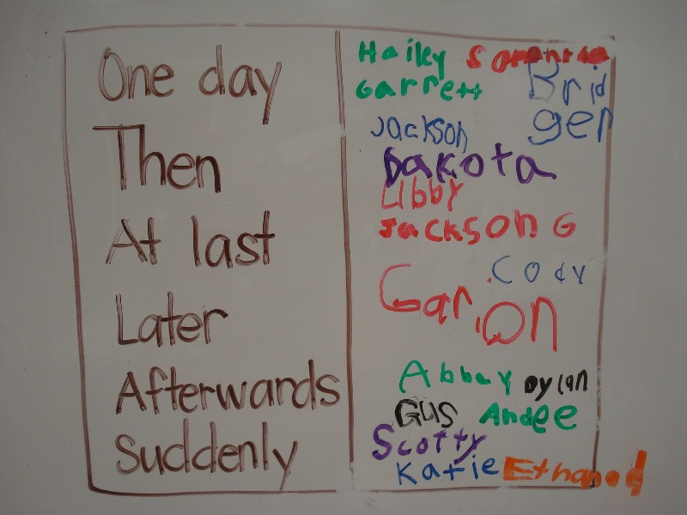



Student Statement:

By submitting this assignment, I confirm that this is my own work.

Student Signature | Sukhwinder kaur | Date

For Tutor / Assessor Use Only
Total Marks
Marks Obtained
Percentage / Grade

