Starting Up Interior Design Business

Assessment 18 Total Marks = 20

Q.1. Short Questions: (15)

(All Questions carry equal marks)

- “Being the boss is fun. It is also risky and a lot of hard work”. Explain.

Answer:
It has its advantages and disadvantages which
has to be considered before starting a business.
Owning a business comes with a lot of responsibility.

- Briefly describe three main advantages of owning a design business.

Answer:
Do not have to report to a boss- its your design
business, you chose your own hours, your own
style, decide on your own strategies, make
choices that are right for you, don’t have
to do what someone else tells you to do.

Making a potentially higher income- your earnings will be higher if its your own business as the more clients you get, the more designs you have to make- the bigger your business gets the higher income you will get.


Potential satisfaction in achieving success-

YOU
TAKE
CREDIT
FOR
YOUR
ACHIEVEMENTS
NOT
SOMEONE
ELSE.

- What is the first thing you should look at in yourself before starting your own design practice?

Answer:
Before starting your own design practice you should consider if you have the right qualities for it- if you’re motivated, versatile, social, you also need to be good at solving problems and multi tasking.


- “An interior designer has to be versatile and should be able to change with time.” Why
Answer:
It is crucial if you want to be successful
in this field, you need to be able to
change your way of thinking with new
trends.

- Why is it essential for a designer to possess skills for negotiation?
Answer:

It is essential to have good negotiation skills to acquire clients or on budget requirements. You will also have to negotiate with suppliers, contractors etc. not just clients, so the better you negotiate the higher are chances of you saving and getting a higher income.

Q. 2 What is a portfolio? How important it is for an interior designer? (05)
Answer:
A portfolio is like a scrapbook of photographs and listings of your work, its like the best tool in marketing in design business. It helps to show your client of the work you’ve done and what you’re capable of.

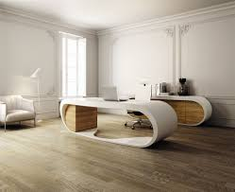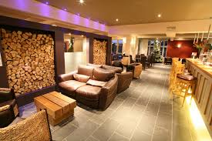
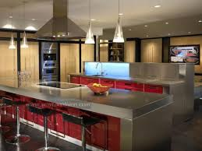
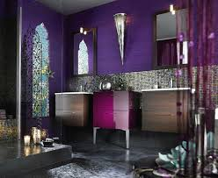

www.bolc.co.uk | Brentwood Open Learning College

