
Assignment Cover Sheet

Student Name: | Salma Mohamed Safaa
Student Number: | 1170
Course: | Interior Designing
Assignment NO: | 12

Student Statement:

By submitting this assignment, I confirm that this is my own work.

Student Signature | Salma Mohamed Safaa | Date | 08/12/2015

For Tutor / Assessor Use Only
Total Marks
Marks Obtained
Percentage / Grade

Student Name: | Salma Mohamed Safaa
Student Number: | 1170
Course: | Interior Designing
Assignment NO: | 12
Page NO: | 1

Interior Designing Course
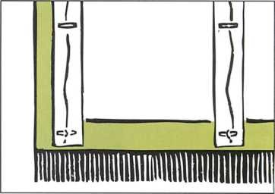
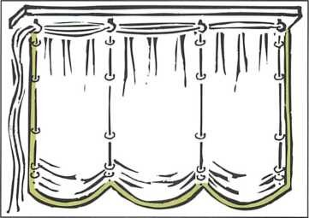
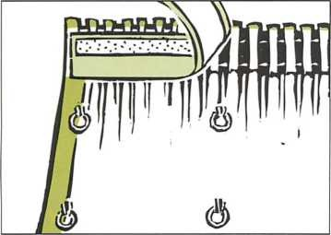
Unit 12: Soft Furnishings
Q.1. Short Questions:
I . Austrian Blinds are kind of curtains, that work in a different way .
How does an Austrian blind works: The blind is pulled up from the bottom to the top by means of cords attached at the back, and are made longer than the required finished drop. There top rings that are threaded with each cord and is attached to the lower ring. The top is attached to the Austrian blind track or a wooden batten. The extra fabric in the length forms scallops, even when the blind is in the lowered position.
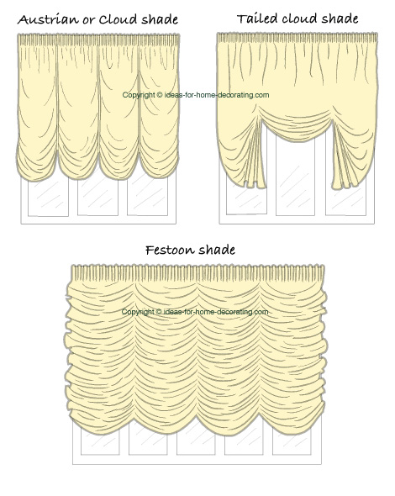

The main difference between Austrian and festoon blinds:
An Austrian blind falls flat like a curtain, while a festoon blind needs twice the length of fabric for the finished drop.
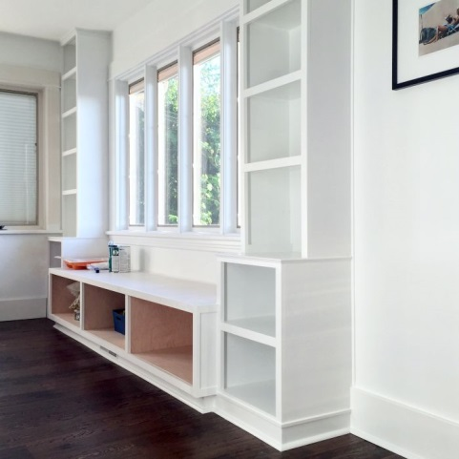
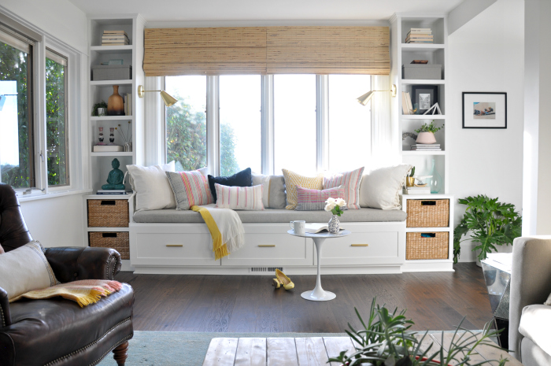
II. To create Window seats: Create a wooden frame around the top and sides of the window and down to the floor. Put a foam cushion on the seat and use scatter cushions to hide the wall between the window sill and seat. A window seat creates an illusion in the room; it makes a small window seem longer.

Student Name: | Salma Mohamed Safaa
Student Number: | 1170
Course: | Interior Designing
Assignment NO: | 12
Page NO: | 2

III. Different options for Upholstering the dining chairs:
- Same fabric can be used in two or more different colours, according to the style and mood the designer wants to create.
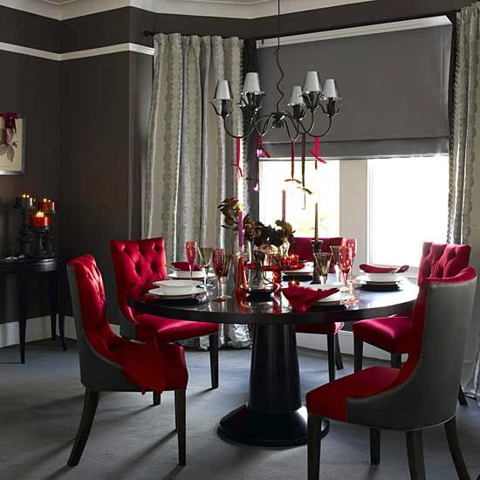
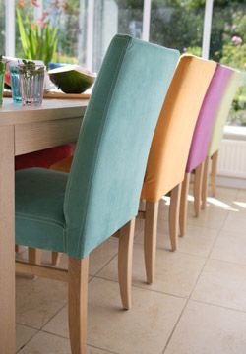
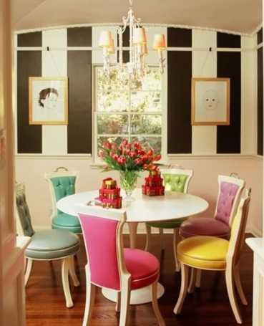

- Same color can be used in different fabrics and different patterns.
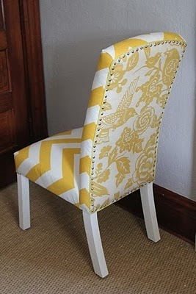
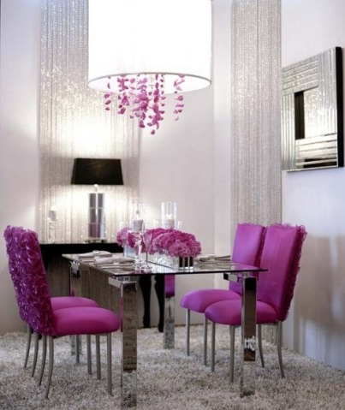
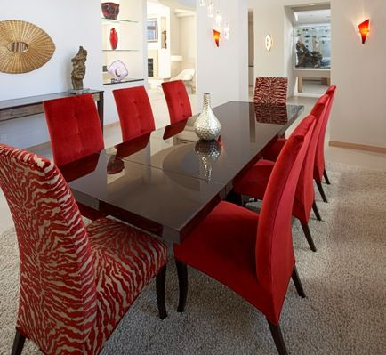

- Mixing between plain and patterned fabrics with matching tones and colors.
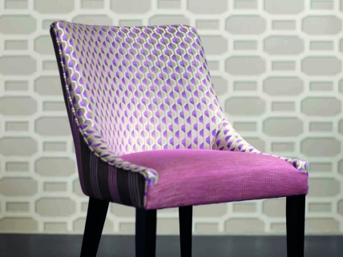
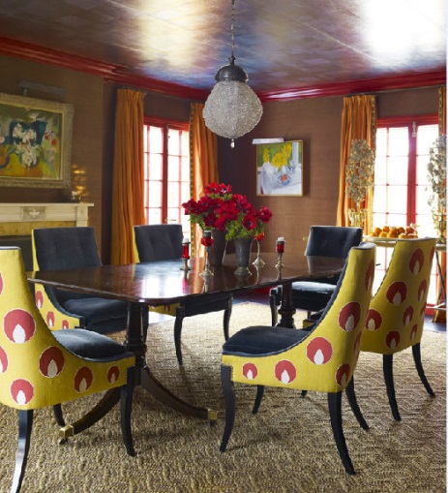
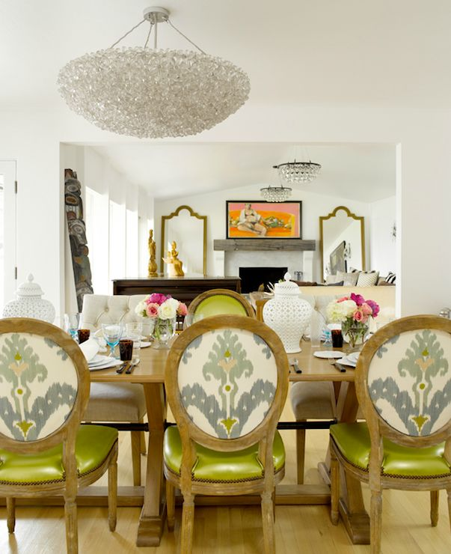

Student Name: | Salma Mohamed Safaa
Student Number: | 1170
Course: | Interior Designing
Assignment NO: | 12
Page NO: | 3

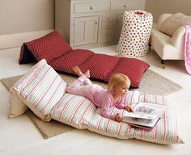
IV. The best type of cushions to be used for children’s rooms; floor cushions, should be fully stuffed internally to be comfortable and safe.
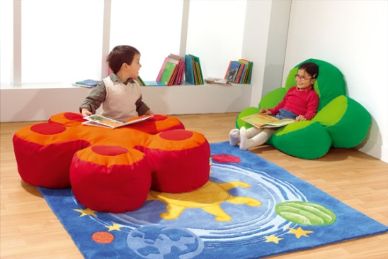
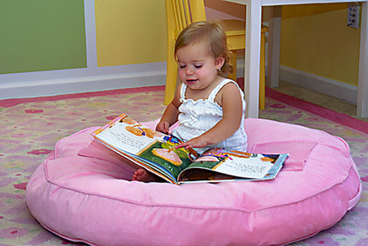
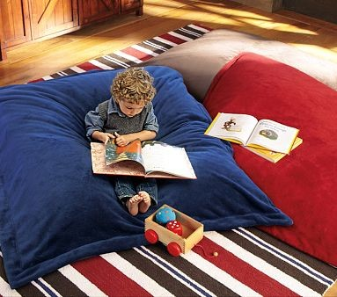
There is a variety of designs, sizes and colors.
V. Different ways for decorating the cushions:
Cushions with trimmings
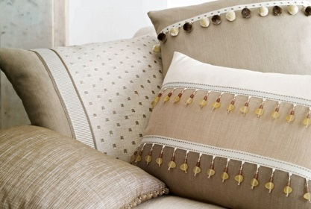
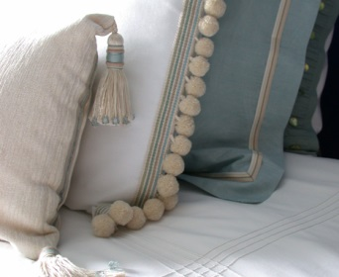
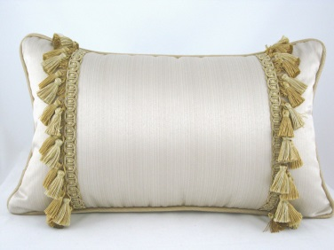
Cushions with piping
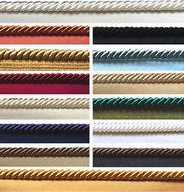
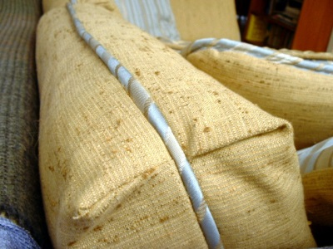
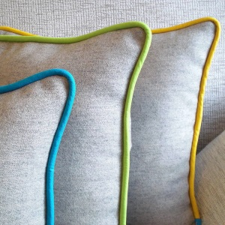

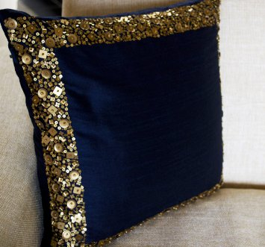
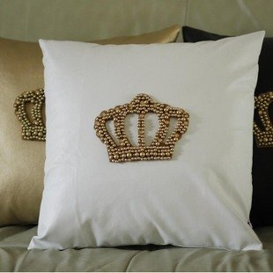
Cushions with buttons & beads
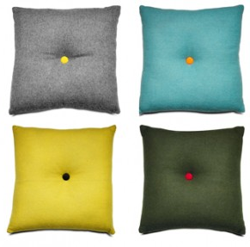
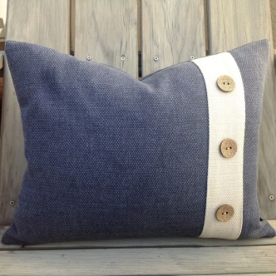

Student Name: | Salma Mohamed Safaa
Student Number: | 1170
Course: | Interior Designing
Assignment NO: | 12
Page NO: | 4

VI. When choosing bedding for a bed there are important factors to consider:
Design wise: Pattern, scale and colour are important here; these factors should be chosen carefully to suit the look of the bedroom, be it romantic or smart, country or simple.
Function wise: make the bedroom should be as comfortable as possible, so the right fabric should be chosen to be comfortable. What fabrics for the beds sheets? What kind of blankets, eiderdowns or throws, and kind of pillows rectangular pillows or square ones?
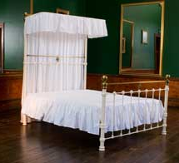
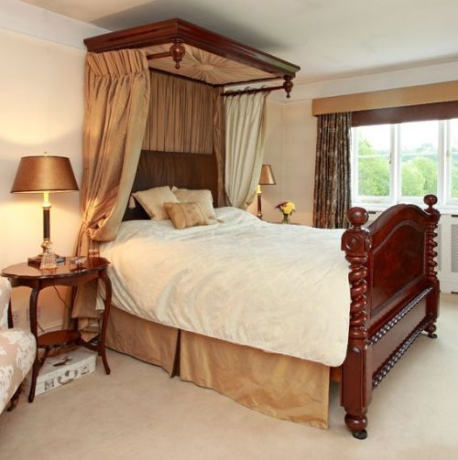
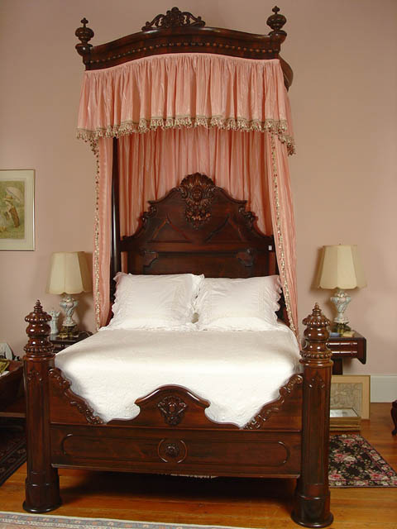
VII. A Half tester: is a canopy over the bed, that covers half of less of it, used to hang curtains from it.

VIII. The main difference between a half tester and a coronet:
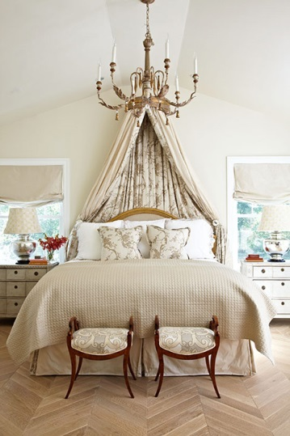
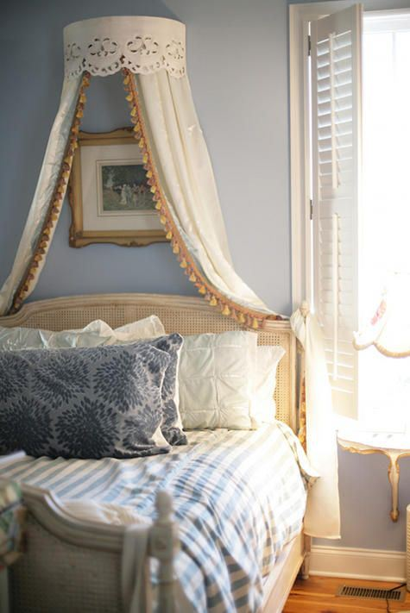
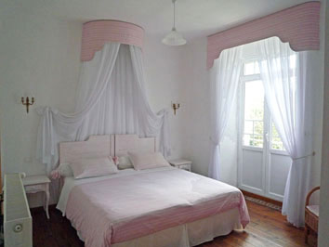
Is their shape; a coronet is a small semi-circular pelmet hang on the wall from which you hang drapes, but a half tester is often rectangular.

Student Name: | Salma Mohamed Safaa
Student Number: | 1170
Course: | Interior Designing
Assignment NO: | 12
Page NO: | 5
Activity
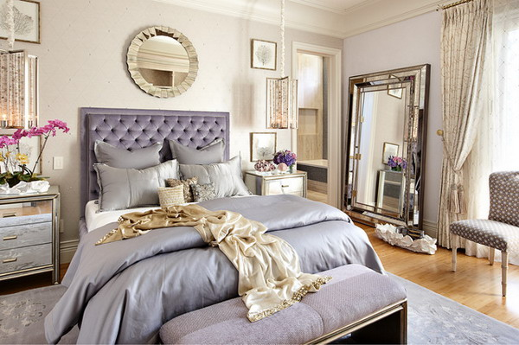
- Designing fabric for my bedroom room.
So for some inspiration I took a look on different room designs.
It turns I prefer a very feminine aesthetic themed created with fabrics like; voile, satin, textured fabrics, fur, and materials with some sort of visual interest.
The color scheme is lavender and champagne. I love almost any shade of purple, but also I opted to use champagne as the dominant color, which helps keep things looking bright and clean.
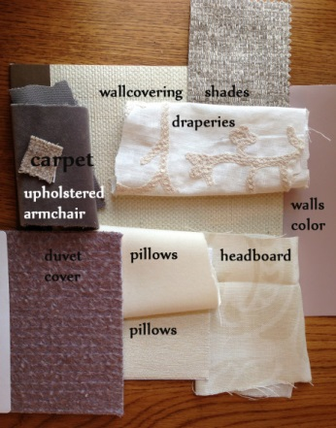
The gray velvet (top left) has some purple undertones and even a bit of brown, so it complements the lavender and champagne colors perfectly. I found a gray-brown woven drapery material (top right) that has metallic threads running through it, so I thought that coordinated well with the gray velvet and could be used for Roman shades.
The pillow fabrics are white velvet (top) and a sparkly cotton- silk blend (bottom). The duvet cover is mohair and wool and it gives the feminine soft touch. The headboard and drapery fabrics are both linen, the drapery is embroidered with a floral pattern while the headboard is a plain damask. That tiny square sample is for the carpet. It has a bit of a sheen to it and it’s a brownish-grayish color.

Student Name: | Salma Mohamed Safaa
Student Number: | 1170
Course: | Interior Designing
Assignment NO: | 12
Page NO: | 6
Activity B.
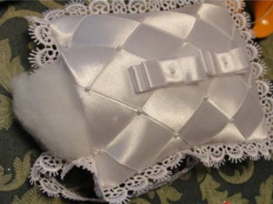
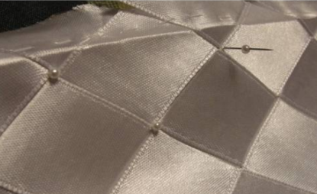
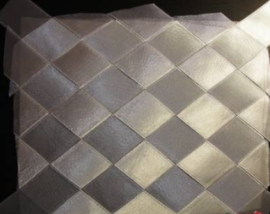
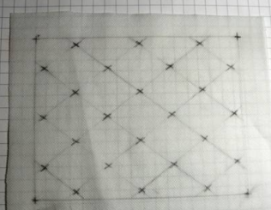
Designing a cushion show.
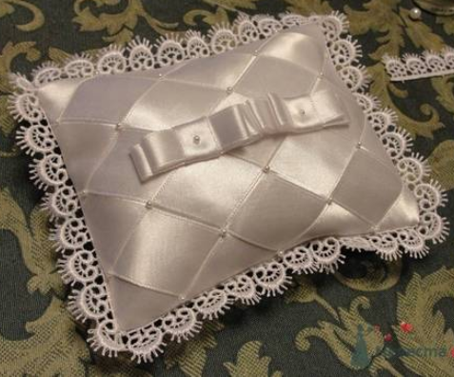
I designed a cushion of white satin ribbons. First crossing the ribbons diagonally, then embroidered little pearls on their intersection; to add a decoration feature and also to hold them together. Finally adding patterned frills for a softer touch.
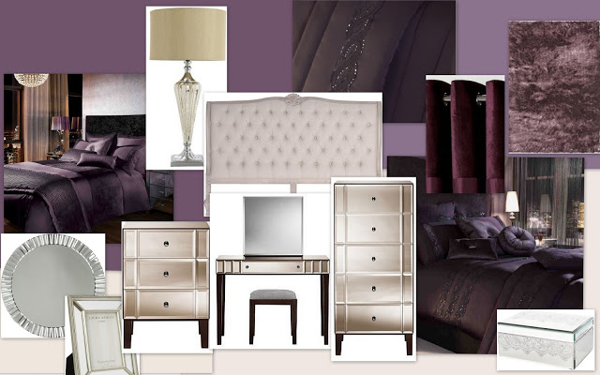
How it will coordinate with the room scheme. This is a mood board of the regal and feminine look of the room scheme. It can be easily achieved, as Lavender and Purple tones can also be effectively combined with a range of neutral and champagne shades(as the selected fabrics above).
The feminine scheme can work great with metallics, shimmering silvers, beaded, glittered and crystal objects. So I designed a pillow from shimmering satin to achieve this combination.
Also it would be perfect to add other designs of cushions to the designed cushion in order to coordinate with the room scheme. For example; the following designs;
