
Assignment Cover Sheet

Student Name: | Ray Wilson
Student Number: | 1336
Course: | Project Management
Assignment No: | 11

1. Give short answers for the following questions: (16)

- Which processes are involved in project risk management?
All of the risk management processes available follow the same basic steps, although sometimes different terminology is used to describe these steps. Together the following 5 risk management process steps combine to outline and deliver a simple and effective risk management process (a sample flow is illustrated below).
Step 1: Identify the Risk. The Project Manager and his team uncover, recognize and describe risks that might affect your project or its outcomes. There are a number of techniques you can use to find project risks. At this stage the preparation of the Project Risk Register commences.
Step 2: Analyze the risk. Once risks are identified the group decides the likelihood and consequence of each risk and then they develop an understanding of the nature of the risk and its potential to affect project goals and objectives. This information is also input into the Project Risk Register.
- 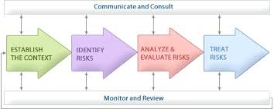
Step 3: Evaluate or Rank the Risk. The risks are evaluated and categorized by determining the risk magnitude, which is the combination of likelihood and consequence. Decisions then need to be made as to whether the risk is acceptable or whether it is serious enough to warrant treatment. These risk rankings are also added to your Project Risk Register.
Step 4: Treat the Risk. (Also referred to as Risk Response Planning). During this phase an assessment is made of the highest ranked risks and these are set out in a plan to treat or modify these risks to achieve acceptable risk levels. The creation of risk mitigation strategies, preventive plans and contingency plans are developed and then the risk treatment measures for the highest ranking or most serious risks are added to the Project Risk Register.
Step 5: Monitor and Review the risk. This is the period when the Project Risk Register is used to monitor, track and review the identified risks.

- Define the term ‘risk holder’s tolerance’.

Stakeholders and managers will have differing tolerances for risk, depending on the type of project, the circumstances, and the potential for loss or reward this risk entails. The level of risk that an individual (or organization) is prepared to accept, before action is deemed necessary to reduce it represents a balance between the potential benefits of innovation and the threats that change inevitably brings

These risk tolerances, or appetites as they are sometimes referred to, may be identified at the introduction of the project, by their actions during the project, or through written policy statements.

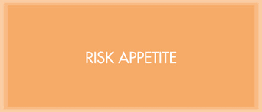
The appropriate level will depend on the nature of the work undertaken and the objectives pursued. For example, where safety is critical (e.g. operating a nuclear power station) the stakeholders tolerance or appetite will tend to be low, while for an innovative project (e.g. early development on an innovative computer software program) it may be very high, with the acceptance of short term failure that could pave the way to longer term success.
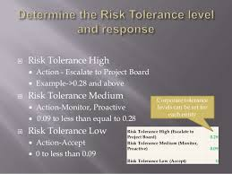
Of course somewhere in the middle will be medium ground as illustrated above. Examples of broad approaches to setting risk appetite that individuals or companies may adopt to ensure a response to risk that is proportionate (given their business objectives) is categorized as follows;
Averse Avoidance of risk and uncertainty is a key organization objective.
Minimal Preference for ultra-safe options that are low risk and only have a potential for limited reward.
Cautious Preference for safe options that have a low degree of risk and may only have limited potential for reward.
Open Willing to consider all potential options and choose the one most likely to result in successful delivery, while also providing an acceptable level of reward and value for money.
Hungry Eager to be innovative and to choose options offering potentially higher business rewards, despite greater inherent risk.
The appropriate approach may vary between individuals and organizations bearing in mind the time and money costs required to eliminate the chance of failure is in proportion to the stakeholders’ or businesses tolerance of risk on the project. The cost of assuring there are no threats must be balanced with the confidence that the project can be completed without surprising costs.

- What is risk identification?

Risk identification is the process of determining risks that could potentially prevent a project from achieving its objectives. It includes documenting and communicating the concern.

The objective of risk identification is the early and continuous identification of events that, if they occur, will have negative impacts on the project's ability to achieve performance or capability outcome goals. They may come from within the project or from external sources.



All projects come with risks. If a possible risk of the project is not identified early, then the project will be at a high risk to complete as per schedule, within budget and to meet specified quality expectations.
Project Risk identification is the most important process in the Risk Management Planning. Risk Identification determines which risks might affect the project and documents their characteristics. However it is important not to spend too much time in identifying risks. After the list is made, qualitative and quantitative analysis is done to figure out which risks you spend time and/or money on.

- Define ‘qualitative risk analysis.

Qualitative risk analysis is a project management technique concerned with discovering the probability of a risk event occurring and the impact the risk will have if it does occur. This risk analysis is an all-inclusive approach to ranking risks by priority, which then guides the risk reaction process.

Specifically, qualitative risk analysis examines and prioritizes the risks based on their probability of occurring and the impact on the project if the risks did occur. Once risks have been identified and ranked, qualitative risk analysis can give an indication to more in depth quantitative risk analysis, or move straight into risk response planning

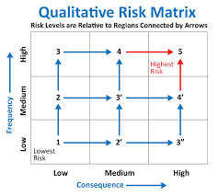

All risks have both probability/frequency and impact/consequence, as illustrated above. Probability is the likelihood that a risk event will occur, and impact is the significance of the consequences of the risk event. Impact typically affects the following project elements: schedule, budget, resources, deliverables, costs, quality, scope and performance.

- What is a decision tree method? How it is used for examining risks?

A decision tree is a method/graph that uses a branching method to illustrate every possible outcome of a decision

Decision trees can be drawn by hand or created with a graphics program or specialized software.
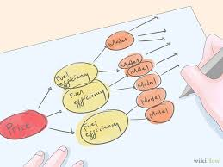

Informally, decision trees are useful for focusing discussion when a group must analyze the cost and benefits and determine the probability of success before make a decision.

This “tree” process can be used to determine lease-or-purchase calculations, buy-versus-build consequences, or whether to use in house resources rather than outsourcing the project work. Ultimately the purpose of the decision tree is to make a conclusion, calculate the value of that conclusion, or to determine which choice costs the least.

Programmatically, they can be used to assign monetary/time or other values to possible outcomes so that decisions can be automated as illustrated below. Decision tree software packages are readily available and used to simplify complex strategic challenges and evaluate the cost-effectiveness of research and business decisions. Variables in a decision tree are usually represented by circles however all types of shapes are often utilized.

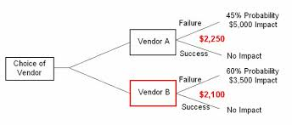

- Explain the term ‘risk response’.

Risk response planning is an integral aspect of risk treatment. The planning covers discusses and evaluates inputs like risk register, risk profiles and cause control matrix. Strategies are formulated and documented in this stage and the following four different options are discussed.
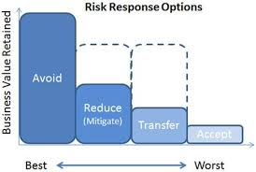
- Avoiding Risk - Risk avoidance requires identification of the risks first and foremost. This can be achieved through previous project experiences and histories. A study is made upon those risks that have a tendency to arise upfront at project initiation. Then finally a course of action is arrived upon after assessing the relative impact of the risks.
- Mitigating Risk - Risk mitigation is a control process that essentially stops a risk before it starts making an impact on the project and bringing it to an acceptable level. Often a contingency plan is put in place to prevent the risk.
- Transferring Risk - Risk transfer is one of the better means to dilute the impact of the risk and is covered in detail in VIII below.
- Accepting Risk - Finally, there are certain risks that are unavoidable. This strategy is the best when the risk is low. But there has to be a due plan for the same such as determining when the project will be exposed to the risk and making small adjustments accordingly.
The whole purpose of risk response planning is to bring the overall risk of the project down to an acceptable level and by the end of risk response planning process various risks and the corresponding strategies are documented. A risk register is ready that contains all details vis-à-vis the time of occurrence, priority and the people involved in handling the risk. The risks have already classified as either internal or external. Relevant risks are assigned to relevant stakeholders accordingly.

- What is ‘risk acceptance’?

Risk acceptance is a risk response technique employed when the risk cannot be avoided/mitigated or the project team decides to accept the risk and its consequences. There are primarily two types of risk acceptance strategies – Passive Acceptance and Active Acceptance

- Passive acceptance requires no action by the project team who deal with the risks as and when they happen.
- Active acceptance involves developing a backup plan should the risk occur.

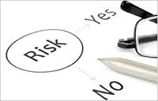

A contingency plan is a predefined set of arrangements the project team will need to take should the risk event occur. Normally a project will make a budget allowance that caters for risk acceptance and this contingency allowance is an amount of money the project will likely need in reserve based on the impact, probability, and expected monetary value of a risk event and clearly this amount will vary dependent on project size and complexity.

- Give some examples of risk transfer.

Risk transfer is a risk reduction method that shifts the risk from the project to another party and by transferring the risk and ownership to a third party, that risk doesn’t disappear, it’s just someone else’s problem to manage.

The purchase of insurance on certain items is classed as a risk transfer method. The risk is transferred from the project to the insurance company. A construction project in Australia that is exposed to the yearly “cyclone season” may purchase insurance that would cover the cost of a cyclone damaging the construction site. The purchase of insurance is usually in areas outside the control of the project team such as weather, political unrest, and labor strikes are examples of events that can significantly impact the project and that are outside the control of the project team.



Transfer of risk, as highlighted above, usually costs a premium for a third party to own and manage that risk and as well as insurance cover there are a number of other examples of risk transference such as;
- Fixed-priced contracts
- Warrantees
- Guarantees
- Performance bonds

2. How can the effects of risk be mitigated? Give some examples. (4)

Risk Mitigation
After the risk has been identified and evaluated, the project team develops a risk mitigation plan, which will reduce the impact of an unexpected event. The project team first mitigates risks in the following ways:
- Risk avoidance
- Risk sharing
- Risk reduction
- Risk transfer
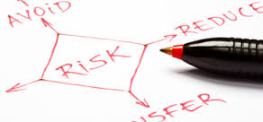
Each of these mitigation techniques, as illustrated above, can be an effective means in reducing individual risks and the risk profile of the project. The risk mitigation plan captures the risk mitigation method for each identified risk occurrence and the actions the project management team will take to reduce or eliminate the risk.
In summary risk is about uncertainty and if a developed framework surrounds that uncertainty, then you effectively de-risk your project, meaning there will be more confidence in achieving the project goals.
By identifying and managing a comprehensive list of project risks, unpleasant surprises and barriers can be reduced and golden opportunities sometimes discovered. The risk management process also helps to resolve problems when they occur, because those problems have been envisaged and plans to treat them have already been developed and agreed. It is important to avoid impulsive reactions and going into “fire-fighting” mode to rectify problems that could have been anticipated. This makes for happier, less stressed project teams and stakeholders.

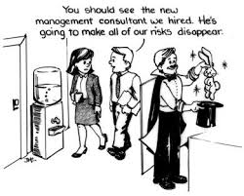

Examples of mitigation can include;

- Developing ways that the project can reduce the risk probability or impact
- Carrying out more audits on the project work before implementation
- Developing specific models, replications, and limited issues
- Simplifying the processes within the project

A good illustration of risk mitigation is associated with outsourcing of essential services to vendors as there are legal, reputational and operational risks to be considered. Operational risks, such as a vendor's operation not performing adequately and affecting customers negatively either through cost or schedule, can be mitigated through due diligence during the vendor selection process. Additional risk mitigation plans involve a “watertight” vendor contract, management, monitoring and contingency planning

3. Discuss in detail the process of identifying project risk. (10)

There are numerous methods of identifying risk and these processes are detailed as follows;

The creative process includes brainstorming sessions where the team is asked to create inputs via a list of everything that could go wrong. It is important that risk identification should be a planned, meticulous approach. Should identified risks travel in several different directions at once then some risks may go unnoticed. Therefore a methodical, logical approach is best. All ideas are welcome at this stage with the evaluation of the ideas coming later.
A more disciplined process involves using checklists of potential risks and evaluating the likelihood that those events might happen on the project. Some companies and industries develop risk checklists based on experience from past projects. These checklists can be helpful to the project manager and project team in identifying both specific risks on the checklist and expanding the thinking of the team. The past experience of the project team, project experience within the company, and experts in the industry can be valuable resources for identifying potential risk on a project.
Identifying the sources of risk by category is another method for exploring potential risk on a project. Some examples of categorization of potential risks are included in the following illustration;
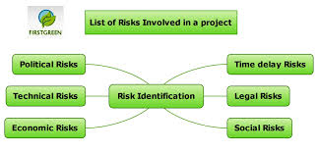
The project documentation is another risk region that should be reviewed by the project team, and areas such as the project plan, project scope, and other standard project documents should be studied broadly speaking. Constraints and assumptions should then be reviewed, considered, and analyzed for risks.

Interviewing project stakeholders and discipline based experts is another admirable approach to Identifying risks. The people responsible for risk identifications share the overall purpose of the project, the project’s WBS, and likely the same assumptions as the interviewee. Through questions and open dialogue, the interviewer shares his insight on what risks he perceives are hidden within the project. The goal of the process is to learn from the expert being interviewed what risks may be hidden within the project, what insight the person has into the project work, and what risks this person has encountered on similar work on past projects.



People themselves are potential risks to a project. Examples of people risks include the risk of not finding the skills needed to execute the project or the sudden unavailability of key people on the project due to skill shortages or project remoteness.

The Delphi Technique (which is based on the principle that forecasts (or decisions) from a structured group of individuals are more accurate than those from unstructured groups) is an anonymous method to query industry experts about foreseeable risks within a project, phase, or components of a project. There can a series of discussions with the Delphi Technique—without fear of repercussion or upsetting other participants involved with the process. The outcomes of the survey are then analyzed by a third party, organized, and then circulated to the experts.



This technique is completely secretive and the goal is to gain consensus on project risks within the project. The anonymous nature of the process ensures that no one expert’s advice overtly influences the opinion of another participant.

Student Statement:

By submitting this assignment, I confirm that this is my own work.

Student Signature | Raymond Wilson | Date | 23rd Jan 2015

For Tutor / Assessor Use Only
Total Marks
Marks Obtained
Percentage / Grade

