
Assignment Cover Sheet

Student Name: | Elizabeth Abidemi Akinlabi
Student Number: | 1380
Course: | Diploma in Fashion Design
Assignment NO: | 11

Marking Criteria:
We expect the learners to write minimum one well expressed point in three lines against each allocated mark. This means one needs to write 15 lines with 5 well expressed points to get high grades for a 5 marks question.
For high grades use examples and illustrations where appropriate.
Please insert your completed assignment ( in word format) here:

ELIZABETH ABIDEMI AKINLABI

1380

ASSESSMENT 11

DIPLOMAINFASHIONDESIGN

ELIZABETH ABIDEMI AKINLABI
1380
ASSESSMENT 11
PAGE 1

- Discuss in details how designers work? Designers work through creative thinking, this understanding, enables the designer in generating fresh designs. While designing, designers keep in mind the context in which they will be designing and maintain that context. Designers use;

- Memory and idea generation: A designer’s interests is stimulated by their environment, things they’ve seen and experienced, it maybe the pose of a dancer, or a pattern on a sidewalk. Memories are collected and stored. From this mental archive, creative thinking is developed, which is then adapted,modified,translated into the creative work of the designer.

- Strategies for guiding idea generation: The designer finds strategies for guiding the creative process of idea generation by mentally combing their memories and pairing these creative thoughts with the present sources of inspiration. This mental selective process helps the designer understand what works and what doesn’t in correlation to his or her ideas.

ELIZABETH ABIDEMI AKINLABI
1380
ASSESSMENT 11
PAGE 2

- Fashion Research and Range planning: The importance of fashion forecasting is imperative to the designer. The designer must have a keen sense of what will trend and how to translate these trends into garments from the trending silhouettes, styles etc. It is also important for designers to be aware of what other companies are designing, but since they attend the same fashion shows and are exposed to the same fashion information available, a similarity in designs will always be present. All this will influence the designers ‘creative works’

- ‘A fashion storyboard is a summary of your collections, inspirations and theme. It is a design tool that will help you remain focused and consistent as your line develops’

Discuss: The storyboard ‘tells a story’; it tells the story of how the designer became inspired and how the journey progressed. He or she collects photographs, newspaper clippings, rocks, flowers, pieces of fabric, etc. and puts it on his board. The fashion storyboard is a summary of the designer’s collections, inspiration and theme.
ELIZABETH ABIDEMI AKINLABI
1380
ASSESSMENT 11
PAGE 3

The reason why this design tool helps the designer remain focused and consistent, as his or her line develops is because it is a ‘visual form of expression’.
This ‘visual form of expression’ is built upon by adding notes which express the collection, and any other visual ideas, relevant to the fashion forecast will be added to the board. For example; my storyboard has images from the Victorian era, lace strips, pieces of colorful African prints, a fan, some beads, it is a work in process as I find things that I hope will inspire a collection which embodies the refinement of the Victorian era and paired with the flamboyance of African Urban fashion.
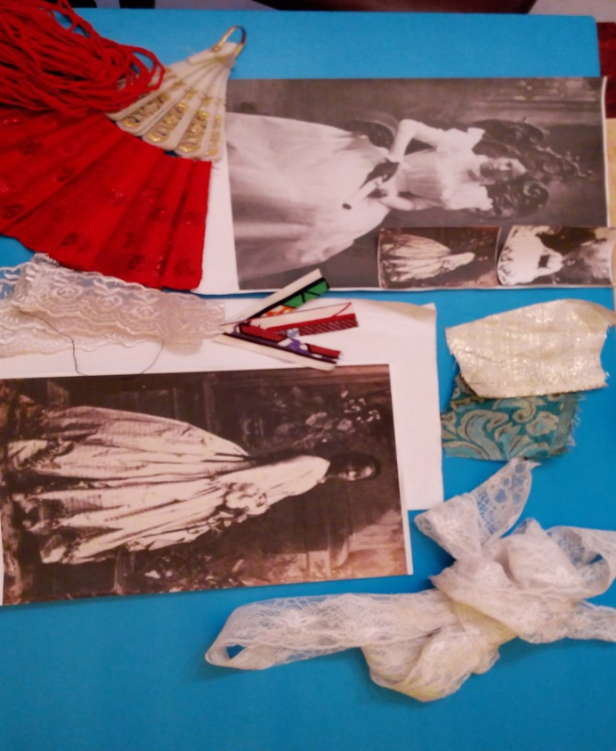
ELIZABETH ABIDEMI AKINLABI
1380
ASSESSMENT 11
PAGE 4

- What is the difference between a storyboard and a color board? The difference between a storyboard and a color board is that, a storyboard is a collection of memories and ideas, which are in tune with that seasons fashion forecast, this process of how the fashion designer works is first tackled before the color board is formulated. The color board is a tool used to choose color for the collection, which is usually chosen according to the season, the right colors are usually chosen using pantone chips, the chips enable accuracy in color and shade.

Student Statement:

By submitting this assignment, I confirm that this is my own work.

Student Signature | Elizabeth Abidemi Akinlabi | Date | 22/09/2015

For Tutor / Assessor Use Only
Total Marks
Marks Obtained
Percentage / Grade

