
Assignment Cover Sheet

Student Name: | Annur Zara Liyana Othman
Student Number: | 1227
Course: | Diploma of Fashion Design
Assignment NO: | 2

Student Statement:

By submitting this assignment, I confirm that this is my own work.

Student Signature | 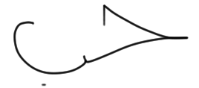 | Date | 9th May 2014

For Tutor / Assessor Use Only
Total Marks
Marks Obtained
Percentage / Grade

Principles of Fashion
Assessment 2
Total Marks: 30
1.Give short answers for the following questions:

I. What is fad?
Answer:
Fad is a desirable trend characterized with lots of enthusiasm and energy over a short period of time. This term was first known use on mid 19th century. Generally as a result of fad being perceived as popular by one’s peer or being deemed as cool by certain source such as famous people. For example if a popular celebrity starts wearing a certain style of cloth, other people would follow. This had happened because that celebrity is popular. A fad is said to catch on when the number of people following it begin to increase rapidly. However, fad will normally fade quickly once the perception of novelty is gone and because most of them are cost very high, so not everyone can afford to buy it. Few examples of fads are fringed flapper dresses, twiggy lashes, big shoulder pad for women, and flashy polyester shirt with glitter designs for men.

II. Define the term ‘fashion forecasting’.
Answer:
Fashion Forecasting is a global career that focuses on upcoming trends. A fashion forecaster predicts the colours, fabrics and styles that will be presented on the runway and in the stores for the upcoming seasons. In other words, Fashion Forecasting is practice predicting what’s to come in fashion trends. It’s based on the past and presents to create what’s coming in the future, what’s happening in the world’s fashion and what the spirit of that time will influence the future trend forecasting. It’s also predicting the moods, behaviors, consumers’ trends and what they want. There are many Fashion Forecasting companies that’s they propose is to predict what’s going to happen in the industry. Also lots of other research gathered from consumers, what’s going on around globally, what’s affecting consumers directly to be able to predict future trends, and what’s going on currently. Long-term forecasting is the process of analyzing and evaluating trends that can be identified by scanning a variety of sources for information. It is a fashion, which lasts over 2 years. Short-term forecasting focuses on current events both domestically and internationally as well as pop culture in order to identify possible trends that can be communicated to the customer through the seasonal color palette, fabric, and silhouette stories.

Fashion Forecasting is done through many communicating media, such as, cinema, fashion shows, press, magazines, newspapers and window display. It includes; market research, consumer research, surveys, consumer focus groups, in-store informal interviews, shopping, sales records, evaluating the collections, fashion trends, and trend for target markets.

III. How would you differentiate fashion forecasting from trend forecasting?
Answer:
Basically, Fashion Design is the recourses that help in predicting trends in the fashion industry. The Fashion Forecaster must bring his/her own knowledge of fashion design and history with consumer business information. They also predict how long a particular fashion will last in the market. Fashion forecasting can be done through market research, consumer research, survey, consumer focus group, informal interviews, shopping, sales record, evaluating the collection, ect. Design companies and retail markets use forecasting service to predict trends in colour and fashion.

Trend forecasting is a prediction work that can be done by the past result of fashion history in the industry. Each retailer trend forecasting varies and it’s mainly dependent upon whether the company is a wholesale brand or private label fashion company. “Every season, there are hundreds of designers showing breathtaking collections that the average consumer will never see. What does matter is who sees them. In-the-house designers and buyers at fast fashion retailer. People, who are paying close attention, identifying and predicting which styles, pattern and cuts will appeal to the average woman”-Mayer, Lindsay (freelance trend forecaster).
Big company have their own trend forecasting department that do the prediction work for the new collection by their past styles, fabrics and colours.
Overall, Fashion Forecasting can be label as a prediction for up coming style based on their research. Meanwhile, Trend Forecasting can be label as a prediction for upcoming style based in the past fashion result.

IV. What is meant by fashion trends?
Answer:
Trend can be defined as a changing or developing of something. Meanwhile Fashion mean a popular trends that already been accepted by consumer. When a certain styles become popular and many designers make an almost similar style for their new collection, its can be label as trends. Fashion trends can be referring as famous new style/design in fashion industry. When a designer introduces a new style in their fashion house, it may be accepted or rejected by consumer. Once the consumer accepts it by start buying, the new style/design will become trend. Later then, when the number of people buying increase, its become a fashion trend. Which mean designer will create a common style of fashion garment and many people purchase the same design or similar design clothes. The life-span of a trend is now about five months instead of a year. For the junior market, the span is only three months.

V. Outline the basic practical considerations that a customer takes into account when selecting fashion garments or accessories?
Answer:
Manufactures and consumer will consider a few of criteria of choosing fashion garment and accessories. Here are the basic practical considerations that a customer takes into account when purchasing any items.

Price
This is probably the most important consideration for the average consumer. Some of them even choose what to buy by the price. In other situation, they tend to consider if the price is worthy for the item. For not average consumer, they don’t really mind about the cost and just focus in other aspect.

Fit
This is also an important thing to consider when buying a new fashion garment. For ready-to-wear cloth, they provided few sizes and some just come in one size. Consumer’s body type is different, so the try-on in the fitting room method has applied in most of the store nowadays. This way allows customer try the cloth before buying it to make sure it’s perfectly fit or not.

Appropriateness
Its an aspect that consumer will clearly will consider before making any purchase. For example, if a customer work as professional officer, which required she/he to wear a formal looking clothes. If the customer buys very casual clothes such as ripped jeans, the purchase can be just a waste. For addiction examples, when winter season comes, the store tends to sell the thick clothes rather than thin one because consumer will buy according to the appropriateness.

Brand
An identification of manufactures, many consumers tend to buy based on the reputation of the brand’s name. Famous brands also advertise their new items widely and heavily. For example, if the famous clothing brand offer a dress that consumer can purchase it from the small store or not very well known for a lower price they still willing to spend more money because of the brand’s name. However, we can’t deny that famous brand always comes up with not only good-looking fashion garment but also winning with the quality aspect.

2. What is the difference between fashion and style? Explain with examples.
Answer:
Style can be referring as a certain characteristics that distinguish it from other design. Fashion can be referring as a support and acceptance by people for the new style/design. Every new season, designers try to come out with the different style and hope that style can be accepted well. Here are a few example of certain style that already became a fashion. Also through picture below, the differences between fashion and style can be easily shown.

Mulberry (shape, colour, accessorize)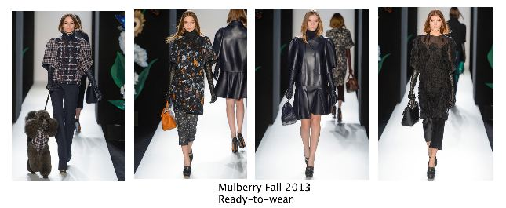
Mulberry presented the cutesy/kooky style for fall 2013 ready-to-wear collection. For this season, the style of oversize jacket, swollen sleeves, dark tone colour, and similar-look handbag for accessorize has chosen by Mulberry designers. This style became a big fashion.

Louis Vuitton (shape, colour, material)
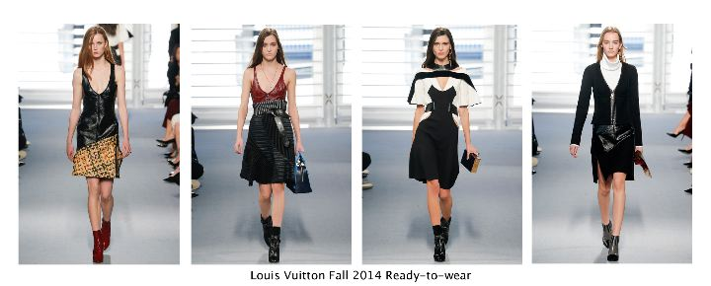
Louis Vuitton Fall 2014 ready-to-wear collection presented a low v-shape neckline, strong tone in colour, material such as leather style. It’s applied to many in their collection. Despite on the differences of material, colour, and shape, designers seem to keep that low neckline look. This style became a hit fashion.

Marc Jacobs (colour, texture, shape)
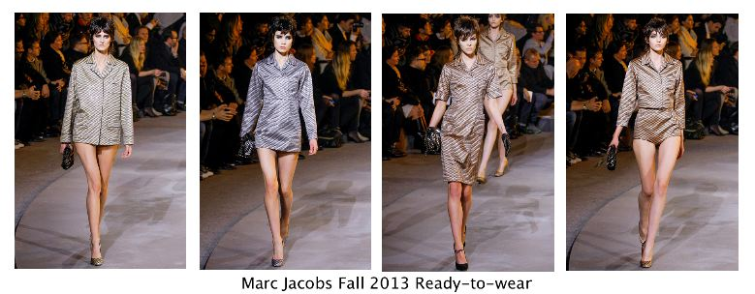
This season designers came out with a little heavy texture for their new collection. They choose for the style of silk pajamas and sequins. For this collection, designer tends to use a grey and sephia look colour. Once this style being accepted by people, it will be a fashion.

Givenchy (Material and colour)
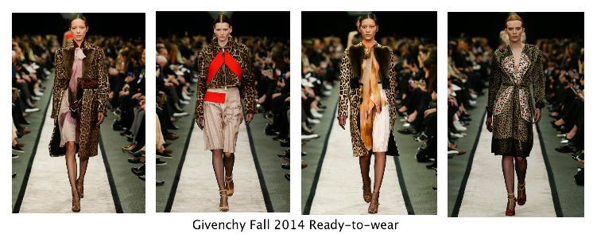
On the season of Fall 2014 ready-to-wear, Givenchy presented a leopard printed style on their few collections. For some design the material used is almost the same. Designers tend to use thick and little furry material for the long jacket also designers create a cloth using a thinner material. But still, keep the leopard look. This style became a hit fashion in industry.
Overall, style is always constant. In other words, style is a modification that later, once be supported by people then its become a fashion.
Resources
Information: Wikipedia, Fashion magazines and books, Fashion websites and blogs
Image: Fashion websites

