
Youssef
Assignment Cover Sheet

Student Name: | Gehan Aly Youssef
Student Number: | 1092
Course: | Interior Design Diploma
Assignment NO: | Module 13

Student Statement:

By submitting this assignment, I confirm that this is my own work.

Student Signature | Gehan Youssef | Date | 17/8/2015

For Tutor / Assessor Use Only
Total Marks
Marks Obtained
Percentage / Grade

Name: Gehan Aly Youssef
Student no.: 1092
Assessment no.: Module13
Course Name: Interior Design Diploma
Address: Beverly Hills Compound, Build. No. 89,Square 1,El Sheik Zayed, 6 October, Giza,Cairo,Egypt
Page no.: 1

Q.1. Short Questions:

- How can a focal point be created in a room by using mirror?

A focal point is that the first thing that your eyes see when you enter. It’s the thing that you put spot light on to make interest and pleasure to the place. So you can use anything as a focal point even a mirror can be used as a focal point. It can be placed behind a sofa in a living room or behind a bed in a bedroom put the size of the mirror must be large enough as to attract attention to it, also the frame must be different it can has a unique design or a shiny color or a very beautiful sort of wood .
Also mirror can be used as a groups a different size of mirrors with same frame can be a focal point that placed behind a sofa or upper a chimney , it can be used in corridors or behind stairs also different size and frames can be used.
From the advantage of mirror also that it make the place look larger so it’s a focal point with a function that also draw attention to other side of the room.

Here are some examples for mirror as focal point:

Name: Gehan Aly Youssef
Student no.: 1092
Assessment no.: Module 13
Page no.:2

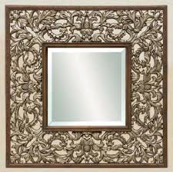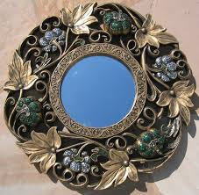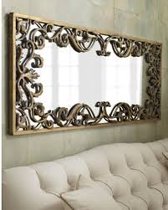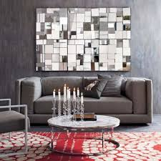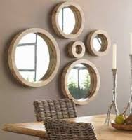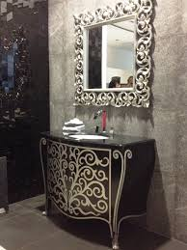
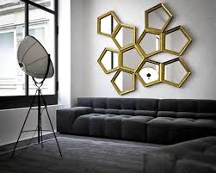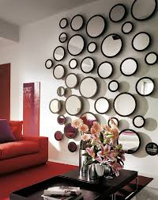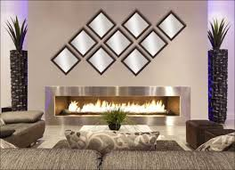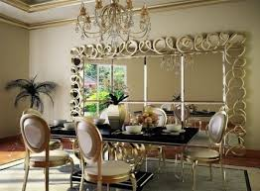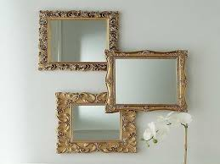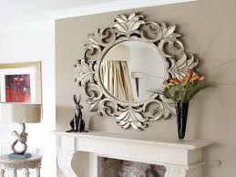

Name: Gehan Aly Youssef
Student no.: 1092
Assessment no.: Module 13
Page no.: 3

- When grouping together number of small objects which factor is of great importance that should always be considered?

It’s very simple and beautiful way to decorate using a number of small objects as this will give you a large focal point together or a large art of decoration, but we must take in consideration a several factors when grouping small objects together like :
- Color if they have the same color they will be chic and wonderful together they will draw attention to them and appear as same group.
- Pattern if they have same pattern even if they have different sizes or colors they will seem nice and also draw attention to them.
- Material for example if they all has same material as glass, wood, brass, silver, stainless, candles. They will look very nice and beautiful.
- Also texture, shape or origin can be common elements for grouping.
Grouping can be hanged on wall like mirrors or pictures even if they are different they can have same frame and background they will look very cozy on a living room or reception. Also groups can be used to decorate tables we can use a set of candles or crystal objects on table they will look very decorative, books also can used in a decorative way they can be used as groups.
Any other materials also can be used like pebbles, stones, plates, Marble, sculptures, flowers, dolls or teddy bears……etc.

Here are some examples by photos for grouping:

Name: Gehan Aly Youssef
Student no.: 1092
Assessment no.: Module 13
Page no.: 4

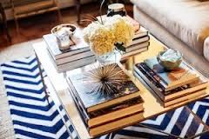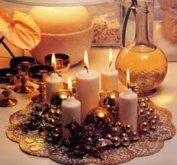

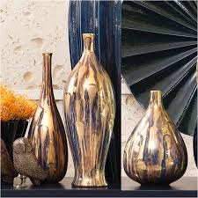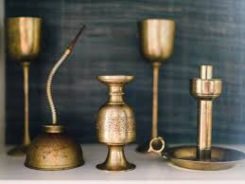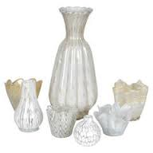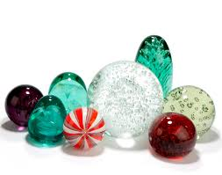

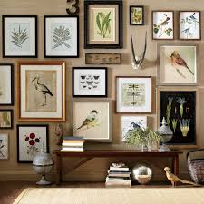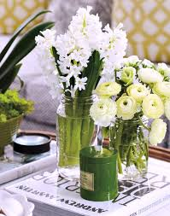
Name: Gehan Aly Youssef
Student no.: 1092
Assessment no.: Module 13
Page no.: 5

- How can a set of different photographs and prints be unified?
When we have a group in general we unify color, texture or material. Here in the case of photographs or prints it can be unified by using same frame material and color whether wood, metal, brass or silver. Also background must be unified as to appear photos inside and also appears symmetrical objects. Size can be fact of unification as we can use same frame sizes and photos can be hanged in equal rows and columns with same spaces in between. We can also use odd number of frames with similar or different size can be hanged in a random way to give a nice decorative view.
Here are some photos:

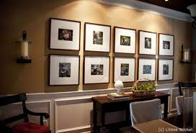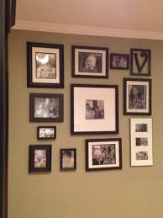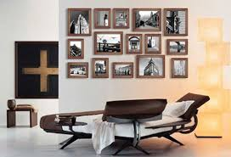
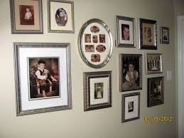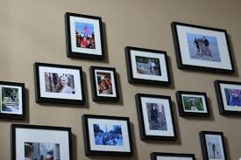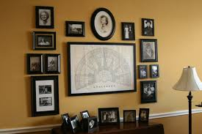

Name: Gehan Aly Youssef
Student no.: 1092
Assessment no.: Module13
Page no.: 6

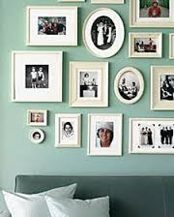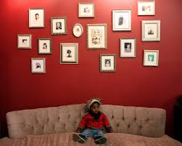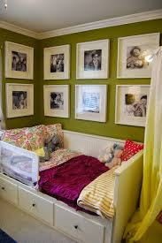

- If the walls are strongly pattered how you would display the pictures that they are not lost in the surrounding background?
If the walls are strongly patterned we must choose frames or backgrounds for the pictures that are strongly colorful that has deep colors or materials like wood can be in dark brown, Silver and brass be shiny plated .
Also backgrounds should be in shiny plan colors for example green apple or light blue color on a beige or grey patterned wall, white or cream background on dark red , velvet walls.
This will make them appear and doesn’t lose on patterned wall.
Here are some examples:
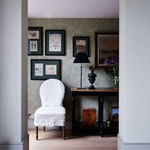n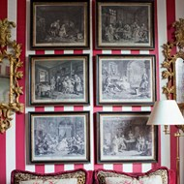 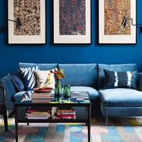

Name: Gehan Aly Youssef
Student no.: 1092
Assessment no.: Module 13
Page no.:7

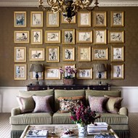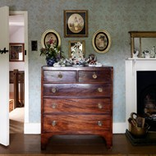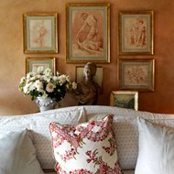

- If there is a large picture on the wall how would you balance it with small pictures?
If there is a large picture on the wall it would be balanced with small pictures by hanging it in the middle and around it the small pictures either in rows or columns it can be set above a sofa in the middle and at 2 sides 2 rows from small pictures or 2 columns or both above it one row and beside it 1 column. There is another solution that they all can be randomly hanged with the large on in the middle with a lot of small pictures around it. Or it may be hanged on one wall and other small pictures hanged on the opposite wall. Also there can be groups of pictures some are small and other are large so they can all be together set randomly hanged on same wall .
Here are some examples shown by photos:

Name: Gehan Aly Youssef
Student no.: 1092
Assessment no.: Module 13
Page no.:8

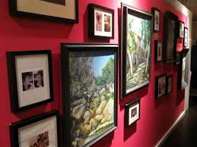

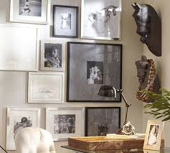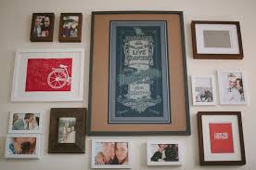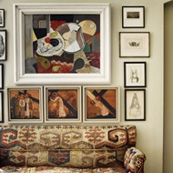

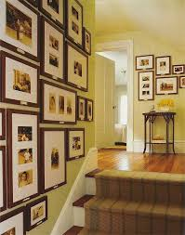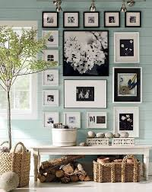

Name: Gehan Aly Youssef
Student no.: 1092
Assessment no.: Module 13
Page no.:9

- How important it is to achieve a balance between accessories and rest of the objects in the room?
Balance means equilibrium which means that the relation between accessories and the rest of the objects in the room must be based on equilibrium which means that if we have simple decorated room accessories can play a role of adding a décor to the place to be interesting one not boring poor room and vice versa if the place is highly decorated so we can just use simple accessories which can be unique or have good value and size in the place. We must take inconsideration while choosing accessories colors, materials, textures, sizes, patterns that match highly with the place with walls, furniture, tables, paint, curtains everything must been take in consideration as to make at the end a very beautiful scene or tableaux .
So there must be a balance all over the place whether we choose to make it symmetrical or not it’s according we want to make classic or modern scene also the objects and accessories themselves together how they look.
Here are some photos:
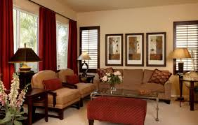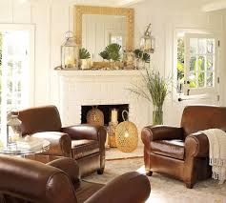

Name: Gehan Aly Youssef
Student no.: 1092
Assessment no.: Module 13
Page no.:10

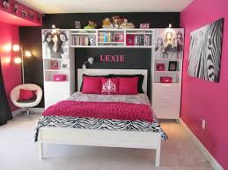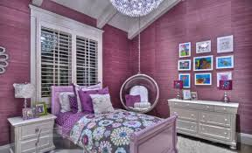

- How can dry flowers be used creatively for decorating rooms? Mention one simple method for drying flowers.
Dry flowers although they are old dead but they look very romantic, old age piece in a vase on your table, they are very pretty, admirable. You can take some flowers and put them in a bunch then dry them Even though these dried flowers are essentially dead, they’re still beautiful and can leave a pretty mark on a small space in your home. Recycle, reuse its absolute finest, dried flowers are the perfect project to turn something old into something brand new.
You can use dry flowers to decorate anyplace in your home specially living rooms and receptions, corridors also look nice when they have dry flowers put in a glass vase in them wherever you put them on tables, above fireplace. They always look nice whatever you use to put them in any material you use will appear the flowers.

Name: Gehan Aly Youssef
Student no.: 1092
Assessment no.: Module 13
Page no.:11
A method to dry flowers take them when they are style young and fresh and separate flowers from stems then rape them together in a bunch by using rubber rod and hang them upside down in an airy dry room for at
least 4 weeks until they are fully dried then take them and spray by hair dry spay as to be strong, then put them in any vase they will look very nice.
Here are some photos for dry Flowers:

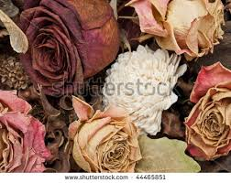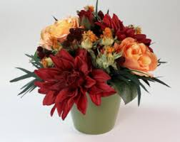

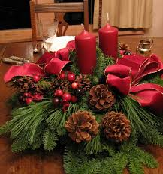

Name: Gehan Aly Youssef
Student no.: 1092
Assessment no.: Module 13
Page no.:12

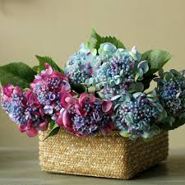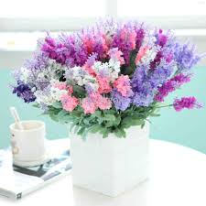

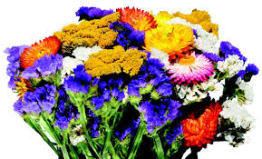

Name: Gehan Aly Youssef
Student no.: 1092
Assessment no.: Module 13
Page no.:13

- What makes some work of art better than others? How can you differentiate good art from bad art?

The quality is the main thing that differ work of art than other the finishing touches if it is good and clean the work will look good or perfect if the finishing touches aren’t good it will look poor , also quality of material itself differ like in wood art the kind of wood make a great difference in work. In painting the material of colors and offcourse the quality of paint itself the drawing itself differ . According to metals the finishing of the work and the details differ good work than bad work.
There is another point of view for this question that is there is no good art and bad art as it depend mainly on the eye of the person the viewer how he views tha art as it differ from age to age ,time, place, country, culture may be religion to another .Colors that artist use you love it or not materials,….etc. As taste of people differ also there eyes or point of view differ which make a piece of art may be very admirable to a person and another one see it not that much good, so there is no really good and bad art it depends mainly on the person and his point of view.
Some people say that good art is the art when your eyes first fall on you feel it, you love it, you can’t compare anything with it.So it’s a relation between humanbeing and art.

Name: Gehan Aly Youssef
Student no.: 1092
Assessment no.: Module 13
Page no.:14
Activity
Make a collage of the accessories that you would like in your living room (use cuttings from the magazines)

Here are some examples for a collage of accessories that I had made by myself.

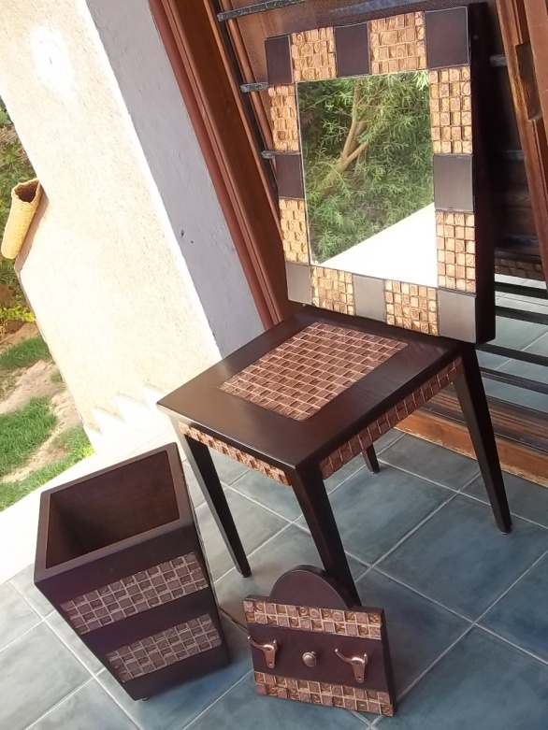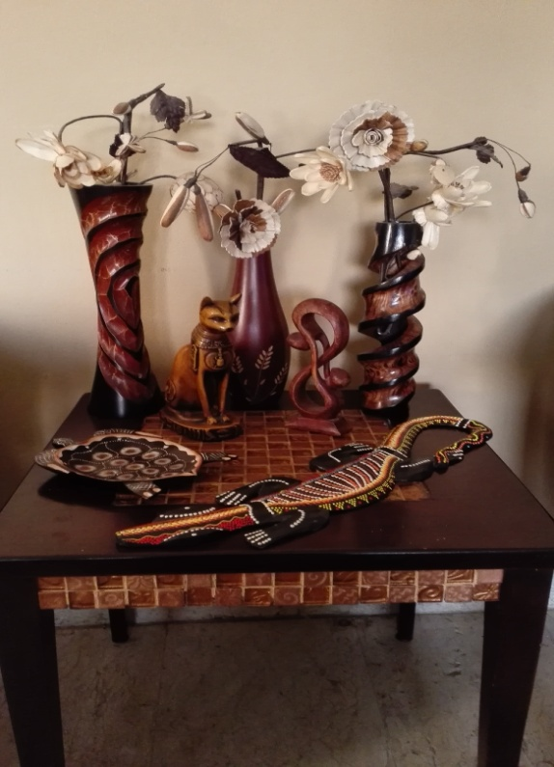

Name: Gehan Aly Youssef
Student no.: 1092
Assessment no.: Module 13
Page no.:15
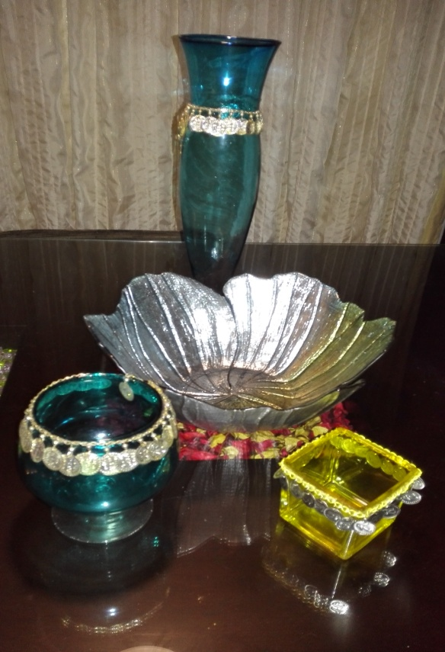
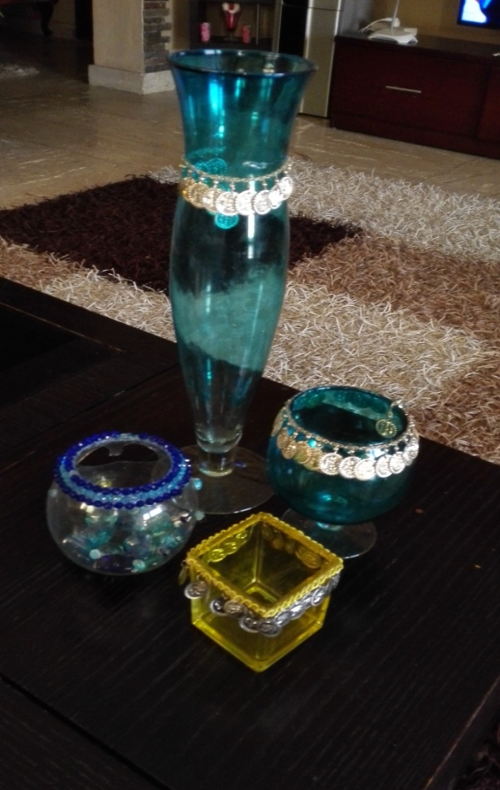
Name: Gehan Aly Youssef
Student no.: 1092
Assessment no.: Module 13
Page no.:16
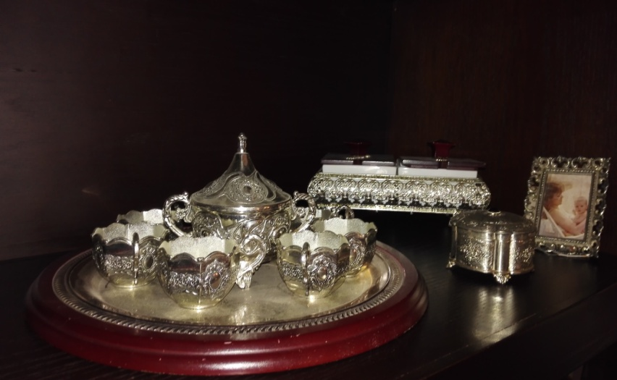

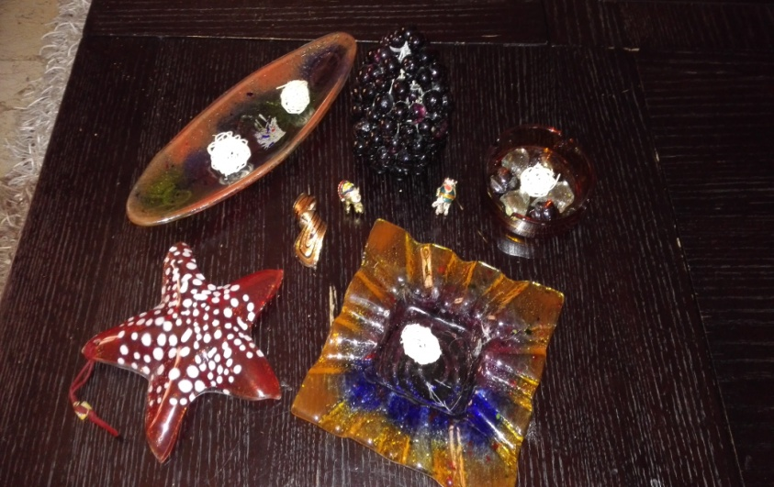

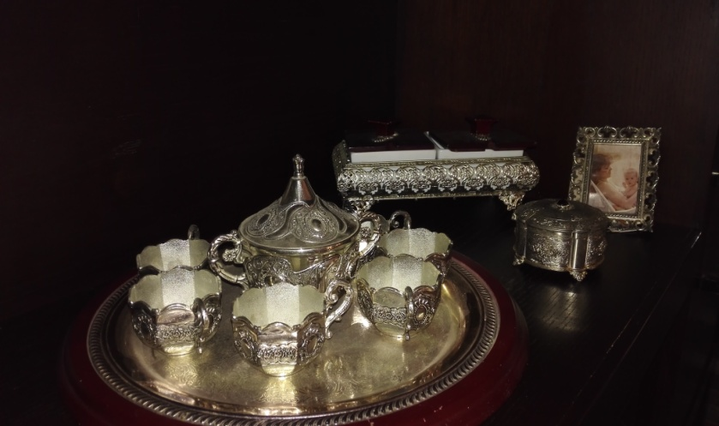

Name: Gehan Aly Youssef
Student no.: 1092
Assessment no.: Module 13
Page no.:17

