
Assignment Cover Sheet

Student Name: | Marshall Rufura
Student Number: | 1303
Course: | Diploma in Forensic Accounting
Assignment NO: | 4

Question 1
Fraud Risk Factors
A fraud risk factor is an event or condition that tracks the three conditions of the fraud triangle. Although fraud risk factors do not necessarily indicate that fraud exists, they often are warning signs where it does. Fraud generally occurs when three conditions are present:
Management or employees have an incentive or are under pressure.
Circumstances exist that provide an opportunity for fraud to be perpetrated.
Individuals involved are able to rationalize committing a fraudulent act.
Fraud Risk Factors are categorized into the following
Administration characters refer to the administration’s capabilities, pressures, style, and approach, adapted to deal with internal control and the financial reporting procedure.
These characteristics comprise the management’s interest to get involved in fraudulent financial reporting, for instance, compensation depending on achieving aggressive financial objectives; excessive contribution of nonfinancial organization in the selection of accounting values or estimates;
Industry characters are related to the financial and regulatory environment in which the entity functions
Functional characters and financial wellbeing hedging items such as the nature and complication of the goal and its transactions, the environmental areas in which It functions, the number of localities where transactions are noted and payments are made, the entity’s economic condition, and its efficiency

control mechanisms that could be adopted against corruption
Make anti-corruption a strong part of company culture.

Company culture needs to incorporate ethics and anti-corruption

Raise awareness.
Raising awareness of policy errors and successes helps reduce corruption
Train employees.
Training employees, especially through e-learning, as a means of communicating company policies helps reduce corruption
Update and inform.
Update policies and inform employees in order to keep corruption issues top-of-mind
Increase control.
Adopt a controlling mechanism, such as a whistleblower system, an open-door policy, or internal or external audit, as a necessary element to any anti-corruption policy

Reinforce zero-tolerance policies.
A Zero-tolerance policy is an example of a strict approach that sends a clear message to employees and other stakeholders, but it should also be supported by proactive measures that influence the source of corrupt activities
Specify gift policies.
Gifting policies should be as explicit as possible in order to avoid loopholes and grey zones where bribery may occur.

Be transparent.
Transparency facilitates the reduction of corruption and bribery

Assess risk
Implement country-specific risk assessments before entering a foreign market in order to help prevent corruption incidences abroad

Engage constructively.
Constructive engagement – the attempt to influence the business environment - can be a proactive, long-term approach to combating bribery and corruption.
Follow the leaders.
Follow the example of companies and industries that have had a head start in dealing with corruption, like the pharmaceutical industry
In summary, the following are the anti-corruption pills or mechanism(Company practices for Corruption Reduction, Stockholm School of Economics MBA 2008)

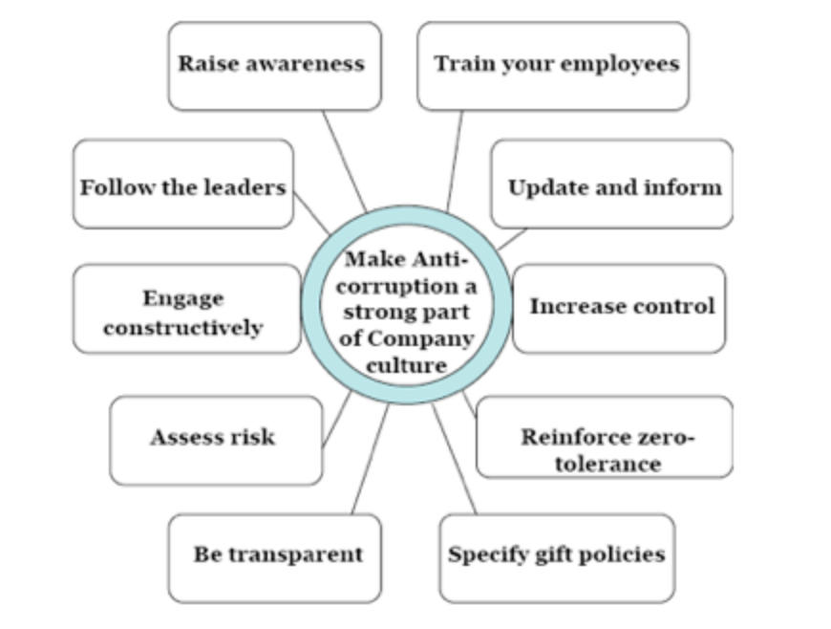

Main benefits of using analytic procedures in audit process.

Analytical Procedures consist of ‘evaluations of financial information through Analysis of Plausible relationships among both financial and non-financial Data

Benefits of using Analytic procedures in audit process
Substantive analytical procedures Play an Important part in a risk-based audit approach
Properly Designed executed analytical procedures can allow the auditor to achieve audit objectives more efficiently by reducing or replacing other detailed audit testing.
It Is vital that analytical procedures be sufficiently documented to enable an experienced auditor, having no previous connection with the audit, to understand the work done
The effectiveness of analytical procedures Depends on The auditor’s understanding Of the entity and its environment and the Use of professional judgment; therefore, Analytical procedures should Be performed or reviewed by senior Members of the engagement team

common rationalizations for a fraudster which tempt him to commit fraud
“ I was only borrowing the money”
“ I was entitled to the money”
“I had to steal to provide for my family”
“ I was underpaid; my employer cheated me”
“ my employer is dishonest to others and deserved to be fleeced”

important points to be considered when evaluating fraud risk factors
Risk factors relating to management's characteristics and influence over the control environment.
Risk factors relating to industry conditions
Risk factors relating to operating characteristics and financial stability
Analytic procedures that are used throughout the audit process for three primary

Analytical procedures consist of ‘evaluations of financial information through analysis of plausible Relationships among both Financial and non-financial data’. They also encompass ‘such investigation as is necessary of identified fluctuations or relationships that are inconsistent with other relevant information or that Differ from expected values by a significant amount

To obtain audit evidence, the auditor performs one – or a combination – of the following procedures:
Inspection
Observation
External
Confirmation
Inquiry
Re-performance
Recalculation
Analytical
procedure

Question 2
Opportunity
Opportunity is the ability to commit fraud. Because fraudsters don’t wish to be caught, they must also believe that their activities will not be detected. Opportunity is created by weak internal controls, poor management oversight, and/or through use of one’s position and authority. Failure to establish adequate procedures to detect fraudulent activity also increases the opportunities fraud for to occur. Of the three elements, opportunity is the leg that organizations have the most control over. It is essential that organizations build processes, procedures and controls that don’t needlessly put employees in a position to commit fraud and that effectively detect fraudulent activity if it occurs.

Question 3
Statement on Auditing Standards No. 99: Consideration of Fraud in a Financial Statement Audit abbreviated as SAS99 is an auditing statement issued by the Auditing Standards Board of the American Institute of Certified Public Accountants (AICPA) in October 2002(Wikipedia) .
SAS 99 requires auditors to ask management questions about their awareness and understanding of fraud. Auditors will then make a decision as to whether they need to ‘educate’ management about fraud and the types of controls that will deter and detect fraud. The standard also requires auditors to make inquiries of the audit committee, internal audit personnel and others within the entity.

Case Study
Question 1
Types of evidence gathered or collected
Evidence can be divided into two categories:
Testimonial - statements or the spoken word from the victim(s) or witness (es).
In this instance, testimonials can be from the Bank, previous property owners, property agencies and close relatives
Physical - also referred to as real evidence, consists of tangible articles such as receipts, invoices, tittle deeds, bank statements, properties, and other supporting documents
Question 2
Documents that could have helped the forensic expert in gathering evidence.
Receipts
Bank statements
Title deeds
Invoices
Property adverts(newspapers)

Student Statement:

By submitting this assignment, I confirm that this is my own work.

Student Signature | MR | Date | 2/12/2014

For Tutor / Assessor Use Only
Total Marks
Marks Obtained
Percentage / Grade

