
st
Assignment Cover Sheet

Student Name: | Saleema Soendas Choudrey
Student Number: | 1240
Course: | Fashion Designing
Assignment NO: | Unit 3

Fashion Forecasting
Assessment 3

  - How the income groups influence fashion?
Income group with high income level jobs and who are living in a standard area will adapt fashion changes easier and quicker than other income groups.

  - Why is awareness of fashion forecasting important for the designer and the buyer?
It is important for buyers and designers to know what will be in fashion for long term
And which colors, silhouettes. That’s what fashion forecaster is for. They predict long term fashion.

  - What is meant by fashion trend?
A “trend “means the acceptance of a “new” design. The new designs are mostly copied from the past fashion. It occurs only when the public accepts it.

  - What are the different factors that affect fashion trend?

Different factors that affect fashion trends.

1.Styles
2. fabrics
3.Color,
4. yarn mills

Textile specialist work two years ahead to find out guidelines for every season.
Long term forecasting is used by cooperate planning and short term forecasting is used by product developers.

Color is a very important aspect of yarn mills. The color is discussed in the early stage of the designing process. Fashion Forecasters come out with colors and fabrics from the early yarn and fabric trade shows.

3. Define the following terms;

Classic

Classic fashion styles suits anybody. A fashion style that remains in fashion for years.
Classis is timeless. For example the ‘little black dress’ it suits different body shapes, different personalities and different styles. It’s the perfect style to wear to any appropriated occasion.

Fads

FAD means “Short lived fashion trend that comes out on the fashion aspect all of a sudden and die out as quickly as they appear. From makeup, jewelry, handbags to shoes, jeans and dresses and many styles that just make a permanent appearance. Fad fashion is also very expensive not everyone can afford it. It’s the society that’s responsible for how long the Fad fashion exist.

Interrupted cycles Buying fashion items can be stopped ahead of time because manufacturers don’t want to risk producing by a sudden fashion change.

recurring cycles
Fashion copied from the past. That gets re introduced in a new century by changing the fabric or details in the design to give it a total new look.

Fashion adaptation
Adaption of fashion is divided by 3 variation of the fashion adoption process. Traditional adoption, reverse adoption and mass adoption. The important part is how Fashion is spread, how the ideas are expanded to understand consumers taste, lifestyle and their budget.

traditional fashion adoption
Traditional fashion is a concept that is founded in high fashion which is very expensive not very one can afford it. To attract consumers, cheaper versions are designed until the fashion becomes less attractive.

reverse adoption
Ideas are often adapted from fashion designers through traditional process. Sportswear and denim wear are styles designed by consumers. That’s called the reverse adoption. Consumers create their own look with old, new, handcrafted clothes.

Dissemination
Original fashion that is designed for juniors are highly priced which not everyone could afford that would be mass dissemination

Activity :

- (Metro) Newspaper 15 May 2014

Season: Spring
Colours: pastels, Light green, Light blue, Light Yellow, contrast with black,grey
Style: Classic
Fabric: Cotton ,metallic,
Accessories: Mini Bag, jewellery , Shoulder bags, tote

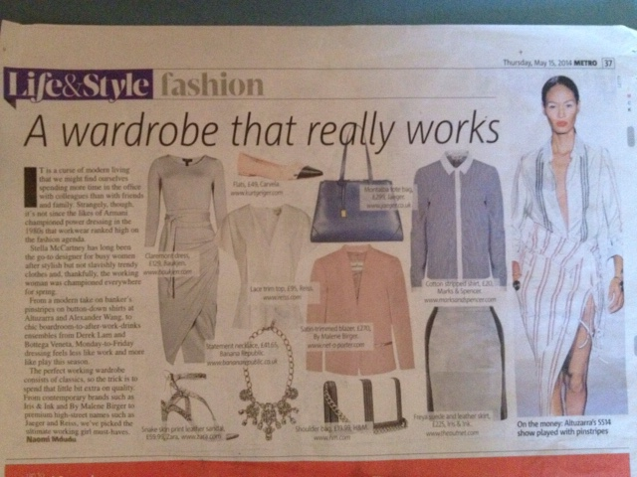
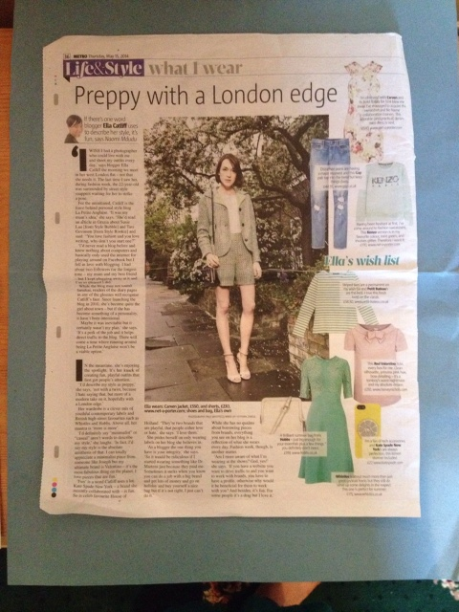

2. (Metro) Newspaper 20 October 2014

Season: Autumn
Colors: Dark, Red, Black, Brown
Style: Bold
Fabric: Wool, felt,
Accessories: Hats, leather handbags. Scarfs,

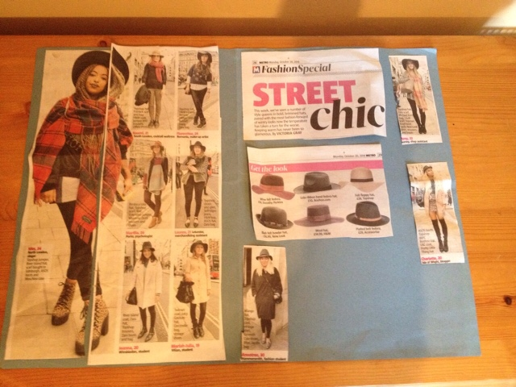

Conclusion:
The fashion items that were showed up in the Metro Newspaper were Mass Fashion & High fashion, the items were mixed.
Future Fashion according current fashion shown on TV, music videos, Media etc. will be more going towards sci-fi designs.

Sample of Future Fashion :

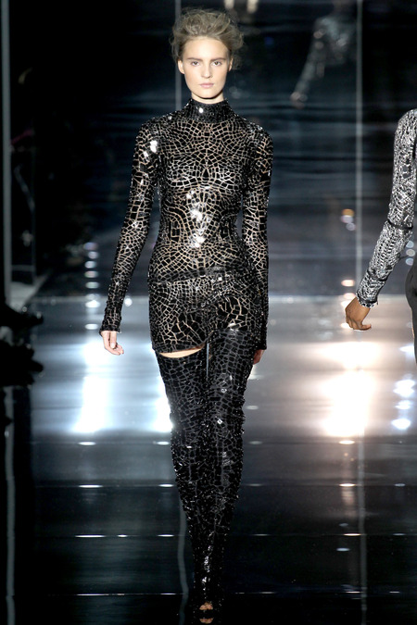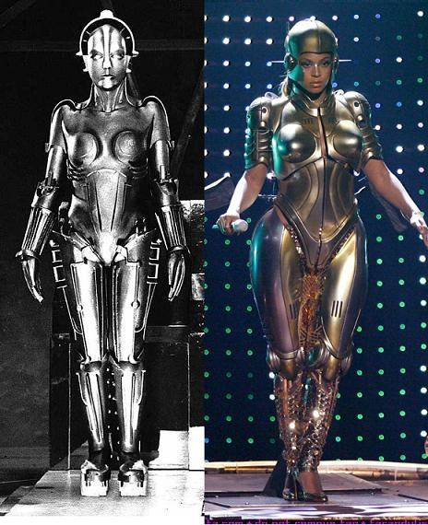

Forecasting

Fashion Basics | Color | Fabric | Silhouette | Line
- Skirts | Dark colors | Jersey ,stretchy, leather | Skater .pencil, flared, | H&M
- Day Dresses | dark colors | Woven, knit, leather | A-line, maxi, drop waist | Atmosphere
- Basics | White /classic colors | Jersey | Loose fitted, drop shoulder | Curated fashion

Examples of Fashion

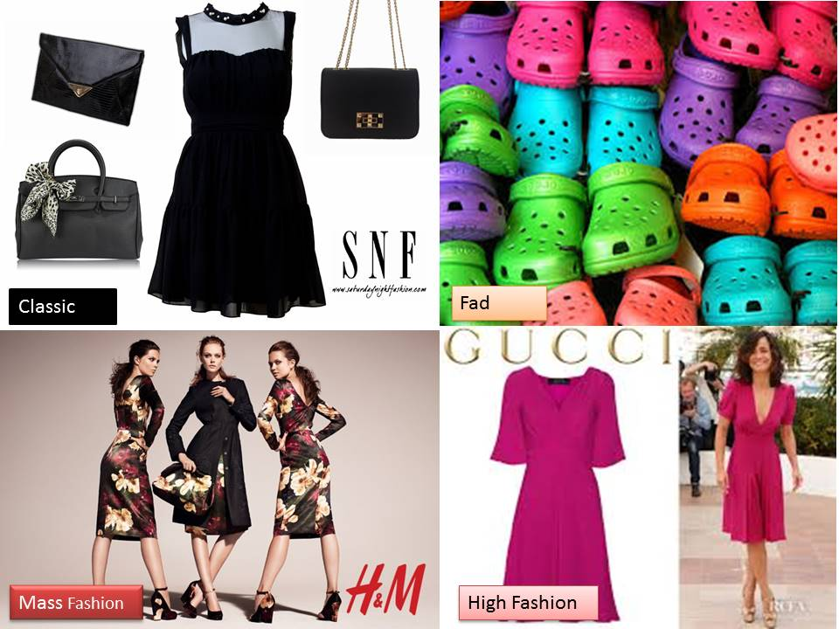

Classic – Fad – Mass Fashion – High Fashion

Reference

www.google.com
http://www.wetpaint.com/
www.vogue.com
www.h&m.com
http://www.gucci.com/
www.primark.com
www.trendstop.com

Student Statement:

By submitting this assignment, I confirm that this is my own work.

Student Signature | S.S.Choudrey | Date | 30/11/2014

For Tutor / Assessor Use Only
Total Marks
Marks Obtained
Percentage / Grade

