
Assignment Cover Sheet

Student Name: | Lucy Stone
Student Number: | 1407
Course: | Diploma in Hotel Management
Assignment NO: | 3

Marking Criteria:
We expect the learners to write minimum one well expressed point in three lines against each allocated mark. This means one needs to write 15 lines with 5 well expressed points to get high grades for a 5 marks question.
For high grades use examples and illustrations where appropriate.
Please insert your completed assignment ( in word format) here:
Assessment 3 – Housekeeping, Engineering & Security

Question 1
- The housekeeping manager or executive housekeeper is responsible for the housekeeping team and their training and development, the profitability of the department, checks up on the rooms and standard, implements the operating standards and procedures (SOP) of the department, the overall all cleanliness of the entire hotel and maintenance. This position is the communicator between the housekeeping department and the rest of the hotel, ensure all issues are dealt with, for example ensuring maintenance issues are fix. In many establishments another duty involves managing the laundry facilities and hiring of staff alongside the human resources department. Finally, purchasing of required stock for the guest rooms, for example snacks and beverages, cleaning supplies, as well as toiletries.
The floor supervisor is responsible for a certain floor and number of rooms, its their position to ensure the room attendants fulfil the duties they are required to do. They provide training to new staff members and/or training to existing staff regarding new operating procedures. This position is directly answerable to the housekeeping manager, and duties passed onto the room attendants are directed from the manager.

- The main duties of the whole housekeeping department involves the constant maintenance of cleanliness of the entire hotel, throughout the front and back of house and providing a hygienic and safe environment for all guests and staff. The main functions of the staff include the complete cleaning of all the room amenities, reporting maintenance issues throughout the rooms and hotel, often direct contact with customers, cleaning of front of house e.g. all the floors and public areas, cleaning of back of house, laundry services, lost and found, and first aid.

- The amenities within a room need to be useful and profitable, therefore the housekeeping department must manage the supplies. Regular checking if the amenities are worthwhile, in turn boost profits for the hotel, for example, if there is a certain drink within the mini bar very rarely gets used then it is not worthwhile to the hotel to continue supplying, a more popular drink would be profitable.
The department complies a standard operating procedure (SOP) to ensure the room attendants follow a check list to standardise the rooms; this in turn monitors all the useable amenities in the rooms to guarantee they are refreshed and the room cleaning is consistent.

- Amenities within the hotel can be split into two groups: in-room and outside-room. Within the room, typical amenities include a television and dvd player; wi-fi; telephone; mini bar facilities; personal items e.g. hairdryer, toiletries; information documents e.g. hotel information, menus, activities; and sometimes kitchen facilities. The outside-room amenities include the restaurants; bars; swimming pools; amusement facilities; gyms and exercising facilities; recreational facilities e.g. golf courses and vending machines.

- The security staff within a hotel are responsible for the safety of all guests and staff, ensuring emergency and evacuation plans are in place, key security and fire safety. The department is there to train employees to know how to react to an emergency efficiently and safely; alongside trying their best to avert an emergency by following protocols and safety procedures. The security department is in charge of the safety of the entire property, the hotel is divided up into sections to easily manage this, these include: the building entrances, hotel lobbies, guest rooms and amenities, exterior of the property e.g. gardens and pathways and finally the parking areas.

- The security department of any establishment is vital to ensure safety to all within, they work with speed and urgency to react to any threats and emergencies that may arise. A typically overlooked department that works in the background without too much guest awareness. The department should be run by a head of department, security manager, and an assistant manager, then an appropriate number of security staff members.

- Security services can be outsourced from the establishment, this method may be considered to be more cost effective. However, if there is an outside company in charge of the security of the property, there must be a leader to ensure a good communication between the management and the security staff. The management of the hotel and the outsourced security company must communicate to ensure the correct protocols and procedures are followed to guarantee the guests and staff are safe at all times. In-house security are run under a hotel department and paid a monthly salary and benefits, therefore paying for an external company can be more cost effective as the hotel pays a monthly fee for their services, and the company pays their staff an hourly wage and benefits.

Question 2
Hotel guests expect a certain level of security to be taking place within the establishment, often many guests forget and overlook the level of services this department provides. However the typical services expected include overall safety of the guests in the form of monitoring all areas of the hotel to reduce possible threats to themselves and their belongings; guests rely on the hotel front desk to ensure room key safety, however this is a typical service provided by the security department. Car park safety is a major factor considered by all guests, as many are concerned about damage or theft. Monitoring of CCTV systems is an important factor of consideration, this can reduce theft and can enable thieves to be caught, and many guest look out for visible cameras and rely on them for a feeling of safety.

Activity
A top tourist destination is the Victoria Falls in Livingstone, Zambia; one of the seven natural wonders of the world. A destination on many peoples bucket lists. Within the area there are a number of tourist attractions many people partake in, these include:
- White water rafting.
- Helicopter flights over the falls.
- Microlight flights over the falls.
- Game drives.
- Birding Safaris.
- Walking with Rhinos.
- Walking with Lions.
- Walking with Cheetahs & watching a Cheetah run.
- Elephant rides.
- Horse riding safaris.
- Bungi jumping.
- Gorge Swing.
- Zip Lining.
There are many facilities in the area catering to a range of guest styles and budgets; the top destinations in the area are Sun International Zambia and David Livingstone Safari Lodge. Sun International hosts two hotels of very different styles on the complex, The Royal Livingstone, a five star retreat hotel and Zambezi Sun, a three star family hotel. Within the complex there are a range of amenities including a number of differently styled restaurants and bars, a gym, a boma (an African outside eating and entertainment area), bush walks, activity centre, business centre, conference rooms, a clinic, a spa, swimming pools, sunset decks, laundry services, Wi-Fi, shuttle service and golf cart transportation around the complex, car parking, and shops. The guests are able to use facilities at both hotels; a concierge service and friendly, helpful staff cater for guests every needs.
Whereas, at the David Livingstone Safari Lodge, also along the Zambezi river offers a different upmarket style of accommodation. Rated the best hotel in Zambia and a nominee for the World Luxury Spa awards. The lodge offers the following facilities: activity centre, 24hr reception services, spa, swimming pool, restaurants and bars, pool deck, shuttle service, nature centre, laundry service, baby-sitting services, Wi-Fi, gift shop, business centre, river cruises, sunset deck, disabled facilities and car parking.
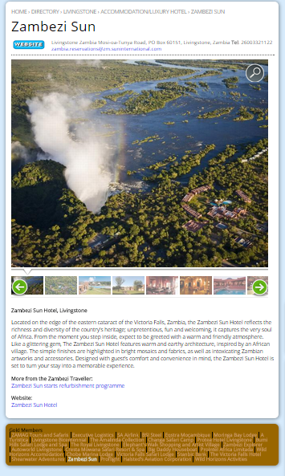
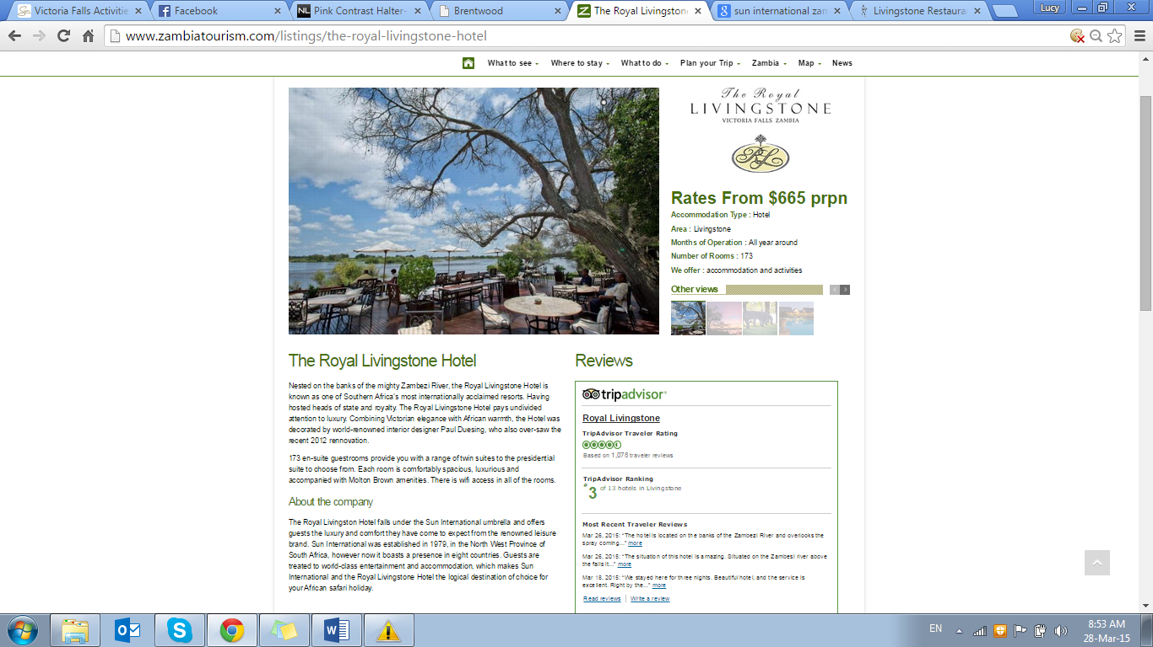
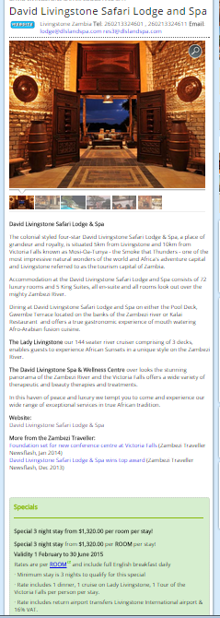

Fig. 1.1: Advertisements for the 3 hotels in the Zambezi Traveller and the Zambian Tourism Board.

The three hotels host a range of facilities, many overlapping due to the high standard of service provided within upmarket establishments. However the Sun International complex hosts a wider range of the facilities due to the vast size of the site, the number of guests the site can hold and also the clientele the company caters for worldwide. Another major selling factor for Sun International is the location, as it’s the only hotel sited closest to the Victoria Falls, no other hotel can compete with the setting.

Student Statement:

By submitting this assignment, I confirm that this is my own work.

Student Signature | Lucy Stone | Date | 06/04/15

For Tutor / Assessor Use Only
Total Marks
Marks Obtained
Percentage / Grade

