
Assignment Cover Sheet

Student Name: | Christian Blackmore
Student Number: | 1394
Course: | Construction Management
Assignment NO: | 08

Marking Criteria:
We expect the learners to write minimum one well expressed point in three lines against each allocated mark. This means one needs to write 15 lines with 5 well expressed points to get high grades for a 5 marks question.
For high grades use examples and illustrations where appropriate.
Assignment 8

- Give short answers for the following questions:

I. What do you understand by inventory management?

Inventory management is a very important procedure which should be taken very seriously in all respects whatever business you are running.

The main objectives of inventory management are:-

- Supply the right inventory at the right time but also be able to reduce or minimize costs, these objectives sometimes conflict with each other.
- Maintain supply at sufficient level to avoid excessive or shortage of material.
- Minimize inventory ordering costs
- Investment in inventory should be kept at an optimal level.
- Protect inventory against theft from within the company and from outsiders.

This procedure is implemented to insure all materials large or small are stored correctly and in an orderly manner with the correct coding system, this will insure that all materials can be tracked and located easily so not employing additional costs to the company. Many companies use ICT systems such as barcodes, RFID´s and GPS which contribute greatly in the control of inventory.



Inventory management should be controlled by a specialist team who have the experience to control the quantity, and quality of all materials entering or being withdrawn from the storage area. Materials which have been ordered must be put to use promptly so wastage is not caused by over ordering and equipment which has been hired or bought must not lay idle which will cause extra costs, these items must be controlled by the inventory management team.

II How would you maintain spare parts inventory on a construction project?

Having the right quantity of spare parts on a construction project is crucial for site functionality. Many inventory departments make the mistake of ordering items which are not required or are already in stock and don´t order the actual items that are required.

The categorization of spare parts stock can be very effective as it will separate all items by importance of use,

- Consumable parts
- Fast-moving parts
- Slow-moving parts

Categorization also enables parts to be located and installed more efficiently, this procedure will also make it easier to set effective safety stock levels.

Where possible the use of temporary facilities for storing spare parts and equipment for maintenance purposes will save on significant costs to the developer. This facility should only hold minimal spare parts usually a supply for 10 days is acceptable except if the project location is in a remote area, if this is the case then orders should be made in advance to enable suppliers to reach the location without causing delay or extra costs to the project. The storage area should be well organized to maximize its function:-

- The facility should be sized and equipped aptly with all types and quantities of parts required for work and maintenance to be carried out effectively.

- The facility should be kept in good order at all times, keeping material or equipment out of the isles enabling stock taking and stock up to be carried out.

- The facility should be separate from the main buildings; this will discourage possible thefts of material also a monitored access procedure should be in place to monitor all access to this area by operatives.

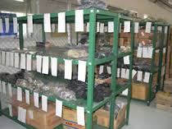

An ICT system should be in place to control and maintain all aspects of spare parts procedures such as:-

- Data base information listing equipment and spare parts on site

- Information of spare parts to be ordered from suppliers

- Ordering of spare parts

- Reception of spare parts and costs involved

- Controlling quantity and quality of parts, materials and equipment

III What are the advantages of interchangeability of spare parts? Also List the problems of establishing interchangeability of spare parts?

Interchangeable parts also known as (standardized parts) have become a huge advantage for industries since there invention by Eli Whitney and Simeon North in the 1800´s. These days interchangeable parts are mass produced all over the world.

This makes obtaining spare parts easier and cheaper than in the past. Interchangeable parts were made to have the same dimensions as every other part built for the same purpose. If for example a piece of machinery lays idle because of breakage which can cause significant extra costs to the developer, having interchangeable parts on hand means maintenance operatives can simply replace the damaged part with very little idle time involved, instead of having to build an entire new machine as in the past.

With interchangeable parts available onsite repairs to equipment and machinery can be achieved quicker without implying huge costs. Some of the spare parts utilised most frequently on construction sites for main diesel equipment consist of:-

- Air systems
- Axles
- Break systems
- Differentials
- Hydraulic components
- Transmissions
- Etc.

Manufacturers also produce parts such as; bolts, belts bearings, nuts and filters, gaskets, seals just to name a few. These components are all identical and can be interchanged between various types and makes of equipment.

The greatest problem that occurs with interchangeable parts is the cost of equipment and preparation to produce each identical part.

IV Why is lubrication of equipment important?

The function of a lubricant is to protect against friction and wear. Lubricants are also used to protect against corrosion by displacing moisture and leaving a continuous coating on the part. Equipment heavy or small must be maintained with sufficient lubrication at regular intervals as it is vital to maximise efficiency and machine/component lifespan, this on many occasions is overlooked by engineers.

Even when the need for regular lubrication is understood and applied, the application of lubricant is not always appropriate and problems with the equipment can arise when either too much or too little lubricant is used. Engineers should be aware that insufficient lubricant will allow bearings to run dry and bring a mechanical system to a standstill; there is a tendency also to over lubricate. However, while the elevated temperature of an inadequately lubricated piece of equipment could lead to machine failure, it is important to be aware that too much lubricant can increase friction, increase the temperature and cause migration of grease into parts where it can cause damage.

A schedule should be implicated by the engineers indicating:-

- Type of lubricant to be applied
- Quantity of lubricant necessary
- Which parts are to be lubricated
- Dates indicating scheduled maintenance control
Correct maintenance will increase the lifespan of all equipment; lubricants should be correctly labeled and stored to avoid possible misuse on equipment causing setbacks in productivity and extra costs to developers. It is important to consider the intended application as well as the environmental conditions to which the equipment will be exposed. Environmental conditions are important to the correct selection of lubricant products. Factors such as high temperatures, harsh chemicals and contaminants may have an effect on the lubricants performance.

V What is the utility of a data bank?

In recent years, most contractors have increased their investment in maintaining, updating, and replacing their equipment to satisfy the needs of project construction. Equipment managers in charge of different types of equipment and machinery need both information and tools to make strategic decisions pertaining to resource allocation and equipment maintenance, repair, and replacement.

Keeping accurate data for equipment, machinery and parts implemented on a construction site is vital. Documentation, reports, inventory and invoices should be backed-up by a computerized data system, which will provide the contractor with an efficient system to control all aspects anticipated by equipment management. Data systems are additionally more reliable and faster when an analysis is required for a certain piece of equipment.

Imputed data should be checked daily to keep records updated with the correct information. Inaccurate information caused by improper input to a database system by operatives or incorrect information received from the maintenance department will cause confusion, complications and subsequently increase costs.
Documentation, maintenance records and reports should be archived but to improve productivity and results a computerized system should be installed.

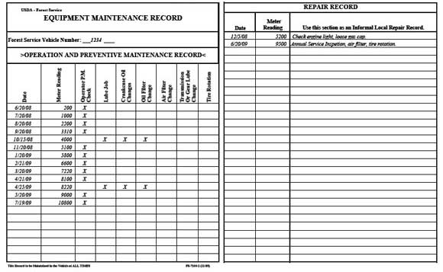

- What are the requirements of lubricants? How should lubricants be stored?

The proper handling and correct storage for lubricants must be applied; this will increase the life of the product, the misuse or handling of lubricants can be the cause of contamination or deterioration. This can cause inadequate lubrication to equipment resulting in engine failure.

The use of First In, First Out (FIFO) method to control lubricant inventory will help to eliminate possible deterioration due to long periods of storage.

Possible causes for contamination and deterioration:-

- Damaged containers
- Condensation seeping into containers
- Dirty dispensing equipment
- Badly conditioned storage area
- Exposure to excessive hot and cold conditions

Example of a well-conditioned lubricant storage area:-

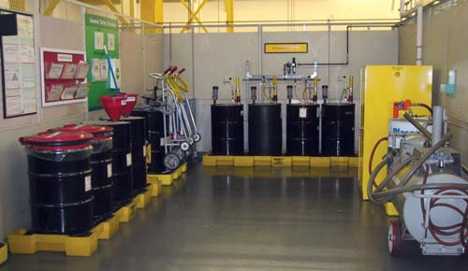

Outdoor storage for lubricants is not recommended, however if lubricants must be stored outside certain precautions can be taken to help minimize the effect of outdoor storage. When stored outdoors, drums should always be covered by a shelter or a plastic cover to protect the drums from rain and other sources of water. The best position for outdoor storage of lubricants is with the drums on their sides and bungs approximately horizontal, this position maintains the bungs submerged by the contents of the drums, this preventing moisture and water collecting inside. On most construction sites the need for a mobile lubricant apparatus is imperative for equipment which is in need of maintenance but too far from the work shop.

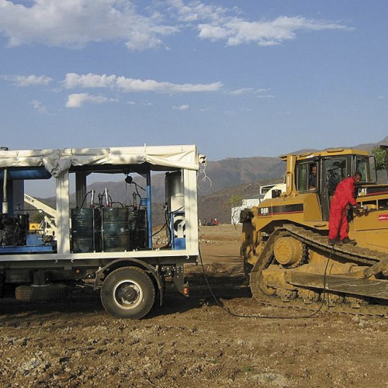
Example of onsite maintenance vehicle, which must be equipped with fuel, water, air compressor unit, transfer pumps and lubricating containers for different types of lubricants with corresponding pumps. Also waste containers are essential for collecting used wastage.

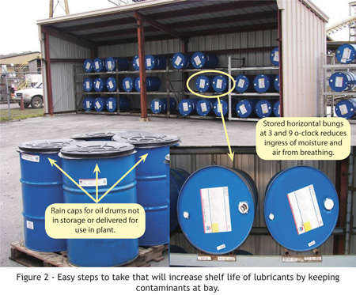
Example of outdoor storage for lubricants

Contaminated lubricants can be a major cause of equipment failure. This will result in downtime for repairs which can be very costly. The correct organization of lubricant stocks and making sure that they are handled and stored correctly will save time and money by increasing production and reducing maintenance costs.

- What are the general rules of equipment replacement?

The replacement of equipment is a major decision that a contractor will have to face regularly during any equipment’s life span. Equipment with advanced technologies often makes replacement an attractive option. More efficient and advanced models will provide lower cost, better quality and operationally more productive. However, replacement decisions may have a serious effect on the developer´s budget, operational flexibility, and overall profits.

Contractors should follow certain procedures for replacing their equipment. A separate policy is often followed by contractors to purchase new equipment and to replace the old ones. This replacement policy is to aid contractors in choosing the best replacement alternative that maximises the total profit and reduces the expenses and losses. Contractors need such a policy to replace inefficient equipment, or to add equipment to satisfy their work demands.

The contractor initially must carry out an equipment life analysis to establish what decision would be feasible for the company. With the information derived from this analysis a cost and productivity comparison between onsite equipment and possible alternatives is assessed.

Equipment life span can be divided into various definitions:-

- Physical life - The stage at which the equipment is worn down to such extent that it becomes unreliable and non-productive. At this point the equipment will normally be scraped or abandoned. As equipment ages so increases the maintenance and operating costs, the equipment’s life span depends on effective maintenance procedures being followed.

- Profit life – This is the period where the equipment has earned profit, but now spends more time being repaired than operational. Major components to equipment wear out and need to be replaced. The equipment manager must be able to clearly state when a piece of equipment is in need of replacement whilst the major components are still functional.

- Economic life – This is associated to the period of time that equipment maximises it´s profits over its productive life span, the economic life of equipment is shorter than the physical life therefore precise records of maintenance and repairs costs will assist to determine the economical time to replace equipment. Costs which must be included to determine this consist of:-

- Ownership/Operating costs
- Depreciation
- Inflation
- Investment
- Maintenance/Repair/Downtime
- Obsolescence costs

Student Statement:

By submitting this assignment, I confirm that this is my own work.

Student Signature | Christian Blackmore | Date | 12-10-2015

For Tutor / Assessor Use Only
Total Marks
Marks Obtained
Percentage / Grade

