
Assignment Cover Sheet

Student Name: | Kyle Pentland
Student Number: | 1605
Course: | Diploma in Environmental Management
Assignment NO: | 5

Marking Criteria:
We expect the learners to write minimum one well expressed point in three lines against each allocated mark. This means one needs to write 15 lines with 5 well expressed points to get high grades for a 5 marks question.
For high grades use examples and illustrations where appropriate.

Page 1
Q1.
Urbanisation is the "proportion of people living in built environments such as towns and cities". The U.N.O. states an urban population as any population living close together with a population of 20000 or more, though this opinion varies between countries. Urbanisation takes place from rural migration (job opportunities, better life) to towns and cities and natural urban population growth. The urban global tipping point was reached in 2007 when for the first time in history over half of the world’s population 3.3 billion people were living in urban areas.
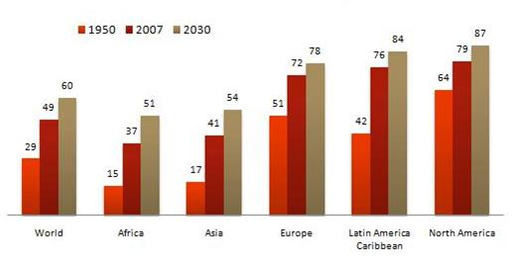
Percentage of population in Urban Areas
Rapid urbanisation has led to extensive land use change, particularly in developing countries. Urbanisation tends to begin on land rich in productivity, where settlements first began. As urbanisation increases the surrounding environment suffers. Arable, savannah and forested land are decreasing dramatically, which presents a threat to the food security for human beings. An example of this is the growth of Sao Paulo, in a bio-geographic crossroads. It borders interlocking ecosystems of wet tropical lineage (Amazon), lakes, rivers and coastal forest cover which has now vanished.

Page 2
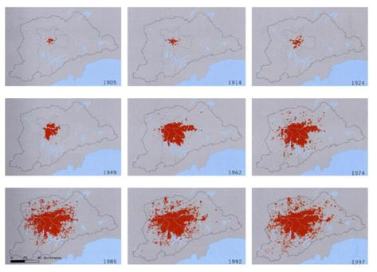
Sao Paulo urbanisation from 1905-1997
Many of the water systems that keep ecosystems thriving and feed a growing human population have become stressed because of increased urbanisation. Rivers, lakes and aquifers are drying up or becoming too polluted to use. 53% of the world’s wetlands have gone. Agriculture consumes more water than any other source and wastes much of that through inefficiencies. Climate change is altering patterns of weather and water around the world, causing shortages and droughts in some areas and floods in others.

Page 3
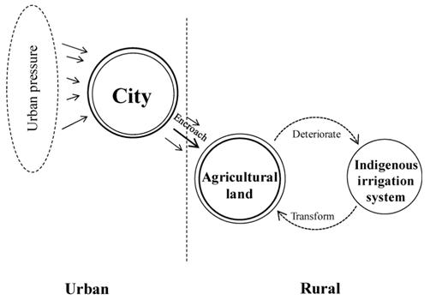
All building materials have an impact on the Environment in some way, from the extraction of iron ore to the production of concrete. They all start as chemicals in the ground. Forests, lakes and wetlands need to be destroyed in order to access these chemicals. Energy is required to transport, process and fabricate the product. Manufacturing processes produce both toxic and non-toxic waste. It finds its way to rivers and groundwater, through landfill. Of the 14 million tonnes per year of landfill in Australia, 44% is due to the construction industry.
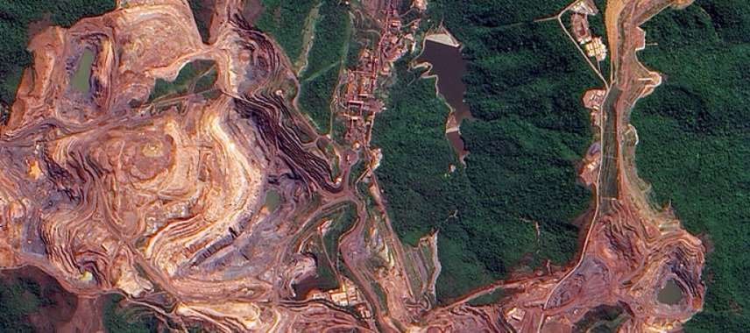
The Carajas Iron Ore Mine, North-East Brazil
Page 4
With increased urbanisation, habitats become more isolated and ultimately degraded into less favourable habitats for many native species. Species which are naturally adapted to habitat fragmentation will do well in this system. Like rats and mice. Those species that need large areas of stable habitat will not succeed in an urban area, as complex community ecosystems are eradicated. It is often these species that disappear with urbanisation, through migration and local extinction and biodiversity drops. Hedgehog populations have dropped up to 80% in nearly 50 years across U.K. due to habitat fragmentation, roads and housing developments.
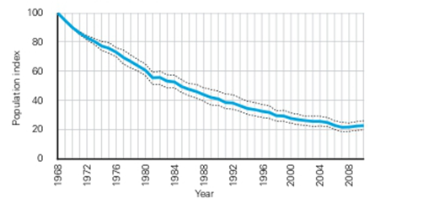
Q2.
Within urbanisation in Developing Countries, a poor solid waste disposal system (from lack of infrastructure, overcrowding and poor sanitation) encourages the dumping of wastes in water courses, storm drainage and irrigation channels, which in turn can cause flooding and the release of contaminating elements from sewerage systems. Where people draw their household water from open water courses, the dangers are increased. In Abidjan, Ivory Coast, 700,000 households have no connection to sewerage systems.

Page 5
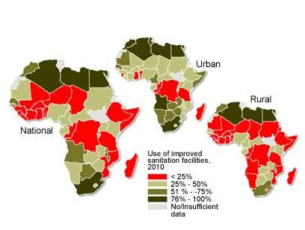
In 18 countries in sub-Saharan Africa less than a quarter of the population uses an improved sanitation facility

Air pollution from cars, factories and burning waste emit dangerous gases that change the air quality in urbanised areas and pose threats to health. Dangerous gases like carbon dioxide and nitrogen oxide cause respiratory diseases (like asthma and bronchitis) and have long term affects on the Environment. According to air pollution experts, the concentration of suspended particulates should be 6 or less micro-grams per cubic meter. Delhi was recorded at 153 micrograms per cubic m3.

Page 6

Air quality % in Delhi in for November 2015
.Increasing urban consumption of energy helps create heat pockets that can change local weather patterns. The heat pocket is created because cities radiate heat back into the atmosphere 30% less than rural areas. The combination of the increased energy consumption and difference in radiation means that cities are warmer than rural areas (0.6 to 1.3c). These heat pockets trap atmospheric pollutants. Smog occurs more frequently. Precipitation is 5% to 10% higher in cities. Death from heat waves against young, poor and elderly are more prevalent.

Page 7
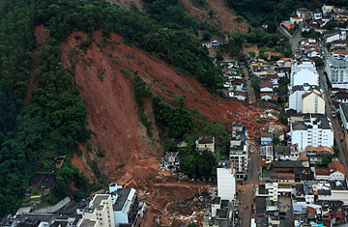
Teresopolis, Brazil 2011
Private property development is booming in Africa. The poor are being edged off better-located land with increasing frequency. As the city becomes ever more inaccessible, informal settlements expand rapidly. Funds go to new developments that aim to attract investment and provide new homes instead of infrastructure for the basic needs of the poor. Sprawling development intensifies the effects of the scourges of African cities – inadequate infrastructure and opportunity, and more people living in areas at high risk from landslide, disease, fire, crime or flooding.

Page 8
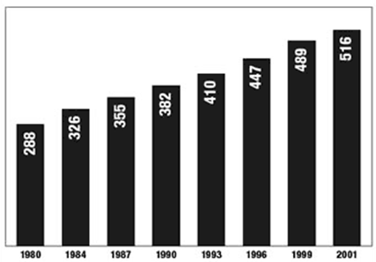
Sub-Saharans living on less than a dollar per day (millions)
As cities grow in number and size, the problem of waste generation is assuming alarming proportions. Toxic chemicals (released in the air or seepage into water systems from rubbish degradation) pose a serious health problem. Most cites in undeveloped countries do not have proper arrangements for garbage disposal let alone recycling capabilities and the existing landfills are full to the brim. An increase in recycling would reduce waste, reduce waste leakage and provide much needed jobs.

Page 9
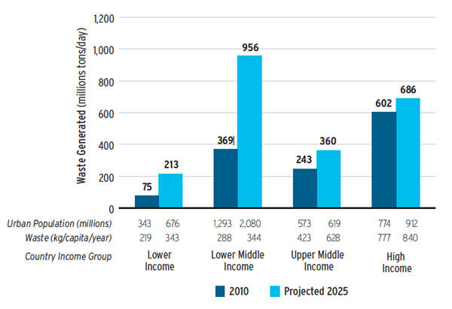
Cities in Kenya, Nigeria and India
Q3.
Low pay and lack of jobs, due to mechanized farming for example is a push factor for young people to the urban areas. More investment flows into industry and service businesses, which concentrate in urban areas near customers and infrastructure such as highways and telecommunications services. As these sectors become the main sources of economic activity, people who once might have spent their lives in rural areas move to cities in search of higher-paying work and better living standards. An example is Western Africa between 1990 and 2020.

Page 10
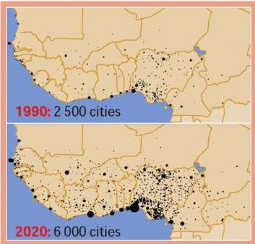
Urban growth in Western Africa
As the world becomes more globalised, countries no longer need to look for trade within their own boundaries. The dawn of the internet means countries can import and export around the globe with the touch of button. Urbanised areas have better transport links, such as rail, roads, air and sea which assists with this, further increasing job opportunities; the more cash that can be earned in the cities, the more cash is spent in the cities.

Page 11
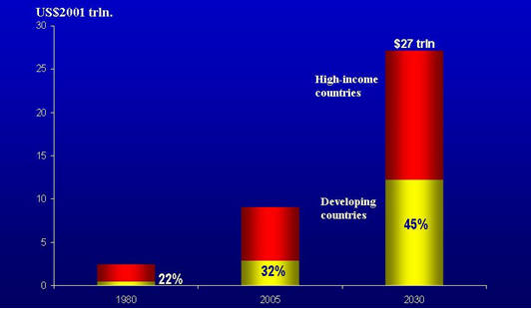
Globalisation increased developing countries share in world trade
Whilst the increase in population to urban areas may offer advantages to economy, it can pose many threats, if not planned. Often cities will offer privileges and incentives to attract a higher population such as lower taxation and subsidized housing. Whilst attractive the urbanised areas need to be able to cope with the increasing populations, such as housing, utilities, and sanitation. Without this in place, the end result could be an overpopulated area in a poor state. In order to reduce these threats, there are a number of policy responses and tools to manage Urbanisation.

Page 12
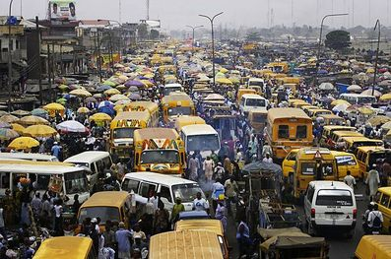
Over-crowding, Freetown, Sierra Leone

National planning to control urbanisation
Governments have adopted policies designed to stagger urbanisation. These policies look at mid to long term strategies for coping with urbanisation and include areas such as development of new housing, water and energy availability and transportation.
Regional/urban planning to keep urbanisation within a manageable level
Regional/urban planning, through action planning and strategic planning, aims to see the planned development of urban centres and their promotion and looks to develop smaller town and cities.
Intra-urban management to copy with problems that arise
With the best intentions, urbanisation problems do occur despite planning measures. Intra-urban management is there to try to mitigate these problems by projecting and building the necessary infrastructures.
Page 13
Participation, partnership and governance
The above measures cannot always be applied correctly due to inadequate institutions and legal systems. Many developing countries have extensive regulations in place however without the appropriate governance, how can they be enforced? This policy tool seeks to ensure that there is greater access to relevant information and an enhancement of public awareness of urbanisation issues.

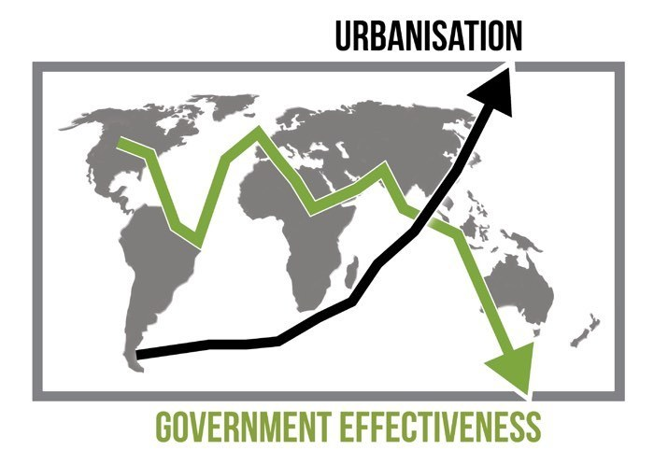
Urbanisation within Less Developed Countries

Student Statement:

By submitting this assignment, I confirm that this is my own work.

Student Signature | Kyle Pentland | Date | 11/02/2016

For Tutor / Assessor Use Only
Total Marks
Marks Obtained
Percentage / Grade

