Stages of a Project

Assessment 17 Total Marks = 20

Q.1 Multiple Choice Questions: (04)

- How many stages are there in a design project?

    - two
    - three
    - four

- The second stage of a design project involves;

    - the designer’s proposal and the client’s agreement

    - gathering information
    - working up drawings in details


- The initial meetings with the client not only establish the brief but also helps the client to understand;


    - the design
    - the whole process
    - the materials

- At which stage of a project survey takes place?
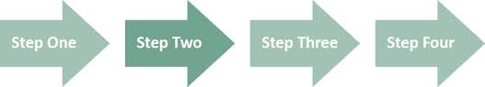
    - stage one
    - stage two
    - stage three

Q.2 Short Questions: (16)
(All Questions carry equal marks)

- What is the importance of design analysis? How does it help the design process?
Answer:
Design analysis is very important in interior design, it is like a confirmation of the brief it helps to define it and set out a free structure as well as gives a client confidence.
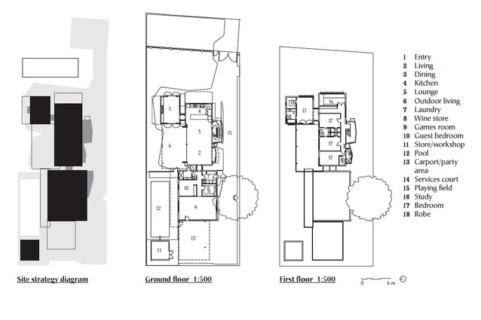
- What are the important points to consider for the delivery of a successful presentation?
Answer:

It helps if you spend some time preparing for the questions that might come up. Designer should be formal and professional during presentation and make sure presentation is pitched correctly. Also body language, eye contact and posture is as important as enthusiasm, voice etc. shouldn’t be forgotten in order to contribute a successful presentation.



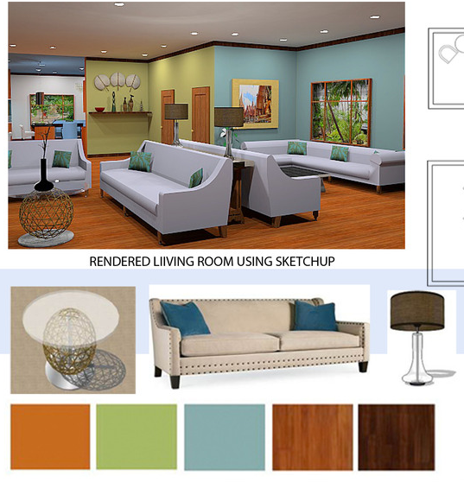
- What is meant by
‘specifications’?
Answer:
By “specifications” in design it is meant that consideration should be given not only to an object but its specific details like size, material, colour, type etc.

- Why is the procurement schedule prepared?
Answer:

A procurement schedule is prepared to ensure that fittings, materials, furniture etc. are available for installation. Designer has to work hard to establish a good relationship with suppliers in order to get the best service possible. If anything has been damaged during delivery designer would be confident that the supplier will provide a replacement.

Unit 17 Brentwood Open Learning College Page 1

