
Assignment Cover Sheet

Student Name: | Raymond Wilson
Student Number: | 1611
Course: | Diploma in Human Resource Management
Assignment No: | 5

Marking Criteria:
We expect the learners to write minimum one well expressed point in three lines against each allocated mark. This means one needs to write 15 lines with 5 well expressed points to get high grades for a 5 marks question.
For high grades use examples and illustrations where appropriate.
Assessment #5 Total Marks: 30

1.Giveshort answers to the following questions: (20)

i. What is Appraisal?
The main purpose of appraisal is to give the appraisee the opportunity to reflect on their work and learning needs over the past year in order to improve their performance for the coming year. This can be achieved through discussing their development and feedback on their job performance in a way that is constructive and motivational. The outcome of this interaction and discussion should result in an effective personal development plan. So lesson one is not to spend a significant amount of the time available purely reviewing past performance and lesson two is to involve the appraisee fully in the discussion so that they can get the maximum benefit from it. Ideally the appraisal method should be;
- A section of ‘two-way’ rather than ‘one-way’ communication
- A process rather than an event
- A tool for development as well as for assessing performance.
It is also important to be clear on a couple of points that an appraisal is not. First, appraisal is not a disciplinary process or dialogue. There are other, separate processes for addressing serious issues to do with conduct or capability, which should be followed and used appropriately. Second, it is not a discussion you ‘save things up for’. Whether containing praise or criticism, merits or mistakes, timely feedback is really the only sort of advice that has value. So there should essentially be no surprises in the appraisal conversation.
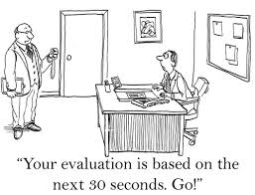
Appraisals are vital tool for the HR managerial team. They provide information and facts that can influence decisions about job selection, salaries, training, promotion, and transfers, etc. as well as identifying which of the employees are performing well, or not, and the reasons why.

ii. Outline the goals of an effective performance appraisal.

The overall goal of performance management is to ensure that the organization and all of its subsystems (processes, departments, teams, employees, etc.) are working together in an optimum fashion to achieve the results desired by the organization.
Performance appraisals therefore are an essential factor of these managerial and employee assessments. From the company’s viewpoint, these appraisals identify where productive and efficient effort is being done, however the following goals need to be defined;

Achieving this overall goal involves several ongoing activities including;
- Identification and listing of realistic goals and their desired results,
- Involving employees in the assessment and development method,
- Starting ways and means to measure progress toward those results,
- Setting principles for assessing how well results were achieved,
- Tracking and measuring progress toward results,
- Exchanging ongoing feedback among those participants working to achieve results,
- periodically reviewing progress,
- Reinforcing activities that achieve results and intervening to improve progress where needed,
- Performing appraisals constructively and with a supportive attitude,
- It is worth noting that results themselves are also measures.

These general activities are somewhat similar to several other major approaches in organizations, e.g., strategic planning, management by objectives, Total Quality Management, etc. Managing performance goals brings focus on overall results, measuring results, focused and ongoing feedback about results, and development plans to improve results. The results measurements themselves are not the key main concern as the priority is really receiving ongoing feedback and adjustments to meet the desired results.

iii. Explain the steps involved in the appraisal process.

Explain the Appraisal Process

In today's workplace, performance improvement and its management, is an increasingly popular subject. Business pressures are ever-increasing and companies are now required to become even more effective, efficient and execute better business strategies to progress and to remain competitive.
In the initial meeting between a manager and employee, the manager should first clearly explain the purpose and the process of the performance appraisal. Generally, a performance appraisal is conducted to clarify job expectations, set goals for improvement of weaknesses and were appropriate reward for accomplishments and overall performance.

Clarify Job Expectations
The next step is to ensure a mutual understanding of the job expectations is discussed so as to confirm an effective performance appraisal is achieved. Without this, the appraisal meeting could spiral downward because the manager and employee might be working from completely different vantage points. A review of the job description, and employee skills, qualifications and responsibilities should precede the actual performance appraisal.

Review and Update Job Skills
At this stage it is important to review the employee’s job skills, meaning what qualifications the employee had at the start of the evaluation period (normally the previous twelve months). Discuss any improvements necessary and praise the employee for skills that have improved during this period. Determine now what additional skills the employee can learn during the next evaluation period, which is again is normally the next year ahead, by setting reasonable goals for professional development.
The employee should be encouraged to provide input throughout the performance appraisal. Employers who formally implement employee input often have an employee self-appraisal form. If this is the case, the employee will come to the performance appraisal meeting with the completed self-appraisal.

Review Accomplishments and Goals
Accomplishments throughout the evaluation year will normally be itemized. If there were quantifiable goals established for the review period, the manager and employee should determine if the goals have been met. Often, a “management by objective” technique is used to track specific goals, progress and completion for each quarter. Using this technique simplifies the performance appraisal because there are intermediate assessments made during the evaluation period.


Final Steps and Rewards
An overall appraisal score may be discussed during the meeting or it may be calculated after the manager has had an opportunity to consider the employee input. In addition, the manager should indicate whether or not the employee will be entitled to an increase in pay or bonus, if applicable, however during difficult operational periods for the company (such as diminishing barrel of oil prices) the remuneration cannot always be offered or guaranteed. When rewards can be made though many employers use a scale that determines a percentage increase for performance appraisal scores. Whenever possible, the manager should inform the employee of the type or amount of increase to expect for her performance during the year.

iv. What are the benefits of an appraisal program?

One of the most significant benefits of performance appraisal is that, in the rush and bustle of normal daily working life, it offers a rare opportunity for a supervisor and employee to have "time out" for a one-to-one discussion of important work issues that might not otherwise be addressed. Almost entirely, where performance appraisal is conducted properly, both supervisors and subordinates have reported the experience as favorable and constructive.
Appraisal offers a prized opportunity to focus on work undertakings and goals, to recognize and correct existing problems, and to encourage better future enactment. Thus the performance of the whole organization, employer and employee, is improved.
The importance of this powerful and purposeful interaction between supervisors and subordinates should not be underestimated with the key benefits being;
Motivation and Satisfaction
Performance appraisal can have a profound consequence on levels of employee motivation and satisfaction - for better as well as sometimes for worse.
Performance appraisal potentially provides employees with recognition for their work efforts and the influence of group recognition as an incentive has been long noted. In fact, there is evidence that appraisee’s will accept negative recognition in preference to no recognition at all, which is sometimes the case through an appraisal process. If nothing else, the existence of an appraisal program indicates to an employee that the organization is genuinely interested in their individual performance and future development.
The strength and prevalence of the natural human desire for individual recognition should not be underestimated or overlooked. Absenteeism and turnover rates in some organizations can be significantly reduced if more attention is paid to it and regular performance appraisal, at least, is a good start.
Training and Development
Performance appraisal also offers an excellent opportunity for a supervisor and subordinate to discuss, recognize and agree upon individual training and improvement needs.
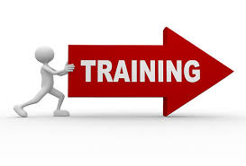
During these discussions, the presence or lack of work skills can become very obvious therefore the performance appraisal can make the need for training more pressing and relevant by linking it clearly to performance outcomes and future career objectives.
From the point of view of the company’s involved, consolidated appraisal data can form a picture of the overall demand for training. This information may be analyzed by variables such as sex, ethnic background, qualifications, department, etc. In this respect, performance appraisal can provide a regular and efficient training needs audit for the entire organization.
Recruitment and Induction
Appraisal data can be used to monitor the success of the organization's staffing and induction practices. For example, how well are the employees performing who were hired during the last two years?
Appraisal data can also be used to monitor the effectiveness of changes in recruitment policies embarked on from time to time. By following the yearly data related to new hires (and given sufficient data on which to base the analysis) it is possible to assess whether the general quality of the workforce is improving, staying steady, or even declining.
Employee Evaluation
Although often unassuming or even denied at times, appraisal is a legitimate and major objective of performance assessment. But the need to evaluate is also an ongoing source of tension, since evaluative and developmental priorities appear to frequently clash. Yet at its most basic level, performance appraisal is the process of scrutinizing and evaluating the performance of individuals.
Though organizations have a clear right - some would say a duty - to conduct such evaluations of performance, many still shudder from the idea believing that the explicit process of judgement can be dehumanizing and demoralizing and a source of anxiety and distress to workers. It is said by some that performance appraisal cannot aid the needs of evaluation and development at the same time; it must be one or the other.
But there may be an acceptable middle ground that benefits all, where the need to evaluate employees objectively, and the need to encourage and develop them, can be balanced.

v. Write short notes on the following appraisal methods:

a. Critical incident methods

The critical incident method of performance appraisal involves identifying and describing detailed events (or incidents) where the employee did something really well or something that needs improvement (based on that event/incident). It's a technique based on the description of the event, and does not rely on the assignment of ratings or rankings, although it is occasionally coupled with a ratings type system for various outcomes.

The use of this method is more demanding of the manager/appraiser since it requires more than just ticking off things on a form – they need to actually write things down. On the other hand critical incidents can be exceptionally useful in helping employees improve since the information in them is more detailed and specific than in methods that involve rating employees, and this information can be tailored to suit precise needs and rewards.
Some company’s and there management encourage employees to record their own critical incidents which is an interesting variant that places more responsibility with the employee, and also does not require the manager to have been present when the incident occurred.
Generally however it's important that incidents are recorded as they occur and not written at or around the annual performance review. Delaying the recording of critical incident reports (either good incidents or not so good) means a loss of detail and accuracy which is what this whole method is about.

b. Behaviorally-anchored rating scales

The behaviorally anchored rating scales (or BARS method) is a technique of evaluating employees that carries typical job appraisals one step further: Instead of relying on actions that can be appraised in any position in a company, the BARS method bases evaluations on specific behaviors required for each individual position with the company.
BARS evaluations requires an in-depth understanding of each position’s key tasks, along with an appreciative understanding of the full range of activities displayed by individuals in carrying out such tasks. The behaviors for each employee need to be rated and then these can attached to points on a rating scale, which indicates whether the behavior is exceptional, outstanding, competent, or unsatisfactory. The result is a rating scale for each task.
The BARS method for a specific job, such as a Change Control Engineer, can be rated as the following example;
5 — Exceptional performance: Accurately completes, records and submits all status change notices within an hour of request.
4 — Excellent performance: Verifies all status change notice information with requesting stake holder/manager before submitting.
3 — Fully competent performance: Regularly completes status change notice forms by the end of the workday.
2 — Marginal performance: Argues or resists when asked to complete a status change notice.
1 — Unsatisfactory performance: Says status change notice forms have been submitted when they haven’t.
Of course, as with any systemized process, there are attractions and limitations with the BARS approach. Some of the attractions are detailed as follows;
- It’s behaviorally based. The BARS system is totally focused on employee performance. Preferably, it removes all ambiguity regarding the meaning of each numerical rating.
- It’s fully individualized. From the viewpoint of consistency within a company, BARS is designed and applied independently and uniquely for every position.
- It’s equitable. With its full emphasis on behavior, the appraisal process comes across as fair for all involved.
- It’s easy to use. The clear interactive indicators make the process easier for the manager or appraiser to perform and the employee to accept.
- It’s action-oriented. With an understanding of the specific performance expectations and standards of merit, employees can much more easily take steps to improve their performance.
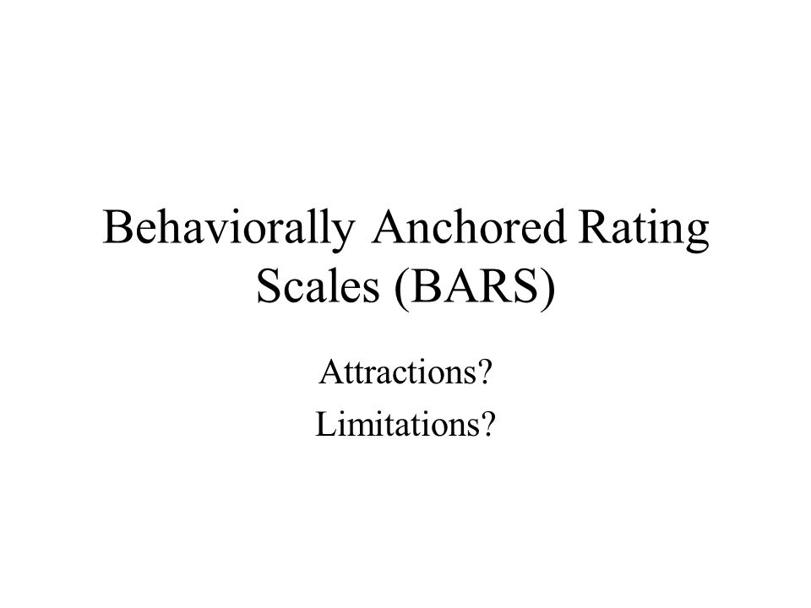
Like any appraisal method however, BARS isn’t perfect. Here are some of the limitations to its approach;
- Sometimes the listed behaviors still don’t include certain actions required of the employee. Managers therefore can sometimes have difficulty assigning a rating.
- It’s high maintenance. Jobs change over time, which means that BARS requires a high degree of observing and maintenance to keep up with this evolvement.
- The process of generating and implementing BARS is time-consuming, difficult, and expensive. Each form used in this process must be created from scratch for every position in the company.
- It’s demanding of managers. In order to successfully conduct BARS evaluations, managers/appraisers need detailed information regarding the actions of their employees. Gathering such data can be quite time-consuming, and many managers end up letting this slide due to other burning commitments.

Case Study (10)

You are a regional manager of a chain of stores, which sells computer equipment and accessories, mainly, based out of town in retail parks. A new manager has been appointed to one of the stores, which employ 20 staff. This store is currently experiencing a number of challenges which John wants the new manager to address. Among these are the following:

- A growing absence problem among the store’s staff
- Deterioration in staff morale, largely due to unpopularity of the previous manager, who left suddenly a month ago
- Sales have been falling since arrival have opened a store on the same site.

The company has a formal appraisal process for all staff but the previous manager is known to have neglected this area. Based on the above issues, select which you think are the most appropriate objectives to be included in an annual performance management plan, and compile a suitable set of performance objectives for your newly appointed manager, complete with measures and timescale.

Absence problems

If any of your employees comes in to your business late every morning — or is absent, or taking personal day after personal day — you'll soon develop a problem. For starters these employees can’t be relied on to complete his or her part of projects and this can also then lead to morale issues, if other employees think the problem employee is getting preferential treatment.
- Lateness - For starters, it needs to be stopped before it becomes chronic. Even if the best employee shows up late for the first time, they need to be called out. You don’t have to read the riot act; you just need to let him or her know that you noticed.
If you address tardiness the first time, and it then repeats it has clearly become a performance issue. Handle it like any other performance issue — it's time for a serious one-on-one meeting.
- Absenteeism - Of course, everyone gets sick from time to time (most people call to let you know they won’t be at work on a given day) but what if days turn into weeks, or the absences exceed acceptable limits over a period of time? Once the problem is apparent action needs to be taken.
If an employee doesn’t come to work and doesn’t call, contact the individual that morning and ask whether he/she plans to come in. Find out their reasons for nonattendance and once attained, remind him or her that you need and expect all employees to call in as soon as possible, regardless of the situation.


Chronic lateness or absenteeism is often a sign of a serious personal issues. The employee could be dealing with anything from a family sickness, to alcohol or drug dependency, to living in an abusive partnership or situation. During a one-on-one meeting consideration should be made to ask the employee if he or she has anything going on that you can help with — just be prepared to give the help once you've offered it. A real positive from this is by assisting an employee through a particularly rough patch in his or her life can turn a problem employee into one of your most loyal employees once the issue is in the past.

Morale issues

Employees with low morale cost companies millions of pounds each year through health-related issues, missing work and general unhappiness at work. Several consistent issues cause low employee morale;

Polling information claims that almost 92% of managers claim to be doing an "excellent" job supervising employees, but only 67% of employees agree with this.

Not only are managers one of the main causes of low morale, they often don’t know that they are. Poor leadership often comes in the form of lack of communication, micromanagement and discrimination. According to some sources, positive leadership and poor leadership are what determine the tone of an office, directly improving or deteriorating employee morale.

Falling Sales
The main problem is that your newer, neighboring, upstart competitors already know how to keep their customers and if you don’t learn what they’re doing, they may take over more of your market share in addition to the initial “new kids on the block” initiative. This may sound obvious, but few established businesses know how to do this – or they waste time trying to manually keep track of their customer needs.

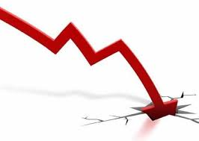

The trouble isn’t your competitors…
Disruptive newcomers appear on the scene every single day with innovative ideas that constantly threaten to overtake your company. These upstarts don’t know as much about business as you do, and they don’t know as much about your customers as you do but why are they stealing your customers?
Most businesses of our size offer:
- Customer support (help desk, customer care, etc.)
- Outstanding sales team
- High responsiveness to customer needs
After all, we wouldn’t have succeeded so far without those.
It’s no secret that superior customer service keeps your customers coming back to you again and again, and it’s no secret that high levels of customer satisfaction is what makes your customers give you the referrals that your pipeline needs. So if staff morale is low, absenteeism is rife then this will reflect on how you sell your business and products.
With all these issues in mind it’s time to resurrect the Company’s annual performance appraisal plan to recover the momentum lost by the previous management regime.
The following SAMPLE appraisal review template will be sent out to the employees to outline what needs to be done with this rethink in mind;

Year – end Performance review

Review Period 01/01/2015 – 31/12/2015

Name: | TBA
Position: | Shop Floor Salesperson
Operating unit: | Out of town retail outlet
Location: | Out of town
Manager: | John the manager
Co-planner(s): | Me the regional manager

Review of objectives (WHAT)
Please review progress and achievement against current objectives, provide comments and support with evidence as appropriate.
Documents may be attached to the review.
Feedback from others may be gathered to support the selected ratings. Once provided you can paste it into the comments box.
The ratings and their descriptors are detailed below:

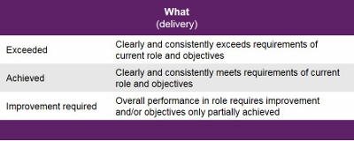

PART i – EVALUATION OF PERFORMANCE DURING PREVIOUS YEAR / REVIEW PERIOD

I
  - Performance against Job Responsibilities (What)

Key Job Responsibilities (as per Job Description) | Performance Rating  (Exceed / Meet / Below) | Summary comments with evidence and examples

  - IMPROVEMENT ACTIONS:

Clearly this section cannot be completed to the lack of data and appraisals from previous year

1.3 Performance against previous year objectives (What)
.
Objective Description  From previous year | Performance Rating  (Exceed / Meet / Below) | Summary comments with evidence and examples

1.4 IMPROVEMENT ACTIONS:
Clearly this section cannot be completed to the lack of data and appraisals from previous year

1.5 OVERALL ‘WHAT’ PERFORMANCE RATING:

Exceeded ☐ Achieved ☐ Improvement Required ☐

Review of objectives (HOW)

Please review the behaviours below and provide comments on how you are demonstrating these along with any supporting evidence.
The value you are required to rate each cluster of behaviours rather than each statement individually.
Documents may be attached to the review.
Feedback from others may be gathered to support the selected ratings. Once provided you can paste it into the comments box.
The ratings and their descriptors are detailed below:

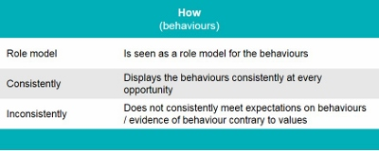

1.6 Behaviours and Values (How)

Values | Behaviours |  | Performance  Role Model / Consistently / Inconsistently
Summary comments with evidence and examples
Summary comments with evidence and examples
Summary comments with evidence and examples

1.7 IMPROVEMENT ACTIONS:
Clearly this section cannot be completed to the lack of data and appraisals from previous year

1.8 OVERALL ‘HOW’ PERFORMANCE RATING:

Exceeded ☐ Achieved ☐ Improvement Required ☐
Overall Performance Rating

The combination of the overall ‘What’ and overall ‘How’ rating shall result in an overall rating on the ‘What’ and ‘How’ matrix below:
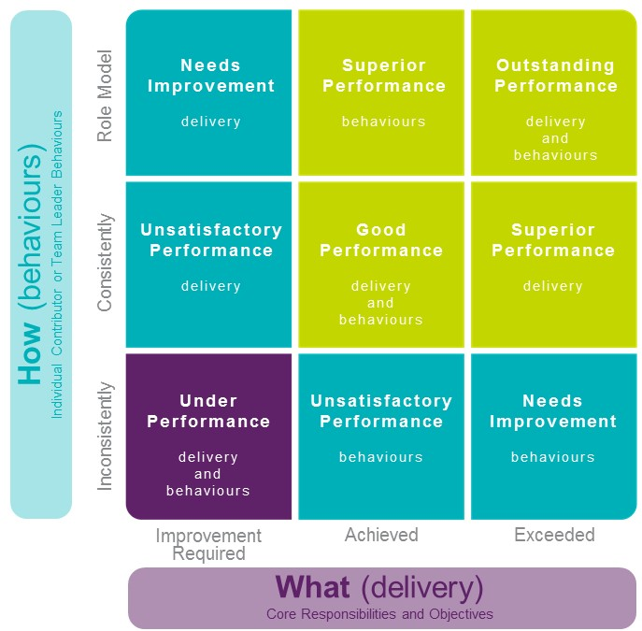
Objectives & Development – for the upcoming year or performance period

Identify SMART (Specific, Measurable, Achievable, Realistic, Time-bound) objectives for the upcoming year over the core job responsibilities. Record related development plans in the Employee Development Plan taking into consideration the improvement actions identified in Part I.

Objective | Measurement Criteria | Complete By | Status
Improve the time keeping and absence from work | - Develop performance objectives KPI’s that can be determined by good timekeeping/attendance  - Provide adequate training  - Carry out interviews to determine if employees get along with their co-workers and manager? | To be reviewed end of each quarter of 2016 | Started and ongoing process
Significantly improve morale of operating unit | - Reinforce employee actions to mirror company values  - Foster a sense of belonging and a recognition culture  - Empower line managers to award positive behaviour  - Improve customer service levels – For every 1% increase in staff loyalty a 0.5% increase may be seen in customer loyalty  - Create a more productive team  - Provide monthly team building opportunities both work related and social | Second Quarter 2016 | Started and ongoing process
Improve Sales figures from those recorded during 2015 | - Internet search engines by competitors' names or key words  - Annual and quarterly reports check against 2015 figures and those of competing companies | To be reviewed quarterly during 2016 | Started and ongoing process

2.1 Development Plan

Development Area & Description | Actions | Completion Date | Progress (%)
Undertake shop floor and customer satisfaction training | Attend Company provided offsite training | By end March 2016 | TBC
Attend sales workshops | Enrol in at least two Company provided workshops | End of 2016 | TBC

Please sign to acknowledge that a performance and development review discussion has occurred.

Employee Signature Date

Appraiser Signature Date

Co-Planner Signature Date

Student Statement:

By submitting this assignment, I confirm that this is my own work.

Student Signature | Raymond Wilson | Date | 23rd Feb 2016

For Tutor / Assessor Use Only
Total Marks
Marks Obtained
Percentage / Grade

