
Assignment Cover Sheet

Student Name: | Raymond Harrison
Student Number: | 1564
Course: | Certificate in project management level 1
Assignment NO: | Unit 2

Marking Criteria:
We expect the learners to write minimum one well expressed point in three lines against each allocated mark. This means one needs to write 15 lines with 5 well expressed points to get high grades for a 5 marks question.
For high grades use examples and illustrations where appropriate.
Please insert your completed assignment ( in word format) here:

- What are priority quadrant? How do these matrix help in selecting projects?

A priority quadrant is a visual aid to help easily see the advantages and disadvantages of a project.
If you had a few projects to choose from then you could draw a priority quadrant such as this:

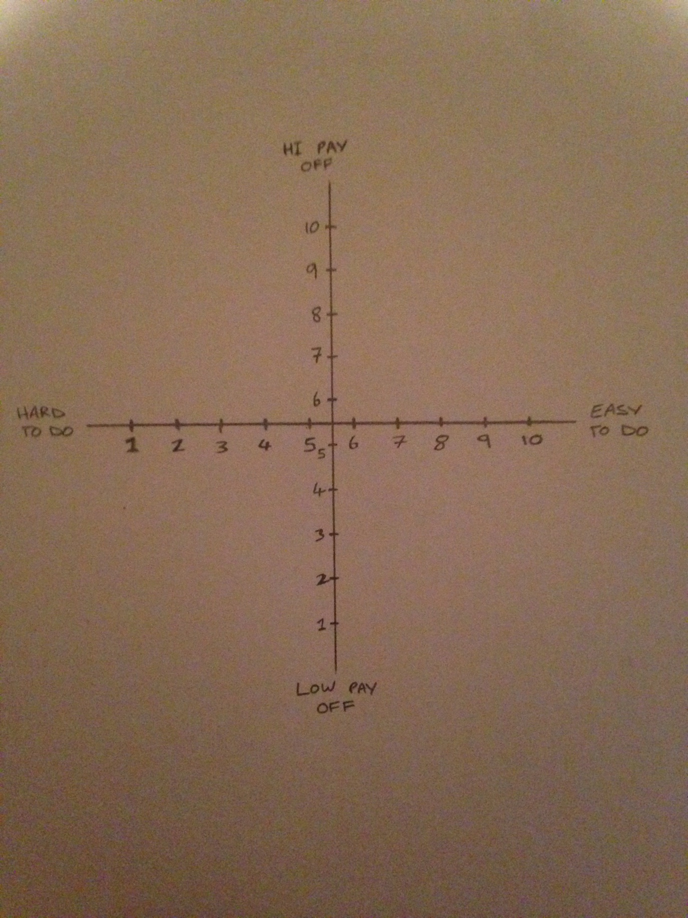

You can now give the projects a rating from 1 to 10 on how easy it is to accomplish. And another rating from 1 to 10 on how good the pay off will be.
You can plot the points accordingly on your priority quadrant and decide which project is the best to select.
For example; if you had 3 projects to choose from, you’ve been weighing them up in your head and can’t quite decide which one to choose, you can give them ratings and plot them on your graph.
Let’s say Project A is very hard to do (a rating of 1) and has a relatively low pay off. (a rating of 3)
It would be plotted on your graph as such:
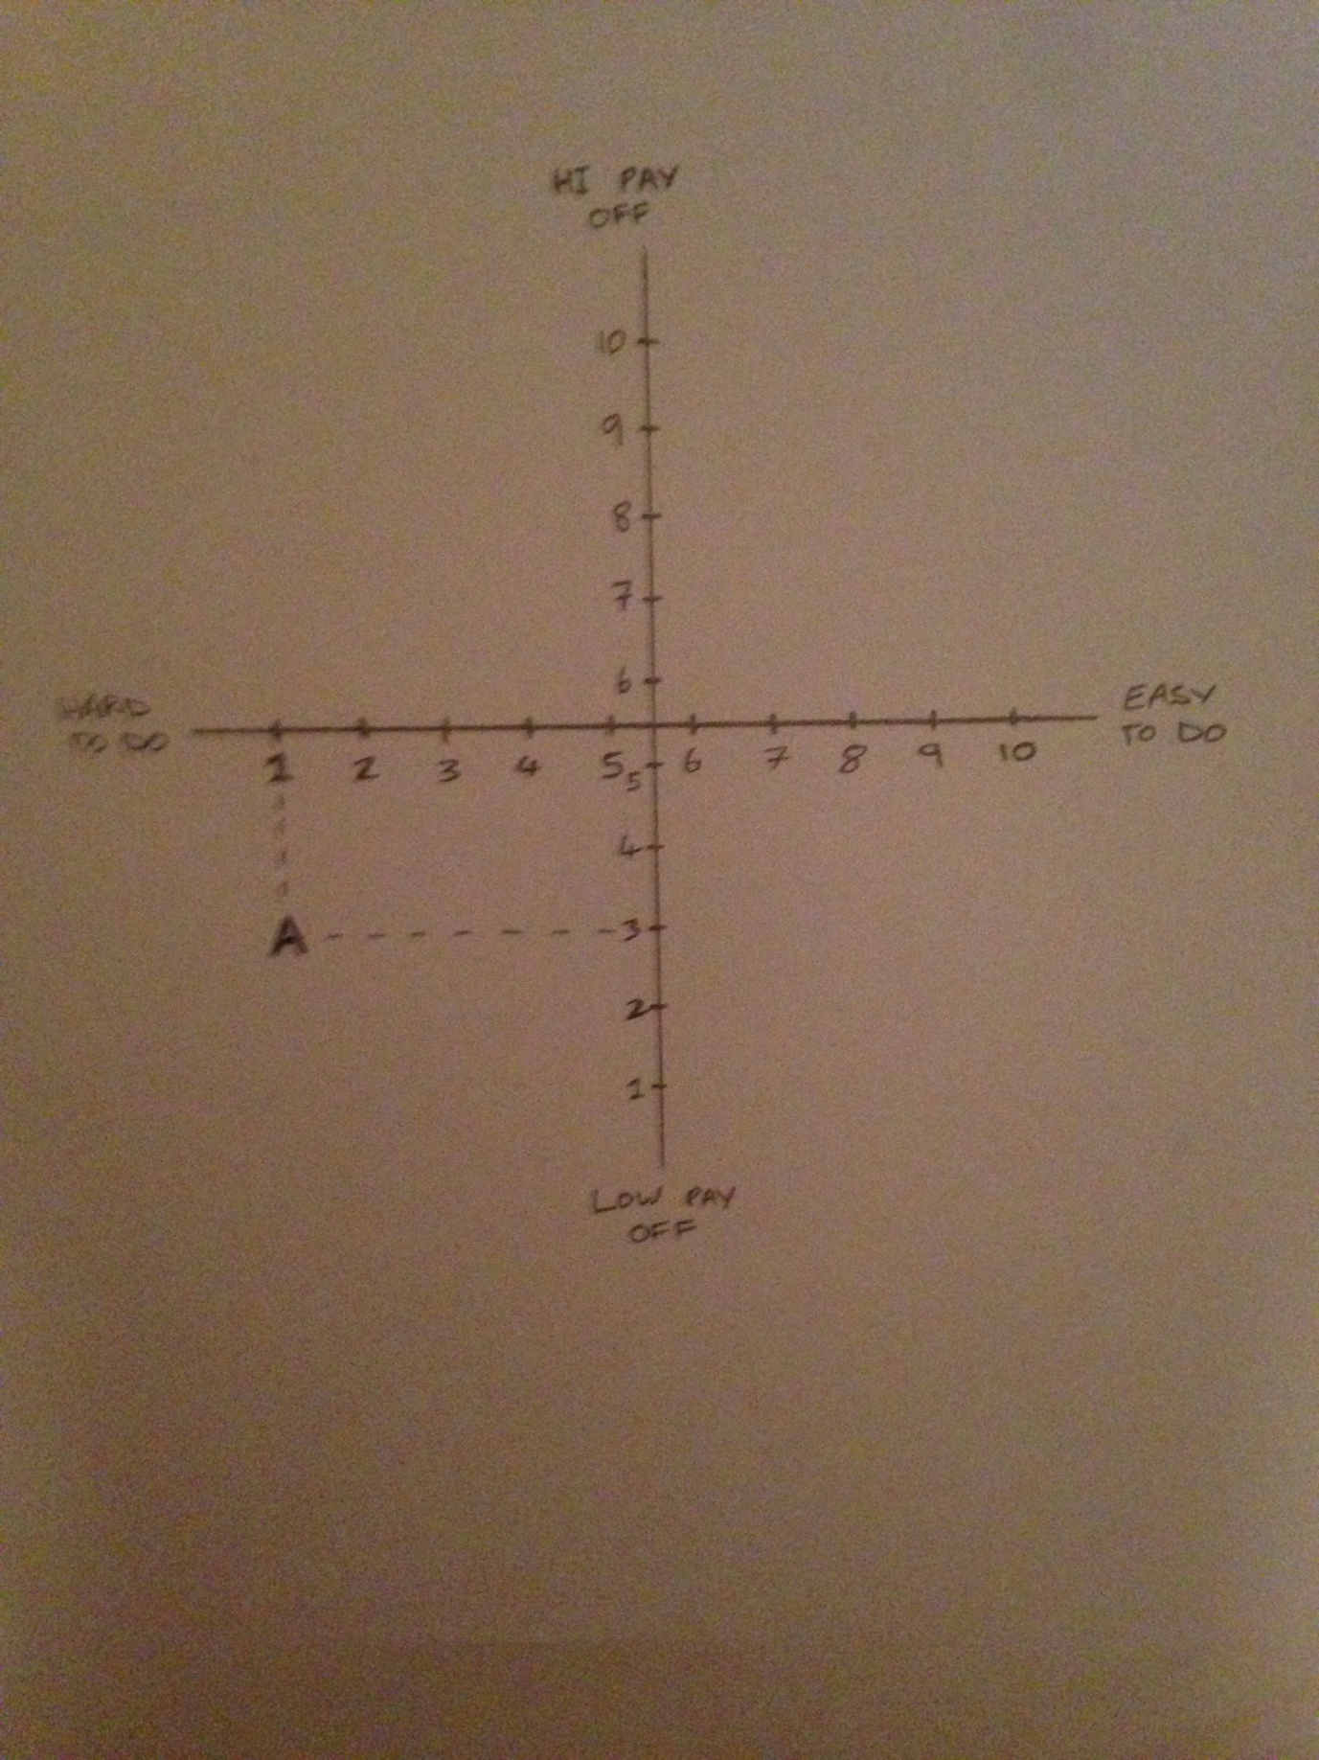

Now if Project B was fairly easy to do (a rating of 7) but the pay off was fairly low (a rating of 4)
And Project C was also fairly easy to do (a rating of 7) and the pay off was quite high (a rating of 8)
Then your priority quadrant would now look like this:
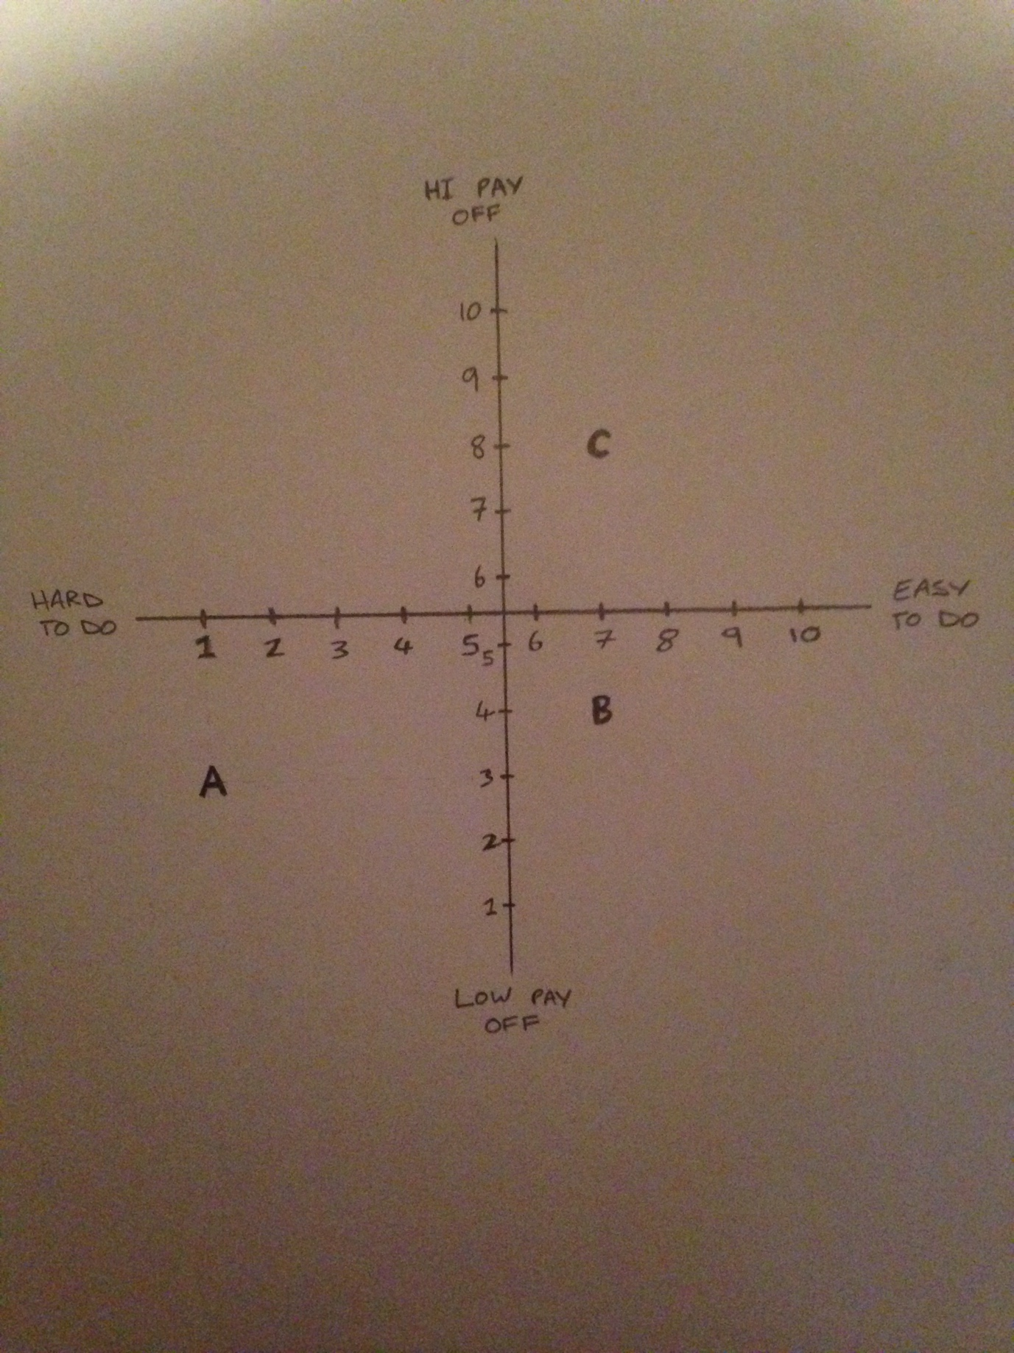

We want our projects to fall as close as possible to the top right hand corner of our quadrant. And as far away as possible from the bottom left hand corner of the quadrant. So from looking at the priority quadrant we can easily see which project is best to select (project C). As well as which one we would least want to select (project A).

So a priority quadrant really is just a visual aid to make selecting a project clear and easy. You don’t have to weigh things up in your head when you can clearly see by looking at the quadrant which project is the best option. This is a good way of making sure you know you have selected the best of the options available to you.

- What is SPIRIT? How is it used for setting goals?

SPIRIT is an acronym, it stands for Specific, Prizes, Individual, Review, Inspiring, Time-bound.
When setting goals you should remember these and try to follow them.

Specific
Project goals should clearly outline the criteria you will use to evaluate your success in a particular project. These criteria include measuring time, costs, and resources to achieve your desired outcomes.
Prizes
Celebrate when you accomplish a goal! If the goal is long term, you can have prizes when various milestones are achieved.
Individual
All members of a team must be involved in goal setting. Find ways for them to link into the project and get motivated. To keep everyone involved, it might be useful to keep a goal chart on the wall.
Review
Project goals also need to be reviewed periodically to make sure you have consensus as you move from stage to stage in a project.
Inspiring
Goals should be high but achievable.
Time-Bound
Make sure that the deadline for the goal is clear.
If all of these are taken into mind when setting goals then your goals should be achievable as well as motivating. Which will make your overall project a success as well as stress-free and enjoyable.

Student Statement:

By submitting this assignment, I confirm that this is my own work.

Student Signature |  | Date

For Tutor / Assessor Use Only
Total Marks
Marks Obtained
Percentage / Grade

