
Assignment Cover Sheet

Student Name: | Sara Spiers
Student Number: | 1486
Course: | Diploma in Wedding Planning (Level 4)
Assignment NO: | 09

Marking Criteria:
We expect the learners to write minimum one well expressed point in three lines against each allocated mark. This means one needs to write 15 lines with 5 well expressed points to get high grades for a 5 marks question.
For high grades use examples and illustrations where appropriate.
Please insert your completed assignment ( in word format) here:

- (i) Explain the most important points which should be considered when selecting a wedding photographer.

The first thing the couple must decide is their photographic needs. The couple needs to decide what style of photos they want, if there are any particular shots they want, if they have any cultural needs that need to be met. The consultant must firstly provide them with details of photographers that specialise in each style, and examples of their work that they have on file. The couple can then choose a few photographers they want to meet with to discuss their needs in more detail.

At the meeting with the photographers, it is important that the couple and the consultant developing a relationship with photographer. The photographer needs to be easy to get along with, be on the same page in terms of how they want the photos to look and be understanding of the couple’s wants and needs. This is vital as the couple want to be able to put their full trust in the photographer to get the shots they want without having to worry about it on the day. The consultant and photographer must also get along as they will be working closely together both beforehand and on the day itself.

(ii) List the questions which should be asked to the photographer when selecting him for the coverage of the ceremony.

How long have you been a photographer for?
Are you the sole photographer or do you have other photographers working for you? If so, which photographer would be working with us on the day and can we meet with him/her?
Do you have any photography accreditations?
What previous work have you done?
Can you provide samples of your work?
Can you provide testimonials from previous jobs?
Do you use solely digital cameras or do you also use film?
What packages do you offer and do you create bespoke packages depending on the needs of the client?
Do you bring back-up equipment with you?
What ways do you present the photos? i.e. digitally, printed, canvas etc?
What is your turnaround time for providing the photographs?
Do you provide the client with a contract to guarantee the work?
Will a deposit be required upon signing the contract?
When will full payment be due? i.e. in advance of the event or afterwards?
Do you require accommodation?
Does your quote include expenses and travel?

(iii) Compare two photography wedding styles (with photos).

Traditional wedding photos are staged or posed photographs in different parts of the ceremony and day. These are usually group shots including the bride and groom, the bride and her bridesmaids, the groom and his groomsmen, the bride and groom with both sets of parents (together and individually) and the entire wedding party. Other typical shots that you will find in the traditional style include the newlyweds standing on the steps of the Church, pretending to cut the cake, pretending to toss the bouquet and the couple sitting in the wedding car. All of these shots are front facing, with everyone looking directly at the camera.
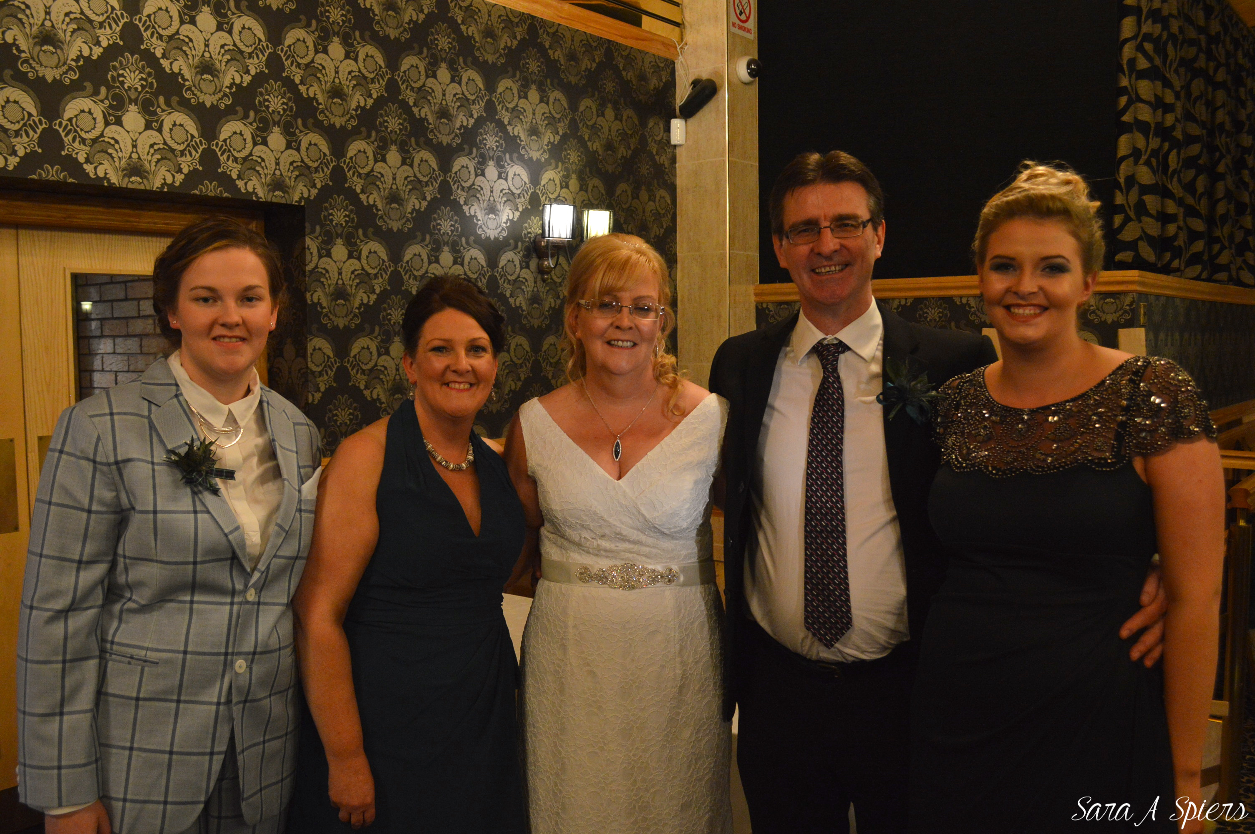 (Traditional Style. © Sara Spiers)

Photojournalistic is more about capturing the candid moments. Photojournalistic photographers will capture shots as they naturally occur, including the bride getting ready, the wedding guests waiting for the bridal party to arrive, the couple saying their vows and the couple walking hand in hand down the aisle. These shots are taken from a variety of angles without the photo subject knowing as opposed to the staged shots in the traditional style. Some couples prefer these shots as they are the ‘real moments’ that sometimes they might not see occur and this makes it more special to look back on. Also, the photographer taking these shots is often unnoticed and doesn’t come across as obstructing the flow of the wedding as they would do for the more traditional shots.

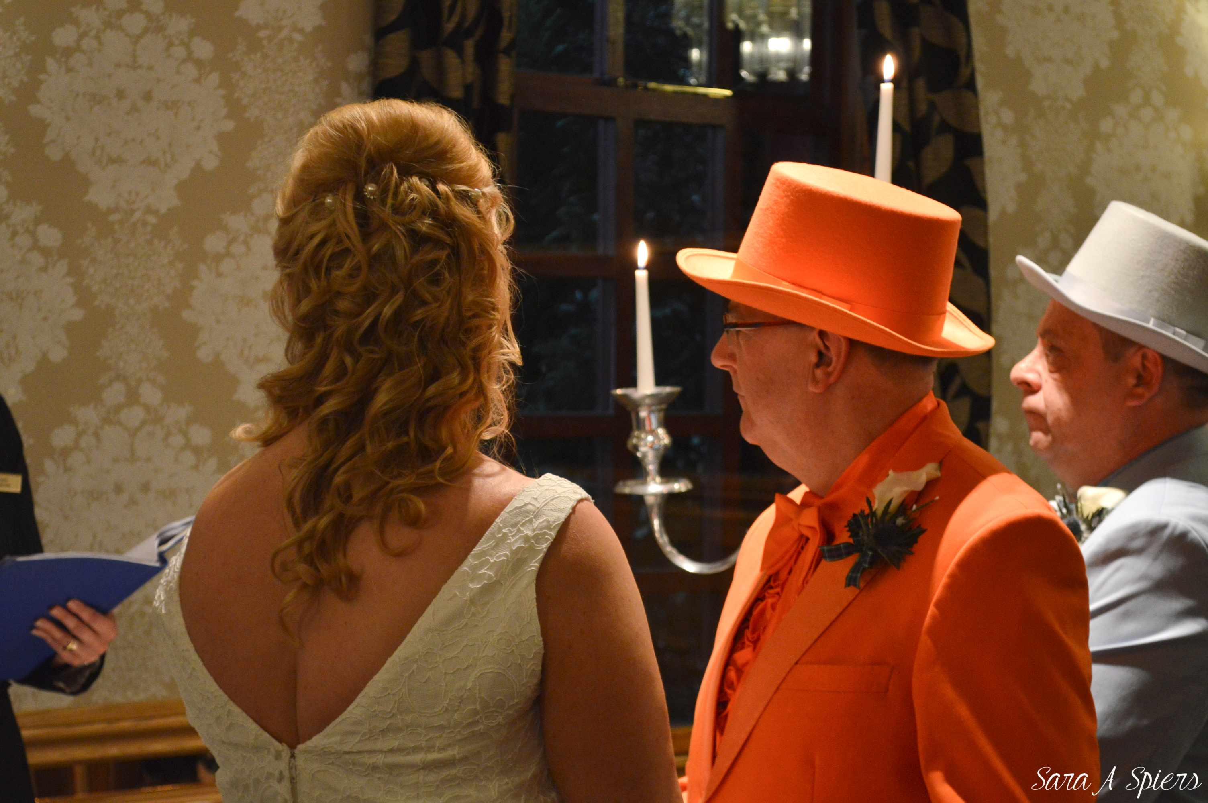 (Photojournalistic style. © Sara Spiers)

(iv) Wedding photos are more costly than every day photos. Why? Which costs are involved in wedding photos?

Wedding photos cost more than every day photos as they require much more work and non-stop attention from the photographer. The photographer is working non-stop from morning until night to capture every moment possible for the couple, taking hundreds or even thousands of photographs, editing and presenting the photos in the couple’s chosen methods. This work is all reflected in the price which can be consolidated into a package or can be listed individually.

The costs in relation to wedding photos include the package the couple want, the style of photographs they want, travel and expenses, fees for working beyond a set number of hours, fees for extra photographs out with what included in the package, fees for presenting photos in different methods out with what is included in the package, fees for certain types of editing such as additional black and white copies, providing images in other mediums such as additional albums, canvases and digital copies, and fees for any extra staff needed on the day to help out the main photographer.

- ‘It is important to view the photographer’s portfolio when selecting him for a wedding’. Discuss the important points which should be considered when viewing the photographer’s portfolio.

When the couple views a photographer’s portfolio, they must consider firstly if the style of photographs is something they like and if they would want something similar for themselves. Many photographers will cover a range of styles to try to appeal to more couples and their tastes so it is worth remembering that the couple may not like all of the photos they see. The couple should point out particular photos that stand out to them, in both a good and bad way, to help the photographer gain an insight into what they like and similarly for what they don’t like. This will help them form an idea of how they want their wedding album to look. The couple should also consider the subjects of the photos in the more traditional shots and whether they look happy and comfortable, rather than stiff and awkward-looking. This gives a sense of whether the photographer has the sort of personality that can create a happy and relaxed atmosphere to ultimately create good photographs.

Another important factor to consider is whether the photos are of good quality. Couples want the photos to be crisp and clear, bright, in focus and presented in a high quality way, whether it is prints, album, canvas or even digitally. The couple must also consider, if the photos are presented in an album, whether the album protects the photos light and dust. Ensuring this is the case will mean that the photos will last much longer. Also, the couple must also enquire as to whether the albums restricted in the number of photos they can hold or is there an option to expand them.

Whilst looking at the photos, the couple must also consider the mediums they are presented in and if there is a variety on offer. This would give the couple the option to choose what they want, knowing that later on if they change their minds, they can request the photos in another medium and they know at what cost.

Activity
The first main difference that you can see from old, posed wedding photos and new wedding photos is that the photographs are very rigid looking. When comparing these to modern posed photographs, there is more expressions of joy and love shown which epitomises the feeling of weddings.

As years go on, traditional style photos have evolved and although emotional expressions were seen more, the single-angle photographs still remains. Journalistic photographs are much more creative by comparison. These style of photos have more subject choices than just people. There is more of a focus on the smaller details such as the rings (seen below) or the bouquet, or even the moment which is being captured – such as the friendship between the bridesmaids and bride.

There is also a wider use of scenery used in journalistic photographs to add to the subject to bring together the moment with its location. The photographs look busier but without deterring from the main subject, and also capture more areas of beauty to enhance the overall photograph. Traditional photographs are almost in tunnel-vision, focusing on the people themselves and nothing else taking away the viewer’s eye.

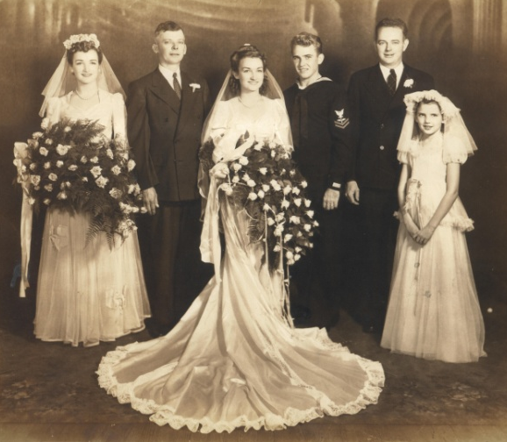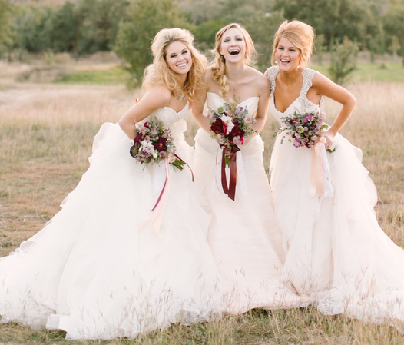
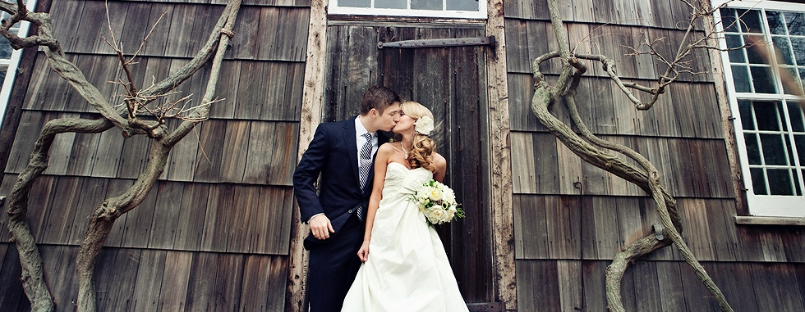
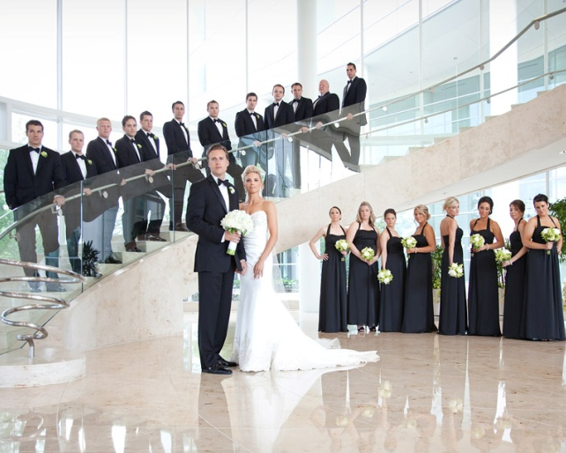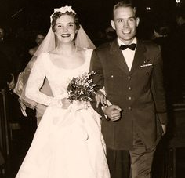
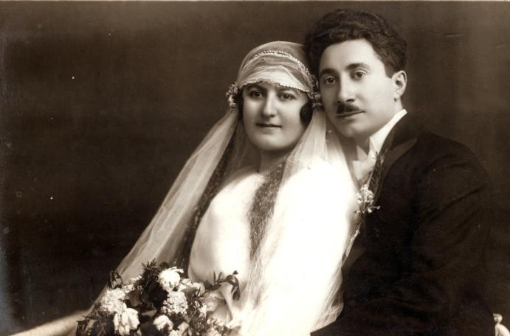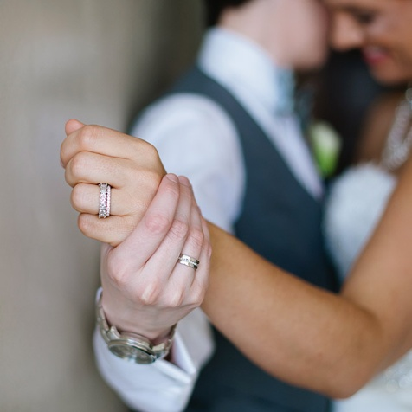
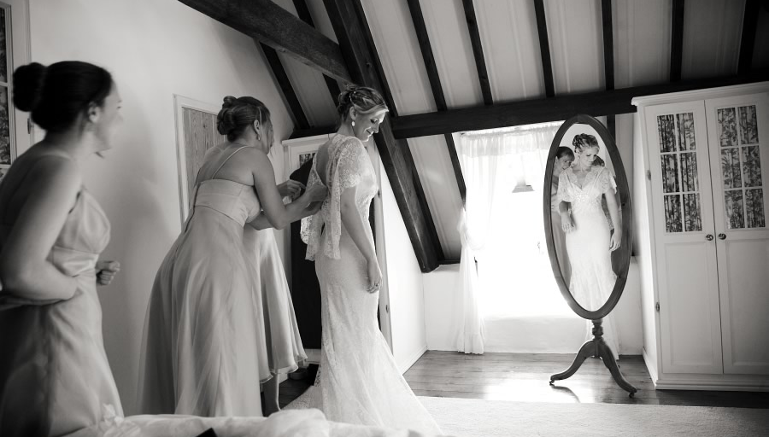

Student Statement:
By submitting this assignment, I confirm that this is my own work.
Student Signature | Sara Spiers | Date | 15/02/16
For Tutor / Assessor Use Only
Total Marks
Marks Obtained
Percentage / Grade

