
Assignment Cover Sheet

Student Name: | Omnia Rafiq
Student Number: | 1343
Course: | Diploma in interior Design
Assignment NO: | 9

Student Statement:

By submitting this assignment, I confirm that this is my own work.

Student Signature | Omnia Rafiq | Date | 27-2-2015

For Tutor / Assessor Use Only
Total Marks
Marks Obtained
Percentage / Grade

Q.1.i. If ceilings are of reasonable height which treatments can be considered for the
Ceilings?
1. If ceilings are of reasonable height, we should paint the top stringing of the cornice (the part that edges out onto the Ceilings) in a contrast color, or cover it with gold or silver leaf.
2. Also we can add moldings such as a cornice or a ceiling rose, if do not exist Already.
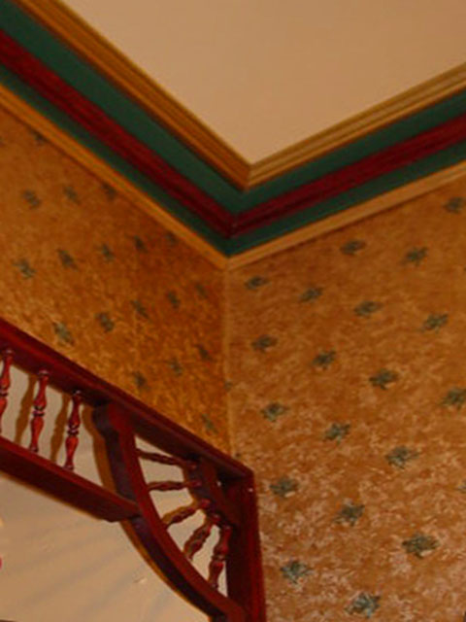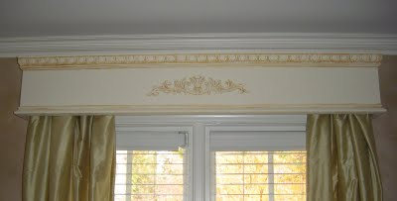

Q.1.ii. If ceilings are too low, which ceiling and wall treatments would you suggest to
Maximise the effect of height?
If ceilings are too low, we can apply one or more of the following treatment ideas :
1. Install curtain pelmets just below the ceiling (rather than just above
The tops of the windows) to make windows seem taller, and so in turn Exaggerate the ceiling.
2. Make tall, narrow panels of walls using moldings, paint or paper, Again to draw the eye upwards.
3. Use shimmer paint on the ceiling.
4. Vertically striped paper or painted stripes lead the eye up to give the Illusion of more height.
5. Plan lighting scheme for the room very carefully. Install cool florescent Lights.
6. Choose fabric for curtains carefully i.e. stretch voile or double thickness cheesecloth which can reflect light to light up the ceiling.
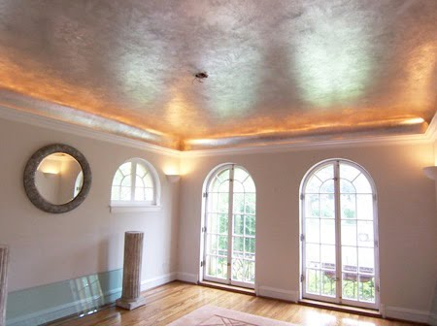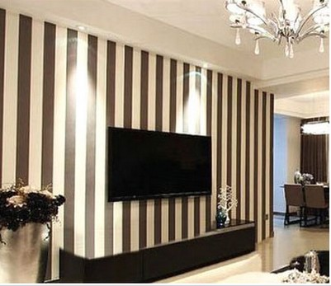

Q.1.iii. If the ceilings are too high how can we break up the height?
While if the ceilings are too high we can:
1. Paint the ceiling a darker shade than the walls.
2. Install some recessed lighting, which will draw attention towards the walls instead of the ceilings.
3. Divide walls into three portions to break up the height.
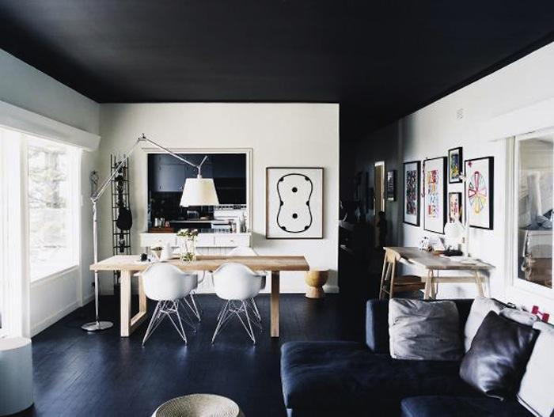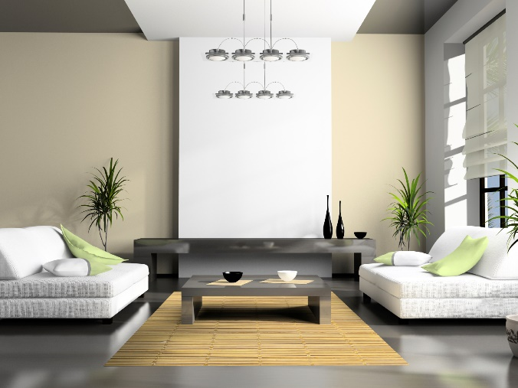

Q.1.iv. If a room has a beautiful door how can it be further enhanced in a scheme?
The most obvious way of drawing attention to a door is to paint it in Contrasting shades to the rest of the room. A most ordinary door, can be replaced, customized, or made to blend in with the rest of the room. Glass- paneled doors allow you to borrow light from outside or from the room next door. If you do not want a clear view through, choose plain frosted or etched glass, which has the same effect but is only translucent. Walls that have several solid wood doors like kitchen cupboards or fitted wardrobes, consider exchanging glass panels. Cut outs are a fun way of customizing doors, particularly for children’s room. These can be simple shapes, such as heart or diamond, or can take on more complicated shapes such as favorite animals. Stenciling on
Doors can also give a decorative effect, whether it is a motif echoed from elsewhere in the scheme or calligraphic device such as a child’s name. Give importance to the handles of the door also. These should be in keeping with the room’s style, whether simple or decorative, period or modern.
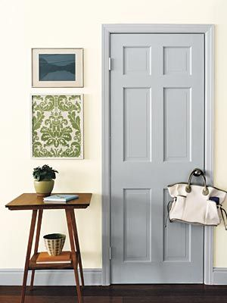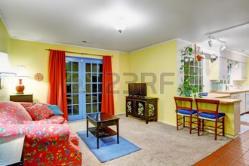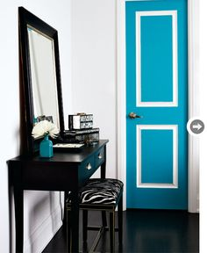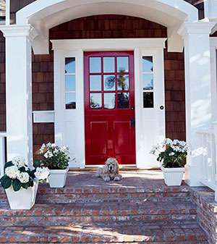

Q.1.v. How can we blend a door in a scheme?
To make the door blend in, paint it the same colour as the walls, or two shades lighter or darker than the walls. Consider how solid a door should be whether it should block out a view of an adjacent space or give a glimpse into it.
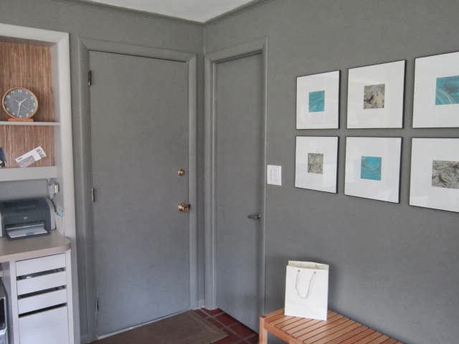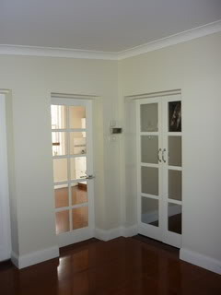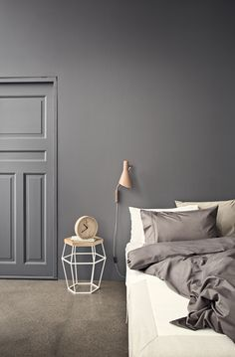

Q.1.vi.What are textured wall papers used for?
These are heavy wall papers with their embossed patterns and are used particularly for covering irregular surfaces. These can be painted over and are usually used for dados in hallways because of their durability.
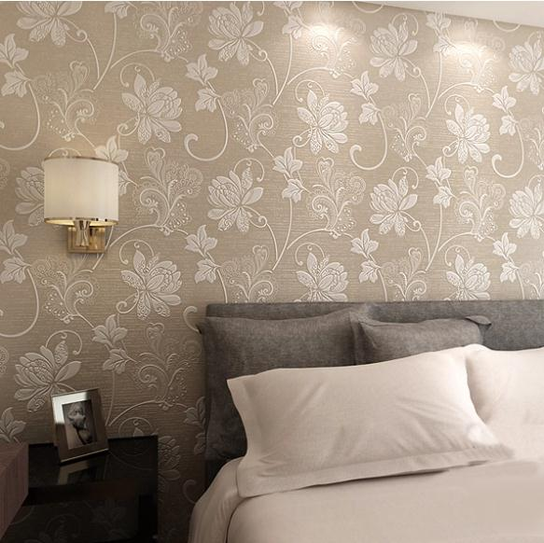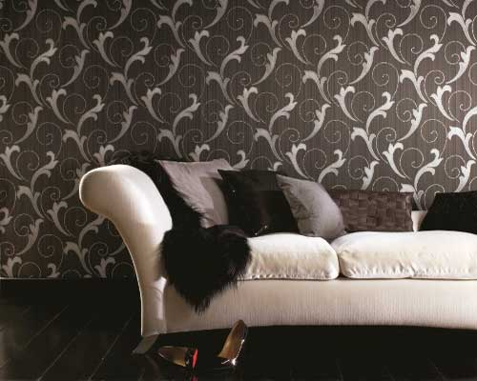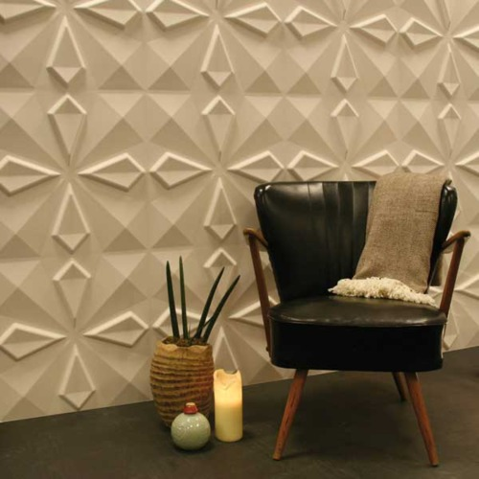

Q.1.vii.What is the purpose of using wall paper borders?
Borders come in various depth and designs from fanciful ribbons and swags, children’s motifs to gardening and sporting themes. The main role of a border is either to define or break up a given space. The most common way to use a border is to buy one that co-ordinates with or matches the chosen paper. These are used usually around the top of the wall, just below the ceiling or just below the cornice if there is one. Borders can also be used along the skirting boards, around windows or doors, or even vertically down the corners of rooms.
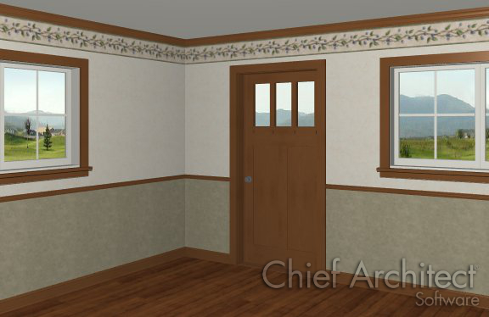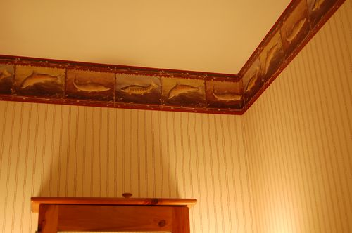

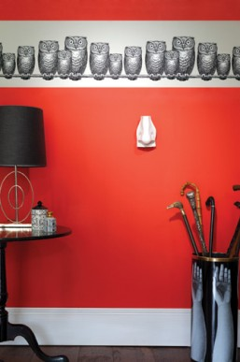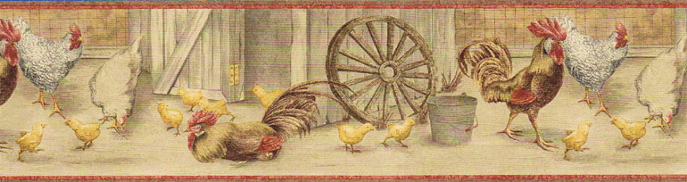

Q.1.viii.Which type of wall papers are good to use as a background for paintings?
Strong or definite patterns can be distracting and do not make good background for paintings. A border frieze is a good way to finish the paper off here.
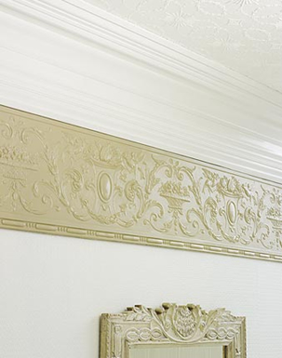

Q.2. Upholstered walls look luxurious and provide insulation against cold and noise. Describe
The process involved in walling.
Fabric has been used to cover walls for centuries, first in India, the Far East, and the Middle East and then Europe. Today the upholstered walls are still common particularly in Europe. The process involves fixing a framework of thin batten to the wall, then lining the walls between with wads of polyester, and finally stretching the fabric over battens. The results are often original and usually luxurious, as well as provide excellent insulation against both cold and noise. Another way of using fabric on walls is to treat it like curtains hanging From just below the ceiling. Some fabrics like tweed, wool, or suede can be stuck to the walls like Wallpaper. Also If ceiling is in bad state of repair, you can try tenting the ceiling, by covering it with fabric.
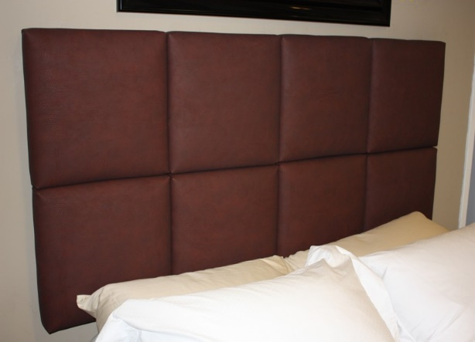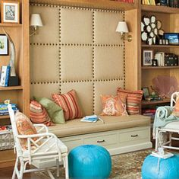

Q.3. Name three decorative details that can appear on the ceilings?
Beams, moldings, pictorial scenes, designs and paint finishes have been the different decorative treatments for the ceilings for centuries.
