
Assignment Cover Sheet

Student Name: | Drew Wilkins
Student Number: | 1318
Course: | Diploma in Fashion Design
Assignment NO: | 5

Elements of design.

What is meant by ‘weight and hand’ in textile industry?
It’s important to know the weight and hand of the material that you’re going to use it will affect the way the fabric hangs and drapes, and just by giving the designer a sample of the fabric they can tell how the fabric will sit and hang which is very important.

Name the warm colours. How best these can be used in dress designing?
Red orange and yellow is classified as warm colours because they make you think of heat and the sun, Warm colours are stimulating, aggressive, and lively. When you think of red in designing you think of love and romance. Red can also be fiery and sexy making it a popular colour for evening wear and sometimes in sportswear. Yellow is bright, cheerful and welcoming but can be a difficult colour to wear because it clashes with many skin tones. Also works the same way with orange although it combines with the sunniness of the yellow and the warmth of the red its sometimes best toned to a soft peach or apricot or even limited to use in active wear.

Why it is important for a designer to consider the scale of a pattern, when using patterned fabric in dress designing?

The scale of a pattern must complement the design. A large print would dominate a design and to show a large print it must not be cut up with seams and details but instead allowed to be the most important element of the garment. The structure of it must be simple so if a design idea begins with dominating lines and detail then the fabric must be plain and of a secondary importance.

What is the difference between conventional design and geometric design?

The difference between conventional design and geometric design is, with convention design it is when an object from nature is adopted to suit the purpose of the object and becomes decorative, the motif ceases to be naturalistic whereas geometric design is not derived from nature is it derived from circles, rectangle’s parallel lines and so on.

Define the term colour dimension. Explain the following terms; hue, value, intensity

Colour dimensions have 3 different dimensions..
Hue - Hue allows us to tell one colour from another, such as red from blue or green.
Value - Value refers to the use of darks and lights; it is the variation of light strength in a colour. The scales run from white to black white is pure light and black is no light at all. Adding white lightens a colour and black darkens it. Lighter values are tints and darker ones are shades.

Intensity - Intensity is the relative brightness or paleness of a colour or the strength or weakness. Bright colours are considered high-intensity, pale ones low-intensity.

Write short note on the following;
Basic Shapes in dress designing

In dress designing there are 7 different types.
Triangle – fitted bodice with the skirt widening as it comes down.
Inverted triangle – this is a good design for a women with a large bust as it’s wide on the shoulders and a narrow skirt.
Oval – the oval shape is perfect for a slimmer figure. Lightly hugs your curves with a touch of decoration and layers to the dress.
Square – for example a cape, can suit all figures if done right, as it has a straight or boat shaped neck like that just drapes down.
Round – this is more afternoon type frocks or formal wear puffy sleeves and crinoline skirts more suitable for a very young and thin figure.
Hourglass – this shape is most flattering on a tall slim person as it hugs in at the waist and has broad shoulders and a loose skirt.
Combinations – this is suitable for all figures for example is your are not broad but want a loose skirt you can add some shoulder pads to make it appear that you are indeed broader there and it will makes the outfit balance out.

My own design of a historic dress that I have modernised.
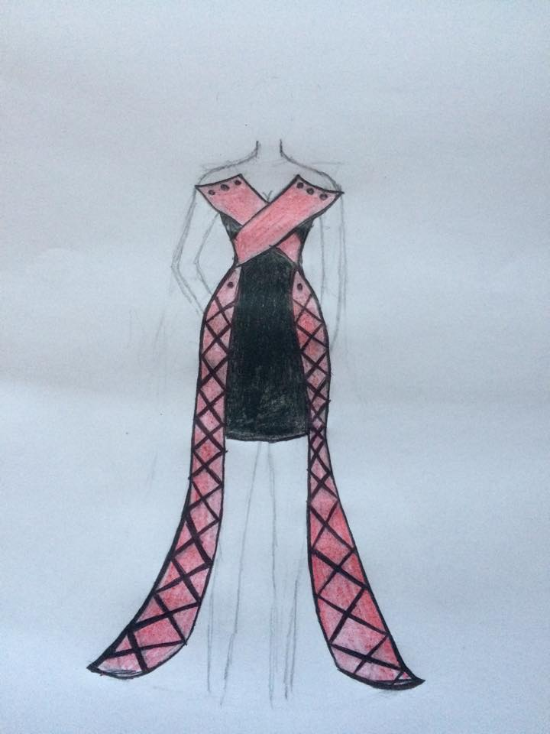

Student Statement:

By submitting this assignment, I confirm that this is my own work.

Student Signature | D wilkins | Date | 18/10/15

For Tutor / Assessor Use Only
Total Marks
Marks Obtained
Percentage / Grade

