
Assignment Cover Sheet

Student Name: | Sukhwinder kaur
Student Number: | 1282
Course: | Fashion design
Assignment NO: | 8

Answer I.
The binary colors made by the mixing of two hues. Examples are orange, green and purple. These are the colours that are obtained by emitted light. The additive primary colours are red, green and blue. If all three of the additive colours were combined together in the form of light, they would produce white. A colour created by mixing two primary colours is called a secondary colour.
For examp: orange is a secondary colour which is created when the subtractive primary colours red and yellow are mixed together. Secondary colours can only be created by mixing true primary colours.
Answer II.
Achromatic means absence of colour. This scheme has white and black at the two extremes with tones of grey in between. Colour is one of the first things people notice about clothing. The use of colour can create illusions of the figure size in the same way as line does. Colour should be selected on the basis of complexion-hair, skin, and eyes-as well as the figure`s size. Colours should complement the complexion. Colours are classified as warm-reds, yellow, and oranges-or cool-blues, and greens. Warm colours tend to create an illusion of greater size. Cool colours tend to create an illusion of reduced size.
Answer III.
If the brunette has a clear skin or good colour,any shade is possible. If she is pale she should avoid colourless dull or pastel shades. The brunette having an olive complexion,especially if she is young, shoud never wear dark colours as they will make her look older. The warmer tones by contrast emphasise the luster of the dark hair and are therefore desirable. It is generally best for the brunette to use the warm colours such as reds, red orange, yellow. This is a variation on the complementary colour scheme in slightly more sophisticated way. It is composed primarily of one dominant colour and two hues that sit across on either side of its complementary colour directly across the colour. A example a split complementary colour scheme would be yellow joined with red violet and blue and blue violet.
Answer Iv.
The brightness or dullness and the lightness and darkness of colours also affect the illusion created. Dull and dark colours seem to recede and make the figure appears smaller. Bright and light colours have the opposite effect. Contrasting colours in tops and bottoms create a horizontal line where they meet and tend to shorten the figure. A single colour outfit gives a vertical feeling and creates an illusion of height and slimness.
Answer v.
When the grey-haired lady wearing black looks well,but she much not forget that a touch of white in the form of a yoke or collar to relieve the black near the face is most necessary. White of course,being a neutral colour is very good for this type. Some of the dull warm shades may also be pleasing, if the colour of the eyes and the features warrant their use.
Answer VI.
For a person with sallow complexion great care must be taken in the choice of colours. Of course there are certain colours that will help a great deal. In fact, it is far better to select those which will reflect colour in the cheeks, and in order to do these choose warm tints such as red, shades of rose, a grey colour having a tint of pink or colours of this particular type. If the complexion is very sallow avoid yellow, tans or browns for it only tends to make the complexion look yellow. Shades of blue green, navy and blue will help to bring oyt the colour in the cheeks helping the skin look less yellow. However, one should be very careful in choosing shades of green, because bright greens are hard to wear by most types and should be carefully avoided by this particular one.
Answer VII.
The blondes with grey blue or green eyes, there seems to be the opinion that grayish colours, like, blues, greens and violets, are far more suitable than the warm brownish tones. This isn`t true when speaking of the fair haired, brown-eyed person, whose skin is somewhat inclined toward the brunette type and who usually looks well in shades of brown. As a rul the blonde should not wear tailored clothes. She is not at all the masculine type, so she will look much better in simple, soft effects. She should not wear tweeds or very heavy materials. Her type calls for jersey, crepes, velveteen and chiffons which are much more suitable.
Answer 2.
The Triad harmony uses three hues placed on equal distance on the colour wheel in sample triad colour sehemes are yellow, red and blue or orage, purple, and green. Monochromatic harmony uses one hue. Various tints, tones, and shades of one hue are used in monochromatic harmony for instance, light pink, rose, maroon, and watermelon. If value and chroma gradations are too close together, the effect may be unpleasing because of ambiguity of colours, giving the impression of a mismatch. These schemes require noticeable differences to avoid a fatiguing and monotonous effect.
An example a split complementary colour scheme would be yellow joined with red violet and blue violet a triad harmony uses three hues placed on equal distance on the colour wheel. A sample triad colour schemes are yellow red and blue or orang , purple, and green. These are the colours that are obtained by emitted light. The additive primary colours are red, green . If all three of the additive colours were combined together in the form of light, they would produce white. A colour created by mixing two primary colours is called a secondary colour. This mixing process can be extended further to create the tertiary colours. These are also called the intetmediate colours. These are created when one primary colour is combined with one secondary colour in equal parts. When the primary colour blue is combined with the secondary colour purple. The colour wheel demonstrates how the different hues visually relate to one another.
1.green colour.
2purple colour.
3.grey colour.

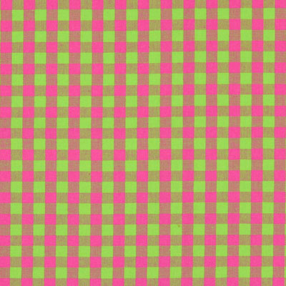

Student Statement:

By submitting this assignment, I confirm that this is my own work.

Student Signature | Sukhwinder kaur | Date

For Tutor / Assessor Use Only
Total Marks
Marks Obtained
Percentage / Grade

