
Brent
Assignment Cover Sheet

Student Name: | Mery Ann Alaba
Student Number: | 1406
Course: | Fashion Design
Assignment NO: | Assessment 7

Marking Criteria:
We expect the learners to write minimum one well expressed point in three lines against each allocated mark. This means one needs to write 15 lines with 5 well expressed points to get high grades for a 5 marks question.
For high grades use examples and illustrations where appropriate.
Assessment 7

Question

- a.) The type of the materials that suits to the thin person is with a shiny one it is
- increasing the appearance of size.

And the recommended stripy print is horizontal movement in the line of dress.

I would suggest to a thin person;

The silhouette of the dress shown broken, rather than long beginning line.

Wear loose clothing.

Use short collars.

Use patch pocket

Wear cap

- For a person with a large waist and hips she must dress in such a way as to
attract the interest away from the defect or from the contour of the body .

And for my own opinion do not put any distraction to the waist and hips make it in a simple design and give some attraction in the upper portion of the body like for example accessories, a nice necklace.

It is suitable the following;

The center of interest kept at the face and away from the waist and hips

Long skirt, in order to add height

Hats of average size or slightly larger.

- Because this merely emphasizes the figure. The stout person must obtain a
vertical movement by the use of devices which will cause the eye to travel
up and down rather than across the dress.

Also should avoid extremes in dress with a very short skirts, very tight
sleeves and the flowing variety.

Bulky appearance and never take a raccoon

Raffles

Thin piping

Heavy, bulky fabrics

Taffetas and other stiff fabrics

- For my own suggestion for a round shoulder person I would prepare to
design with a one attractive silhouette, simple the shoulder is not much
emphasis cause the design is set in a sleeves also from the chest to the
shoulder is not much apart but it gives elegancy and not noticeable the
round shoulder.

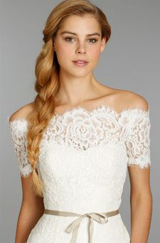

Q:2 Activity

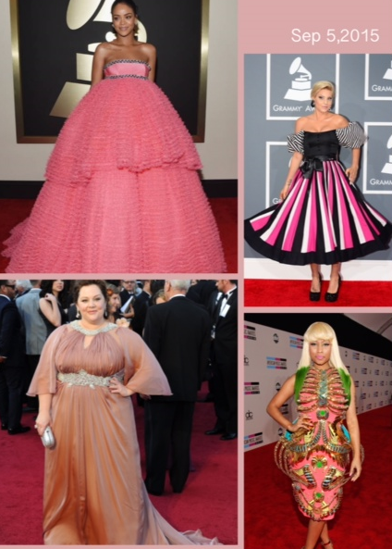

1st Dress: I will change the Color into a light blue or gray, from the chest to waist I will design a simple tube gown and I will make it like ball gown skirt so that she will look like elegant and can use in any occasion.

2nd Dress: This type of dress is not suitable for her to much color, strip from top and down is not good, I prepare to make it a simple on top from neck I will made like turtle neck with no sleeves, fitted from the waist line up to below the knee, color dark blue.

3rd Dress: Ok this type of dress is not suitable for her, I suggest to change the color in black or dark to reduce her size, but not so dark so that it will not get attention to the silhouette , and not to much very long from skirts and not too much flowing sleeves, the long V line to the neck is quite good for her or make it a off shoulder design from the top.

4th Dress: To much excessive design this not suitable for her, I prepared not too much abstract design, make it yellow green color, If she wants attention, put some attractive accessories and wear a simple hat or white hot, curl the hair with highlighted in violet.

Student Statement:

By submitting this assignment, I confirm that this is my own work.

Student Signature | Mery Ann P. Alaba | Date | 5 Aug 2015

For Tutor / Assessor Use Only
Total Marks
Marks Obtained
Percentage / Grade

