
Assignment Cover Sheet

Student Name: | Salma Mohamed Safaa
Student Number: | 1170
Course: | Interior Designing
Assignment NO: | 10

Student Statement:

By submitting this assignment, I confirm that this is my own work.

Student Signature | Salma Mohamed Safaa | Date | 4/11/2015

For Tutor / Assessor Use Only
Total Marks
Marks Obtained
Percentage / Grade

Student Name: | Salma Mohamed Safaa
Student Number: | 1170
Course: | Interior Designing
Assignment NO: | 10
Page NO: | 1

Interior Designing Course
Unit 10: Floor
Q.1. Short Questions:
I. When deciding upon the floor for a room, the most important element that should be considered is the function of the room.

The function and location of the room will have some bearing on the best surfacing to use.
Then ask: How much traffic is this area expected to have? What is the likelihood that the floor here will be exposed to moisture? Will this room need flooring that can help dampen noise levels? What are likely ways this area will become dirty and how much time and money will be devoted to cleaning and maintaining this floor?
Consideration of these various factors helps narrow down flooring options and ensures that the flooring in each area is well-suited to its purpose and use.
II. When choosing floor for a kitchen, consider:

The kitchen is likely to be a busy room and things like pots and pans can be dropped occasionally causing damage to your floor also a lot of spoiling will be accidentally dropped, choose a floor that is durable , impact resistant and stain resistant and easy to clean. It's best to choose surfaces like tiles, stones, varnished wood, or good quality vinyl.
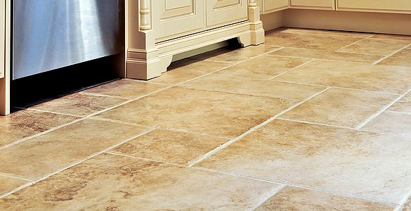
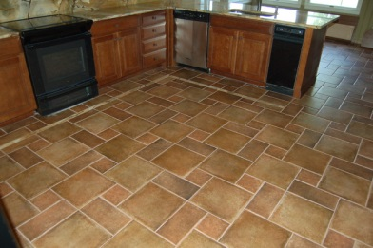
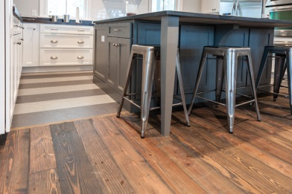
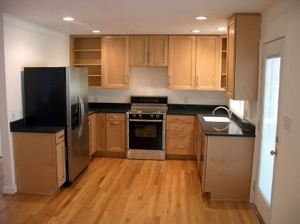
Tiles Abruzzi Stone Tiles Vinyl Flooring
Varnished Wooden floor

Student Name: | Salma Mohamed Safaa
Student Number: | 1170
Course: | Interior Designing
Assignment NO: | 10
Page NO: | 2

III. If a feeling of warmth is required in a room:

Carpeting offers a warmth and softness not found in other surfacing options but it's obviously not for all applications and it's durable and easily stained.
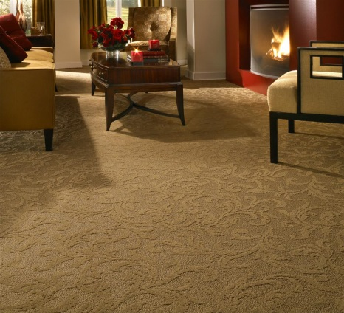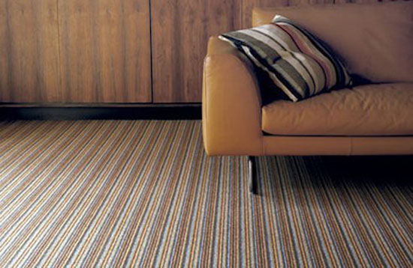

Wooden Flooring could also be considered, as it also gives a warm feeling.
Best option is to introduce two levels of flooring: a foundation floor, such as wood, that is exceptionally durable, and a second layer, for example, a rug.
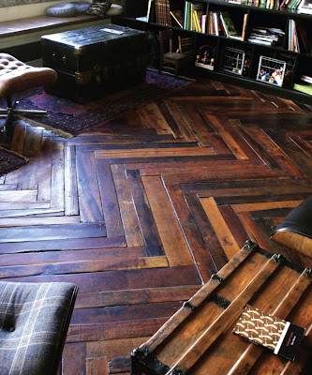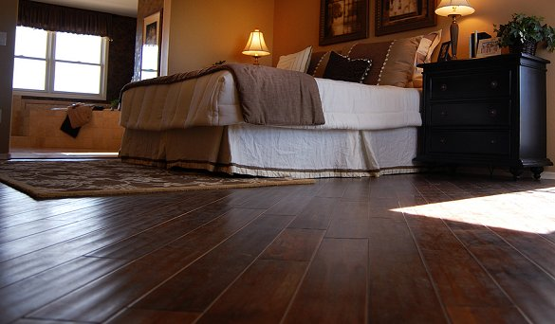
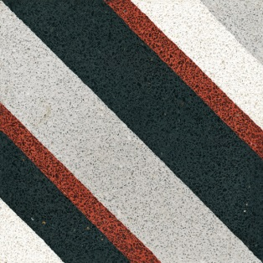
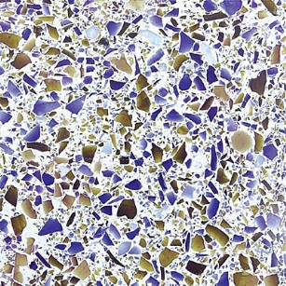
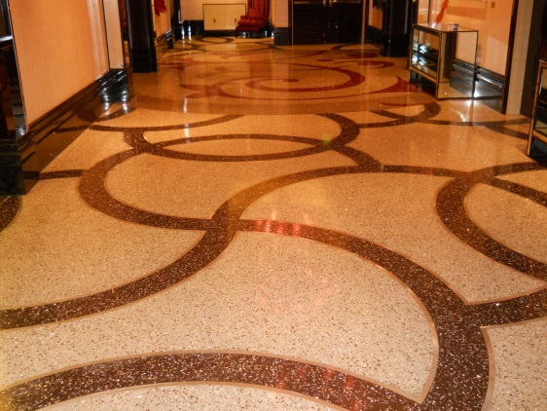
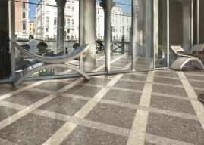
IV. Terrazzo is a flooring material traditionally made by exposing marble chips on the surface of concrete and then polishing until smooth.
Student Name: |  | Salma Mohamed Safaa
Student Number: |  | 1170
Course: |  | Interior Designing
Assignment NO: |  | 10
Page NO: | 3
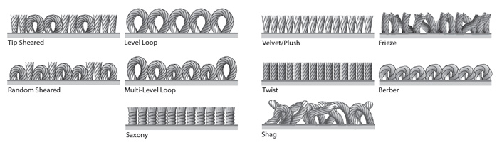
V. Cut pile carpet:
The fibers of the carpet are sheared off creating soft tufts above the carpet backing.

Types of Cut pile carpets:
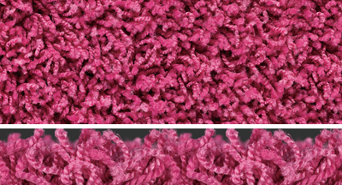
- Freize –carpets are similar to saxony, but the yarns are more tightly twisted and should always be heat set. They have a dense, low pile surface which creates a coarse, pebbly texture. Frieze carpets are very durable and hide footprints, dust and dirt, which makes them suitable for heavy traffic areas.
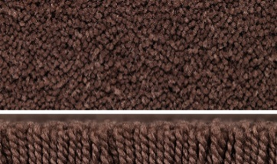
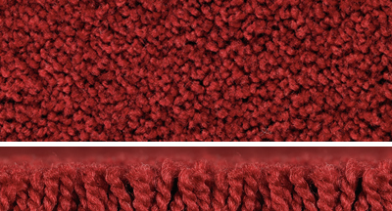
- Saxony – Saxony textures are made of twisted yarns, which should be heat set. The tips remain very distinct, rather than blending together to form a very elegant finish. Saxony textures show footprints and vacuum marks so are suitable for more occasional rooms in the home. More textured variations improve the practicality of saxony.
- Twist – The popular twist carpet is the cut-pile standard. The yarn is tightly twisted and often heat set to retain this feature and the result is a versatile, textured finish that is ideal for plain colours.
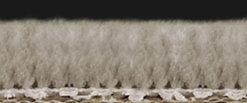
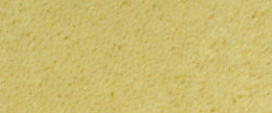
- Velvet – (sometimes called ‘velour’ or ‘plush’) all have a level surface pile of 5mm to 10mm height, which is then sheared to give a smooth finish. With very little twist in the yarn, the ends blend together which then further enhances the overall finish. These carpets tend to ‘shade’ with heavy use. Footprints show easily and the colour looks different from place to place because fibers lying in different directions reflect the light differently.

This type of carpet is usually made of wool, nylon, polyester, acrylic or a
combination of these materials.
Student Name: | Salma Mohamed Safaa
Student Number: | 1170
Course: | Interior Designing
Assignment NO: | 10
Page NO: | 4

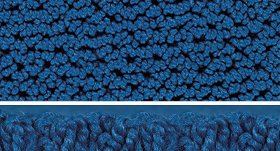
VI.Loop carpet is often made of "olefin fibers" which are naturally stain resistant.
A looped style carpet is often referred to as a Berber. Berbers are really big bulky yarns that are either produced in a level loop or multi-level loop carpet construction. Looped carpets are very durable. This is the result of not cutting the yarn tips. You can see each individual loop.

Although Berbers are made out of olefin fiber, some are made with nylon, or a blend of various carpet fibers.

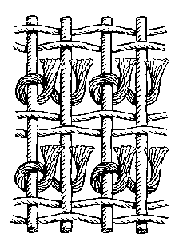
VII. Main characteristics of Persian rugs:
Senneh Knot
- Persian rugs are generally woven in wool, using the special Persian Senneh knot.
- Persian rugs are almost always rectangular or elongated rather than square.
- Indigo or crimson are usually the main colours. Other colours usually include yellows, greens and browns.
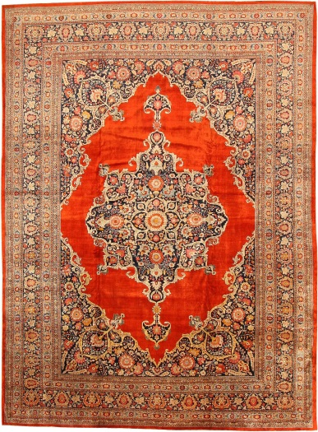
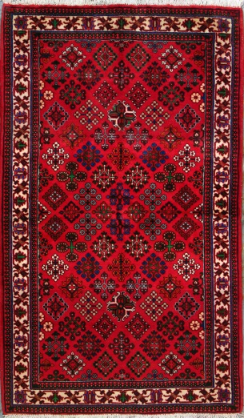
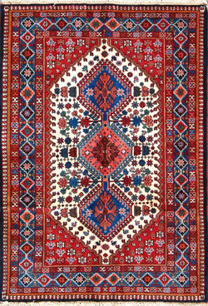
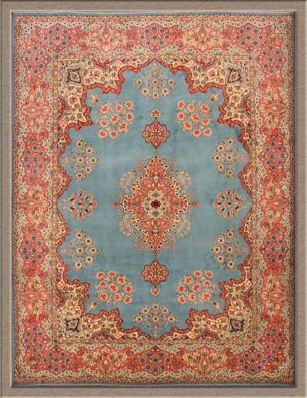
- The designs are usually based on floral motifs, showing flower beds, pools and streams.
Ancient Persian Rug in different designs and colours.

Student Name: | Salma Mohamed Safaa
Student Number: | 1170
Course: | Interior Designing
Assignment NO: | 10
Page NO: | 5

Once the hand knotted Persian oriental rugs are noticed in an interior, it is difficult to notice anything in the room.
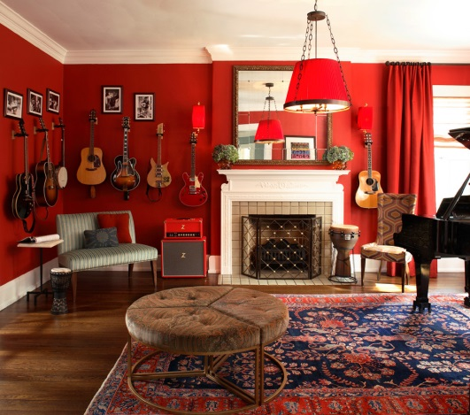
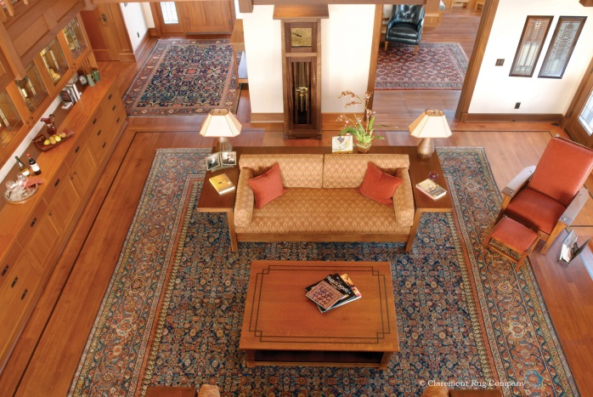
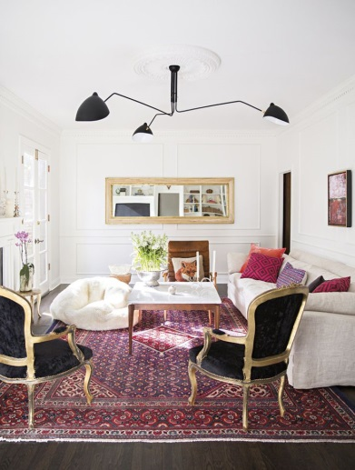
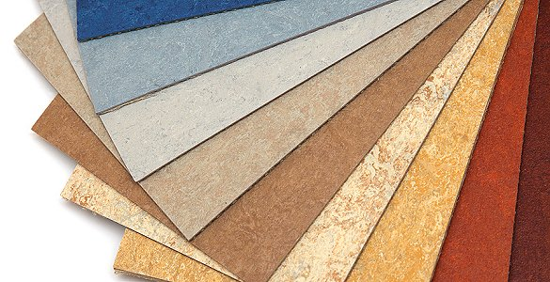
VIII. Linoleum Flooring:

Linoleum is an all-natural product, made up of linseed oil, wood or cork flour, mineral fillers and pigments that are combined and applied to a jute or canvas backing.

It's sometimes confused with vinyl but its natural ingredients provide a more environmentally friendly material than vinyl.

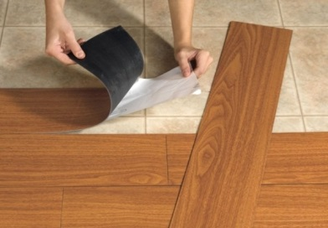
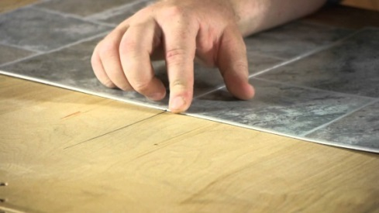
Installation of linoleum flooring is very easy it is glued to a spotless level surface, preferably plywood.

Student Name: | Salma Mohamed Safaa
Student Number: | 1170
Course: | Interior Designing
Assignment NO: | 10
Page NO: | 6
Case Study:

First: For the living room flooring:

The first step in repairing a parquet floor is to check for any missing, damaged or loose blocks and reinstall them. Glue the planks back into place with parquet adhesive or, in a pinch, construction adhesive.

There might be gaps, because the wood has probably warped somewhat over the years. The gaps should all be filled using latex filler. Any excess filler will come off after sanding the floor.
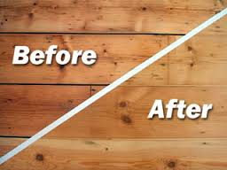
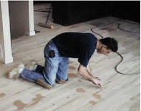

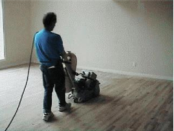

If the new blocks are not flush with the surrounding surface or if the floor is worn, the floor should be sanded until it is smooth. It is best to sand the whole area, not just the re-installed blocks.
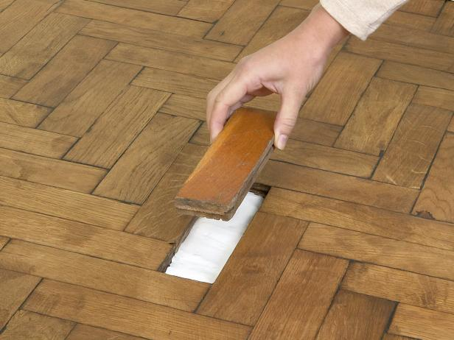
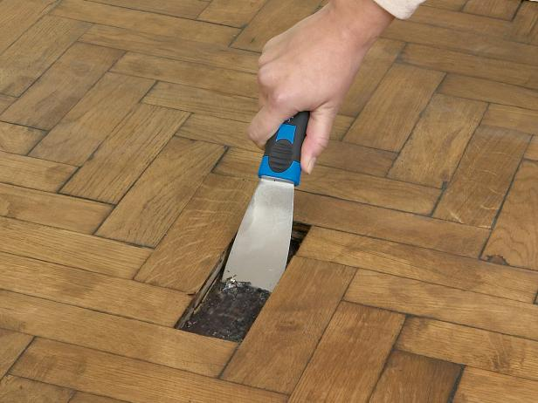

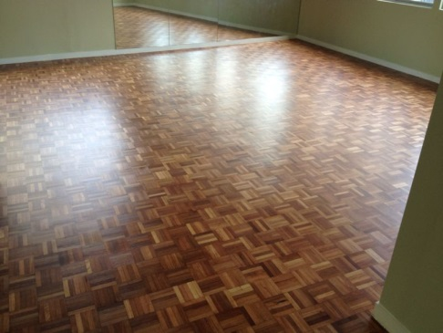
Finally apply finish to the floor surface. This may be wax or varnish, depending on the existing floor. It can then be either stained a different colour or painted it with either floor paint or with acrylic, emulsion paint.

Student Name: | Salma Mohamed Safaa
Student Number: | 1170
Course: | Interior Designing
Assignment NO: | 10
Page NO: | 7

Second: For the hallway tiles:

As described that there are only few cracked tiles in the hallway then the flooring shouldn't be re-laid altogether. The cracks can be repaired to be less visible.
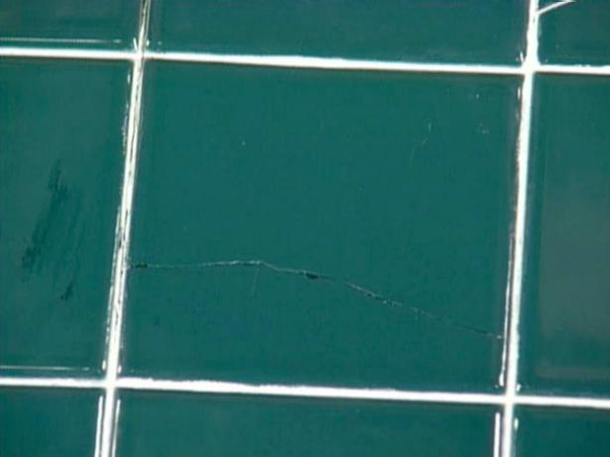
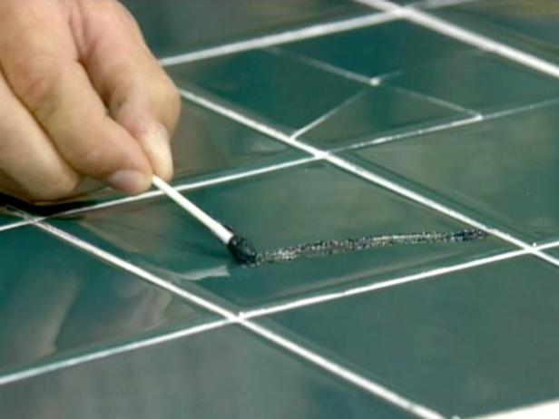

If the tiles are too badly damaged to fix, they can be removed and replaced, but then if the grout has become chipped or stained, it will need to be removed and repaired.
