
Assignment Cover Sheet

Student Name: | Sara Spiers
Student Number: | 1486
Course: | Diploma in Wedding Planning
Assignment NO: | 8

Marking Criteria:
We expect the learners to write minimum one well expressed point in three lines against each allocated mark. This means one needs to write 15 lines with 5 well expressed points to get high grades for a 5 marks question.
For high grades use examples and illustrations where appropriate.
Please insert your completed assignment ( in word format) here:

- (i) What are the three primary food service styles used for weddings.

The three primary food service styles for weddings are buffet, plated and French. The buffet style is the least formal type of food service and can be of two varieties: finger and fork. Similarly, buffets also come with hot or cold foods, or both. Finger buffets are commonly used for the evening reception however, a fork buffet is an alternative option for the wedding breakfast if the couple wish to have a less formal affair. Some buffet styles have servers whereas some do not. This usually depends on the wedding venue or caterer that the couple chooses. Buffets also provide guests with choice as opposed to a set meal from plated food service.

Plated service typically consists of a set meal chosen by the couple and is usually served in 3 courses, although different cultures often have more courses. The plated service is the most formal type of food service and is the most common type of food service for weddings. Unlike the buffet, the meal is portioned in the kitchen behind the scenes and waiters bring the guests’ food to them, one table at a time.

French service is the least common type of service found at weddings. This type of service involves bringing a large platter of food to each table and the server portions the food for each guest. The server must be skilled enough to be able to portion the right amount of food for each person and also present the food as attractively as you would see in plated service.

(ii) What is the difference between buffet and French service styles?

Buffet service involves guests choosing from a range of options of hot and cold food, each presented on individual platters, and often serving themselves and selecting their own portion size. The buffet style gives guests the freedom to choose what they want and they don’t have to have items on their plate that they may not like. The French style differs as guests are presented with a set meal on one large platter and the portion size is determined by the server. The guest also doesn’t get a choice in the food they want as their food is presented to them, much like a plated service.

The two styles also differ in the time taken to receive their meal. Buffet styles often take longer as guests can pick and choose what they want which can often mean that hot foods can go cold from sitting out uncovered before others get to the front of the line. French service is a lot quicker and guests are guaranteed to receive their food hot as the plates are covered when brought out. Also, the two styles differ in their formality with buffet being highly informal but French service being more formal.

(iii) Outline the factors on which cost of the food depends.

Wedding menus are known for being more expensive than any other events. The cost of food is determined by a number of factors. Certain types of food are more expensive including meats that aren’t as readily accessible such as veal and venison, and rare types of mushrooms and truffles. Also leaner cuts of meat can be more costly as they are generally of a higher quality.

Also, food can be costly depending on whether the caterer needs to look beyond their current suppliers to source it. Costs are then determined by the supplier’s costs, plus delivery costs, which is determined by the geographical location it is coming from. Furthermore, some couples may choose to import certain foods, potentially from their home country, to serve at their wedding so costs can be higher for this.

On top of all of this, the caterer looks to make a profit so their profit percentage determines the overall cost. Profit percentages are always higher for weddings as caterers know that higher prices gives couples the mindset that they are receiving better quality.

(iv) Discuss different catering style options. Use examples and illustrations.

There are various different styles of catering couples can choose from. The most popular catering styles are the sit down formal dinner a buffet and finger food, typically canapés. Couples often choose to have a formal sit down meal for the wedding breakfast. This is usually a three course meal served with wine on a fully dressed table.
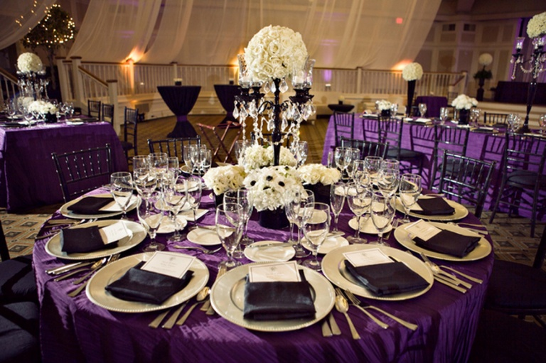
The buffet style is usually chosen for the evening reception which can be served hot or cold, or can be plated or have finger food. The type of buffet reflects the formality of the event, for example, cold food and finger food is seen to be more informal than plated and hot food.

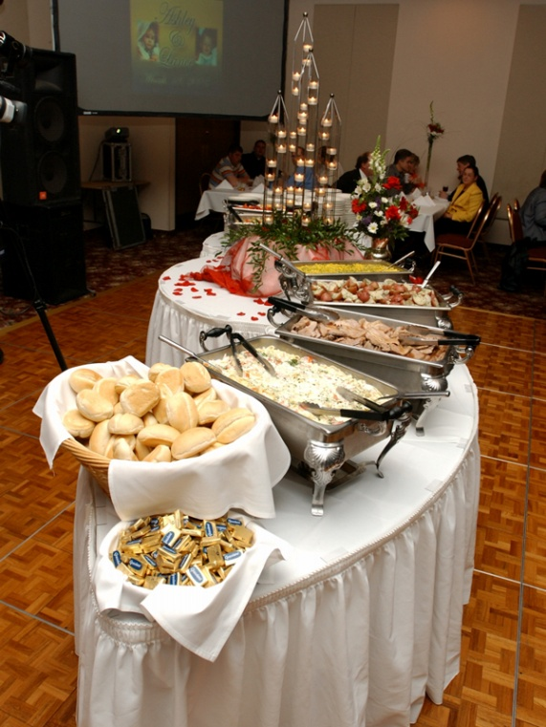

Couples often choose to serve small cocktail-style food during the drinks reception to tide the guests over until a bigger meal later in the day. This is usually in the form of canapés and h’ordurves. These can again be hot or cold and vary in their formality.

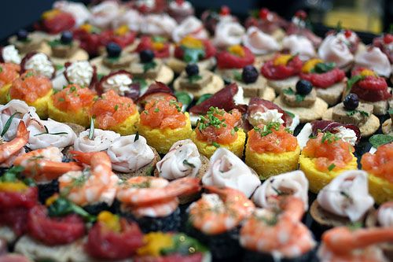

An alternative to a formal sit down meal is a luncheon style meal whereby guests sit around a long table with many plates of food place in the centre to share. This is a more informal style and is a way in which the couple can allow the two sides of the family to come together as one.

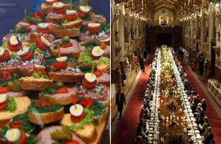

An unusual style of wedding catering which is becoming more popular is an Afternoon Tea style. Foods served include sweet and savory bite size food such as sandwiches, tarts and scones. This can be used to reduce the cost of a large sit-down meal and a more substantial evening buffet would be served in the evening to compensate. This could be used for weddings that are taking place later in the day.

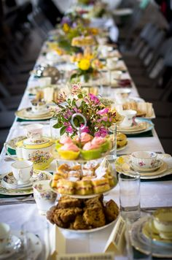

Case Study

To prepare for such a situation, the wedding planner should ask the couple for their “top 3 preferred wedding cakes” that fit within their theme and keep this on file. Secondly, wedding planners should always keep a database of suppliers, noting which location they are based in alongside testimonials and reviews from their websites, review websites and previous clients. From there, the planner can being research for sourcing a replacement as close as possible to the chosen design or one of the other two designs the couple like. Having this plan in place will help to alleviate the situation when it comes to notifying the couple of the issue that has arisen and a clear plan is in place to rectify it.

It is also possibly to look to using synthetic materials to achieve the ribbon design on the top which may help in reducing the time to recreate the cake. This can be chosen from the couple’s chosen fabric samples that they have chosen either for the wedding attire or other forms of decoration.

Also, the shipping costs should include insurance in accordance with the value of the item being shipped. The couple are well within their rights to put in a claim to the shipping company, who are at fault in the situation, and the costs should be covered for sourcing the replacement.

Student Statement:

By submitting this assignment, I confirm that this is my own work.

Student Signature |  | Date

For Tutor / Assessor Use Only
Total Marks
Marks Obtained
Percentage / Grade

