
Assignment Cover Sheet

Student Name: | Salma Mohamed Safaa
Student Number: | 1170
Course: | Interior Designing
Assignment NO: | 5

Student Statement:

By submitting this assignment, I confirm that this is my own work.

Student Signature | Salma Mohamed Safaa | Date | 22/03/2015

For Tutor / Assessor Use Only
Total Marks
Marks Obtained
Percentage / Grade

Student Name: | Salma Mohamed Safaa
Student Number: | 1170
Course: | Interior Designing
Assignment NO: | 5
Page NO: | 1

Interior Designing Course
Unit 5: Space.
Q.1.
I. When planning a space in interior design scheme it is important to establish the purpose for which it will be used in order to understand all the activities that will occur in the space.
This enables the designer to create a space that is efficient and appealing. Planning with a purpose will naturally lead to the smaller details that need to be attended this allows the "Form to follow the Function" of the space, and so results in the perfect design.

II. Painting the rooms of a house in same colour scheme gives the perception of a larger space because it creates a sense of openness in the house that draws the eye towards a smooth flow from one space to another giving the feeling that you are moving a large whole space.
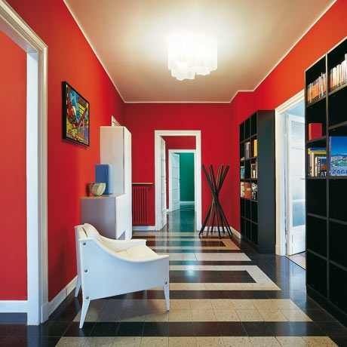
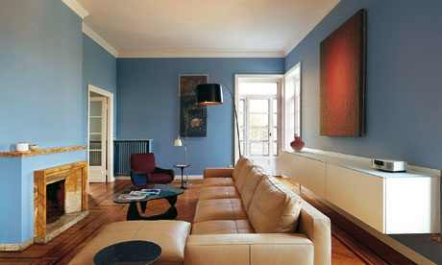

Student Name: | Salma Mohamed Safaa
Student Number: | 1170
Course: | Interior Designing
Assignment NO: | 5
Page NO: | 2

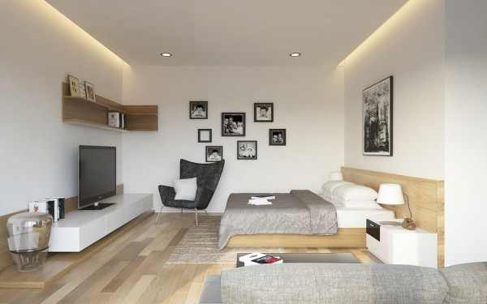
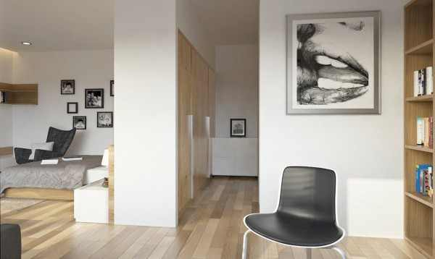
III. Using one flooring style for all adjoining rooms on the same floor creates a sense of continuity as it connects and links the rooms together into a unified whole space.
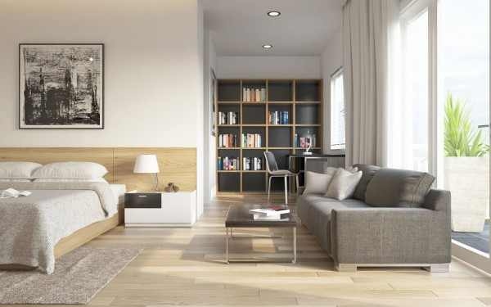
This small apartment space is used as a combination bedroom and living room. But because of unifying the flooring style and ceiling, the space doesn't seem too small or cluttered.

IV. An attractive window treatment that sits well within the window frame could be a perfect solution for a small space, as it is all about visual tricks fooling the eye a bit to make the room seem larger.
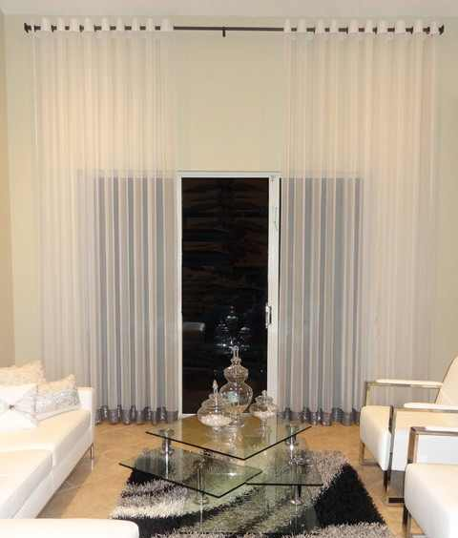
For example;
- Hanging the drapery rod closer to the ceiling will make a low ceiling seem taller and make your room feel larger.

Student Name: | Salma Mohamed Safaa
Student Number: | 1170
Course: | Interior Designing
Assignment NO: | 5
Page NO: | 3

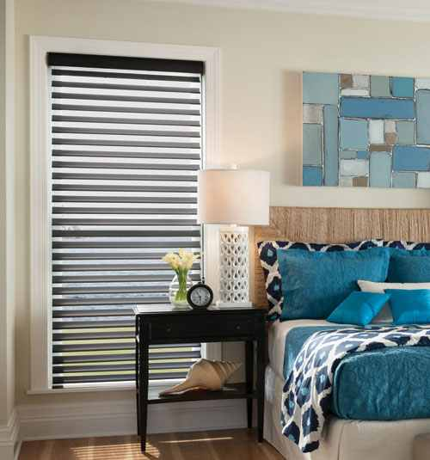
- Sheer shades are great for small rooms because they bring softness to the room without adding the bulk of drapery.
Plus, when the vanes are open, the view-through leads the eye out the window and visually opens up the space.

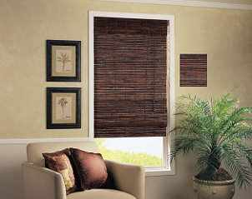
- Roller shades like roman shades or natural bamboo blinds are a great choice, as they offer a thin profile and sleek look that’s unobtrusive for a small window.

V. Introducing different textures in a room creates a visual interest as it draws the person's eye into the space, exploring all the space travelling from a detail of a texture to another. Mixing textures provide the eye with something interesting to look at, but they're also incredibly soothing.
Using different textures works better in a large space because it turns the space into a welcoming, accommodating and a place of coziness and relaxation.

Student Name: | Salma Mohamed Safaa
Student Number: | 1170
Course: | Interior Designing
Assignment NO: | 5
Page NO: | 4

For example;
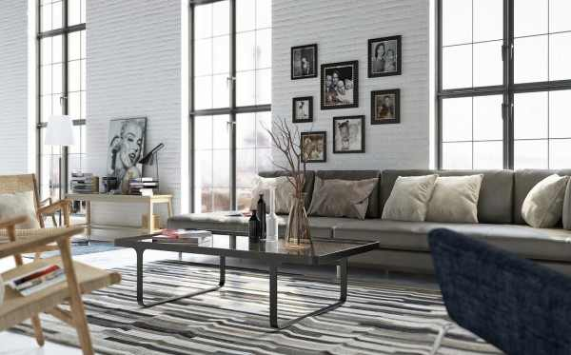
This large open living room design has various textures in the area rug, the tree branches and the painted brick walls. The artwork adds to the aesthetics and the furniture isn’t all one matching color, but the various colors work together and tie in the design, giving the feeling of welcoming and relaxation.

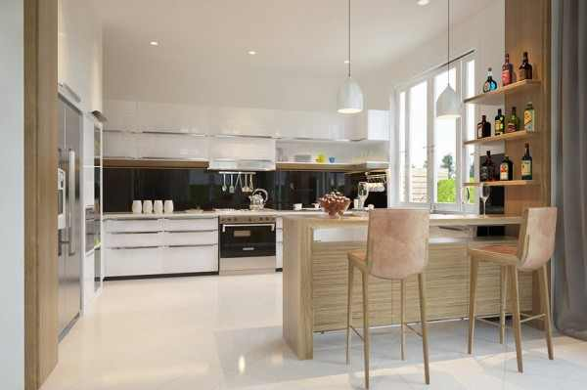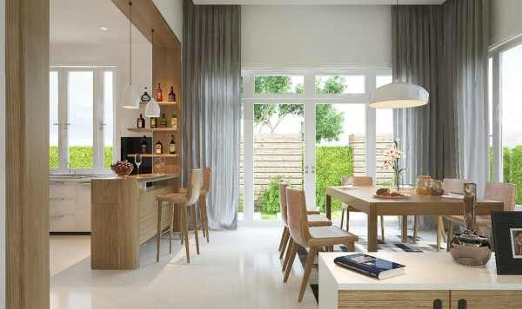
This open kitchen is bright and white, but the medium toned wood finishes tie together the kitchen and the adjacent dining space which has a large wooden table in the same finish, along with the tall light grey curtains and the bright smooth flooring. The strategic mixing of the textures creates that visual perception letting you accommodating in the large space.
VI. Three tricks to make a small room appear larger:
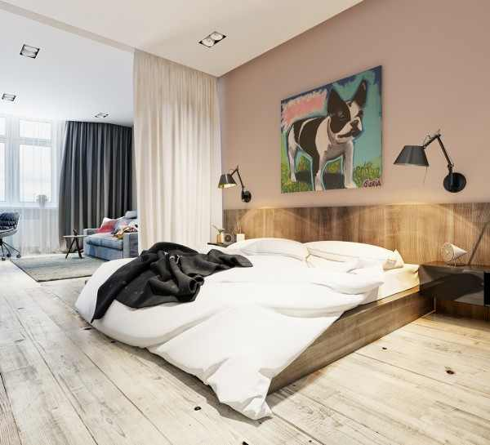
- Expanding the view; by reducing unnecessary walls to create an open and flowing space. Light partitions can be used to give a certain zone its privacy.

Student Name: | Salma Mohamed Safaa
Student Number: | 1170
Course: | Interior Designing
Assignment NO: | 5
Page NO: | 5
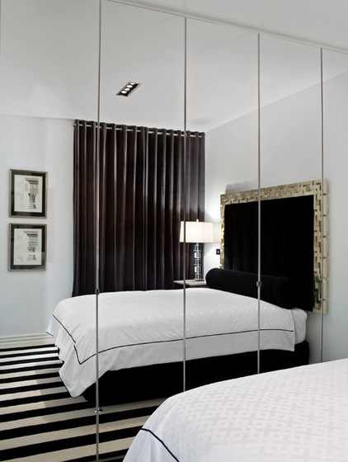

- Using Mirrors and Transparent Partitions; as mirrors' reflections trick the eye into feeling that the space is larger than it is. And using transparent items create a sense of openness.
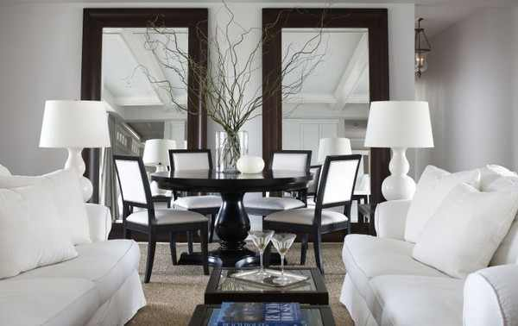
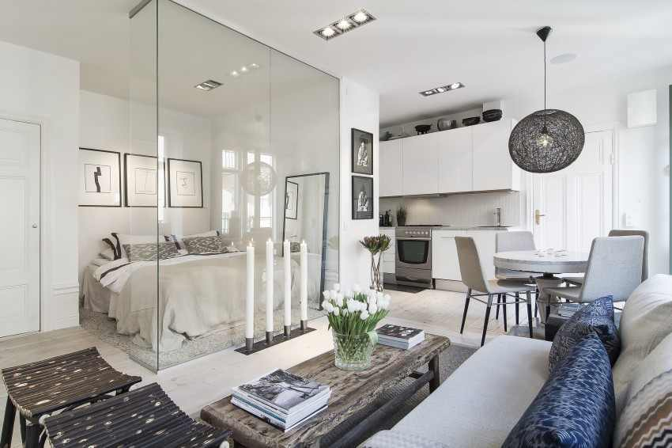

- Using Multifunctional Furniture
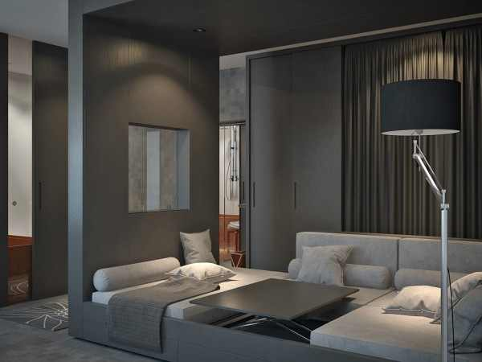
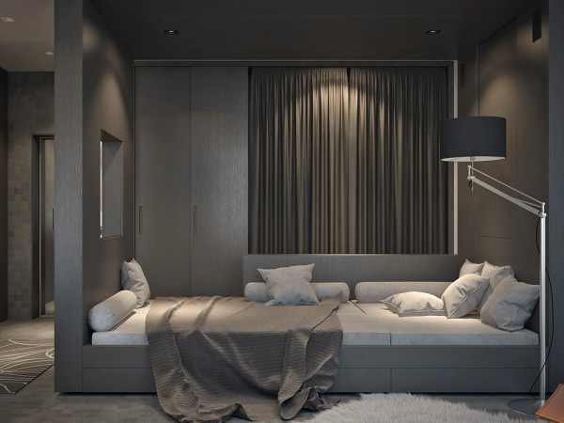
The main room acts as both living and sleeping room with a large convertible piece of furniture taking center stage. It can easily move from sofa with central coffee table to relaxing bedroom with just a few motions.

Student Name: | Salma Mohamed Safaa
Student Number: | 1170
Course: | Interior Designing
Assignment NO: | 5
Page NO: | 6

Q.2. Social Islands:
Social Islands are created in large living rooms by arranging the furniture to have multiple seating areas in the large space. Furniture arrangement can be challenging, but you can create a room with double seating areas. An open console separates the two seating areas while two sisal rugs clearly define each space.It's important to place the furniture in small groups to create a sense of intimacy, a good rule is to not set furniture so far apart that you have to lean in across the coffee table to hear the person you're talking to.
Also designers use area rugs to define seating areas and to add color, pattern, texture or warmth to a room. In an open large space, rugs can anchor floating furniture and enhance the perception of intimate space in the larger design.
Social islands are more practical choice for a large living room because of the sense of intimacy that is created through the several conversations groupings within the space.
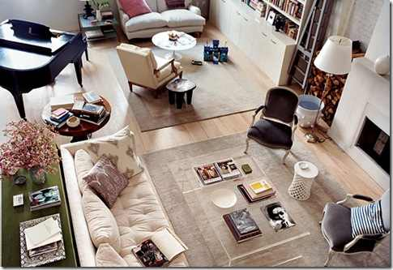
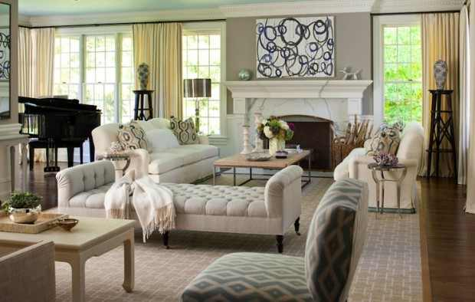
Two seating areas at opposite ends of the long room are anchored by matching rugs…one smaller and one larger. This divides the space into separate areas but keeps your eye flowing over the entire space. If one rug were much different in appearance than the other, the room wouldn’t have the same feel.

In a more neutral color scheme, two seating areas are effectively divided with a gorgeous tufted ottoman. What is nice about this option is that you can sit either way on the ottoman so although two separate areas are created conversation can easily flow through.
Student Name: | Salma Mohamed Safaa
Student Number: | 1170
Course: | Interior Designing
Assignment NO: | 5
Page NO: | 7
Case Study:
Lucy redecorating her house, her living room is large L-shaped with high ceilings. One corner of the room is very dark as there is only one large window in the room which is not enough to light the whole room properly.
Having a living room with extremely high ceilings and a lot of space to fill, gives a cold appearance. Large rooms present some challenges, and that is what we will be tackling today.
These are some suggestions that can help make the room feel balanced and comfortable;
1. CEILINGS:
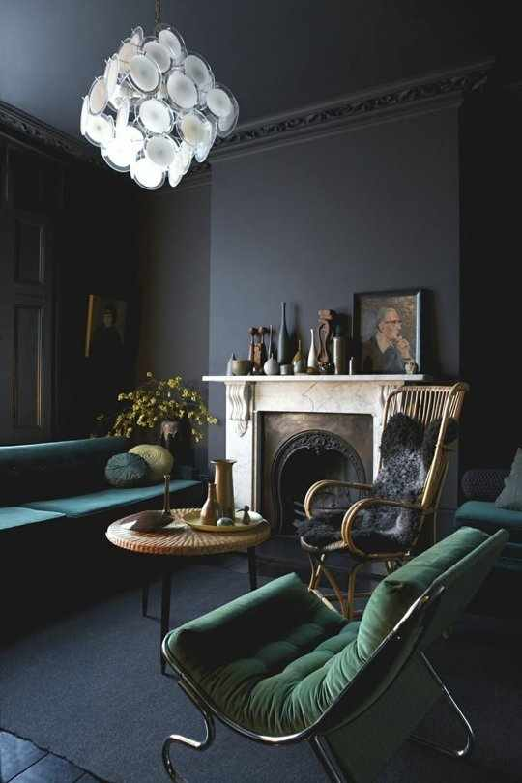
a. Painting the ceiling with dark colors: Paint is an easy, inexpensive way to fool the eye into thinking a room is smaller or larger than it really is. By paying attention to the effects of dark paint colors, you can turn a large room into a cozy, small welcoming space. Dark colors tend to bring down the walls visually.
b. Lower the ceiling by false ceiling
2. WALLS: The color of the walls is just as important as the color of the ceilings when you are trying to create an intimate setting.
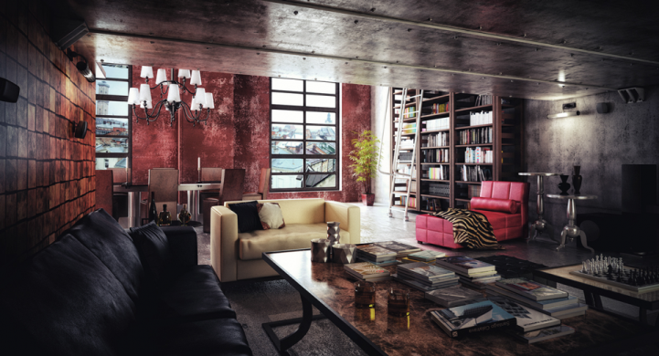
- Paint the walls with a dark color to absorb light and draw focus away from the largeness of the room. You also can paint just one wall with a very dark accent color, painting the other three in a lighter coordinating shade.

Student Name: | Salma Mohamed Safaa
Student Number: | 1170
Course: | Interior Designing
Assignment NO: | 5
Page NO: | 8
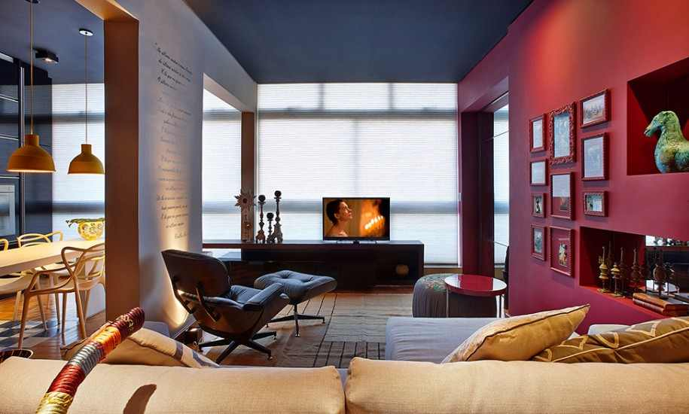
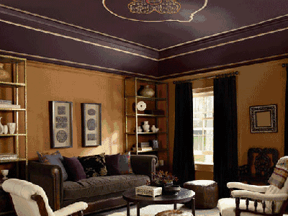
Paint the room’s walls with a warm color such as deep red, gold, brown, tangerine or putty to provide an instant sense of coziness.
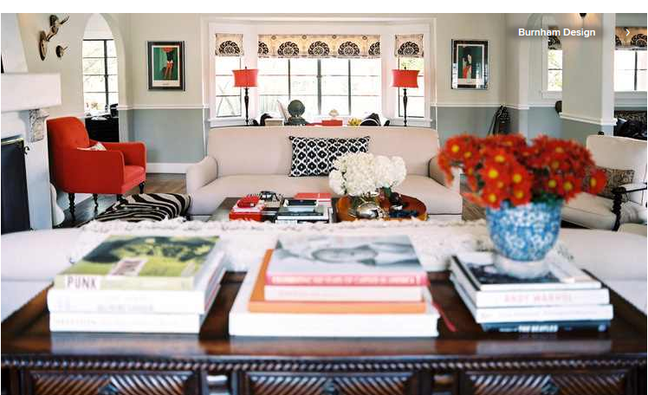
Paint the walls with two colors, dividing the wall space horizontally, will further define the wall sections, serving to visually shorten the walls.

3. DARK CORNER: Using mirrors reflect light from artificial light sources or windows, they make the room appear larger, than it actually is.

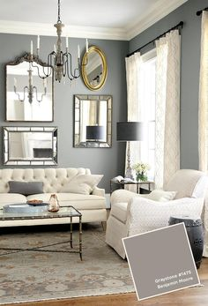
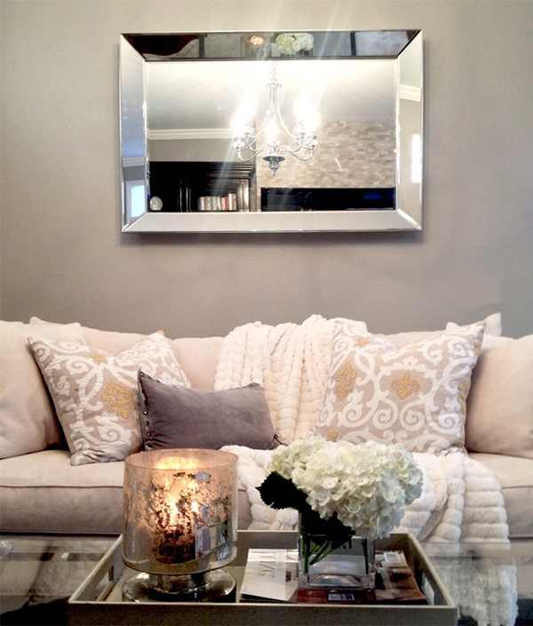
Student Name: | Salma Mohamed Safaa
Student Number: | 1170
Course: | Interior Designing
Assignment NO: | 5
Page NO: | 9

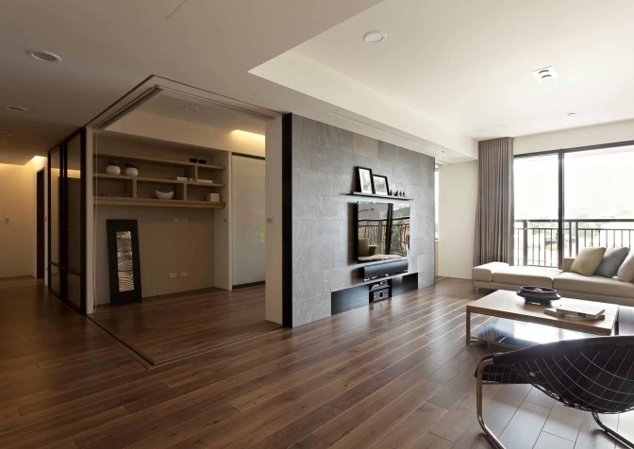
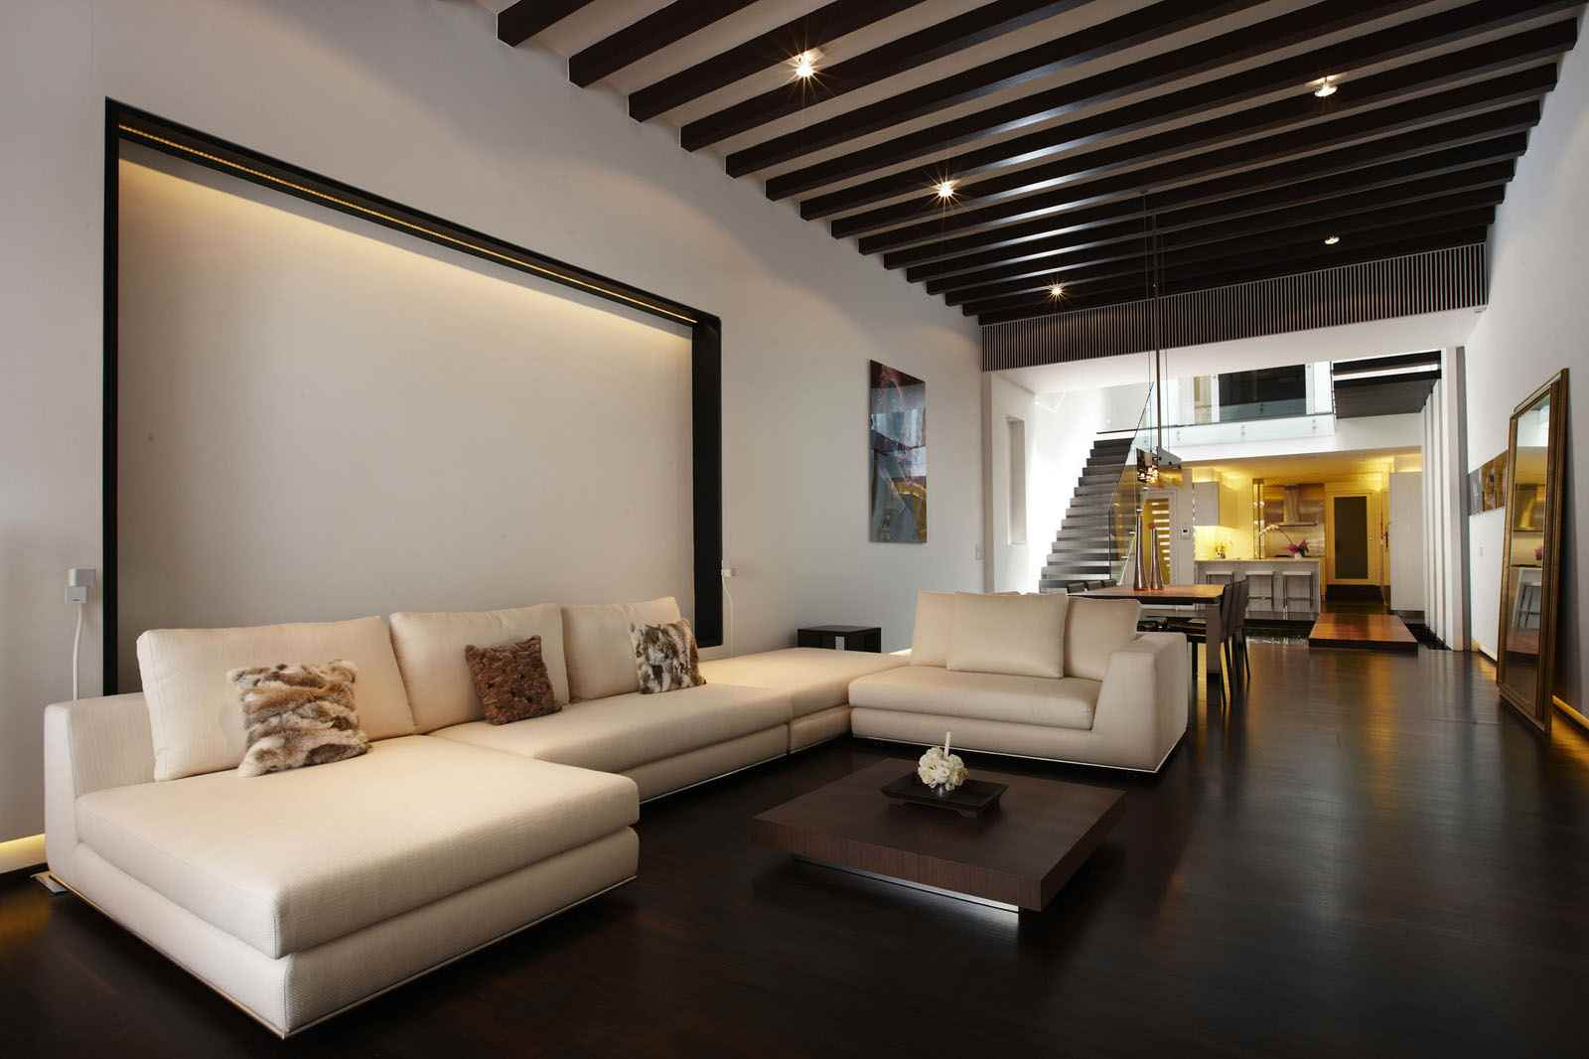
- The suitable flooring for a large living room would be dark flooring wood, stone, concrete, tile, carpet, whatever. Dark floorings definitely make a big space cozy and warm.

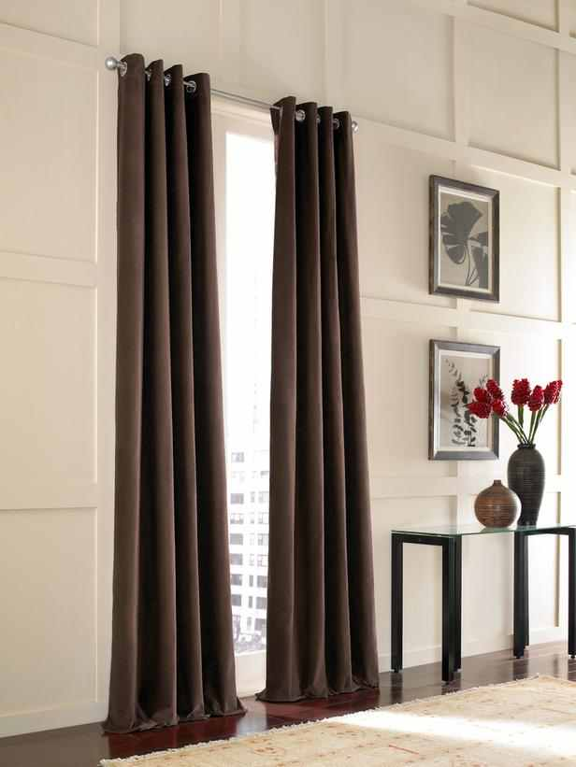
- The suitable window treatment for a small window to look bigger using window treatment tricks.
Make short windows look taller by hanging floor-length curtains or draperies at or near the ceiling.

To make narrow windows look wider, opt for a curtain or drapery rod that’s wider than the window, including the molding. Hang drawing curtains or draperies across the entire space.

