
Assignment Cover Sheet

Student Name: | Salma Mohamed Safaa
Student Number: | 1170
Course: | Interior Designing
Assignment NO: | 2

Student Statement:

By submitting this assignment, I confirm that this is my own work.

Student Signature | Salma Safaa | Date | 18/12/2013

For Tutor / Assessor Use Only
Total Marks
Marks Obtained
Percentage / Grade

Student Name: | Salma Mohamed Safaa
Student Number: | 1170
Course: | Interior Designing
Assignment NO: | 2
Page NO: | 1

Interior Designing Course
Unit 2: A Brief History of the Interior Design.
Q.1
I. The main elements of Tudor interiors are:
- Wood panelling.
- Plaster ceiling panels.
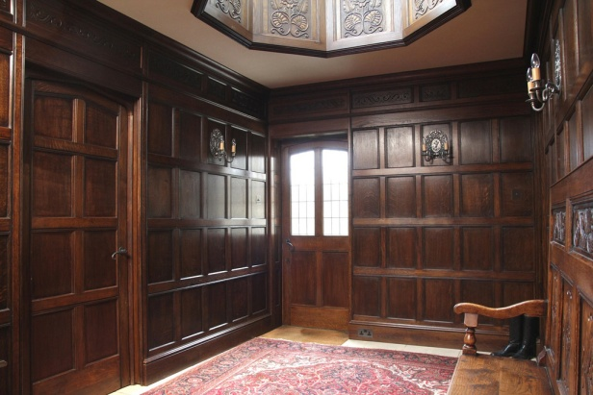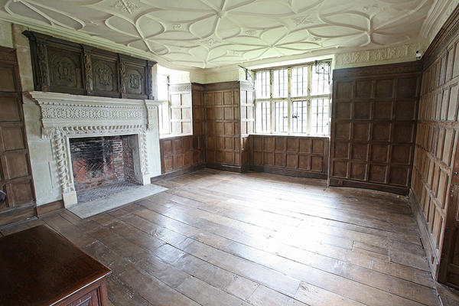
17th century tudor style pannelled hallway & lantern. The great chamber with ribber plaster ceiling.
II. Surface decorations were used in Tudor interiors, which appeared in:
- Carpets.
- Upholstery.
- Wall hangings.
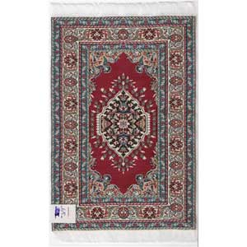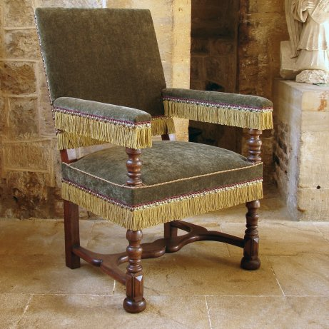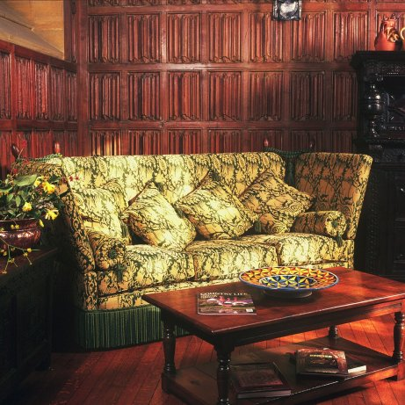
Tudor carpet. Oak - Upholstered Armchair in velvet. Upholstered 17th Century Tudor Sofa.
Student Name: | Salma Mohamed Safaa
Student Number: | 1170
Course: | Interior Designing
Assignment NO: | 2
Page NO: | 2
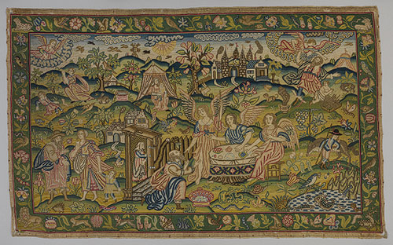 Wall Hanging 17th century tapestery .
III. The modern interiors differed from the period interiors:
- The room planning was now in accordance with the technologies like; television, computer, refrigerator and etc.
- Lighting, both artificial and modern became an important way of adding atmosphere to the room.
- New materials were discovered and used in interiors, such as plastic was no used for where flooring to window frames. Synthetic fibres were used for carpets, curtains, beds and table linens.

IV. A modern kitchen is different from the kitchens of the past.

- The modern kitchen is located in the central area of the house.
- It is more of a food processing space than a traditional kitchen.

V. There are technological developments & life style needs that affects our way of life, and so, affects our interior spaces. With all these developments, to a certain extent the work of an interior designer today is distillation of ideas that are taken from past periods. So, it is very important for an interior designer to have knowledge of period interiors to have the ability to create an interior space with any period style, with only the necessary adjustments made to suit the 20th century way of life.

Student Name: | Salma Mohamed Safaa
Student Number: | 1170
Course: | Interior Designing
Assignment NO: | 2
Page NO: | 3

Q.2
There are three important features of the Oriental Style:
1- Colours: used are those of nature.
2- Furniture: is hand crafted.
3- Fabrics: are dyed in natural ways and reflects the colours of earth and vegetation.

Case Study
A period property built in 1800’s. The owner is interested to decorate it in 17th century style. Anna is the interior designer.
- Anna can re-create the required style through:
- Materials she can choose for the walls, floors, windows and ceilings:
-type of furniture she can use to re-create the effect of 17th century:

1-Walls: -oak paneling can be used with wool tapestries or damask wall hangings.
-Oriental wall papers can also be used.
2-Windows: -Curtains fabrics heavy cotton of linens with printed Jacobean designs.
-Bargello patterns in weave and prints.
- Velvet and silks in faded colours.
3-Floors: - Parquet or any wooden floors, plain or covered with Indian or Persian rugs.
-Black and white vinyl floors.

Student Name: | Salma Mohamed Safaa
Student Number: | 1170
Course: | Interior Designing
Assignment NO: | 2
Page NO: | 4

4-Ceilings: - Painted ceilings to imitate materials like marble and tortoise shells.

5-Furniture: - Chairs: tall chairs with caned backs and upholstery seats. Simple chairs with turned legs and rush seats.
-Tables: with planked top with chunky legs or extending draw leaf tables.
- Fully upholstered armchair in the bedroom with four poster bed (tester bed).
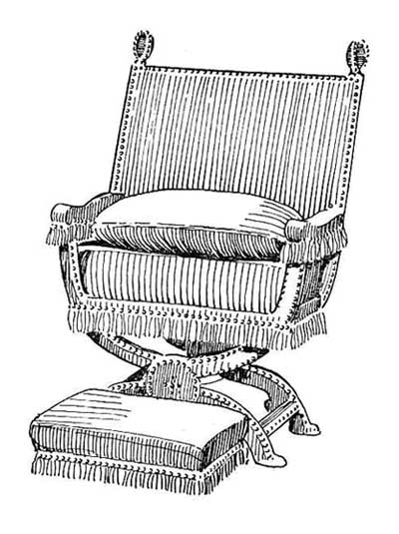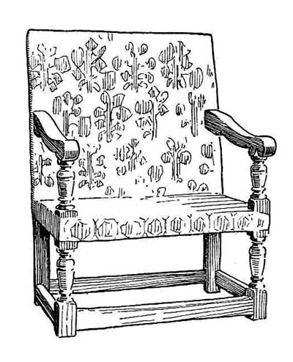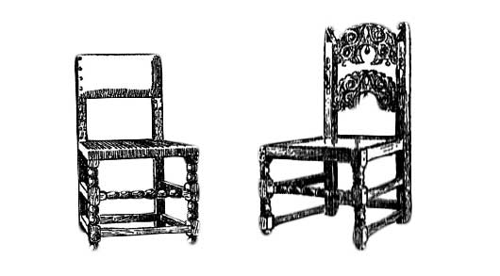
Upholstered Jacobean chairs with twist
Upholstered X pattern chair. turned legs and stretches.

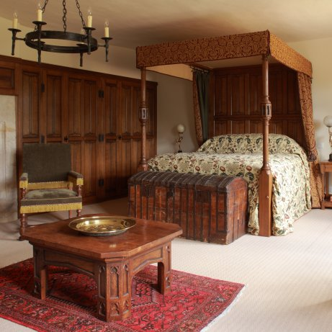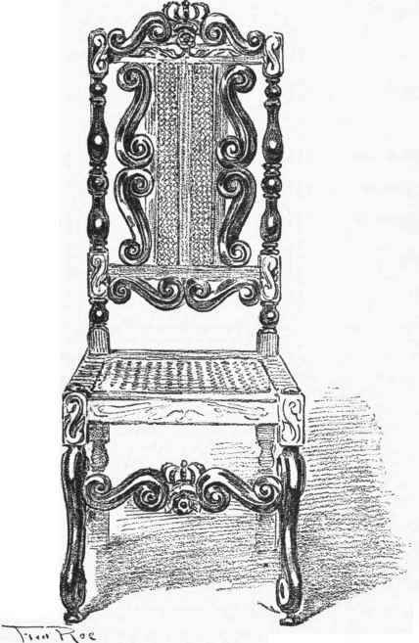
Tudor Style Bedroom with oak furniture. Tall caned back chair.

