
Assignment Cover Sheet

Student Name: | Ray Wilson
Student Number: | 1336
Course: | Project Management
Assignment No: | 7

Assessment 7 Total Marks: 30

1. Give short answers for the following questions. (15)

I. Outline the processes involved in project quality management.

Most quality management systems are designed with ensuring the customer is satisfied with the deliverable.

The key is to Plan, Assure and Control and by doing so ensure that procedures, processes, organization, and resources are in place that are needed to keep the organization focused on its goals and the activities it puts in place to achieve its goals. Often these techniques lead to higher levels of customer satisfaction because organizations have developed products, services and programs that not only please customers, but also ensured the consistent delivery of what it promised.

It is vitally important therefore to make sure the following phases are considered;
- The process of quality management starts by defining how employees’ jobs are tied to your company or organizations goals. Employees need to know the organization’s mission, vision, values, how they relate to the company and their role in it and it is important all employees should receive alignment with regards to the company’s vision, mission, values and goals via suitable training and induction.
- The factors that make an organization’s Quality Management System successful should be identified. Make a list of the primary factors, such as product, technical and customer support, financial security and employee satisfaction that influence the process of quality management and continuously and consistently manage those factors.
- Identify the key groups of customers that make your quality management system work. Often customers are vendors, suppliers, employees or direct customers.
- Customer feedback is essential in the process of quality management. Consistent customer feedback enables organizations to detect and solve quality problems before it become a serious issue. Feedback can be obtained through regular customer surveys, by phone, email, focus groups or in person.
- Quality management is synonymous with continuous improvement. The results or information obtained from an organization’s survey or other customer feedback tools must now be used to make the necessary changes to the quality management process. The vital factor is to study the opinions received and use it to continuously improve the organizations processes in delivering the products and services it sells to its customers.
- Select a suitable quality management software package that not only helps you to implement a quality management process, but also helps you to maintain and improve the process.
- Measure your results. Though there may be many reasons for implementing a process of quality management, one of the main reasons is to ensure your organization executes on its goals. Right from the start of the project make sure that there are measurable goals and everyone involved knows what needs to be achieved. When they are not achieved make sure everyone is clear on what required corrective action is necessary to ensure the goals are achieved.

II. What are the main characteristics of project quality management?

Quality management characteristics include;

- The project must satisfy the customer requirements by delivering what it promised.
- The project team must work towards the quality objective and be supported by management with the required resources to deliver on the quality promises.

- Continuously improve to enable cost reduction and ensure consistency of deliverables or project performance.
- Improve the process or product and compare the costs involved against the increase in revenue made from the improvements. This action in known as the Marginal analysis approach.
- The Plan-do-check-act method is one of the most important aspects of project quality management. Planning for quality is more profitable than the product failing inspection and needing rework to rectify, in essence quality should be planned and built in, not inspected in. The project manager must consider the cost balance of achieving the expected level of quality in contrast to the cost of compliance.



It is also important to acknowledge that all material or services associated with a project have characteristics that facilitate the identification of its quality. The characteristics are part of the conditions of how the material, equipment and services are able to meet the requirements of the project and are fit for use by the recipients. Quality characteristics are not only limited to the material, equipment or service delivered to the beneficiaries, but also applies to the material, equipment and services the project staff uses to deliver the project outputs. These include the vehicles, computers, various equipment and tools and consulting services the project purchases and uses to carry out its activities.

Quality characteristics relate to the attributes, measures, checks, controls and methods attached to that particular product or service such as;

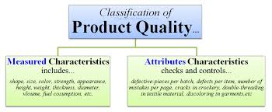

- Functionality is the degree, by which equipment performs its intended function.
- Performance, it’s how well a product or service performs for the owners intended use.
- Reliability, it’s the ability of the service or product to perform as intended under normal conditions without unacceptable failures.
- Relevance, it’s the characteristic of how a product or service meets the actual needs of the beneficiaries, it should be pertinent, applicable, and appropriate to its intended use or application
- Suitability, defines the fitness of its use, it appropriateness and correctness, the operating equipment must be designed to operate on the soul conditions the beneficiaries will use it on.
- Completeness, the quality that the service is complete and includes all the entire scope of services. Training sessions should be complete and include all the material needed to build a desired skill or knowledge

III. What is meant by the term ‘benefits & cost analysis’? And how it is performed?

Benefit/cost analysis is a process of determining the pros and cons of any process, product, or activity. Benefits should always outweigh costs. The direct approach, when it comes to project management, is to consider the costs versus the benefits of quality management activities.
Firstly time should be taken to brainstorm all of the quality costs associated with the project, and make a list of these. Then, do the same for all of the perceived benefits of the activities. Think of any unexpected costs? And are there any potential benefits that you may not initially have anticipated? When you come up with the costs and benefits, think about the lifetime of the project to paint a picture showing the costs and benefits likely encountered during the project duration.
Next include the costs of physical resources needed, as well as the cost of the human effort involved in all phases of a project. Costs associated with quality are often relatively easy to estimate based on similar previous projects. It's important that you think about as many related costs as you can. For example, what will any training cost? Will there be a decrease in inspection activities while people are learning a new system or technology? And how much will this cost? Remember to also think about all the costs that will be incurred on the project. For example, consider whether you will need additional inspection staff, if your team will need ongoing training, or if you'll have increased overheads.

Finally, compare the value of your quality costs to the value of your benefits, and use this analysis to decide your course of action. 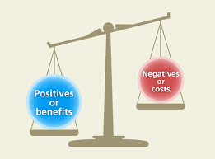
To do this, calculate your total costs and your total benefits, and compare the two values to determine whether your benefits outweigh your costs as not all projects are the same and the right balance needs to be found. At this stage it's important to consider the payback time, to find out how long it will take for you to reach the break-even point. For simple examples, where the same benefits are received each period, you can calculate the by dividing the projected total cost of the project by the projected total revenues as indicated below;
Total cost / total revenue (or benefits) = length of time (payback period).

IV. What is benchmarking?
Benchmarking is the process of comparing one's business processes and performance metrics to industry finest or best practices from other companies. Quality is typically measured, along with time and cost. In the process of best practice benchmarking, the Project Manager identifies the best firms in his industry, or in another industry where similar processes exist, and compares the results and processes of those studied. In this way, he will learn how well the other firms have performed and, more importantly, the business processes that explain why these firms are successful.
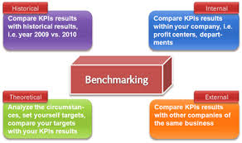
Benchmarking, in relation to quality, is used to measure performance using a specific indicators such as cost per unit of measure, productivity per unit of measure, cycle time of x per unit of measure or defects per unit of measure which results in a metric of performance that is then compared to others.
The process of benchmarking involves looking outward (outside a particular business, organization, industry, region or country) to examine how others achieve their performance levels and to understand the processes they use. In this way benchmarking helps explain the processes behind excellent performance. When the lessons learnt from a benchmarking exercise are applied appropriately, they facilitate improved performance in critical functions within an organization or in key areas of the business environment.
Application of benchmarking involves four key steps:
(1) Understand in detail existing business processes
(2) Analyze the business processes of others
(3) Compare own business performance with that of others analyzed
(4) Implement the steps necessary to close the performance gap
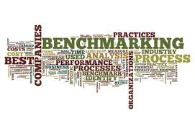
Benchmarking should not be considered a one-off exercise. To be effective, it must become an ongoing, integral part of an ongoing improvement process with the goal of keeping abreast of ever-improving best practice.
V. What is a flow chart? Discuss ‘cause and effect diagram’.

A flow chart is a graphical or symbolic representation of a process. Each step in the process is represented by a different symbol and contains a short description of the process step. The flow chart symbols are linked together with arrows showing the process flow direction.
A simple flow chart indicating the most commonly used symbols can be seen below;
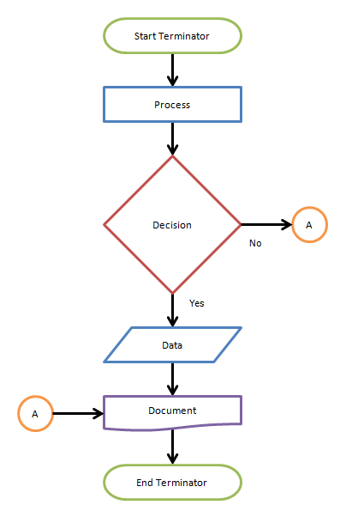

A Cause-and-Effect Diagram is a tool that helps identify, sort, and display possible causes of a specific problem or quality characteristic. It graphically illustrates the relationship between a given outcome and all the factors that influence the outcome.

By constructing a Cause-and-Effect Diagram your team will determine how to,
- Identify the possible root causes, the basic reasons, for a specific effect, problem, or condition.
- Sort out and relate some of the interactions among the factors affecting a particular process or effect.
- Analyze existing problems so that corrective action can be taken

The type of diagram illustrated below is sometimes called an "Ishikawa diagram" because it was invented by Kaoru Ishikawa, or a "fishbone diagram" because of the way it looks,

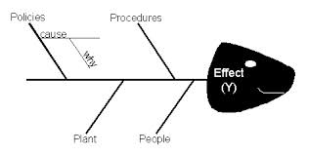

A Cause-and-Effect Diagram is an instrument that is useful for identifying and organizing the known or possible causes of quality, or the lack of it. The structure provided by the diagram helps team members think in a very systematic way. Some of the benefits of constructing a Cause-and-Effect Diagram are that it;

- Helps determine the root causes of a problem or quality characteristic using a structured approach.
- Encourages group partaking and utilizes group understanding of the process.
- Uses an orderly, easy-to-read format to diagram cause-and-effect relationships.
- Indicates possible causes of deviation in a process.
- Increases knowledge of the process by helping everyone involved to learn more about the factors at work and how they relate.
- Identifies areas where information should be collected for further study.

2. Discuss quality management plan. How will you complete quality assurance activities? How will you implement that plan as a manager? (15)
The Quality Management Plan defines the acceptable level of quality, typically defined by the customer, and describes how the project will ensure this level of quality in its deliverables and work processes. Quality management activities ensure that:
- Products are built to meet established standards and requirements
- Work processes are performed efficiently and as documented
- Non-conformances found are identified, recorded and appropriate corrective action is taken
The Quality Management Plan describes the following quality management components:
- Quality objectives
- Quality roles and responsibilities
- Key project deliverables and processes to be reviewed for a satisfactory quality level
- Quality standards
- Quality control and assurance activities
- Quality tools
- Plan for reporting quality control and assurance problems
- Continuous improvement
The Quality Management Plan also helps the project manager determine if deliverables are being produced to an acceptable quality level and if the project processes used to manage and create the deliverables are effective and properly applied.
The people who need to be involved in the plan development are the Project Manager, Project Team members, Project Sponsor and ultimately the Customer. The result of the output will be a Quality Management Plan which will be an important section of the Project Plan
Quality plans apply to both project deliverables and project work processes. Quality assurance activities monitor and verify that the processes used to manage and create the deliverables are followed and are effective. Quality control activities monitor and verify that project deliverables meet defined quality standards. The quality circle is shown below;
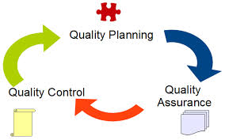

The project manager, project team, and management in general need to ensure the project meets the quality expectations laid out in the approved quality plan. It is essential that Quality Assurance (QA) is implemented before and during the projects life and not at the end of the project. The QA department or perhaps an external body will complete the QA activities for most projects.

The primary aim of QA is to discover defects and then fixing the associated problems. Depending on the quality system the organization or project team has adapted and as eluded too above there are two types of QA:
- Internal QA Assurance (provided to management and the project team)
- External QA Assurance (provided to the external customers of the project)

The QA department, project management or departmental management can complete the necessities for QA. Assurance can be achieved by using the same methods used for project planning such as flowcharting, cost of quality, benefit cost analysis and benchmarking.
The Quality Assurance Strategy defines the quality standards for the project and determines how they are satisfied. Implementation involves carrying out systematic quality activities and uses quality audits to determine which processes should be used to achieve the project requirements and to assure they are performed efficiently and effectively.
Project team members, the project manager and the stakeholders are all responsible for the quality assurance of the project, but the Project Manager will have the greatest impact on the quality of the project. The inputs to the quality assurance process are likely to include the following;
- Quality management plan
- Quality metrics
- Process improvement plan
- Work performance information
- Approved change requests
- Quality control measurements
Two of the main tools of quality assurance are quality audits and process analysis

Quality audits are a potent tool which is all about knowledge. By performing Quality audits the project manager can determine what’s been completed, what’s worked, and what didn’t work. The fundamental purpose of a quality audit is to identify the weaknesses on the current project to determine how to make things better for the project— and other projects within the organization or in the future. The desired outcome of the audit is to improve performance.

Quality audits can be scheduled at key intervals or milestones within a project or they can come without warning, although formal notice is normally provided in a written notification. The audit process may be carried out by internal auditors or hired, third-party experts. By improving the Project Quality undoubtedly the project’s efficiency will also improve.
Process analysis looks at process improvement from an organizational and technical perspective by examining:
- Problems experienced while conducting the project
- Constraints of the project
- Inefficient and ineffective processes identified during process operation
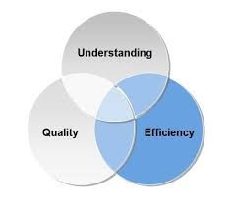
One of the techniques of process analysis includes performing root cause analysis. While examining problems and constraints, for example, the Project Manager should look at what's causing the problem and to move beyond the basic process documents and analyze the data collected and documents. The result of this exercise will allow preventive actions to be developed for similar problems or problems that have similar root causes.

Student Statement:

By submitting this assignment, I confirm that this is my own work.

Student Signature | Raymond Wilson | Date | 05th Dec 2014

For Tutor / Assessor Use Only
Total Marks
Marks Obtained
Percentage / Grade

