
Assignment Cover Sheet

Student Name: | Elizabeth Abidemi Akinlabi
Student Number: | 1380
Course: | Diploma in fashion design
Assignment NO: | 7

Marking Criteria:
We expect the learners to write minimum one well expressed point in three lines against each allocated mark. This means one needs to write 15 lines with 5 well expressed points to get high grades for a 5 marks question.
For high grades use examples and illustrations where appropriate.
Please insert your completed assignment ( in word format) here:

ELIZABETH ABIDEMI AKINLABI
1380
ASSESSMENT 7
PAGE 1

Q. 1 Give short answers to the following questions:

- Which type of materials should be chosen for the dress of a thin person? And when choosing a stripy print which type of stripes would you recommend for the dress of a thin person?

Material that does not cling to the body, like linen and wool would be the best fabric for a thin persons dress. I would recommend horizontal stripes for the dress of a thin person.

- How would you design a dress for a person with large waist and hips? Which designing techniques would you apply?

I would use a soft flowing type fabric, like chiffon, I would take eyes off her large waist and hips by moving the eyes upwards towards her shoulders in an off shoulder boat neck line dress, from the neck to the under bust I would use a lighter colored fabric thereby giving the illusion of a fuller bust, from the waist down to the ankle, I would use a darker color to
ELIZABETH ABIDEMI AKINLABI
1380
ASSESSMENT 7
PAGE 2

make the wearers large waist and hips seem
slender. I would also design a fascinator to draw
attention upwards to the face of the lady.

- ‘A person with a stout figure must never try wearing a dress which is too tight for him/her’. Discuss

First off a person with a stout figure would like to appear lengthier, wearing a dress that is too tight is at a disadvantage for the wearer as this draws eyes to the stoutness of the figure, it is essential to have the eyes sweep up and down and not from left to right, it also makes a much more pleasing silhouette when the lines do not hug the body of a stout person.

- How would you design a dress for a person with round shoulders so this problem is least noticeable?

ELIZABETH ABIDEMI AKINLABI
1380
ASSESSMENT 7
PAGE 3

I would design a dress for a person with round
shoulders so as not to make this problem
noticeable by adding shoulder pads to the
outfit that will give her shoulders a more
balanced look, I can also use 3 dimensional applique on both shoulders to also create the effect of balance. By also designing the dress with set in sleeves and moving the shoulder seam by half an inch backwards, the problem will be masked and the look of the wearer more pleasing.

Q. 2. Activity
Make a collage of the pictures from a magazine, people wearing dresses unsuitable for their figures. For each picture explain how this could have been designed correctly for that person’s figure.

ELIZABETH ABIDEMI AKINLABI
1380
ASSESSMENT 7
PAGE 4

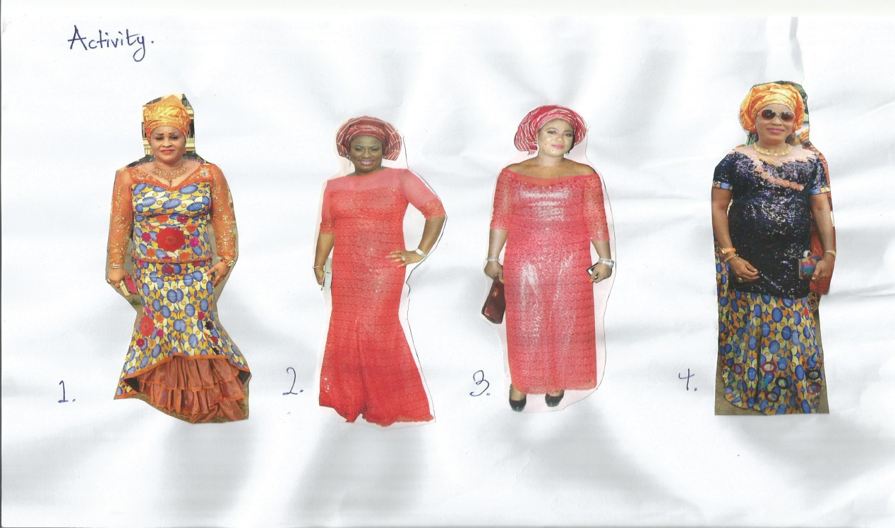

To better explain the designs that I feel would
be suitable for the figure types, I decided to
sketch my ideas.

ELIZABETH ABIDEMI AKINLABI
1380
ASSESSMENT 7
PAGE 5

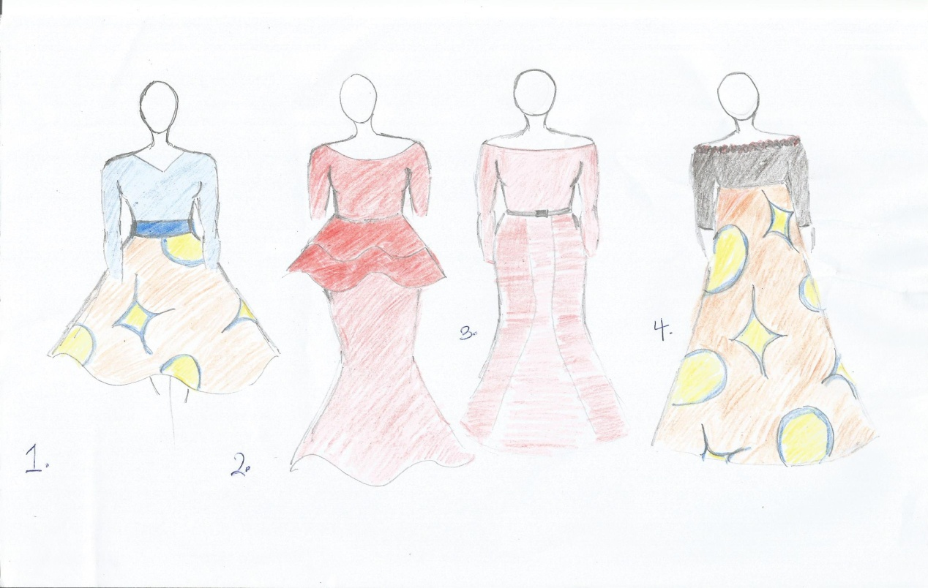

- This first lady has an inverted triangle figure, I would design a blouse with a dark colored material to create the illusion of slender upper body,

ELIZABETH ABIDEMI AKINLABI
1380
ASSESSMENT 7
PAGE 6

the red applique placed in the center of her abdomen, leads the eyes to focus on that part of her body, revealing the fact the she has no waist line, I would use a darker hue of the color of the fabric I used for the top to create a waist band for a full flared skirt, nipping in her waist and making her waist seem much smaller, the flared skirt automatically gives her hips a fullness. I believe the pattern of the skirt should also be larger for added fullness.

- The 2nd lady, with a rectangle figure and a slightly large abdomen, I decided to make her neckline deeper and lengthen her sleeves, I also put a double peplum midriff so as to cover her abdomen and at the same time lend some fullness to her hips, the lightly fitted pencil skirt which flows out at her ankles, worn with the proper heels will elongate her and give her regality. I would also play with the red of the dress, using an ombre effect, to give the slender to fuller effect

ELIZABETH ABIDEMI AKINLABI
1380
ASSESSMENT 7
PAGE 7

- The 3rd lady has round face issues, I recommend a higher head dress to elongate her face, longer sleeves, a darker shade of red would have been much more suitable, the shinny fabric used as the underlining does her a disadvantage and broadens her figure. A division midriff with a slim belt would have been suitable as this would give her a waist, a six piece skirt gently flaring out around the ankles would have also worked for her box like figure.

- The 4th lady has an oval body type with a large abdomen. I chose to show off her shoulders with a beaded off shoulder neckline, this will draw the eyes upwards, I kept the fabric as the shiny sequins adds more volume to her bust, which will compliment the A line skirt because it gently builds out the sides of her figure adding volume to her hips, I would also choose a larger print pattern for more volume as well.

Student Statement:

By submitting this assignment, I confirm that this is my own work.

Student Signature | Elizabeth Abidemi Akinlabi | Date | 04/06/2015

For Tutor / Assessor Use Only
Total Marks
Marks Obtained
Percentage / Grade

