
Assignment Cover Sheet

Student Name: | Christina Kechagia
Student Number: | 1574
Course: | Diploma in Fashion Design
Assignment NO: | 5

Marking Criteria:
We expect the learners to write minimum one well expressed point in three lines against each allocated mark. This means one needs to write 15 lines with 5 well expressed points to get high grades for a 5 marks question.
For high grades use examples and illustrations where appropriate.
Please insert your completed assignment ( in word format) here:

Assessment 5
Q: 1. Give short answers for the following questions:
- What is meant by ‘weight and hand’ in textile industry?
Hand - The way the fabric feels when it is touched. Terms like softness, crispness, dryness, silkiness are all terms that describe the hand of the fabric. A good hand refers to shape retention without stiffness
Textures can also be described as lightweight, medium weight, or heavy weight.

- Name the warm colours. How best these can be used in dress designing?
The warm colours are red, yellow, and orange because of their association with fire and the sun. Warm colours are stimulating, aggressive, and lively.
Red is the colour of love and romance its a popular colour for sportswear and evening wear.
Yellow is bright, sunny, cheerful, friendly, and Optimistic. It is often a difficult colour to wear because it conflicts with many skin tones.
Orange combines the sunniness of yellow and the warmth of red. It can also be a difficult colour to wear: intense orange can be irritating and overpowering and it best toned to a softer peach or apricot or limited to use in active wear.

- Why it is important for a designer to consider the scale of a pattern, when using patterned fabric in dress designing?
The scale of a pattern must complement the design. A large print would dominate a design. To show a large print to its best advantage, it should not be cut up with seams and details, but rather allowed to be the most important element of the garment; construction should be kept simple. On the other hand, if a design idea begins with dominating lines and details, then the fabric must be plain and of secondary importance Pattern can be a large part of how a design looks, and the scale of the pattern should match your scale.

- What is the difference between conventional design and geometric design?

Conventional Design: When an object from nature is adopted to suit the purpose of the object and becomes decorative, the motif ceases to be naturalistic.
Geometric Design: It is not derived from nature. It is derived from circles, rectangle, triangle, parallel lines and so on.

2. Define the term colour dimension. Explain the following terms; Hue, value, intensity
Hue enables us to tell one colour from another, such as red from blue or green
Value refers to the use of darks and lights; it is the variation of light strength in a colour. The value scale runs from white to black. White is pure light, black the total absence of light;
Intensity is the relative brightness (strength) or paleness (weakness) of a colour. Bright colours are considered high-intensity, pale ones low-intensity.

3. Write short note on the following;
Basic Shapes in dress designing

In dress designing there are seven basic shapes
Rectangular. Long, straight, hanging in loose, graceful folds
Triangle. Spanish styles. Fitted bodice, bell shaped gently widening skirt
Inverted Triangle. Wide shoulders, narrow skirt, dolman or raglan sleeves
Oval. Draped and softly molded, very feminine and decorative
Square. Straight or boat shaped neckline, boxy jackets, capes
Round. Wide, crinoline lined skirts, petal shapes, puffed sleeves, Suitable for formal wear or afternoon frock
Hourglass. Wide shoulders, Natural or wasp waist
Combinations. Outline of any current fashion silhouette can be altered and combined with another, and adapted for the specific figure type.

Project 1.
Look through costume books for pictures of an historic dress. Using these inspirations, design a garment using the line, shapes, colours and details from the historic garment in a new combination for our lifestyle.

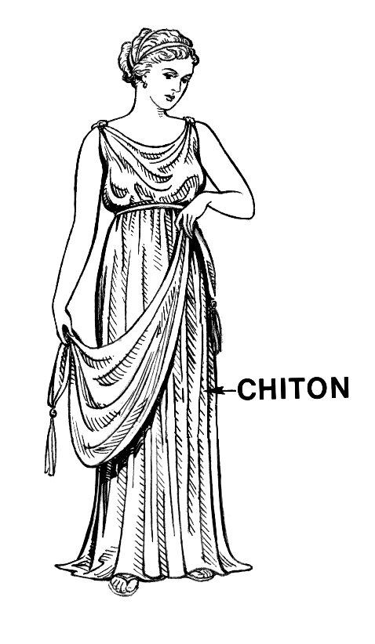

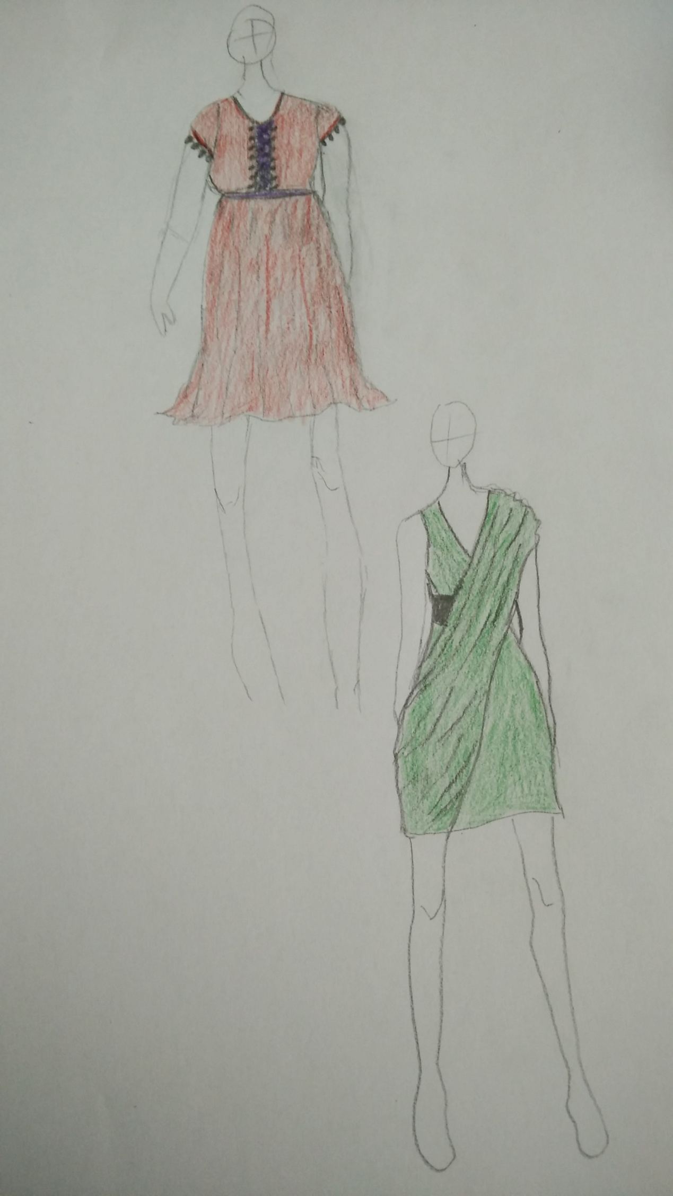

Student Statement:

By submitting this assignment, I confirm that this is my own work.

Student Signature |  | Date

For Tutor / Assessor Use Only
Total Marks
Marks Obtained
Percentage / Grade

