I am pleased to inform you that you have passed assessment 8 by producing excellent work. The work shows that great effort has been put in to it. At the end of the module you have a clear understanding of the followings:
- different types of patterns,
- patterns mixing,
- choosing and buying patterns and using them successfully.
- relationship between colour and texture and
- setting a style through textures and textural contrasts.

Excellent Work: The following questions have been handled brilliantly:
Q: 5
Q: 6
Q: 8
Q: 18
Excellent work: Work Folder & Activities

Well Done
Note: see the correct answer for Q: 12 below:
12 What is the best way of mixing patterns?
Mixing patterns is easy, but making it look good can be a challenge. Follow these easy tips to give your home an effortlessly stylish look.
Colour Plus White
The easiest way to mix patterns is to stick to one colour plus white. The striped panels, floral chair fabric, and geometric floor pillow all stick to the blue-and-white colour scheme.
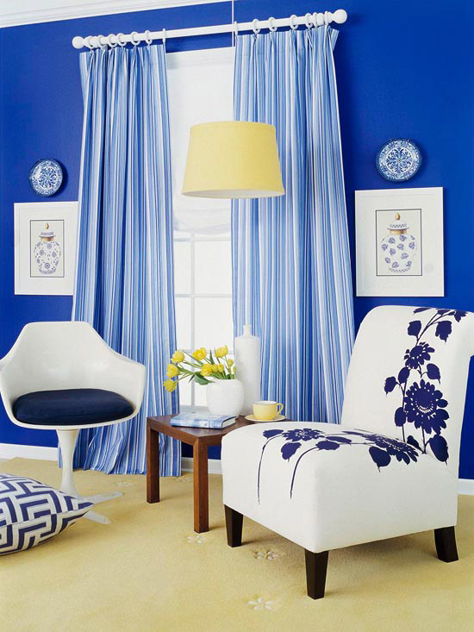
Vary the Scale
Mix and match small and large patterns. Here, the bold flowers on the window shade are a playful contrast to the small stripes of the table runner. These patterns also work well together because both fabrics have the same colour palette.
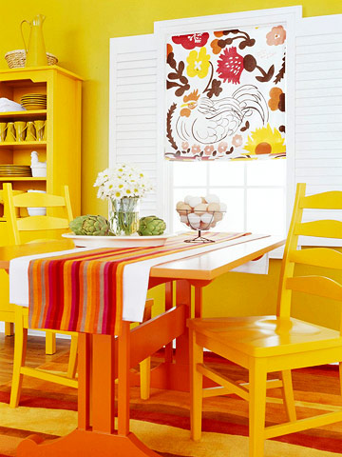
Use Shades and Tints
There's no need to worry about matching when using various shades of a single colour. In this living room, the colour palette goes from black to white, and uses colours in between. The black portiere, antique statues, gray area rug, and white table lamps round out the colour range
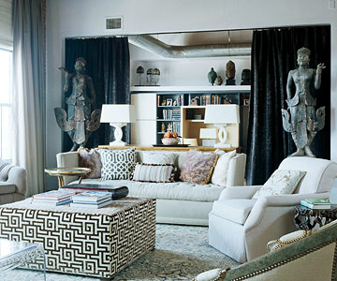
Use Coordinating Colours
An easy way to ensure your patterns will mix is to choose coordinating colours. Red and green are complementary colours because they are directly across from each other on the colour wheel, but moving down one tint to pink adds a fun twist to this colour palette. Yellow and green mix nicely because they share a common hue. Mixing solids and patterns in pink, green, and yellow creates a pleasing colour scheme.
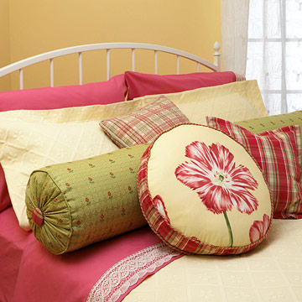

Play with Pattern Size
A good mix should include small-, medium-, and large-scale patterns. In this master bedroom, the largest pattern is on the window panels. Smaller-scale patterns cover the accent pillows. To help the pillows and window treatments coordinate, each fabric has white or black in the pattern.
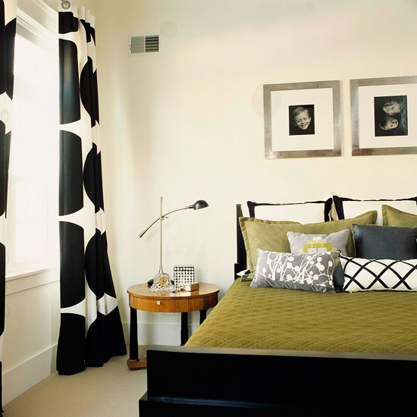
Repeating Element
A living room with three sofas in three different patterns may sound like a mismatch, but this furniture arrangement owes its success to a pattern mix with one common hue: red. The cozy colour appears as the background colour in the floral and striped upholstery and in the accent pillows on the white slip covered sofa.
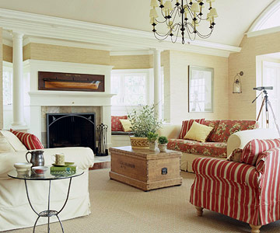
Go Bold
The key to mixing bold patterns is to make sure they share a common colour. In this room, red brings each of these patterns together. The green hue of upholstered chairs connects to the green stems in the painting. A neutral wall colour keeps these eye-popping colours from becoming overpowering.
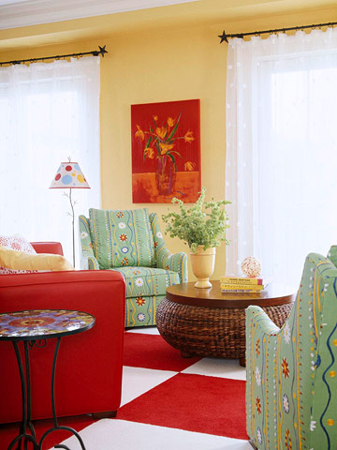
Pattern Play
Stripes and florals are the easiest place to start when mixing patterns, especially when you test the mix on a room's accessories. Layered on top of solid blue walls and an all-white coverlet, the patterned accents in this room are versatile and can be swapped out as the owner's tastes change.
