
Assignment Cover Sheet

Student Name: | John Wozniak
Student Number: | 2725
Course: | Level 4 Diploma in Construction Management
Assignment NO: | Four

Marking Criteria:
We expect the learners to write minimum one well expressed point in three lines against each allocated mark. This means one needs to write 15 lines with 5 well expressed points to get high grades for a 5 marks question.
For high grades use examples and illustrations where appropriate.
1. i. The Environmental Impact Study (EIS) is a development activity or activities outlining the positive and negative effects on local environments. The EIS is carried out at the early phase of development. Many factors must be factored in by site developers including;

- Air Quality – Take the Beijing Olympics 2008 for example. It was widely known that air quality in Beijing was poor and would affect the competing athletes and spectators respectively. The Chine Environmental Monitoring Centre stated the Air Quality Index across the city was measured at 88 - below the 101 the Chinese authorities regard as unsafe, but higher than the World Health Organisation safety limit of 50 (The Guardian 2008).

- Water Quality and Quantity – When considering a site development of any kind considerations must be taken into account as to how that site will receive its water supply. Take Fling, Michigan in the United States for example, the water there is currently unfit to drink and a State of Emergency has been declared (The Guardian 2016). Any developer wishing to invest in the state of Michigan may well chose to avoid Flint until matters improve.

- Noise – Noise pollution is an area where developers will look to mitigate against during development and throughout the project’s lifecycle until demolition. Take the argument with the third runway at Heathrow Airport for example. According to the Heathrow web site (2016) predicted noise reductions will be achieved through a combination of a new runway location, steeper landing approaches and new aircraft technology.

- Energy Supply and Natural Resources Depletion – Developers are looking for ‘greener’ ways to construct and power projects. Logistics Consolidation Centres can reduce CO₂ emissions by consolidating all resources at one location but this is just part of the equation. New developments such as the Aviva Stadium in Dublin was the first to be accredited to certified to ISO50001 standards, meaning a reduction in energy use and carbon emissions (AvivaStadium.ie, 2016).

- Other factors for consideration in the EIS include; Solid Wastes, Radiation from nearby Radioactive-Sources, Hazardous Conditions, Land us in Coastal areas, Neighbourhood character and continuity, Redevelopment in Built-Up areas.

1. ii The basic criterion for judging the suitability of the site for construction is based on the following principles;

- Availability of physical resources. This will differ from geographical location. A construction project in the Nevada Desert, USA is likely to be more constrained than that of a construction project in London where good water and power supplies are readily available. London has excellent access to material supply routes such as airports, railheads, seaports and roads.

- Climatic considerations. Take a construction project in the Arctic or Antarctic circle for example. Weather conditions may have a severe impact on Health and Safety (cold injuries, inability to operate machinery etc.) as well as basic Command and Control functions on the construction site itself. Construction projects in South East Asia will be affected during the Monsoon periods, mitigating facts will have to be factored into the Project Management Plan.

- Physical Factors. Construction projects face many challenges, including ones posed by the land scape, i.e. contour lines. Imagine building a hotel in the Netherlands, where it is relatively flat. Now take that same hotel design and build it at high altitude such as the Himalayas. The contour lines will add to the complexity of the project, not only for construction but for construction supply chains and the workforce in general. Soil quality must also be factored in to the equation, this will identify as to whether or not the soil is contaminated or whether it’s actually suitable for building on in the first instance.

1. iii. Topographic data is a key element to conducting an initially study of a proposed construction site. It can provide planning teams with numerous data sets including;

- Elevation above sea level
- Natural features such as water, gradients of slopes, type of land ie sand, rock etc.
- Scales of measurement
- Polar orientation
- Contour lines
ArcGis.com is an open source topography data toolset. The screenshot below shows the topographic features of Matlock, Derbyshire. Notice the selected area, it is 0.17 Sq Kilometres. 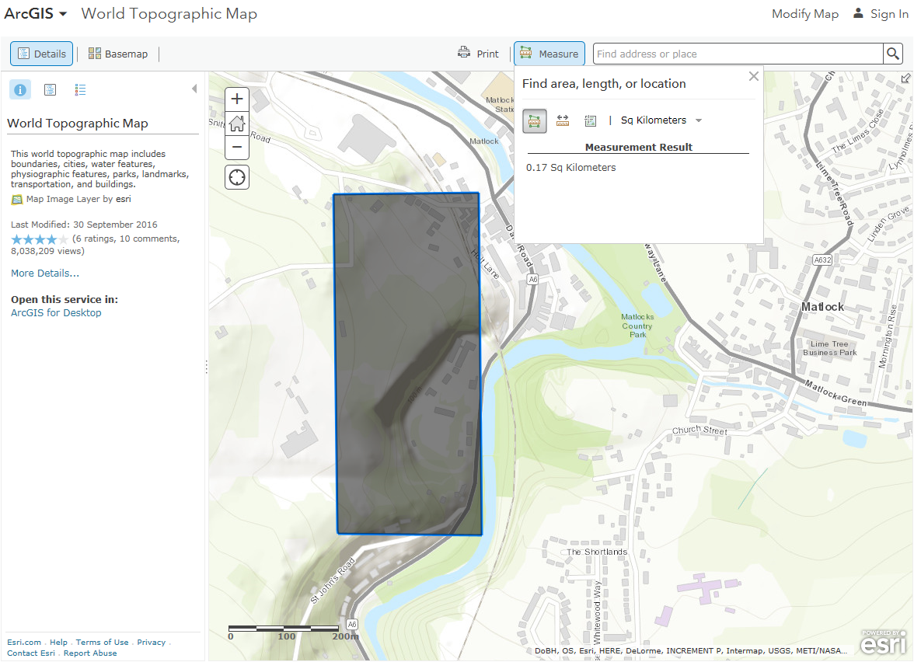

1. iv Ideally all building should be built on firm ground. Depending on the geographical location, a number of factors will have to be taken into consideration. For example in high mountains the risk of landslides will have to be taken into consideration and this will be dependant on their bedding planes and whether or not they are aligned (same direction). Bedding planes and fractures have tendency to move during periods of heavy rain. A construction team in India will face different challenges to those in the European lowlands of Belgium and Holland.

Soil samples will determine engineering properties by drilling holes, thus giving an indication as to the feasibility of construction on that particular site. Soil samples of firm ground will determine a number of factors;
- Susceptibility to erosion
- Depth to bed rock
- Suitability for excavation
- The Water table
If dams are being built the Engineering Geological survey will asses as to whether or not the rock structure is pervious to water.

It is also worth pointing out that projects such as the Palms in Dubai are pushing the envelope of construction, man-made islands are being built in the shallow waters of the ocean. China have also been fastidious in creating man-made islands in the South Pacific, pushing technology and their own territorial claims.

2. They key to the following classifications are the zonal areas. Planners will look to segregate residential areas from industrial areas where possible. It is often the case that commercial and residential areas are co-located.

a) Museum – A museum is classed as D1, a non-residential category. This class covers public services not including in category A (shops and retail outlets).

b) Hospital – A hospital is classed as C2 providing that it is residential. Hospitals can also be classed as D1 if it is not residential.

c) Hotels – Hotels belong to category C1, so long as they are open to the general public.

d) Public Library – A public library belongs to category D1, a non-residential category..

e) Department stores – A department store belongs to category A1, so long as they are visited by the general public.

Student Statement:

By submitting this assignment, I confirm that this is my own work.

Student Signature | John Wozniak | Date | 14 Oct 16

For Tutor / Assessor Use Only
Total Marks
Marks Obtained
Percentage / Grade

