
Assignment Cover Sheet

Student Name: | Mark Aaron
Student Number: | 1832
Course: | Certificate in Coaching and Mentoring (Level 2)
Assignment NO: | Unit 4

Marking Criteria:
We expect the learners to write minimum one well expressed point in three lines against each allocated mark. This means one needs to write 15 lines with 5 well expressed points to get high grades for a 5 marks question.
For high grades use examples and illustrations where appropriate.
Coaching Model
Unit 4

Assessment 4
Q1
- Discuss the four steps of coaching models?
The coaching model is generally flexible depending on the needs of an individual or group but there are four main steps that feature in (or should feature in) most coaching models. Questions such as:
- Where are you now and where do you want to be?
This question alone can help the coach to determine the current ability and future aspiration of the learner and will assist the coach in producing a personal road map for the learner. For example, if the learner wants to be able to drive a car, then the personal road map could look something like this:
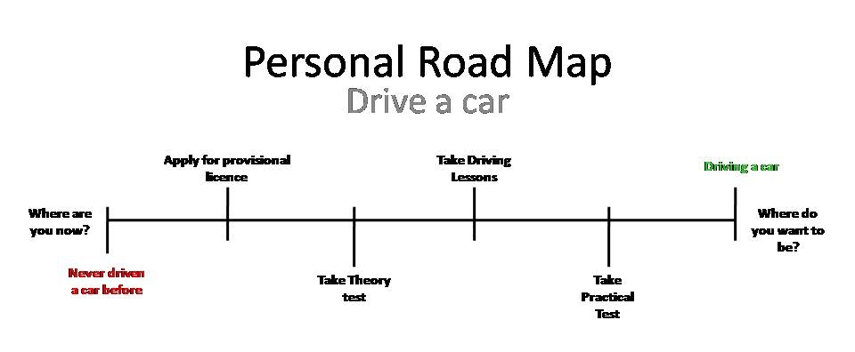
Depending on the individual learner, the coach may need to use probing questions in order to find out where the learner currently is on the learning scale. It may be that the learner has already gained some information about the subject and would therefore be further along on the road map. It is important that the coach recognizes that every learner is different and that flexibility is key when creating a learning programme.

- What are your options?
By having 1-2-1 discussions with the learner it is achievable to reach an agreement about how is best to reach the target or aim. When necessary it may be required for the coach to guide the learner in selecting the best options for them in order to achieve the desired outcome. For example, using the right learning styles will be of benefit to the learning, remembering that everyone learns best in a different way whether it be Visual, Auditory or Kinesthetic as long as the outcomes are the same.
It is also worthy to note that learners learn best when the subject is of interest to them, even if it work related, the coach can assure the learner of the positive benefits that this will have. This will in most cases act as a drive for the learner to succeed as they have been presented with a goal at the end of the learning.

- What steps will you take?
It is important to challenge the learner to be proactive in deciding how they are going to reach their goal, remembering that you are there for guidance and advice but learners will benefit greater when finding answers for themselves. By using ideas like the road map (as above) the learner can create, then follow their own road map in order to achieve their goal with the agreement of the coach. Road maps are literally step by step guides that are taken to reach an end goal and can be added onto at any time if each step needs to be broken down ensuring that a clear understanding of what is being learned has taken place. It is important that a copy of the action plan or road map is kept by both the learner and the coach so that monitoring progress can take place.

- Give feedback and prompt reflection.
An important part of the learner’s journey is for the coach to give positive and meaningful feedback. Positive feedback acts as a catalyst for the learner to continue to be proactive in their learning and outcomes are far more likely to be achieved. Feedback should be done privately and on a 1-2-1 basis. This gives the learner an opportunity to ask questions without feeling any kind of embarrassment and for the coach to prompt the learner to reflect on their progress so far and to agree on an action plan that suits both the learner and coach. Feedback is a good monitoring tool for the coach as it gives a good indication as to where the learner is currently at and where they are heading as well as ensuring that a good coach / learner rapport is sustained.

- What is the importance of feedback in coaching?
Feedback is a two way process where both the learner and coach gather information on the progression of subject. By asking the right questions and using a positive approach will help in ensuring that everything has been done to gain the best possible outcome to both the learner and the coach.
Importance for the learner:
- To gain honest and accurate feedback of their current progress.
- To obtain constructive criticism (if required) in order to improve learning.
- To re-evaluate their action plan / road map if required (make small changes)
- To receive reassurance of how the learning will benefit them in both short term and long term.
Importance for the coach:
- To be able to monitor the learners progression.
- To establish how the learner is coping with the learning.
- To identify potential changes to the way that the learner learns in order to improve outcomes.
- To be able to continue with a good rapport that has been formed between coach and learner.

- What is a balanced feedback?
The use of balanced feedback is to ensure that the learner receives accurate and informative feedback on his/her current learning or performance without using negative monotones from the outset. Starting with some positive attributes about the learner will give them some comfort and they would more likely to take on board any constructive criticism thereafter. It is also worth remembering that any kind of feedback should not be aimed personally at the learner as this may be received in an unfavourable way and would put the coach/learner relationship under undue stress.
There are many ways for a coach to prepare giving feedback including making notes, setting the right environment and speaking in a clear yet sincere manner which portrays that you have a genuine interest in the learners progress.
- What are the key characteristics of constructive feedback?

- In private
Feedback to be given on a 1-2-1 basis to avoid any potential embarrassment and selecting the right environment to hold the meeting are key ingredients in ensuring that privacy is maintained.
- Balanced
Accurate, informative and constructive feedback will help to make feedback more balanced. By being sure to begin any feedback with some positive notes however little they may be in order to put the learner at ease right from the outset of the meeting. People react better to positive feedback and will more likely to try to improve their learning even if this is followed by constructive criticism.
- Relevant
Ensuring that feedback is focussed on the learning that is taking place and recognising what tools or access that the learner has to help them along the way. It is not good practice to expect the learner to produce a good piece of work without giving them access to the learning tools that they require to complete this. It is important that all learning is relevant to both the mentee and to the company and that the feedback should reflect this when providing examples of work/learning undertaken.
- Specific
By being honest and to the point will not only help to bring clarity to what is expected from the learner but will also set the professional benchmark for the work that you do.
For example: “You have chosen not to use the resources that were given to you and this has led to you making mistakes” is direct and to the point whereas “It seems that you didn’t use resources” sounds more like guesswork on your behalf.
- Documented
Being a good coach/mentor requires you to take a hand on approach when working with a learner or mentee. Try to avoid 3rd party feedback if possible and make your own observations in order to ensure that your feedback is based on your own personal findings. Again this will help to build a positive rapport with the learner who will know that you have both honesty and integrity as a skill.
- Personal
Feedback should always be personal where possible so that there can be no misunderstanding as to who the feedback is aimed at. This of course goes for both positive and constructive criticism which is crucial for the development of the learner and by using personal feedback it engages directly with the learner in order to provide the necessary support that may be needed.

Q2 What can you do in the following situations to make your coaching session more effective?
- A staff member will not admit that their behaviour was wrong.
An initial 1-2-1 meeting with the staff member will allow for a discussion to take place, agreeing to listen to the staff member whilst having their say but letting them know that you will be taking notes in order to help you to give accurate feedback.
Sometimes, by reading back to them what they have said often triggers a different response because at the time they may have thought that their actions were correct but by being on the opposite side of the action they may see things differently.
If this does not have the desired outcome, then depending on the seriousness of the behaviour, it is possible to arrange some learning for the staff member in order to understand the importance of correct and positive behaviour and how it affects both themselves personally and also their employer. Relevant courses should be provided to assist the staff member in this as well as buddying up with a good ‘role model’ member of the team in the knowledge that we often learn more from our peers (especially successful ones) than from most manuals.
Finally, if none of the above has any positive impact on the staff member, then informing them of the disciplinary procedure will come into effect.
- Remember – this is done on a 1-2-1 basis throughout and never highlighted in front of clients or other colleagues as it would have a negative impact on everyone involved.

- An employee agrees with what you say, but you feel they are not really committed to change.
It is not so unusual for an employee not to adapt or change to new ideas as they have grown accustomed to the old ones and it is just as important to ‘sell’ your ideas or changes to your employees as well as to the customer.
A good way to do this is to hold an employee workshop, where everyone gets an opportunity to try out, discuss and agree upon your ideas, but most importantly encourage open feedback from your employees to find out the answers to the following questions: What did you like? What didn’t you like? How could you improve this?
By engaging with the employees this gives the coach an opportunity gain an insight into their enthusiasm to new ideas which in turn gives you an opportunity to have 1-2-1 discussions with anyone who you feel does not show the level of enthusiasm that you were hoping for. From these discussions it is possible to ask more probing questions such as the why, where, what & how in order to obtain more detailed feedback. By using this evaluation the coach can put a plan of action together in order to help develop the employees’ knowledge as to why implementing change is a positive step forward for both the business and the employee.

- The individual refuses to accept responsibility. They blame you for not providing enough support and other people for not doing their jobs properly.
In this scenario it would be prudent to hold an immediate 1-2-1 formal meeting with the employee. It is important to inform the employee that the meeting will be documented and details of the meeting may be passed on to relevant personnel.
From this meeting it is important to allow the employee to speak openly in their own words about their grievances, recording specific details in which you can either respond to or seek clarification from another person. Only when they have completed making their statement the coach/mentee/employer should make a measured response ....remembering to ensure that your professionalism is intact and you are seeking to get to the bottom of the issue. It may be possible to challenge the employee with some of their own words that they have used in order to seek clarification of what they meant as it is important that you obtain and understand everything that is being said and the context in which they meant it.
However, there may be a number of factors as to why this situation has arisen and should therefore be dealt with in a considerate and professional manner. For example, the employee may have had recent problems in their personal life that may have affected their behaviour. So it is important that the coach approaches the meeting with an open mind and deal with the facts that are presented rather that making assumptions. It may also be worthy to make notes of the employee’s body language, do they look anxious? Does it look like their minds are elsewhere? Be sure to note down all of your findings when holding 1-2-1 meetings.
Finally, ensure that the company process has been followed as well as being fit for purpose for the session. Ensure that all possible support has been put in place and given to all employees.
Only when all these facts have been discussed and processed can the company decide upon the appropriate action.

Student Statement:

By submitting this assignment, I confirm that this is my own work.

Student Signature | Mark Aaron | Date | 05/07/2016

For Tutor / Assessor Use Only
Total Marks
Marks Obtained
Percentage / Grade

