
Assignment Cover Sheet

Student Name: | Reema Ahmed
Student Number: | 1794
Course: | Diploma in Forensic Accounting
Assignment NO: | Assessment #9

- Short Answers
  - The factors on which fraud risk assessment is dependent on is primarily the knowledge of fraud concepts (fraud triangle, fraud indicators, fraud schemes and accounting information systems) and the consideration of these factors in a fraud environment, such as the timeframe, entity, effectiveness of internal controls, etc. needs to be understood thoroughly. For an effective fraud risk assessment, a continuous and ongoing process is expected.

  - The main concepts of risk assessment are the likelihood of fraud occurrence and the extent of its impact on individuals, and the organization as a whole. Therefore, it becomes of outmost priority to understand the factors in evaluating and managing the risk. Factors can be considered on many levels such entity, people (behavioral), products or services, geographies, divisions, accounting or business processes, controls, or computerizes systems. However, factors are considered first at an entity level. This is because the probability of fraud, embezzlement or theft within the organization is the outcome of the personality of the executive and employees, the working environment, the effectiveness of internal controls and the influence of organizational culture, such as the level of honesty therein. Once the risk assessment process has begun, different perspectives should be examined such as how management incorporates risk management practices.

  - Internal factors that should be considered for fraud risk assessment are namely, the lack of monitoring activities and inadequate controls contribute to the increased probability of fraud and embezzlement. Such controls include the absence of a culture that encourages honesty, inability to set and communicate performance standards, inadequate legal, ethical, fraud detection and security related training, absence of company policies regarding sanctions, failure to provide counsel or take action against questionable behavior, lack of clarity in job roles, accountability, duties and responsibility, and irregular audits, inspections and follow-throughs.

  - Inherent risk is risk that is exposed by an error or omission in financial statements that is likely because of fraud or other factors other than the lack of control within the organization. The inherent risk that is associated with the fraud scheme in question is usually determined by the team or by a particular business process. The factors that need to be considered when measuring this risk includes the industry, strategy, organizational structure and market volatility. Once risk is determined and the relevant factors are considered, the risk can be expressed in percentage form or further expressed by high, medium or low risk.

  - Residual risk determines the organization’s ability to measure and manage risk – so essentially; it is the risk that remains after all controls existing are taken into account. Therefore, it can be calculated by subtracting the level of internal controls used to mitigate risk from inherent risk. The two responses to residual risk are no response or action needed. The risk is assumed as accepted when there is no response. In contrast, if action is needed, preventative measures such as buying insurance should be considered and implemented to mitigate residual risk.

- I’ve chosen to evaluate Toronto Dominion Bank for fraud risk management checklist. Please be advised that all data used to compile this checklist are referenced below.
 | Yes | No | N/A | Ref
1. Does the organization have an adequate level of fraud awareness and are there appropriate policies to minimize fraud risk?
a. Generic risk factors
Has each employee been assigned a maximum ‘‘opportunity level’’ to commit fraud; has management asked itself, ‘‘What is the maximum amount in which this employee might defraud the organization, and does this represent an acceptable risk for each employee”? |  |  | ✔ | Not mentioned in the documents available
Has management asked itself the question, ‘‘Have we ensured that no single employee - or group of employees in collusion - can commit a fraud that would place the organization at imminent risk of collapse?’’; i.e. has a “catastrophic” opportunity level been assigned to each employee? |  |  | ✔ | Not mentioned in the documents available
As per organizational policy, can the management immediately dismiss anyone who has committed fraud? |  |  | ✔ | This hasn’t explicitly been stated, however, the governance section states “The TD Bank Group Financial Crimes and Fraud Risk Management Policy requires employees to act in a proactive and coordinated manner to prevent and detect potential financial crimes and fraud. If we become aware of or suspect any actual, potential or attempted theft, fraud, harm, loss or misuse of TD property, we must immediately notify our manager or other appropriate TD official in order to allow for any corrective action that is appropriate under the circumstances
As per organizational policy, are all frauds reported to the authorities, and do they press charges? | ✔ |  |  | “Irregular business conduct (which includes any criminal, fraudulent or illegal conduct, any impropriety, lack of professional responsibility or dishonesty) will not be tolerated under any circumstances. Such conduct may not only be subject to internal disciplinary action, but may also lead to criminal prosecution, regulatory action or civil suit”.
Have the reasons for all past frauds experienced by the entity been evaluated, and has corrective action been taken? |  |  | ✔ | Not mentioned in the documents I have at hand.
b. Managing individual risk factors by promoting moral behavior and minimizing the motivation to commit fraud
Does the organization’s mission statement include good corporate citizenship (maintaining a good standing in the community) as a goal? | ✔ |  |  | TD’s mission is [to] be the best run, customer-focused, integrated financial institution, with a unique and inclusive employee culture.
Is there a written code of ethical and business conduct? | ✔
Are there ethical and security training programs for new employees and updates for existing ones? | ✔ |  |  | Yes, compliance-training programs need to be completed by both new and existing employees and such programs cover various topics related to consumer protection and business conduct. Please refer to Figure 1 for a chart indicating the programs offered.
Does management set a clear, visible and correct example for other employees by following the mission statement, conforming to the code of ethics and business conduct, and following other organizational policies? |  |  | ✔ | Though this question is hard to answer unless you are an employee of TD, “every employee and director of TD, in every location, every job, at every level, and at all times, is responsible to safeguard the reputation of TD, including by complying with [the] Code”.
Does corporate culture shun unethical behavior such as hostile competitiveness with colleagues, rigid and petty policies, over- centralization of authority, etc.? | ✔ |  |  | TD’s code of conduct highlights the expectation of all employees maintaining courteous and respectful dealings in all business relationships. Lack thereof can be reported via any channel available for escalation.
Does the organization favor individuals of high moral character over unethical people during the hiring process? |  |  | ✔ | Again, I can’t say if this is practiced… however, TD highlights how all people at the bank are willing to meet for a coffee and that the culture at TD is about more than just work.
Are screening procedures such as background checks, psychological tests, drug tests, and lie detector test used for sensitive positions? | ✔ |  |  | TD website mentions that background checks, including references are conducted on everyone being considered for employment.
Are employees with alcohol or drug abuse problems provided counselling by the entity? | ✔ |  |  | An Employee Assistance Program exists that offers confidential third party counselling and referral service for help with a wide range of life events. I have checked yes under the assumption that abuse problems would be included. Please see Figure 2 for a chart illustrating the support programs offered.
Does the organization maintain healthy employee relationships and fair compensation policies including salaries, fringe benefits, promotions, performance appraisals, and severance packages? | ✔ |  |  | See Figure 3.
Are these policies favorable as compared to competitor organizations’ policies and are they successful in deterring fraud and employee disenchantment? |  |  | ✔
Are employee grievances dealt with fairly? | ✔ |  |  | Unpaid leaves are offered.
In order to obtain feedback on its employee relations policies, does the organization conduct exit interviews with employees who are leaving? | ✔
c. Management awareness
Does management seem aware of the possibility of fraud and how it might be committed; i.e. does it see signs of potential fraud such as drug abuse by low-paid employees who suddenly seem to have acquired wealth? | ✔ |  |  | Management is aware of the possibility of fraud and how it might be committed by also undergoing training programs
2. Does the organization have an adequate internal control mechanism?
a. Fraud integral to internal controls
Does the organization’s internal control mechanism express an unambiguous need to prevent fraud? | ✔ |  |  | The Audit committee of the board of directors of TD Bank is responsible for “meeting with management, the Chief Auditor and the shareholders’ auditor to assess the adequacy and effectiveness of the Bank’s internal controls, including controls related to the prevention, identification and detection of fraud”
b. Control over physical and logical access
Does the organization take precautionary fraud prevention measures such as locking doors, desks and cabinets when left unattended, especially in sensitive departments that hold valuable assets and files and documents related to personnel, payroll, cheques, customer and vendor lists, corporate strategies, marketing plans, and research? | ✔ |  |  | Explained on page 17 – 18 in the TD Governance Code of Ethics
As per organizational policy, are passwords and IDs required to access general computers? | ✔ |  |  | Explained on page 17 – 18 in the TD Governance Code of Ethics
Does the computer system require additional access information for sensitive files and applications? For instance, does each user ID have limited access and are there additional requirements such as biometrics, smart cards and temporary PINs for remote access? | ✔ |  |  | Explained on page 17 – 18 in the TD Governance Code of Ethics
Does the organization ensure that access is restricted to those who need it to perform their jobs and prohibit the loaning of keys to or the sharing of passwords with unauthorized employees who do not have access? | ✔ |  |  | Explained on page 17 – 18 in the TD Governance Code of Ethics
Are there additional computer security and electronic surveillance systems for sensitive areas? | ✔ |  |  | Explained on page 17 – 18 in the TD Governance Code of Ethics
Does the organization appear to have sufficient internal controls to an unbiased observer? | ✔
c. Job descriptions
Are job descriptions written and specific in the organization? | ✔ |  |  | All job descriptions have a company overview, department overview, job description, requirements, additional information, hours
Do employees and managers adhere to their job descriptions? |  |  | ✔ | Can’t assume based on information I have available
Is there an organizational chart that reflects and is consistent with employee job descriptions? |  |  | ✔ | Can’t assume based on information I have available
Is there segregation of incompatible duties such as handling cash and other valuable assets, and related records? |  |  | ✔ | Can’t assume based on information I have available
Is there proper segregation of the purchasing function, i.e. ensuring that the same person does not requisition goods and services, approves their payment, and accesses accounts payable? |  |  | ✔ | Can’t assume based on information I have available
Is there duplication of especially sensitive duties? For example, ensuring that cheques worth over a specific amount are double-signed. |  |  | ✔ | Can’t assume based on information I have available
Are annual vacations specified in job descriptions? |  | ✔
Has the process of formulating and specifying job descriptions been integrated with the consideration to prevent fraud? | ✔
d. Regular accounting reconciliations and analyses
Are bank reconciliations carried out for all accounts? | ✔ |  |  | Retail and commercial banking, wholesale banking, etc.
Are accounts receivable being reconciled month to month, and general ledger to sub-ledger |  |  | ✔ | Information not provided on the documents available.
Are accounts payable being reconciled month to month, and general ledger to sub-ledger? |  |  | ✔ | Information not provided on the documents available.
Is there variance analysis of general ledger accounts such as budget to actual and current year to previous year? | ✔
Is there vertical analysis of profit and loss accounts i.e. profit/loss as a percentage of sales, and against historical or budgeted amounts? | ✔ |  |  | Explained under financial results overview in the annual report of 2015
Has there been a detailed analysis of sales and major expenses by product line and geographic territory? | ✔
e. Supervision
Are supervisors and managers aware of fraud indicators and are they alert when an unusual event occurs or when a supplier or customer complains about their accounts? | ✔
Do supervisors and managers diligently carry out employee performance reviews by conducting account reconciliations and even (where appropriate and required) asking the employee to re-perform the task? |  |  | ✔ | Information not provided on the documents available.
For smaller businesses where segregation of tasks and duties is not possible, do managers closely supervise the work being performed by employees to compensate for the lack of division of labour? |  |  | ✔ | Information not provided on the documents available.
Are instances of management override, i.e. when supervisors or managers take charge of, alter, or interfere in subordinates’ work, prohibited and are others aware of it as a fraud indicator? |  |  | ✔ | Information not provided on the documents available.
f. Audit
Does the organization have an internal audit function? | ✔ |  |  | “The Committee shall oversee the internal audit division of the Bank and any aspects of the internal audit function that are outsourced to a third party.”
Does the internal audit function regularly monitor and perform checks to ensure the effective performance and maintenance of fraud prevention mechanisms? | ✔ |  |  | One of the jobs of TD’s internal audit committee is to “oversee the effectiveness of internal controls, including internal controls over financial reporting”. Internal controls include reviewing management’s reports related to the establishment and maintenance of an adequate and effective internal control system and processes (including controls related to the prevention, identification and detection of fraud).
Are external audits performed regularly, i.e. quarterly in large organizations? | ✔
Do external auditors receive the full cooperation of the management through the audit committee during audits and especially during fraud investigations? | ✔ |  |  | One of the main responsibilities of the committee as indicated on the charter is to listen to the external auditors; therefore, it is safe to assume that full cooperation of the management is received.
3. Has the organization addressed the following fraud prevention issues?
Promoting an ethical environment | ✔ |  |  | As mentioned in TD’s corporate responsibility report, “strong governance remains a priority... As a leading financial institution, we understand people expect more from us. So our commitment to them is to do the right thing to the highest ethical standards. How we behave as an organization is enormously important to us, including the open and transparent ways in which we communicate with our employees, customers, shareholders and the public overall. We know it’s up to us to continually look for ways to elevate our performance — all the while, remaining accountable to the public.”
Risk financing | ✔ |  |  | “TD applies anti-corruption and anti-fraud controls to activities that are known to be susceptible to criminal activity or have been designated as being at high risk for money laundering or financing of terrorism”.

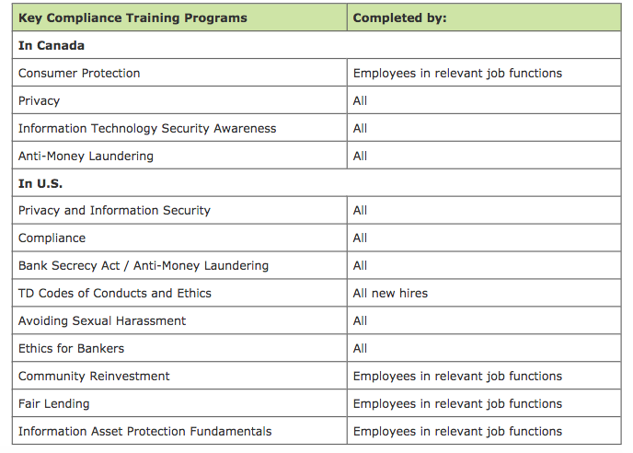
Figure 1: Compliance-Training Programs
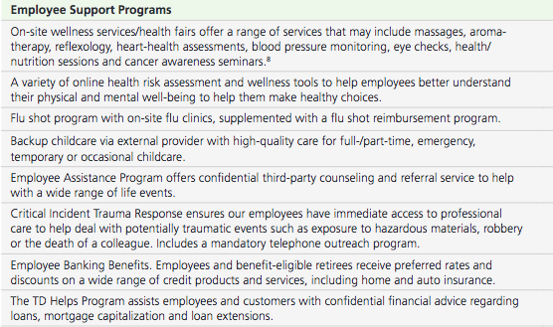
Figure 2: Support Programs Offered
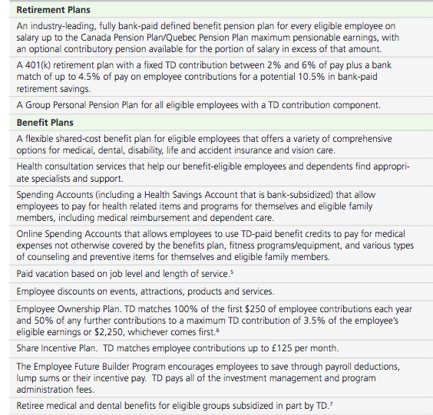
Figure 3: Employee Benefits

References
AUDIT COMMITTEE OF THE BOARD OF DIRECTORS OF THE TORONTO-DOMINION BANK. (2015). 1st ed. [ebook] Available at: http://www.td.com [Accessed 10 Sep. 2016].
Code of Conduct and Ethics for Employees and Directors. (2016). [online] Available at: http://www.td.com [Accessed 10 Sep. 2016].
Corporate Responsibility Report and Public Accountability Statement. (2010). [online] Available at: http://www.td.com/ [Accessed 10 Sep. 2016].
Corporate Responsibility Report. (2008). How are we making a difference?. [online] Available at: http://www.td.com [Accessed 10 Sep. 2016].
Corporate Responsibility Report. (2009). Providing a safe and secure banking experience and protecting privacy at all times. [online] Available at: http://www.td.com [Accessed 10 Sep. 2016].
Overview of Benefits for TD Employees. (n.d.). [online] Available at: http://www.td.com [Accessed 10 Sep. 2016].

Student Statement:
By submitting this assignment, I confirm that this is my own work.

Student Signature | Reema Ahmed | Date | September 10, 2016

For Tutor / Assessor Use Only
Total Marks
Marks Obtained
Percentage / Grade

