
Assignment Cover Sheet

Student Name: | Annur Zara Liyana Othman
Student Number: | 1227
Course: | Diploma of Fashion Design
Assignment NO: | 9

Student Statement:

By submitting this assignment, I confirm that this is my own work.

Student Signature | 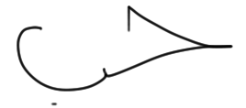 | Date | 1st July 2014

For Tutor / Assessor Use Only
Total Marks
Marks Obtained
Percentage / Grade

Choosing the Right Material
Assessment 9
Q: 1: Write short notes on the following topics:

a) Engraved roller printing
Printing is used to apply design or pattern to fabrics. There are three basic printing techniques: engraved- roller printing, screen-printing, and heat transfer printing.
Engraved roller printing
Engrave roller printing also called as Roller Printing. It is a modern continuous printing technique. In this method, a heavy copper cylinder (roller) is engraved with the print design by carving the design into the copper. Copper is soft, so once the design is engraved, the roller is electroplated with chrome for durability. This printing technique developed in the late 19th and early 20th centuries. Until the development of rotary screen-printing; it was the only continuous technique. Designs with up to 16 colors present that no problem in Roller Printing. The main parts of Engraved roller printing are color doctor, lint doctor, blankets, back grey, furnishers, colour box tray, and color unit. This machine has a main cylinder that is fitted with a large gear. In this printing, the print paste is supplied from reservoirs to rotating copper rollers, which are engraved with the desired design. These rollers contact a main cylinder roller that transports the fabric. By contacting the rollers and the fabric the design is transferred to the fabric. As many as 16 rollers can be available per print machine, each roller imprints one repeat of the design. As the roller spins, a doctor blade in continuous mode scrapes the excess of paste back to the colour trough. At the end of each batch the paste reservoirs are manually emptied into appropriate printing paste batch containers and squeezed out. The belt and the printing gear (roller brushes or doctor blades, squeegees and ladles) are cleaned up with water.
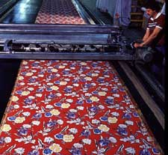

Example of Engraved Roller Printing.

b) Flat- bed screen printing
Screen printing is by far the most popular technology in use today. Screen printing consists of three elements: the screen which is the image carrier; the squeegee; and ink. The screen printing process uses a porous mesh stretched tightly over a frame made of wood or metal. Proper tension is essential for accurate color registration. The mesh is made of porous fabric or stainless steel. A stencil is produced on the screen either manually or photochemical. The stencil defines the image to be printed in other printing technologies this would be referred to as the image plate.
In flat bed screen-printing, this process is an automated version of the older hand operated silkscreen printing. For each color in the print design, a separate screen must be constructed or engraved. If the design has four colors, then four separate screens must be engraved. The modern flatbed screen-printing machine consists of an in-feed device, a glue trough, a rotating continuous flat rubber blanket, flatbed print table harnesses to lift and lower the flat screens, and a double-blade squeegee trough. The in-feed device allows for precise straight feeding of the textile fabric onto the rubber blanket. As the cloth is fed to the machine, it is lightly glued to the blanket to prevent any shifting of fabric or distortion during the printing process. The blanket carries the fabric under the screens, which are in the raised position. Once under the screens, the fabric stops, the screens are lowered, and an automatic squeegee trough moves across each screen, pushing print paste through the design or open areas of the screens. Remember, there is one screen for each color in the pattern. The screens are raised, the blanket precisely moves the fabric to the next color, and the process is repeated. Once each color has been applied, the fabric is removed from the blanket and then processed through the required fixation process. The rubber blanket is continuously washed, dried, and rotated back to the fabric in-feed area. The flatbed screen process is a semi-continuous, start-stop operation. Flat screen machines are used today mostly in printing terry towels. Flatbed screen printing is versatile but expensive.
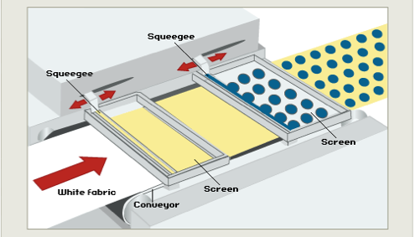
Example of Flat-bed Screening Printing process.
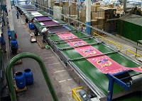

Example of Flat-bed Screening work done in the factory.

c) Rotary screen printing
In basic operation, rotary screen and flat screen-printing machines are very similar. Both use the same type of in-feed device, glue trough, rotating blanket (print table), dryer, and fixation equipment. The process involves initially feeding fabric onto the rubber blanket. As the fabric travels under the rotary screens, the screens turn with the fabric. Print paste is continuously fed to the interior of the screen through a color bar or pipe. As the screen rotates, the squeegee device pushes print paste through the design areas of the screen onto the fabric. As in flat-bed screen printing, only one color can be printed by each screen. After print application, the process is the same as flat screen printing. By converting the screen-printing process from semi-continuous to continuous, higher production speeds are obtained. Initially, no continuous patterns such as stripes were available with this method due to the seams in the rotary screens. However, with the development of seamless screens, continuous patterns such as linear stripes or plaids became possible. Rotary screen machines are more compact than flat screen machines for the same number of colors in the pattern. Therefore, they use less plant floor space.
Also with rotary screens, the size of the design repeat is dependent upon the circumference of the screens. This was initially seen as a disadvantage, because the first rotary screens were small in diameter. However, with today’s equipment, screens are available in a range of sizes and are no longer considered design limited. The fact is that today’s rotary screen machines are highly productive, allow for the quick changeover of patterns, have few design limitations, and can be used for both continuous and discontinuous patterns. Estimates indicate that this technique controls approximately 65% of the printed fabric market worldwide. The principle disadvantage of rotary screen-printing is the high fixed cost of the equipment. The machines are generally not profitable for short yardages of widely varying patterns, because of the clean up and machine down time when changing patterns. Flat screen-printing is much more suitable for high pile fabrics, because only one squeegee pass is available with rotary screen. However, rotary machines are used for carpet and other types of pile fabrics.

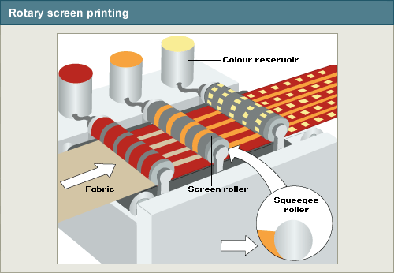

Rotary screen-printing process
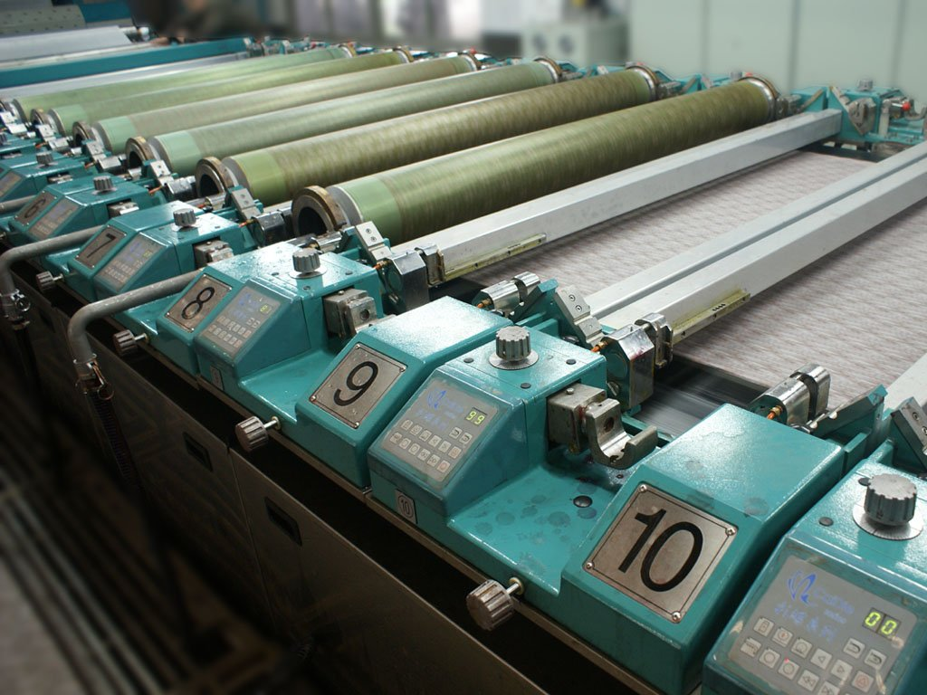

Example of Rotary Screen Printing done in the factory

Q: 2: What is the difference between weft knitting and warp knitting?
Knitting can be refers as the method of creating fabric by transforming continuous strands of yarn into a series of interlocking loops, each row of such loops hanging from the one immediately preceding it. The basic element of a knit fabric structure is the loop intermeshed with the loops adjacent to it both sides and above and below it.
In the simplest form, a knit fabric is made by the longitudinal and vertical repetition of the same element, the loop, which is the basic element of the fabric. The loop is a length of yarn that is forced to assume a curvilinear shape. It can be divided into three main sections. Knit fabrics are mainly categorized into two types respectively Weft Knitting and Warp Knitting. The horizontal or vertical repetition of loops forms the typical structures of knit fabrics, which can be divided into Weft Knit Fabric and Warp Knit Fabric.

Weft Knitting
In a weft knitted structure a horizontal row of loops can be made using one thread and the thread runs in horizontal direction.

Warp Knitting
In a warp knitted structure, each loop in the horizontal direction is made from a different thread and the number of threads used to produce such a fabric is at least equal to the number of loops in a horizontal row. One can say that in a warp knitted fabric the threads run roughly in a vertical direction.

The other differences between these two types of knitting are:

Warp Knitting | Weft Knitting
The loops are produced to the length of fabric. | The loops are produced to the width of the fabric.
It is elastic to the length. | It is elastic to the width.
Elasticity of the warp knitted fabrics is less than weft knitting. | Elasticity of the weft knitted fabrics is higher than warp knitting.
Its shrinkage properties are less. | Its shrinkage properties are higher than wrap knitted fabrics.
Here courses are needed for each pattern row. | Courses are equal to the pattern.
Yarns are supplied from beam. | Yarns are supplied from cone.
At least one yarn is required for each needle. | Any number of needles.
Creating fabric by this method is suitable to dry wash. | Hand wash is suitable for weft knitting.
Any design is done easily. | All types of design are complex.
It is especially suitable for producing coarse fabric. | It is suitable for producing thin fabric.
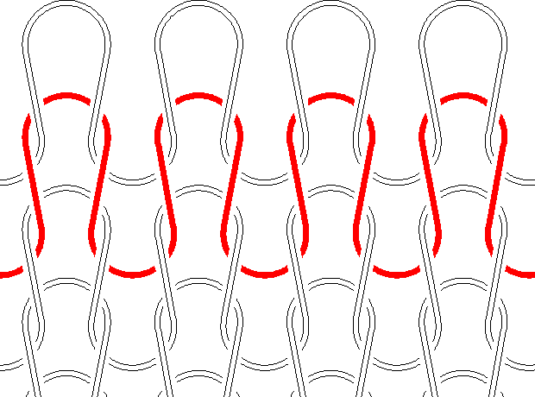

Weft Knitting
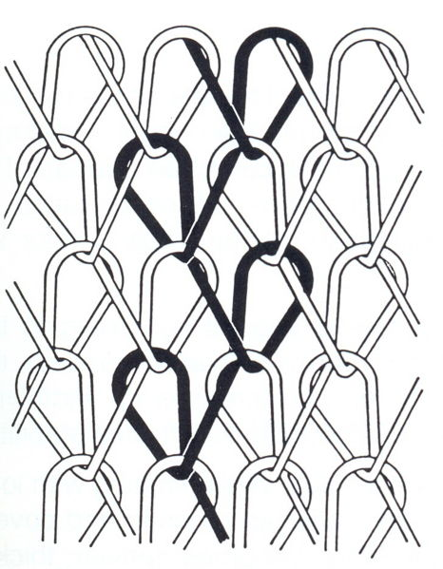

Warp Knitting

Activity

1. Examine the fibre content labels in the clothes in your wardrobe. How many garments are made from natural fibres? How does the fibre content affect the care of the garments?

Natural Fibres
The most important natural fibres are flax, wool, cotton, and silk. Others are ramie, jute, sisal, and hemp. All of these are derived from either animals or vegetables. Used for thousands of years, they are still considered the most luxurious fibres. For beauty, nothing can compare with natural fibres.

There are two type of natural fibres that I used the most.

Cotton

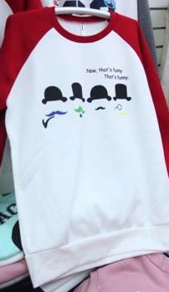
This is a cotton T shirt. The fabric a little stretchable. Based on the information given, cotton is washable and durable, holding up well after many launderings. But because it has little elasticity or resilience, it wrinkles easily. (However, wrinkle- resistant finishes have been created that make cotton easier to care for). Cotton absorbs dyestuffs easily to produce a wide range of vivid colours.
The Care for cotton cloth is very easy and I can be wash by washing machine. The fabric became stretch after wearing it but easily go back to original shape after washing it.

Wool
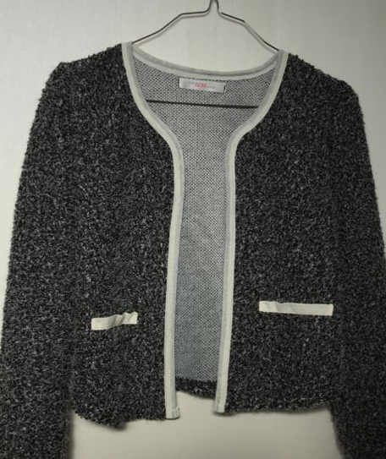

This a thin wool Jacket. The surface gives a very good feeling when you touch it. Wool fabric is kind of expensive and the care id much harder than cotton. It should be dry cleaning only. I normally separated this jacket to the other clothes. It did not wrinkle easily and it also so warm to wear.

2. Visit a local fabric store and find examples of a plain weave, a twill weave, a satin weave, and a non woven fabric. Collect swatches of each type.

a) Plain weave

A plain weave is the simplest, most common weave. The warp and filling yarns alternately
pass over and under each other.
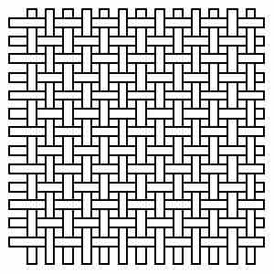
Plain Weave
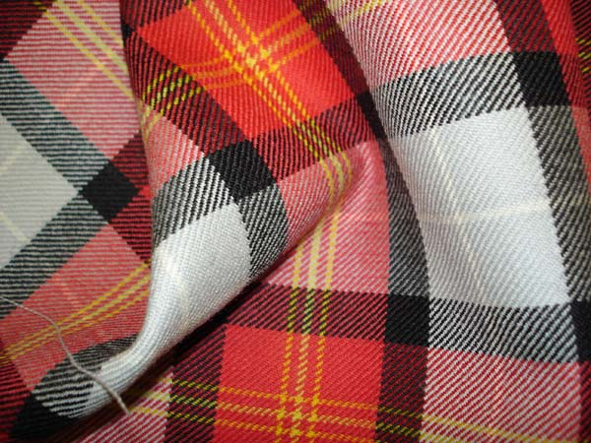
This is an example of a fabric made using plain weave technique.
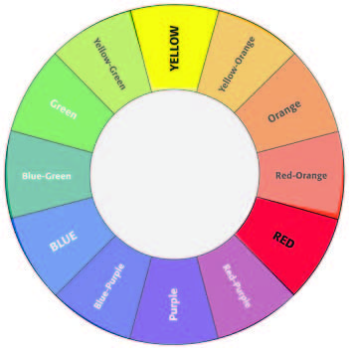
The colours used for this fabric were Red, Yellow, grey and black.
b) Twill weave
In twill weave, the filling yarn passes over a number of warp yarns before going under one. The same pattern is repeated row after row, but each time the repetition begins on the next warp yarn, creating a diagonal weave. The resulting fabric is very durable.
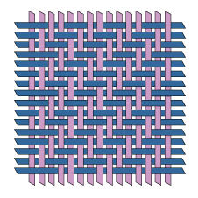
Twill Weave

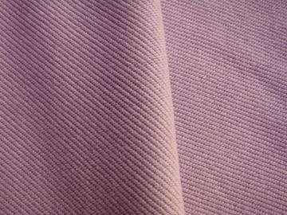
This is an example of twill weave technique on a polyester fabric.
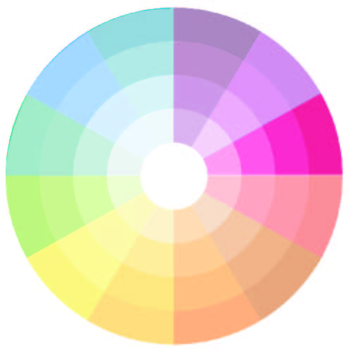
The colour used for this fabric was tint red or called pink.
c) Satin weave
A satin weave is achieved by one warp yarn crossing over several filling yarns, creating floats on the face side of the fabric. The floats give the fabric lustre and smoothness.
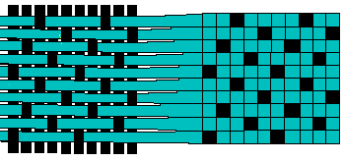
Satin Weave
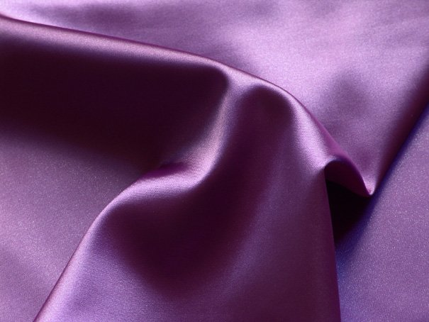
This is an example of satin weave on a fabric. It gives smoothness for eye and hand

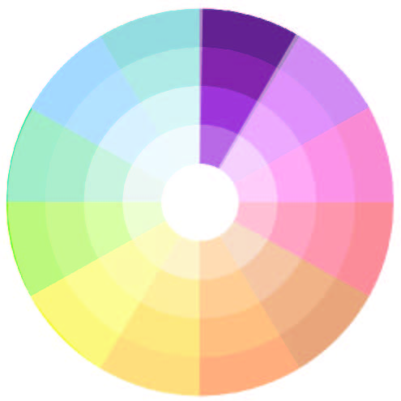
The colour used was purple.

d) Non-woven fabric
Nonwoven (or engineered) fabrics are made by either bonding or interlocking fibres, filaments, or yarns into a web or sheet by mechanical (pressure), chemical, thermal (heat), or solvent means. Examples of such fabrics include nonwoven interfacings such as Pelion. Felting is a process for making matted fabrics, such as nonwoven felt. Nonwoven fabric production usually includes four stages:
- Fibre preparation
- Web formation
- Web bonding
- Post treatment
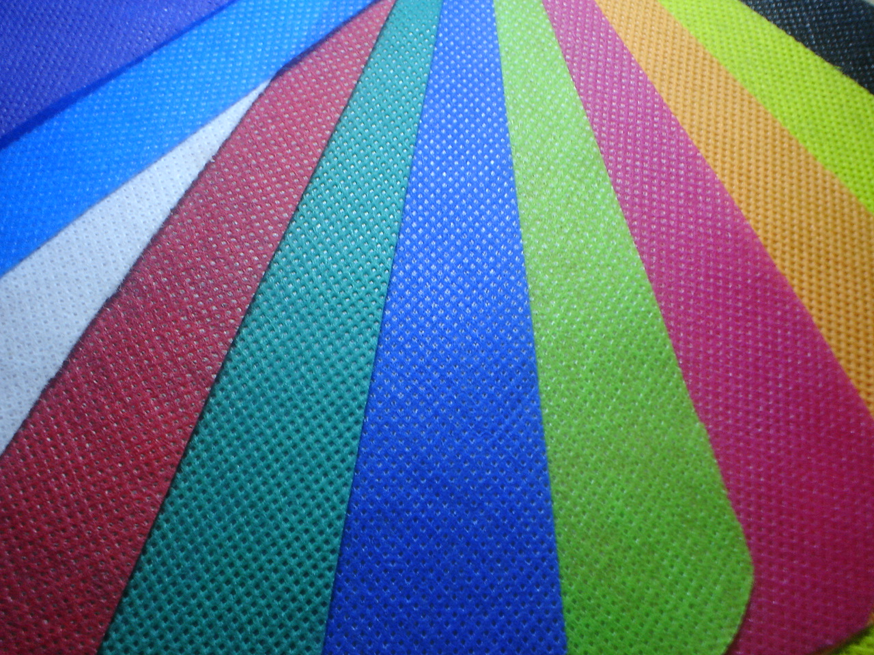
Example of non-woven fabric. This fabric constitute one of the fastest growing segments of the textile industry. It can in any colour. Non-woven fabric normally are used for bag or other thing and not suitable for making garment.
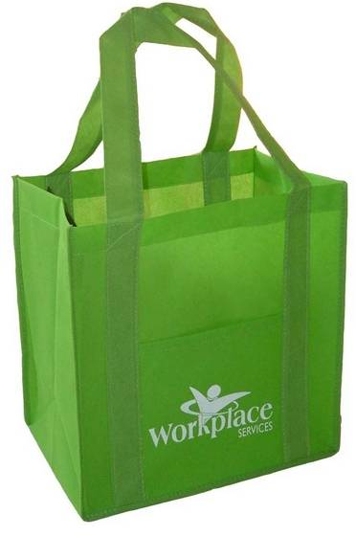
Example the usage of non woven fabric to make a shopping bag.
Reference
Information: BOLC Unit 8 note, Fashion textile Lecturer at Hongik University South Korea- Miss. JooEun Park, Fabric stores, Fashion website, Fashion blog.
Picture: Fashion magazines offline and online, Fashion books, Google Images.

