
Assignment Cover Sheet

Student Name: | Phelim Kakulunda
Student Number: | 1800
Course: | Certificate in Project Management (Level 1)
Assignment NO: | 1

Marking Criteria:
We expect the learners to write minimum one well expressed point in three lines against each allocated mark. This means one needs to write 15 lines with 5 well expressed points to get high grades for a 5 marks question.
For high grades use examples and illustrations where appropriate.
1. What is a project? How do projects differ from routine work?
A project is a temporary endeavor undertaken to create a unique product, service, or result. An Example being “The Financial Manager prepares quarterly Financial Reports.” Furthermore it’s an endeavor that requires an organized set of work efforts that are planned in a level of detail that is progressively elaborated as more information is discovered.
Projects differ from routine work because a project is mainly a planned set of interrelated tasks to be executed over a fixed period and within certain cost and other limitations, i.e. a week or month. Whereas routine work is just the normal work that is done on a regular basis
2. What are five process groups in Project Management?
The Five process of project management are;
Initiating, this involves the processes, activities, and skills needed to effectively define the beginning of a project. Setting all permits, authorizations, and initial work orders in place to secure an effective and logical progression of initial project activities sets the stage for subsequent success throughout all project phases. Setting clear phases for work to be completed, initializing teams, and having the budget in place before work begins are vital for a strong start to any project across industry.
Planning, sets forth the processes needed to define the scope of the project, set strategic plans in place to maximize workflow, and begin to assemble priority lists and plan team needs. This process group also addresses a more narrow clarification of all project goals and expectations and puts in place the project infrastructure necessary to achieve those goals according to the timeline and budgetary constraints.
Executing; this involves managing teams effectively while orchestrating timeline expectations and reaching set goals. Project managers using this set of skills will demonstrate a high degree of organization and communication skills while addressing team concerns or other complex situations associated with getting the work done on time and within budget.
Monitoring and Controlling; Processing change orders, addressing on-going budget considerations, and mitigating unforeseen circumstances that may affect a team’s ability to meet initial project expectations are all part of the core skills and competencies involved in the monitoring process. Seasoned managers keep the momentum moving forward and guard the project against stalling by actively monitoring progress and using foresight and quick response to address project challenges
Closing; this is bringing a project to a successful close on time and within budget. The closing process addresses the culmination of strong project management skills demonstrated throughout the other interrelated processes that guided the project. Following through to close all aspects of the process and submitting necessary paperwork on time is just as important as all other skills and processes. Good closure brings great reviews and can increase future word of mouth referrals.
3. Name nine knowledge areas of Project Management.
The nine knowledge areas of Project Management are;
- Project Integration Management.
- Project Scope Management.
- Project Time Management.
- Project Cost Management.
- Project Quality Management.
- Project Human Resource Management.
- Project Communications Management.
- Project Risk Management.
- Project Procurement Management.
4. Outline key responsibilities of a project Manager.
Some of the key responsibilities of a project manager comprise of the following:
- Planning and Defining Scope
- Activity Planning and Sequencing
- Resource Planning
- Developing Schedules
- Time Estimating
- Cost Estimating
- Developing a Budget
- Documentation
- Creating Charts and Schedules
- Risk Analysis
- Managing Risks and Issues
- Monitoring and Reporting Progress
- Team Leadership
- Strategic Influencing
- Controlling Quality.
5. Define the project lifecycle and explain its phases?
The project manager and project team have one shared goal: to carry out the work of the project for the purpose of meeting the project’s objectives. Every project has a beginning, a middle period during which activities move the project toward completion, and an ending (either successful or unsuccessful). A standard project typically has the following five major phases (each with its own agenda of tasks and issues): initiation, planning, execution, monitoring and controlling and closure. Taken together, these phases represent the path a project takes from the beginning to its end and are generally referred to as the project “life cycle.”

INITIATION PHASE
During the first of these phases, the initiation phase, the project objective or need is identified; this can be a business problem or opportunity. An appropriate response to the need is documented in a business case with recommended solution options. A feasibility study is conducted to investigate whether each option addresses the project objective and a final recommended solution is determined. Issues of feasibility (“can we do the project?”) and justification (“should we do the project?”) are addressed.
Once the recommended solution is approved, a project is initiated to deliver the approved solution and a project manager is appointed. The major deliverables and the participating work groups are identified, and the project team begins to take shape. Approval is then sought by the project manager to move onto the detailed planning phase.

PLANNING PHASE
The next phase, the planning phase, is where the project solution is further developed in as much detail as possible and the steps necessary to meet the project’s objective are planned. In this step, the team identifies all of the work to be done. The project’s tasks and resource requirements are identified, along with the strategy for producing them. This is also referred to as “scope management.” A project plan is created outlining the activities, tasks, dependencies, and timeframes. The project manager coordinates the preparation of a project budget by providing cost estimates for the labor, equipment, and materials costs. The budget is used to monitor and control cost expenditures during project implementation.
Once the project team has identified the work, prepared the schedule, and estimated the costs, the three fundamental components of the planning process are complete. This is an excellent time to identify and try to deal with anything that might pose a threat to the successful completion of the project. This is called risk management. In risk management, “high-threat” potential problems are identified along with the action that is to be taken on each high-threat potential problem, either to reduce the probability that the problem will occur or to reduce the impact on the project if it does occur. This is also a good time to identify all project stakeholders and establish a communication plan describing the information needed and the delivery method to be used to keep the stakeholders informed.
Finally, you will want to document a quality plan, providing quality targets, assurance, and control measures, along with an acceptance plan, listing the criteria to be met to gain customer acceptance. At this point, the project would have been planned in detail and is ready to be executed.

EXECUTION PHASE
During the third phase, the execution phase, the project plan is put into motion and the work of the project is performed. It is important to maintain control and communicate as needed during implementation. Progress is continuously monitored and appropriate adjustments are made and recorded as variances from the original plan. In any project, a project manager spends most of the time in this step. During project execution, people are carrying out the tasks, and progress information is being reported through regular team meetings. The project manager uses this information to maintain control over the direction of the project by comparing the progress reports with the project plan to measure the performance of the project activities and take corrective action as needed. The first course of action should always be to bring the project back on course. Throughout this step, project sponsors and other key stakeholders should be kept informed of the project’s status according to the agreed-on frequency and format of communication. The plan should be updated and published on a regular basis.
Status reports should always emphasize the anticipated end point in terms of cost, schedule, and quality of deliverables. Each project deliverable produced should be reviewed for quality and measured against the acceptance criteria. Once all of the deliverables have been produced and the customer has accepted the final solution, the project is ready for closure.
MONITORING AND CONTROLING PHASE
This is all about measuring project progression and performance and ensuring that everything happening aligns with the project management plan. Project managers will use key performance indicators to determine if the project is on track. A project manager will typically use key performance indicators to measure project performance:
- Project Objectives: Measuring if a project is on schedule and budget is an indication if the project will meet stakeholder objectives.
- Quality Deliverables: This determines if specific task deliverables are being met.
- Effort and Cost Tracking: Project Managers will account for the effort and cost of resources to see if the budget is on track. This type of tracking informs if a project will meet its completion date based on current performance.
- Project Performance: This monitors changes in the project. It takes into consideration the amount and types of issues that arise and how quickly they are addressed. These can occur from unforeseen hurdles and scope changes.
During this time, Project Managers may need to adjust schedules and resources to ensure the project is on track

CLOSING PHASE
During the final closure, or completion phase, the emphasis is on releasing the final deliverables to the customer, handing over project documentation to the business, terminating supplier contracts, releasing project resources, and communicating the closure of the project to all stakeholders. The last remaining step is to conduct lessons-learned studies to examine what went well and what didn’t. Through this type of analysis, the wisdom of experience is transferred back to the project organization, which will help future project teams.
Below is a diagram illustrating the project life cycle.
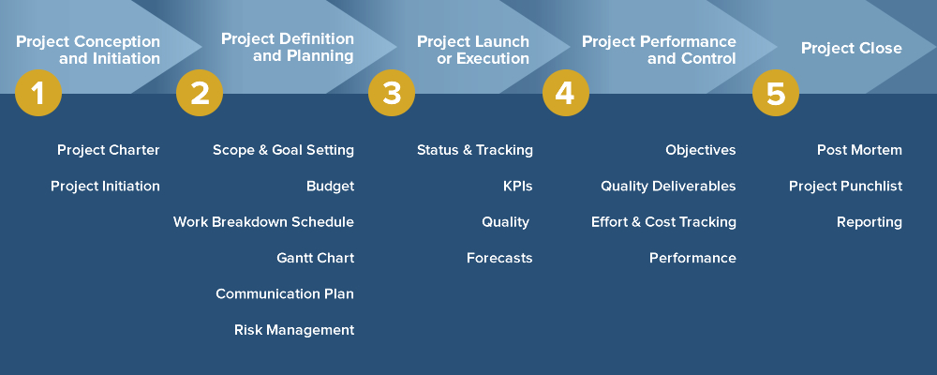

Student Statement:

By submitting this assignment, I confirm that this is my own work.

Student Signature | Phelim Kakulunda | Date | 4/05/2016

For Tutor / Assessor Use Only
Total Marks
Marks Obtained
Percentage / Grade

