
Assignment Cover Sheet

Student Name: | Aleksandar Vasilic
Student Number: | 3226
Course: | Diploma in Forensic Accounting
Assignment NO: | Assessment 9 - Fraud Risk Assessment

Marking Criteria:
We expect the learners to write minimum one well expressed point in three lines against each allocated mark. This means one needs to write 15 lines with 5 well expressed points to get high grades for a 5 marks question.
For high grades use examples and illustrations where appropriate.
1. Give short answers for the following questions:
i. Outline the factors on which fraud risk assessment depends.

Probability (the likelihood of an event occurring) and impact (the magnitude of the event) form the foundation of risk assessment. Although these concepts are fairly simple, their application is difficult. Several questions must be answered: Which factors should be considered? How might risk be measured precisely? Which tools will help in risk assessment? Risk assessment factors can be considered on different levels such as entity, behavioural, products and services, geography, divisions, accounting and business processes, controls, computerized systems, etc.
Usually, factors are initially considered at the entity level because fraud, embezzlement or theft can only be successful with the combination of executive and employee personalities, working environment, organizational culture and internal controls. After the process is initiated, different perspectives, such as the ability of management to incorporate risk management practices, should also be examined.
- Corporate Environment Factors According to the Association of Certified Fraud Examiners (ACFE) 2008 Report to the Nation (RTTN), when its members were surveyed regarding resolved frauds, it was revealed that 959 cases had been reported. One of the statistics concerned the industries represented in these cases. Some industries and organizations are more vulnerable to theft, fraud and embezzlement than others. While ACFE statistical results show the industries that need to hire Certified Fraud Examiners (CFE), they may also indicate different industries’ susceptibility to fraud. A factor to consider while conducting risk assessment is whether the entities working in industries that have a higher susceptibility to fraud are at a greater risk of fraud as well. Economy is another factor to consider during risk assessment. People steal in good times, and in bad times they steal even more! In a 2008-2009 survey ACFE asked 507 CFEs to report fraud that had occurred since the beginning of the economic crisis. According to this survey, more than half of the CFEs reported that fraud had increased during the economic downturn.
- Internal Factors Internal factors that contribute to the increased probability of fraud and embezzlement are lack of monitoring activities and inadequate controls such as: - Absence of a culture that encourages honesty. - Inability to set and communicate performance standards and standards for personal conduct. - Inadequate legal, ethical, fraud detection and security-related training. - Absence of company policy regarding sanctions for financial crime and breach of security. - Failure to provide counsel or take action against unsatisfactory levels of performance or questionable personal behaviour that violates organizational principles. - Lack of clarity in job roles, accountability, duties and responsibilities. - Irregular audits, inspections and follow-throughs to monitor compliance with organizational goals, policies, procedures, priorities and government regulations due to which there is a general lack of accountability in key positions.
- Fraud Factors Risk assessment should also consider fraud schemes that have the probability of occurring while guiding the anti-fraud program. For example, in financial statement fraud, executives have a higher probability of being involved, and in asset misappropriation and corruption a trusted employee is more likely to be involved. Corruption cases may also involve outsiders who collude with fraudsters working for the entity. It is important during risk assessment to take these individuals into account and take countermeasures to detect fraud.

ii. What are the main concepts about risk assessment?

Fraud risk assessment depends on the investigator’s knowledge of fraud concepts, such as the fraud triangle, fraud indicators, fraud schemes and accounting information systems, and an understanding of the fraud environment, which includes timeframe, entity, efficacy of internal controls, etc. Effective risk management, as opposed to a point-in-time risk assessment, is a continuous process. This unit deals with risk assessment concepts and tools that help in the process of risk management. While most of these tools and concepts are applicable in internal investigations, they might also be used during external fraud inquiries.
A risk assessment process should also take into consideration the various fraud schemes that may occur during the process of an anti-fraud program. Countermeasures intended to detect and prevent are most effective if they are able to deal with the fraud schemes most likely to occur. For example, in financial statement frauds, the executives of the company are the ones most likely to commit fraud; therefore, a risk assessment process should take them into consideration. Similarly, in asset misappropriation cases, a trusted employee will be the most likely culprit. Corruption cases may involve a trusted employee as well as someone on the outside who is colluding with the internal fraudster. Productive brainstorming among cross-functional teams and statistics from Report to the Nations provided by the Association of Certified Fraud Examiners may help with risk assessment.

iii. What are the internal factors that should be considered for fraud risk assessment?

- Internal Factors Internal factors that contribute to the increased probability of fraud and embezzlement are lack of monitoring activities and inadequate controls such as: - Absence of a culture that encourages honesty. - Inability to set and communicate performance standards and standards for personal conduct. - Inadequate legal, ethical, fraud detection and security-related training. - Absence of company policy regarding sanctions for financial crime and breach of security. - Failure to provide counsel or take action against unsatisfactory levels of performance or questionable personal behaviour that violates organizational principles. - Lack of clarity in job roles, accountability, duties and responsibilities. - Irregular audits, inspections and follow-throughs to monitor compliance with organizational goals, policies, procedures, priorities and government regulations due to which there is a general lack of accountability in key positions.

iv. What is ‘inherent risk’?
Inherent risk associated with a fraud scheme is determined by the team for the entity or a particular business process. It can be expressed in percentage form or simply as high, medium or low risk. A number of factors need to be considered while measuring this risk including industry, strategy, organizational structure and market volatility.

v. Define the term ‘residual risk’.

Residual risk can be simply calculated by subtracting the level of internal controls being used to mitigate risk from the inherent risk. There are two possible responses to residual risk: no response, as it is accepted; or action to take further preventive measures (such as purchasing insurance) in order to mitigate residual risk. In either case, the response should be documented and tracked in order to determine the organization’s ability to measure and manage risk.
2. Prepare a fraud - risk assessment check list for any business of your choice.

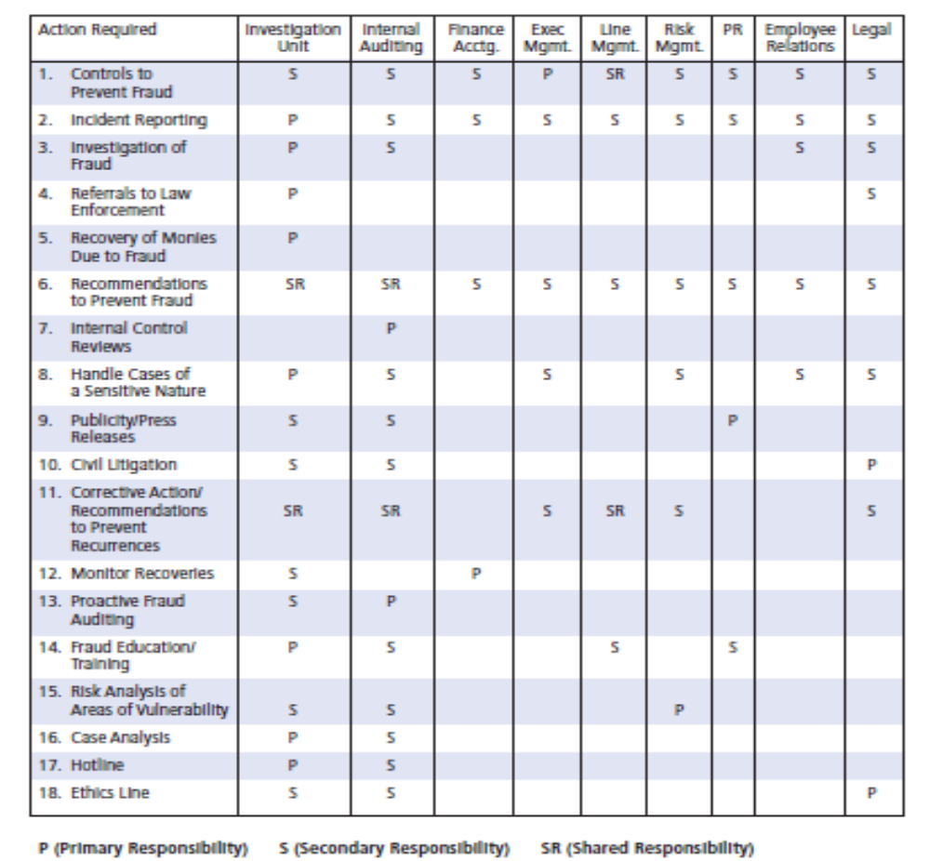

Student Statement:

By submitting this assignment, I confirm that this is my own work.

Student Signature | Aleksandar Vasilic | Date | 24.11.2016.

For Tutor / Assessor Use Only
Total Marks
Marks Obtained
Percentage / Grade

