
Assignment Cover Sheet

Student Name: | FATIMA CRUZ
Student Number: | 3537
Course: | DIPLOMA IN BUSINESS ADMINISTRATION
Assignment NO: | 3

Marking Criteria:
We expect the learners to write minimum one well expressed point in three lines against each allocated mark. This means one needs to write 15 lines with 5 well expressed points to get high grades for a 5 marks question.
For high grades use examples and illustrations where appropriate.
Please insert your completed assignment ( in word format) here:

- What does human resource department do?
Basically, human resource department is the heart of every organization. This department deals with different activities related to its workers. There are different functions related to HR.
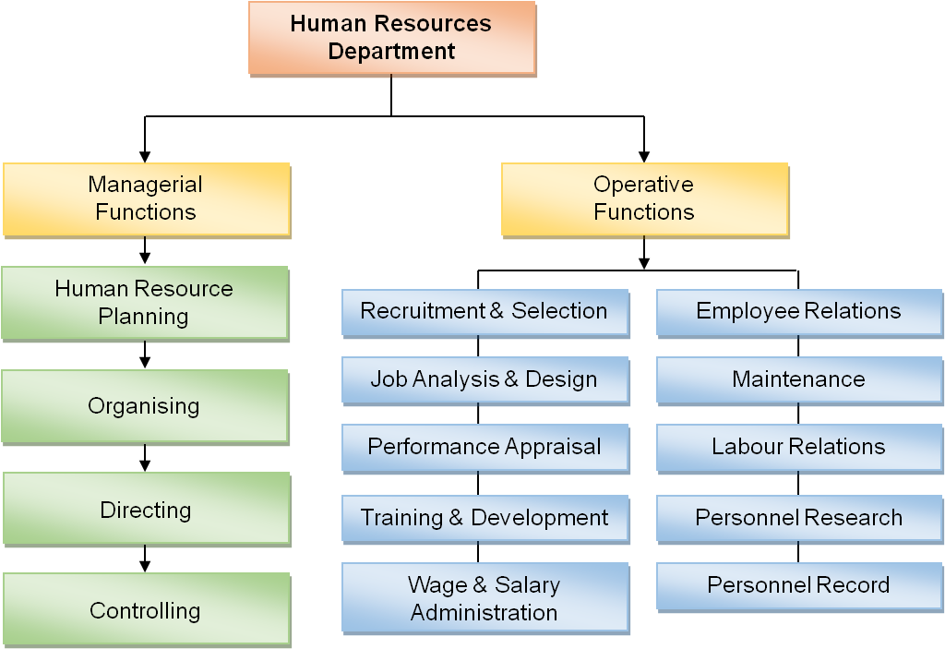

HR Department is assigned to plan, hire employees, distribute these employees to different departments inside the organization, and help to improve their standards. They give unique facilities for their employees such as pantries, entertainment areas, gym, nap rooms, etc. They also give good benefits like educational allowance for the employee and children, transportation, laundry, food, and accommodation allowances. HR is known for its best practices they offer to their employees in forms of incentives and other activities.
Human resources department gives the organization a detailed and possibility of meeting its success by means of managing their main resources, which are the employees. Sometimes, company does not see the value of the employees as they are only after gaining of profit, but in reality, their workers are unhappy with their work and has a tendency of leaving the company. This department should be an outlet for employee’s growth as an individual, as well as an effective professional.

- Outline the objectives of Human Resource management in an organization.
Objectives of the Human Resources Management:
- To help the organization understands its goals and objectives
- To maintain worker’s contented disposition towards their work by means of attending to their needs
- To motivate the employees to work at their best and allow to use their talents to help the organization
- To promote personal and professional growth among the employees
- To acquire new talents to help the organization to succeed
- To sustain balance of work and personal life of the employees
- To be socially responsible to the society and its employees; to be treated equally by their colleagues, subordinates, and management.
- To improve the skills and add knowledge to the workers so they can be flexible in their work
- To improve the morale of the employees and to make them feel that they are treated as a family member.

- Outline the ethics of HRM as relating to the organization and the individual employee.
- HR professionals should be competent and committed to learn the changes in the HR functions.
- HR professionals should show their leadership skills to be a role model
- HR professionals should practice fair and justice for all the employees
- HR professionals should sustain the level of trust that the management has given to them by means of being protective with their own interest and their intergrity
- HR professionals should protect employee’s rights as individuals

- What are the benefits of clear recruitment process?
A recruitment process is needed in an organization for it has to be guided with the process of recruiting and selecting new talents. It aims to help the company to ensure that acquiring new talents will not be biased and very transparent. This process will be an aid for the company to meet its business targets, to assess candidates based on the set of criteria, to abide the laws, to persuade the candidates that the offer is genuine and not a fraud offer, and to set an example for the entire organization.
One of the benefits of a clear recruitment process, it will attain accurate description of the job to be given to the worker. The HR should have a detailed job description to be given to the candidate, if the description will fit the candidate, he or she will be more likely to perform his or her job better. Also, it will be consistent, such as the recruiters have to initial screen the candidates and invite them for face to face interview to assess if there is consistency with the answers of the candidates. Another benefit will be the credibility of the company. People are very hooked up to job ads that are catchy to the eyes, but in reality, these advertisements are not genuine. If the company has a clear recruitment process and the candidate experiences to go through those stages of recruitment, that candidate will be confident and he or she will not feel hopeless to get the job. Lastly, a clear recruitment process will have a transparency towards the candidates. Candidates should be informed regarding their status, whether their application is successful or not.

- How many opportunities of staff development can you think of? Here are some ideas.
- Refresher training
- Providing materials for self study
  - team building
  - personality development
  - motivational activities
  - seminars and forums
  - general assemblies

2. Is there a need for human resource management specialists and if so what should their role be? How is this role evolving?
For me, I would not recommend to have a human resource management specialist. I think, it is good enough to have HR personnel so they can learn the process of HR Department. The role of human resource management specialist will be redundant in the department as the other personnel do the same. And if the company has a good and developed HR policy, they can help each other to attain success in the department, as well as in the organization.

Case Study
Tony works in Big Star a city hotel. He is full time employee and has been working there for the last three years. But he is not happy with his job. He says that his pay is poor and he has to work on the weekends.
- What does his statement suggest about the motivation of this hotel worker?
Tony is demotivated towards work because of 2 reasons: 1) low salary and 2) working on weekends.

- Identify and explain two possible ways of how Tony’s his motivation could be improved?
There are ways to improve Tony’s motivation. First, HR should speak to Tony and to the other staff as well, that they will be given an appraisal form, and from that, they will assess their performance. If they attain a good quality of work, the company can give them rewards and incentives for being a hardworking employee. If the company sees that Tony is very dedicated to his job, he just deserves any amount for his good work. Also, if they ask Tony to work on off day and/or weekdays, they should give him an overtime pay as per the law and policy of the company. Monetary rewards are known to be effective to boost up worker’s motivation to work. Employees can use the money for so many things like they can use it to buy something they like for themselves or give it to their family. The worker’s quality of work will be improved by this system.

Secondly, the company can conduct a general assembly for their employees and give appreciation to the workers like Tony who puts dedication to work. Also, they can have a bulletin of information where they can post Tony’s name and picture that he is the best employee. In this way, Tony can feel that the company appreciates his effort that he gives for the organization.

Student Statement:

By submitting this assignment, I confirm that this is my own work.

Student Signature | FATIMA CRUZ | Date | 21 DECEMBER 2016

For Tutor / Assessor Use Only
Total Marks
Marks Obtained
Percentage / Grade

