
Assignment Cover Sheet

Student Name: | Raymond Wilson
Student Number: | 1611
Course: | Diploma in Human Resource Management
Assignment No: | 9

Marking Criteria:
We expect the learners to write minimum one well expressed point in three lines against each allocated mark. This means one needs to write 15 lines with 5 well expressed points to get high grades for a 5 marks question.
For high grades use examples and illustrations where appropriate.
Assessment #9 Total Marks: 30
Health, Safety and Welfare
1. Give short answers to the following questions: (20)

i. What are the main purposes of Health and Safety at Work Act?

The Health and Safety at Work Act (1974) was legislated as a result of the need to categorize much of the pre-1974 legislation that was already in place. The principle purpose was to create a single comprehensive system of regulatory law. There are three primary aims therefore of the HSWA;
- To secure the health, safety and welfare of persons at work.
- To protect persons other than persons at work against risks to health or safety arising out of or in connection with the activities of persons at work.
- To control the keeping and use of explosive or highly flammable or otherwise dangerous substances, and generally preventing the unlawful acquisition, possession and use of such substances.

HSWA imposes various general duties upon both Employers and Employees.
Employers are obliged to provide their employees;
- Provide and maintain safe plant and systems of work.
- Provision of required PPE.
- Ensure the safety of Employees in connection with the use, storage and transport of articles.
- Provide the necessary information, instruction, training and supervision.
- Ensure the safe maintenance of the place of work.
- Provide and maintain a safe working environment.

Duties owed to persons who are not Employees
There are a number of limited duties owed to persons who are not employees:
- Not to expose such persons to risks in relation to their health and safety.
- Provide such persons prescribed information about the way in which the Employer or Self-Employed person conducts their undertaking.
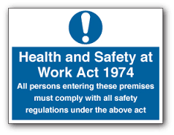

Duties owed by employees at work
There are also duties imposed upon employees in the workplace including the following;
- To take care for the health and safety of themselves and other persons.
- To cooperate with any requirement imposed by the Employer in order for the Employer to perform and comply with any required duty.
- Not to intentionally or recklessly interfere or misuse anything provided in the interests of health, safety or welfare.

ii. Outline the benefits of health and safety at workplace.
The clear benefit from workplace H&S is that it helps protect yourself and your colleagues from illness or injury. Companies that take care of their staff will see them being more inclined to look after that company’s interests. They will feel safer, more confident and valued. It therefore makes good business sense to get equipped with the knowledge and skills to improve safety at work.
Health and safety legislation exists so as to protect the worker, and the business owner and there are plenty of business benefits such as;
• A reduction in the number of working days lost due to illness and injury
• Retaining of staff/workforce
• Motivation of the workers, which will help boost morale and productivity
• Protect the reputation of your company
• Shield yourself from potential legal action and reduce your insurance premiums
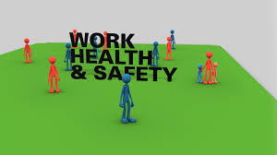
Health and safety does not have to be costly or time consuming. Small businesses often reap the benefits of implementing health and safety laws. Most companies will eventually see a reduction in operating costs, for example lower insurance premiums. Reducing the number of sick days lost and better retention of staff, AS indicated previously, can also often occur when you put health and safety laws at the heart of your business.

III. What is risk assessment about?
Risk assessment is the process used to ascertain;
- Identify hazards.
- Analyze or evaluate the risk associated with that hazard.
- Determine appropriate ways to eliminate or control the hazard.
In real-world terms, a risk assessment is a thorough look at the workplace to identify those things, situations, processes, etc. that may cause harm, particularly to people. After identification is made, evaluation is carried out as to how likely and severe the risk is, and then it needs to be decided what measures should be in place to effectively prevent or control the harm from happening.
The aim of the risk assessment process is to remove a hazard or reduce the level of its risk by adding precautions or control measures, as necessary. By doing so, you have created a safer and healthier workplace.
Risk assessments are very important as they form an integral part of a good occupational health and safety management plan. They help to;
- Create awareness of hazards and risks.
- Identify who may be at risk (employees, cleaners, visitors, contractors, the public, etc.)
- Determine if existing control measures are adequate or if more should be done.
- Prevent injuries or illnesses when done at the design or planning stage.
- Prioritize hazards and control measures
Assessments should be done by a competent team of individuals who either have a good working knowledge of the workplace or are specialists in the activities to be undertaken. Staff should be involved and always include supervisors and workers who work with the process under review as they are the most familiar with the operation.
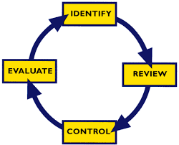
In general, to do an assessment, you should;
- Identify hazards
- Review all available health and safety information about the hazard such as MSDSs, manufacturer’s literature, and information from reputable organizations, results of testing, etc.
- Control the risk and take actions necessary to eliminate or control that risk
- Evaluate and monitor to confirm the risk is controlled and also evaluate the likelihood of an injury or illness occurring, and its severity.
Keep any documentation or records that may be necessary to support the above. Documentation may include detailing the process used to assess the risk, outlining any evaluations, or detailing how conclusions were made.
When doing an assessment, the following must be taken into account;
- The methods and procedures used in the processing, use, handling or storage of the substance, etc.
- The actual and the potential exposure of workers.
- The measures and procedures necessary to control such exposure by means of engineering controls, work practices, and hygiene practices and facilities.
By determining the level of risk associated with the hazard, the employer and the joint health and safety committee (workers, supervisors) can decide whether a control program is required. It is important to remember that the assessment must take into account not only the current state of the workplace but any future potential situations as well.
iv. What are the different types of risk assessment?
Assessing Risk is the resolve of quantitative or qualitative estimates of risk related to a well-defined situation and a recognized threat or hazard. Quantitative risk assessment requires calculations of two components, risk and the scale of the potential loss, as well as the probability that the loss will occur. An acceptable risk is a risk that is understood and tolerated usually because the cost or difficulty of implementing an effective countermeasure for the associated vulnerability exceeds the expectation of loss.
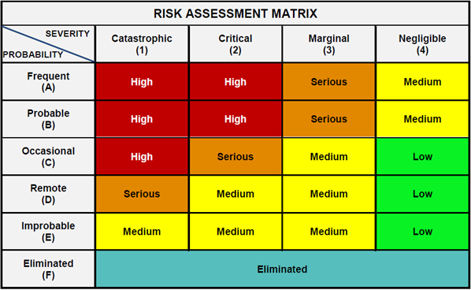
In all types of engineering, sophisticated risk assessments are often made within the safety and reliability spheres when it concerns threats to life, environment or machine operations and functioning. The oil, nuclear, rail, aerospace, and military industries have a long history of dealing with risk assessment. Also, medical, hospital, food and social service sectors control risks and perform risk assessments on a continual basis.
Quantitative risk assessments include a calculation of the single loss expectancy (SLE) of an asset. The SLE can be defined as the loss of value to the asset based on a single dangerous incident. The team will then estimate the Annualized Rate of Occurrence (ARO) of the threat to the asset. The ARO is an evaluation based on the data of how often a threat would be successful in exploiting such a vulnerability. From this information, the Annualized Loss Expectancy (ALE) can be calculated. The ALE is a calculation of the single loss expectancy multiplied by the annual rate of occurrence, or how much an organization could estimate to lose from an asset based on the risks, threats, and vulnerabilities. It then becomes possible from a financial perspective to justify expenditures to implement countermeasures to protect the asset from such risks.
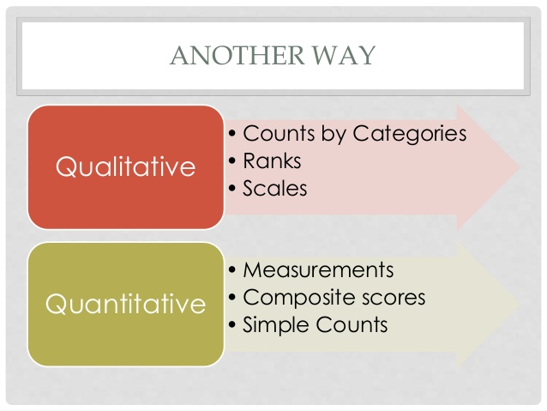
Qualitative risk analysis is a project management practice concerned with discovering the probability of a risk event taking place and the impact the risk will have if it does occur. All risks have both possibility and impact. Probability is the prospect that a risk event will occur, and impact is the significance of the consequences of the risk event. Impact typically affects the following project elements, which are clearly far reaching; schedule, financial plan, resources, deliverables, costs, quality, scope and performance.

v. What is Health and Safety audit?
Health and safety legislation require all employers to provide healthy and safe conditions for employers to work in. A health and safety audit will establish the health and safety status of your organization. The audit will clearly need to examine the whole business in order to test whether it is meeting its safety intentions and objectives as defined in the HSE plan. It will examine hierarchies, processes, decision-making, delegation, policy-making and execution as well as all areas of safety program planning process.
A health and safety audit can be very useful when establishing whether Health & Safety Training has actually worked and whether employees are observing health and safety practices at work.
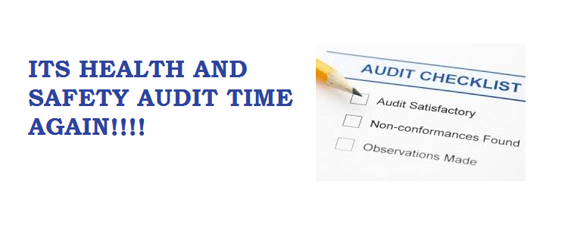Periodical health and safety audits are also an effective way of monitoring the safety performance of the business and observing what is really happening in the work place.
Health & Safety audits evaluate the following principles in any business operating sphere, in no particular order;
- Policy & procedures
- COSHH / Asbestos
- Accident Reporting
- Noise at Work
- Contractor Control
- Manual Handling
- Safety Training / Information
- Management Monitoring
- Refuse / Pest Control
- Facilities
- Structure / Ventilation / Light
- Work Equipment
- First Aid
- Electrical / Gas / Water
- Personal Protective Equipment
- Slips, Trips and Falls
- Disability Access (Optional)
Once the audit report deficiencies are identified, reviewed and approved they are then prioritized for action and they must describe;
- The nature of each deficiency
- What to do to rectify the situation
An executive summary report detailing the general safety status of the business that has been audited is then published and this and provides helpful advice on the state of the company.

2. Discuss different approaches that employers can adopt to help employees manage stress. (10)

Managing workplace stress is not too difficult and doesn’t need any major monetary investment. It involves creating a healthy organizational environment that requires the building of an atmosphere of trust and respect, where good communication, employee acknowledgement, flexibility of control and cultural difference are all valued and nurtured. Reducing stress levels within an organization can be achieved by adopting simple techniques such as engaging all levels of the workforce to make them feel more valued.
The aim therefore should be to foster principles where everyone feels that they are a part of the business – from the shop floor worker to the CEO – a climate where everyone is important to the organization and where all employees work towards a common goal for the success of the business or public service. Implementing and maintaining a healthy corporate structure helps lower stress levels, increases productivity and reduces absence through sickness – all without raising costs.
Work environment accountability
Managers need to be held responsible for the climate they create in the workplace. It is a manager’s role to build a “listening culture” where it is the norm for any individual to feel comfortable talking about any stress-related issues. Managers need to have an “open door” policy and be there when an employee needs to communicate with them in person – or at least be accessible soon after. They also need to know how, when and where they can call on Occupation Health for support.
Ensuring that effort is rewarded is another way to improve workplace culture. This means making sure that employees are recognized and rewarded appropriately for the effort that they put in. The best way to ensure this would be to ask employees directly what single action by management would make them feel more valued. Many of those questioned will no doubt say that they would appreciate merely a simple “thank you” for a job well done and delivered on time.

A healthy work environment is a key element for a stress-free workforce. Wherever possible, stress factors such as excessive noise, heat, and cold, overcrowding or long working hours need to be identified and mitigated. Staff wellbeing must be a primary consideration – internally and externally. Health screening and stress awareness program should be a part of a normal workplace routine, and the place of work needs to feel more like a community rather than simply the place where people earn their living and are treated as a number.
Stress management – the key factors
There is a modern day tendency for Companies and organizations to be over-reliant on technology and systems, and they should adopt approaches that are more effective in engaging the individual. The missing ingredient in achieving effective performance is often the fact that many management systems lack leadership, personality and are neither motivating nor inspiring.
Good communication needs to be a key factor in the principles of any organization in order for stress to be quickly identified and effectively managed. It is important not only to have an open two-way dialogue between employer and employees, but also between the CEO and the board, between the board and its line management, and between OH and staff at all levels. Ineffective communication has often been found to be a fault in many organizations, regardless of size, and insufficient time, effort and training is given to this key area. Middle managers often find themselves promoted to a position with responsibility for a team without the necessary communication skills to manage that team effectively.
Managers nowadays need a comprehensive “toolkit” of people management skills in order to encourage a two-way dialogue between themselves and the members of their team.
It is essential to get “buy-in” from their team in order to establish loyalty and commitment in return. While it may not be always possible to increase remuneration, praise and recognition will encourage most employees into wanting to do more for their manager and to give it their best. The team that is inspired, motivated and less stressed out – will consistently build up a competitive advantage.
The morale of an organization is essential to its success. High morale levels suggests a well-motivated and energized workforce that is keen to succeed. Employees will often be dedicated to meeting, and even exceeding, targets when stress factors are identified and either eradicated or minimized. There is little that is more important to personal morale than receiving praise for a job well done.
Regular or annual appraisals identify strengths and weaknesses and allow for assessment of both continuing professional development and on-the-job training. Appraisals should be a two-way process that enable the manager and the team member to agree targets for performance and to have a clear area of responsibility. It is at times such as these that stress-related issues should be identified, addressed and resolved.
Being acknowledged as a crucial part of the business machine is almost as important as the monetary reward on offer. Recognition and reward have to be proportionate with the task, but undervaluing skills at any level can lead to low productivity and poor morale and a stressful environment. Providing specific additional benefit packages, over and above the basic salary, is another way of expressing recognition and enhancing reward.
Long working hours are endemic in some sectors, understanding the importance of work-life balance, and how to achieve it, is a key management skill. This balance needs to be implemented as part of an organization’s legal framework and company policy.
How to achieve a healthy workplace culture
Communication skills to motivate individual talent needs to include;
- “Active listening” techniques to identify and rectify grievances
- Techniques for effective announcing, interviewing and cautioning
- Getting important answers without appearing to interrogate; and defusing conflict through key phrases to keep dialogue moving.
- Better interpersonal communication results in smoother running, better outcomes and, quite often, less pressure.

Some companies adopt using a first-contact counselling teams – where volunteers from the organization are trained to listen effectively to employees’ stress-related problems – and this is just one example of how employees can be encouraged to commit “more” of themselves for the benefit of their colleagues, their customers, their employer and the community.
Creative self-development is the new dynamic of career progress widely used in the workplace today. Individual empowerment requires a greater understanding of the impact of positive attitude on individual and group performance; an increased opposition to those who are condescending of effort.
Flexibility is also vital to reducing stress levels. Organizations often lose valuable talent because of an unwillingness to be flexible in their operations, or to alter work patterns in order to cater for particular needs, such as those of the disabled, single parents and the like. Home working, flexi hours and buddying schemes (where new recruits are provided with an informal mentor) are just two examples of the approaches that can be taken to reduce stress levels.
Activities such as supporting a local charity can prove beneficial to both parties by becoming identified with the community in a positive role. Being associated with a local charity is something that professional firms such as lawyers and accountants are often well aware of, but many commercial and industrial companies could also learn and benefit from this.
The “war on stress” – How to win it
One of the main ways of winning the “war on stress” means attracting the finest and brightest employees by improving the organization’s cultural understanding of diverse mindsets.
Within a properly created and managed workplace culture, employees need to feel included within the vision of the business and to have a sense of security and belonging and, as we spend at least half of our non-sleeping hours at work, that is of great importance.
The determination to ensure that stress is recognized and mitigated wherever practicably possible needs to come from senior management down. The top management team should therefore ensure that all employees;
- Are not frightened to talk about stress-related factors
- Know that if they have problems, then it is acceptable to discuss them
- Are aware that they can go to line/senior management and occupational health as and when they are needed.
An organization’s HR group is the essential key to sustainable success in this aspect. When that simple fact fails to be appreciated, then staff turnover and associated costs will rise, and valuable training, talent and ability will be lost – leading to higher overheads and a reduced return on the most important investment of all, human resources.

Student Statement:

By submitting this assignment, I confirm that this is my own work.

Student Signature | Raymond Wilson | Date | 25th Apr 2016

For Tutor / Assessor Use Only
Total Marks
Marks Obtained
Percentage / Grade

