
Assignment Cover Sheet

Student Name: | Tracy Kam
Student Number: | 3200
Course: | Diploma in Fashion
Assignment NO: | 10

Marking Criteria:
We expect the learners to write minimum one well expressed point in three lines against each allocated mark. This means one needs to write 15 lines with 5 well expressed points to get high grades for a 5 marks question.
For high grades use examples and illustrations where appropriate.
Please insert your completed assignment ( in word format) here:

Fashion Sketching

Assessment 10 Total Marks: 30

Q: 1: Multiple Choice Questions: (3)
a) A fashion figure is about;
Seven and one half heads tall
Eight to ten heads tall
Fifteen heads tall

b) The best rule to follow in sketching the face is to;
Give as much details as possible
Define as much detail as possible
Omit as much detail as possible

c) The fashion artist exaggerates the;
Length of the figures and maximises the width of the hand
Exaggerates the length of the arms and minimises the hands
Exaggerates the length of forearm and minimises elbow

2. What is most important thing to consider when sketching for dressing the figure? (3)
The most important cthing to consider when sketching for figure is the designer must absolutely familiar with the human figure , and capable making the garment appear on the body .dress must place on a live model .Visualised a line through the centre of the figure .contour the lines of the dress to get the thickness .add wrinkles to placed across the abdomen and pelvis as can see the figure clearly .lastly must able to get the effect of the material used .
3. How does fashion design sketch help a fashion designer? (4)
The fashion sketch can help a designer by to obtained a correct proportions , can visualized the figure before converting to the actual , can create the sense of design and mood , also certain sketch can makes the design looks lively.

4. How should bottom of the skirt be sketched? Why is it important to harmonise the mood and action of the figure with the clothes in which artist draws her. Explain giving at least one example. (5)

The bottom skirt should never be sketched straight across , but have the general feeling of rectangle .If its too straight can create the feeling of being too straight .Rectangualr can create the appaearnce of the round figure . Striv for rhytm in the lines expressing the folds of the skirt .

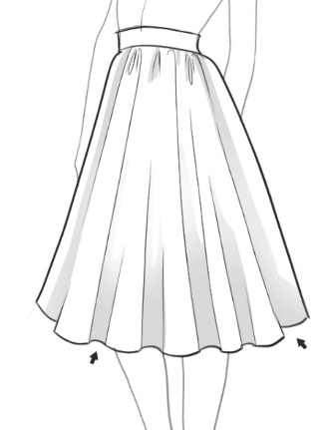

Activity

Sketch a fashion dress for a female showing all the details required in that garment. Then sketch a fashion figure dressed in same outfit. (15)

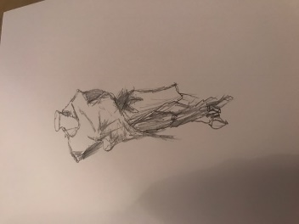
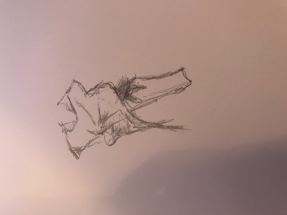

Student Statement:

By submitting this assignment, I confirm that this is my own work.

Student Signature | Tracy Kam | Date | 24112016

For Tutor / Assessor Use Only
Total Marks
Marks Obtained
Percentage / Grade

