
Assignment Cover Sheet

Student Name: | Hissourou Aboubakar
Student Number:
Course: | Write Business Plan
Assignment NO: | Unit - 3

Marking Criteria:
We expect the learners to write minimum one well expressed point in three lines against each allocated mark. This means one needs to write 15 lines with 5 well expressed points to get high grades for a 5 marks question.
For high grades use examples and illustrations where appropriate.
Answer the following questions:

1. How to create a marketing strategy? Discuss with Detail? (10)
2. How to analyze competition and yourself? Discuss. (10)
3. How to create a marketing plan? Explain with detail? (10)

- How to create a marketing strategy? Discuss with Detail?

Answer

Creating a Marketing Strategy
Introduction to Marketing

The Purpose of the Plan
Marketing processes may vary in terminology or process depending on the material you read. They may
Include more or fewer steps than this session will cover. What is common, however, is that marketing is
A cyclical process and it uses very particular terms. We will also use those terms here so that you can
Plan, speak to, and perform these functions within your business.
A marketing plan can be so complex (as a reflection of the business, your environment, your staff, or a
blend of all of these) that it is created separately from the business plan and then incorporated later, but
It is still an essential function of the business planning process.
Your marketing plan may undergo many revisions until all stages work effectively. This frustrates people
Who do not like working in a fluid state, or have trouble dealing with change. As a result, you need to
Recruit marketing professionals who love their work and have a strong track record.
Cycle Overview
Marketing uses the following steps:

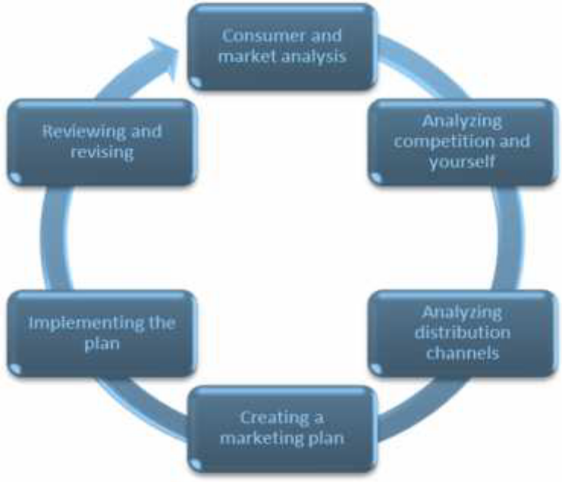

Consumer and Market Analysis
This is the research segment of the process, as you carefully consider your customer and what they
Need. You have to be honest with yourself and look at their needs in direct contrast to what you may
Think of as your ideal customer. People don’t all have the same needs and wants. Your goal is to identify
groups of people (called segments) who have related or similar needs so your marketing dollars can be
Directly pointed at them. There are several questions to ask yourself as you work on this portion of your
business plan:
• What do they need?
• Who is buying our product? Who is using our product?
• What is the buying process?
• How can I leverage segmentation?

What do they need?

The answer to this question may seem simple to you, but we want you to take a deep look so that you
Get the real answer. When answering this question, you can potentially uncover a segment of the
Marketplace that has been overlooked or underserved until you arrived. IKEA has a tremendous market
presence for furniture and home furnishings, which has led to businesses who now concentrate on
Recovering and upholstering IKEA’s old furniture. How did the aftermarket business get started? They
knew that people don’t like to get rid of their IKEA furniture and were able to capitalize on their
Consumers’ energy for repurposing.

Who is buying our product? Who is using our product?

Babies don’t buy diapers, their parents do. Dogs don’t really care what their food looks or tastes like, but
Their owners do. Who does most of the purchasing in the market segment you will serve? There is no
point marketing an item in a men’s magazine if the item is normally purchased by women and given to
Men; you need to market to the women in their own spaces.

What is the buying process?

Grocery and corner stores place candy and chocolate bars at the cash register because so many people
Purchase those items on impulse. Staple items such as bread and milk are often located at the back of
The store to force shoppers to walk past and view all of the other items on display.
Large items like a car or truck take more time to consider. They are a significant investment of money,
And are an item that the buyer wants to have for a long period of time. As a result, people may do some
Research on the internet and they will visit a car lot to see the features of the vehicle for themselves.
Then, they will take it for a test drive (or two or three test drives) before they make the decision to
Purchase. The buying process generally follows the steps below:



- How to analyze competition and yourself? Discuss.

Answer,

Analyzing the Competition and Yourself

You must have a plan that sees you exceed the competition, and you will need to take an honest look at
Your operation in order to do this. We can hide all kinds of things in an analysis to make things look
Better than they are. Be honest with yourself to protect the integrity of your business.
Some of the questions you will want to ask include:
• What are your advantages?
• What are your core competencies (the things you do well)?
• What are your weaknesses?
• Where are your shortcomings?
• What can you do to capitalize on your strengths?
• What can you do to exploit the competition’s weaknesses and shortcomings?
SWOT Analysis
We recommend that you use a SWOT analysis to address each question in the list above. SWOT stands
For strengths, weaknesses, opportunities, and threats. It is a method of analyzing external factors
(Opportunities and threats) and internal factors (strengths and weaknesses) in a methodical way.
In addition to using SWOT analysis to answer the questions about your company, you will repeat the
Process to consider your competition.
Next Steps
Once you have gathered your information, there are several ideas that you can use to help lessen the
Impact of the competition. For example, perhaps you have eliminated barriers that the competition has
Not been able to minimize for them. If you have partnered with a great distributor and the
Competition is struggling to get their product out to stores, you have eliminated a barrier.
As you decide what makes your product stand out from the competition (your unique selling proposition,
Image or brand), you can decide how to position your product. You also need to create a name for what
You have, because names stick in people’s minds. For example, when Apple Computers was ready to
Evolve; their product was called a Macintosh. They have moved from fruit branding to making their items
Personal through their “i” branding and products like the iPod, iPhone, and iPad.

- How to create a marketing plan? Explain with detail?

Answer,

Creating a Marketing Plan

Your marketing research gets applied in a marketing plan based on the P’s of marketing: product, price,
Place, promotion, and packaging. All of these P’s influence the positioning of your product (how your
Product compares to similar products from other companies).

Product

Marketing your product includes differentiating it from other products in the market place. There are
Lots of ways to do this, and you will want to pick a few that make sense. Some ideas:
• Capabilities
• Style
• Warranties/guarantees
• Service
• Labeling
• Size
Here is an example. When Lulu lemon was first established, they were looking for a name that was
Attention-grabbing and that people would remember. They also wanted something that had appeal
Around the globe. Their made-up word, with three l’s, helped them to stand out.

Price

Even a non-profit or not-for-profit company has to make a certain amount of money in order to
Continue. If you own a for-profit company, you’ve got to be making money. This means that no matter
Who you are, you need to understand every aspect of your business when establishing price. If you
Forget to allow for certain costs and sell the product at a loss, your stakeholders won’t stand for it.
On the other hand, some products are deliberately priced at a “deal” price (also known as a loss leader)
To draw people in to the store where they will be sold other products. A car can be priced below cost,
but by the time that the extended warranty, roadside service, fabric protection, and chrome package are
Added, there is no loss for the company any longer.
Psychological pricing is what has stores using prices that end in 95 or 99 cents. The idea is that people
Will pay $39.99 for a product they won’t pay $40.00 for.
In a competitive market, you will see marketing strategies that will meet or beat a competitor’s price in
Order to gain (or regain) market share. If you pick up a flyer and see the phrase, “We will match any
competitor’s advertised price and beat it by 5% on all our products,” you are witnessing meet or beat
Competition in action.

Price and quality are things that must always be considered in pricing services and non-tangible
Products. If you have a service and price it very cheaply, people may not value what you offer in terms of
The knowledge and expertise that is required to develop that service.
Penetration refers to introductory pricing that is deliberately low in order to gain market share. The idea
is to price products at a low per unit amount and then sell a high number of units with the objective of
Gaining recognition in the market.

Place

This is all about how you will distribute and provide your product. Your analysis of distribution channels
Will help you flesh out this part of your plan. Will you be a wholesaler, distribute products through a
Franchise, have brick and mortar retail outlets, or be an online-only store? You can also choose several
Methods to create a big presence.

Promotion

Promotion refers to the way that the market sees your product. It is very difficult to get shelf space in a
Retail store, so you have to decide how you will draw your potential purchasers’ attention. Pizza shops
Might send staff members to stand on the corner with a sandwich board describing this week’s deal.
Cupcake stores might have someone dressed in a giant cupcake costume waving to passersby. Coupons,
Flyers, newsletters, and special deals are also part of a promotion strategy.
Public relations campaigns are another form of promotion. Internet marketing is another form of
promotion that can use programming and keyword techniques to ensure that a search for products like
Yours will lead to your company’s website.

Packaging

The esthetic value of your packaging can draw a customer’s eye or can turn them away. Designers and
marketing firms aim to create the best packaging possible to attract consumers or at least create some
Kind of reaction. In addition, items must also be packaged in a way that protects the contents. Cardboard
boxes, protective materials (like Styrofoam), labeling, color, and appeal must all be considered to present
Your product appropriately and protect it from damage.

Student Statement:

By submitting this assignment, I confirm that this is my own work.

Student Signature | Hissourou Aboubakar | Date | 05/01/2017

For Tutor / Assessor Use Only
Total Marks
Marks Obtained
Percentage / Grade

