
Assignment Cover Sheet

Student Name: | Yassim ELFASSI
Student Number: | 3405
Course: | Diploma in Logistics & Supply Chain Management
Assignment NO: | 72085957SUPPLY CHAIN ASSESSMENT 2

Note to Tutor, Mr. Ahsan, Mehmood :
Dear Mr. Mehmood,
Thank you very much for excellent grade for unit 1. In order for me to improve myself, I will appreciate if you can share with me (if possible) your answers expectations or critics to reach a higher level.
Thank you and Best Regards,
Please insert your completed assignment ( in word format) here:
1. | Give short answers for the following questions: | (14)

- Outline the activities involved in logistics.
- Procurement or Purchasing
- Inward Transport or Traffic
- Receiving
- Warehousing or Stores
- Stock control
- Order Picking
- Materials Handling
- Outward Transport
- Physical Distribution Management
- Recycling, Returns and Waste Disposal
- Location
- Communication
According to the size of the Organization and / or its core activities, we can also consider following steps as part of logistics:
- Sales forecasting
- Customer Service Management
- Production scheduling
- Third part Operations
- Overseas Liaisons

- What is meant by the term ‘cross docking’?
- Unit Definition: Cross-docking directs the supply and delivery, so that merchandise arrives at the receiving region and is transferred directly to a loading area, where they are loaded onto delivery vehicles.
- Cross-docking is the transfer of materials from an inbound transporter to an outbound transporter, without them actually entering the warehouse or being put away into warehouse.
- Briefly describe the main aims of logistics.
The areas of responsibilities of Logistic Department is quite large but we can categorize 3 mains aims:
  - To Server customers materials needs in highly efficient way
    - To attain high customer Contentment
    - Minimum input and waste
    - Quick delivery
    - High productivity
  - Cost Reduction: Minimizing the variable costs associated with movement and storage.
  - Capital Reduction: Minimizing the investments and Maximizing the ROI

- Which activities are included in Stock Control Procedures?
- The Stock Control creates regulations for inventory. It also monitors the stored material, the overall cost, stock level, order timing, customer service, order sizes,…

- What is the importance of communication in a supply chain?
- Along with flow of materials, the smooth flow of communication is also essential. The entire supply chain runs through communication and passing information regarding customer demands, products, need of material movement, stock levels, problems, timings, costs, etc…
- Without Communication, no information can be exchanged, no materials can be moved or stored without mistakes and problems.

- How are logistic activities organized in different sizes of organizations?
“Logistics in organizations appear in different forms. The arrangement of activities varies from organization to organization but there is without doubt no single ‘best’ way. The scale of logistics activities also depends upon scale of organization. A small organization might have just one person to look after the things while in large scale organization, over hundreds of workers might be there under the department. Sometimes, organizations that lack physical and financial resources for in house logistics department outsource this function to outside third parties.”

- How do logistics affect the price of products?
Logistics is an expensive function, though; it holds a big impact on the financial performance of the organization. The impact can be illustrated by discussing various financial terms, starting from the Return on Asset. The return on assets is the pre-tax profit that an organization earn, divided by the worth of the assets utilized.
The formula is:
Return on assets = profits earned
Assets employed
This figure actually gives an accurate view that how well the
Organization has been using its resources.
The higher this figure, the better is the performance, whereas, the assets
can be both current assets (cash, stocks, and receivable etc) and fixed
Assets (building, equipment’s, etc.). Effective movement of material leads to lower stock level. Though it means less

2. “Logistics are essential for every organization.” Discuss this. (4)
Logistics is the backbone for any organization as without it no movement of material occurs, no production is achieved, no product is delivered and thus it leads to zero customer satisfaction and the success of any business solely depends upon its customer Satisfaction. If it does not please customers, it is doubtful to stay alive in the long term, left alone making profit, have more return on assets, more shareholder value, or attain any other means of success.

- What are some ways in which logistics can improve on issues related to environmental (4)
Protection?
As Logistic core activity is materials storage and moves, the pollution is generated by A/C Chillers, Trucks Consumptions, forklifts, etc., For logistic to shift to a greener side, it needs to work on Energy efficiency (Route optimization and Load optimization for example, …) and control drain emissions, recycle packaging, switch to environment friendly options of transport, boost recycling through reverse logistics, add security features to ships, expand brown-field sites, and so on

Case Study | (8)
Questions

- Why do all the logistics costs seem to be rising at the same time when the quantity of the order is reduced?
The entire chain is actually being affected due to bad Sales Forecasting, Hence:
- Wrong Stock Management
- Wrong Planned Production
- High usage of Express Delivery at a higher cost
  - Transportation & Load management not optimized
- Suppliers Payments delays impact on the delivery the raw material which has an impact on the production planning and going on…
- Cash flow being impacted due to high running expenses and late customers payments due to late deliveries
- Usage of Bank overdraft which generates fees and overdraft interests to add to the manufacturing costs.

- What do you think are the basic problems in McDonald Timbers?
McDonald Timbers must improve
- Visibility on the Sales forecast planning
- Communication & Coordination between departments
  - It seems each department is reacting instead of Pro-acting.
- Negotiate better transportation costs, probably outsourcing logistics
- Negotiating Payment Terms with Suppliers (AP) higher than the payments terms with customers (AR). Usually Suppliers Payment terms are 60 days from invoice date where customer’s payment terms is 30 days from delivery. This will help to manage properly the cash flow.

- What would you recommend Chris to do?
I recommend Chris to do the following:
- Using Forecasting and demand planning tools for the Sales / Marketing Dept.
- To use a WMS solution to control stocks levels and movements
  - Reducing stock to a safety level only
- To use Fleet management System to optimize Route and Load of Trucks
  - To set up Route Planning for customers deliveries and size trucks accordingly
- To set up Payment terms with suppliers
- To set up KPIs across and within departments.
  - More collaboration along the Supply Chain
Student Statement:
By submitting this assignment, I confirm that this is my own work.

Student Signature | 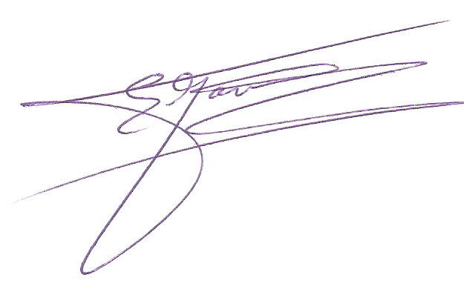 | Date | Nov.28th 2016

For Tutor / Assessor Use Only
Total Marks
Marks Obtained
Percentage / Grade

