
Assignment Cover Sheet

Student Name: | Eniko Surjanne Schuller
Student Number: | 2459
Course: | Diploma in Business Administration
Assignment NO: | 10

Marking Criteria:
We expect the learners to write minimum one well-expressed point in three lines against each allocated mark. This means one needs to write 15 lines with 5 well-expressed points to get high grades for a 5 marks question.
For high grades use examples and illustrations where appropriate.
There are golden rules of customer response techniques. They are:
- Customer is the most important part of the business as if there are no customers no revenue
- First, listen to the customer, and then if needs ask questions
- Identify their needs and anticipate with them: maintain superb communication with them
- Tell and suggest that they are important and appreciated
- Always tell them how works your business what is the procedures of that special case what the customer needs
- Never say NO to a customer, always end the conversation with a, yes, or I/we can do it
- Even if the hardest word to say is the sorry, when something goes wrong, apologies
- Always give a plus to what customer expected, surprise them with an extra

The role and function of policies and procedures in meeting customer needs: satisfaction surveys and feedbacks are necessary to follow the customers after sales, in order to develop the business procedures. These feedbacks are a big help to the organisation because they show the process from the other side. If some problems occur or develop is needed sometimes these will not going to the business side. Communicating through feedbacks helps to maintain the relationship between the company and the customers.

The role of quality management in meeting customer needs:
- to provide better customer service which will cause better satisfaction and more revenue
- to discover new customers and send them marketing promotions, special products or services customised to them
- to provide products which will the customer needed beside the original product, or to offer premium products
- to help the sales department to close purchases quicker
- to ensure the call centre department the details about a specific customer, product or service
- to simplify marketing and sales processes

To achieve customer’s trust you must build and maintain a long-term relationship with them. The most important thing is to make them sure you will deliver what you promise and what is expected. This is achievable by knowing customers needs and expectations, listen to them, understand them and ensure them about a solution what will help to solve their problems convey as an empathic act if this case were personal to you. Thereafter, you will build a stronger relationship with them after every solved problem

CRM is the abbreviation of Customer Relationship Management. This is a complex database which helps you to follow every movement in the business from find, meet, attract, win, hold customers. It includes the contact details, activities, future and past sales, actions, prepares reports for forecasts and past periods, marketing procedures with mailing lists and email integration, notes, phone calls, etc.

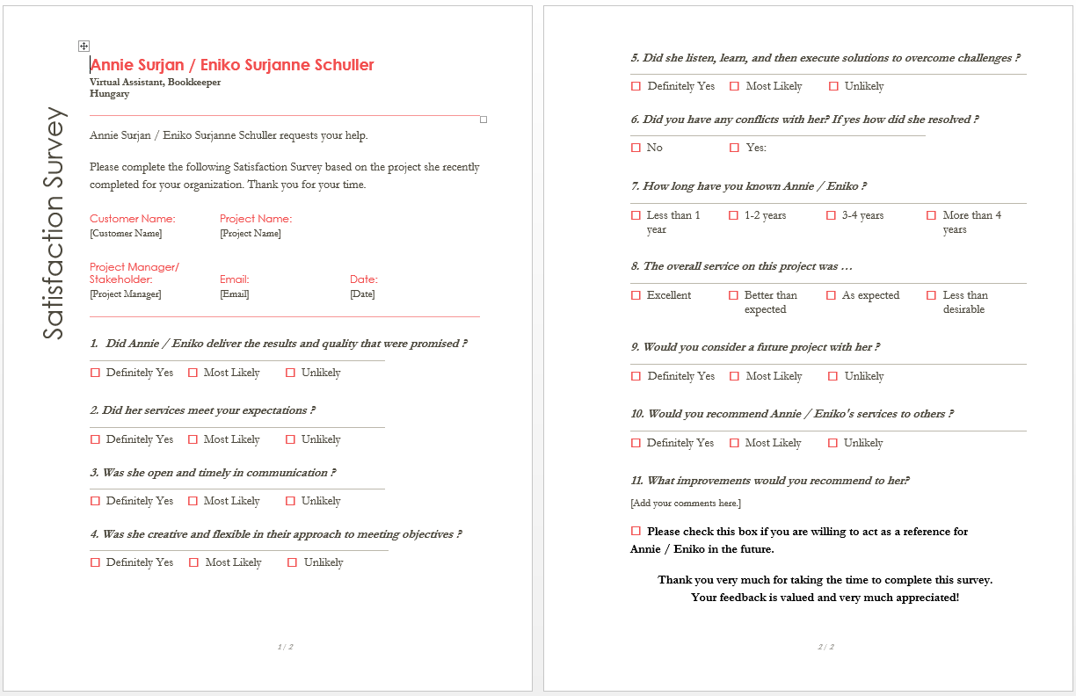

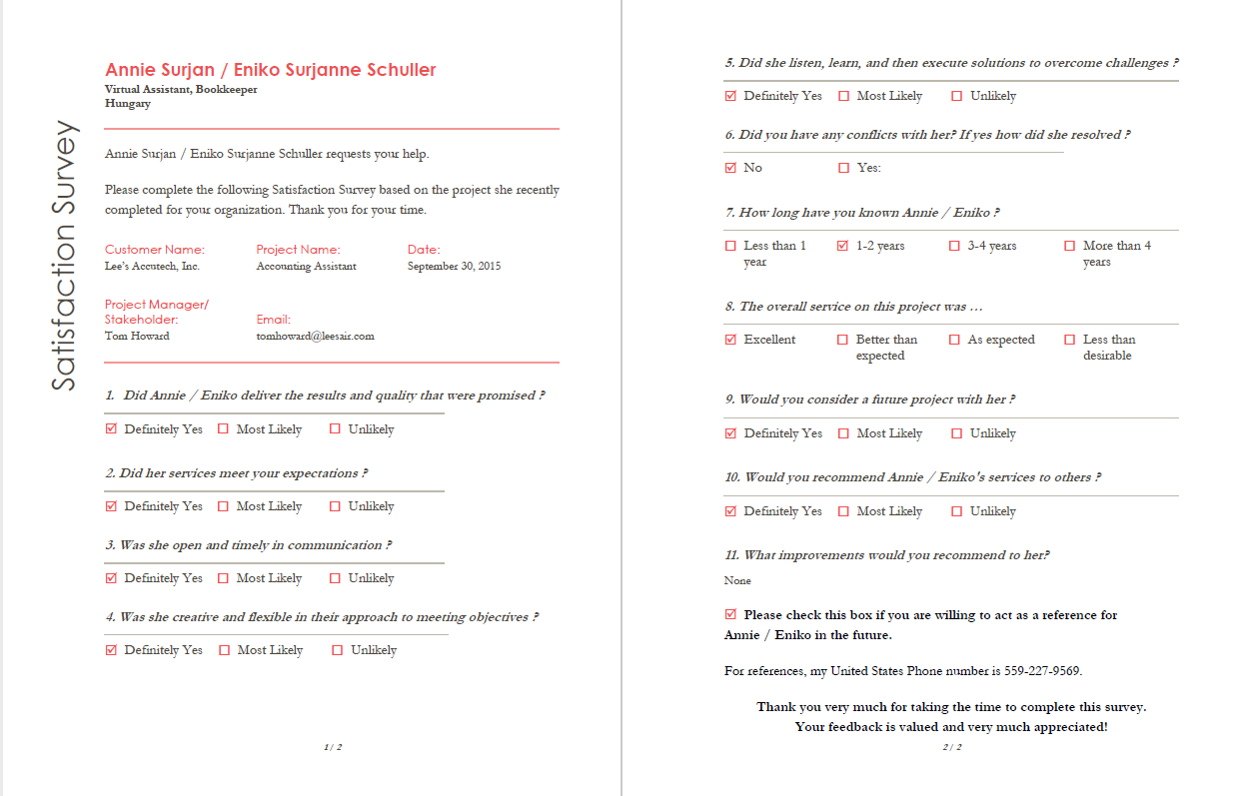

The success of the completed survey was good, as I received the survey with all the answers and a reference number on it. The answers were satisfied overall conventions: there are no problems or situations need to be changed.

Case Study:
- It is very important to classify the target users because gym facilities and activities needed by different ages, sexes, background are different because for the older community there is no need for prolonging exercises, there s more need for yoga or stretching exercises. For university students, there should be more variety for the facilities and equipment, unlike stay-at-home-moms.
- This could be helpful before buying equipment or hiring instructors in order to avoid high budget marketing campaigns, or buying expensive equipment without knowing the target customers.

Student Statement:
By submitting this assignment, I confirm that this is my own work.

Student Signature |  | Date | 4-Oct-2016
For Tutor / Assessor Use Only
Total Marks
Marks Obtained
Percentage / Grade

