
Assignment Cover Sheet

Student Name: | Rebekka Annika Schendel
Student Number: | 1391
Course: | Running the Fashion Design Business
Assignment NO: | Unit 16

Marking Criteria:
We expect the learners to write minimum one well expressed point in three lines against each allocated mark. This means one needs to write 15 lines with 5 well expressed points to get high grades for a 5 marks question.
For high grades use examples and illustrations where appropriate.
1. Give short answers for the following question:

I. Define the following terms and concepts as discussed in the module:

sale

Sales promotion, advertising, publicity, formal fashion shows.
The definition for sales promotion is this; sales promotion is a
technique to encourage the persons to buy something and to buy more - for example the sale action “buy two things for one price” – the persons probably buys more than by a sale action “50%”.
50 % off
With advertising is meant to attract consumer’s attention to the product, the company or an event. This is made through television, billboards, newspaper, radio, magazines or direct mail.
Publicity can be defined as a voluntary advertising this happens when consumers and others began to talk about the product or company etc.
Formal fashion shows (also called runway show) are events where the clothes are being shown and presented on models. Today it is more like a theatre than only to presenting the cloths on models it includes music and so on.

II. What is the purpose of fashion promotion?
The purpose of fashion promotion is to make the consumers ready to adapt the fashion style and to make the consumers ready to follow the fashion trends. On this way the consumers will buy the fashion of the fashion trend and also buy the fashion of the next fashion trends.

III. Explain the difference between advertising and publicity?
The difference between advertising and publicity can be explained in this way: advertising is made through television, billboards, magazines etc. this takes a lot of time, effort, planning and especially many. Publicity takes not so much time and many it is made by volunteers (for example consumers and other people) who like your company, product or event or are interested in it. They love to talk about your product etc. This most of the time than in social media. Those people can be also called fans. Publicity is the best and most effective advertising method then all other advertising methods.

IV. When supplying apparels to the retailers sometimes financial problems are created. How?
Sometimes financial problems are created when supplying apparels to the retailer because the retailer buys on credit allowances. That means that the retailer does not need to pay for the merchandise for thirty to sixty days. Now the manufacturer has a financial problem because the manufacturer has to buy the trims and fabric and also have to pay for overhead and labor. Manufacturer can become help from Banks and other finance companies.

V. ‘Textile sales people encourage manufacturers to make a commitment early in the season to buy a specific amount of yardage’ Why?
Textile sales people encourage manufacturers to make a commitment early in the season to buy a specific amount of yardage because it needs a lot of time for the production of the fabric and to dye the yarns most of the time eight weeks or even six months for popular colors and fabrics. The manufacturer has to consider well to prevent to buy not enough fabric and to buy not too much fabric.

VI. How the fabric should be inspected when it is received?
The fabric should be inspected when it is received in the way of counting the yardage to check if all of the ordered fabric has arrived, it have to be also inspected how the quality of the fabric is. This is made by checking the fabric of flaws, it also contains to get to know how the fabric reacts by washing, steaming and dry-cleaning.

2. Describe various types of media and their role in fashion promotion.
A big role in fashion promotion plays the television. A lot of people watch television some hours per day, most of the time in the evening. The people associate with television good feelings because they watch television after work and can relax from the workday. On this reason television can reach many people and they associate a good feeling even when there is so much advertising, most of the time they do not consciously perceive it – on this way the fashion style or taste of the consumers can be changed and prepared for the next fashion trend (most of the time the consumer does not notice it, this happens in the subconscious). In television consumers can see the new fashion “live” on models or on famous personalities. The reason why television is so efficient is because the person who watch can see and hear - on radio the person only can hear. On radio fashion promotion can be made by advertisements which come over and over again. On radio it is very important which kind of voice gives the advertisement and which music is used. Computer games and films for kids have also an enormous effect on the taste or style of fashion which the consumers prefer to buy. Magazines also play a role in fashion promotion. Magazines reached especially the female consumers because they are more interested in magazines. In magazines they can see attractive example for the (new) fashion trend. A role in fashion promotion plays also newspapers, billboards etc.

Projects
1. Find at least two example of co op advertising from a fashion magazine.
The first picture is an example of co-op advertising from a “how to sew” business for a yarn business. It gives also co-op advertising for a sewing machine for a sewing machine business.

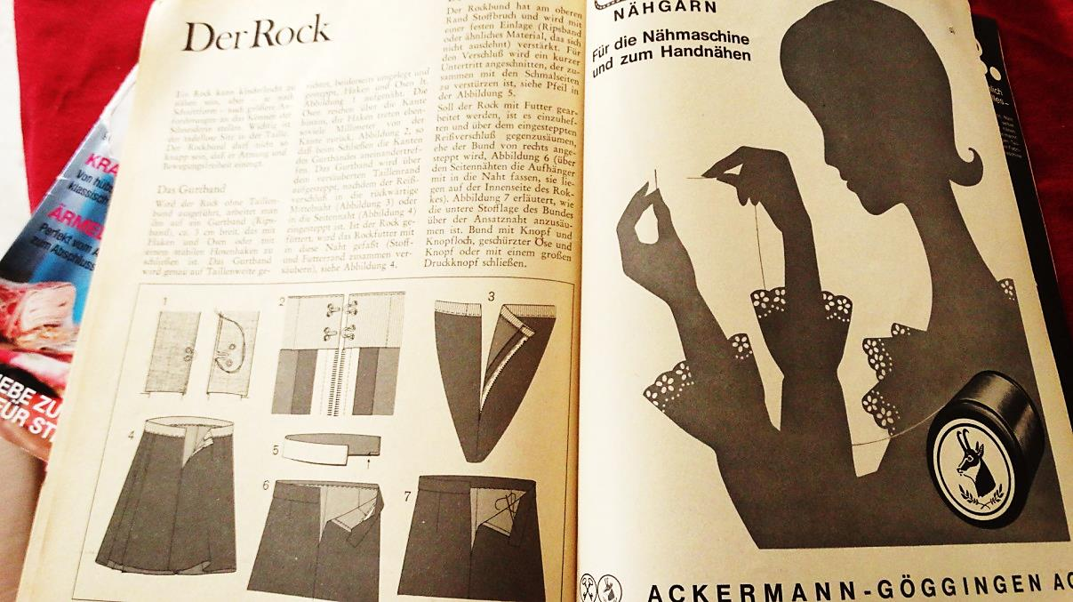

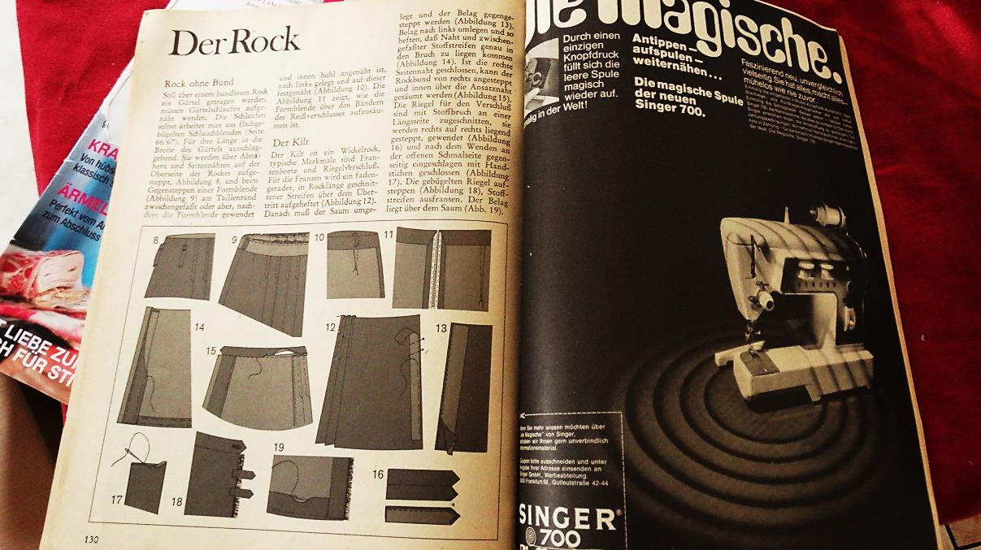

2. Analyze the advertising campaign by a fashion designer in newspapers and fashion magazines. Do they have a high fashion image or popular appeal? Do you feel that the advertisements were effective? Do they use photography or the artists’ illustrations? (write a report and produce the image of the campaign)
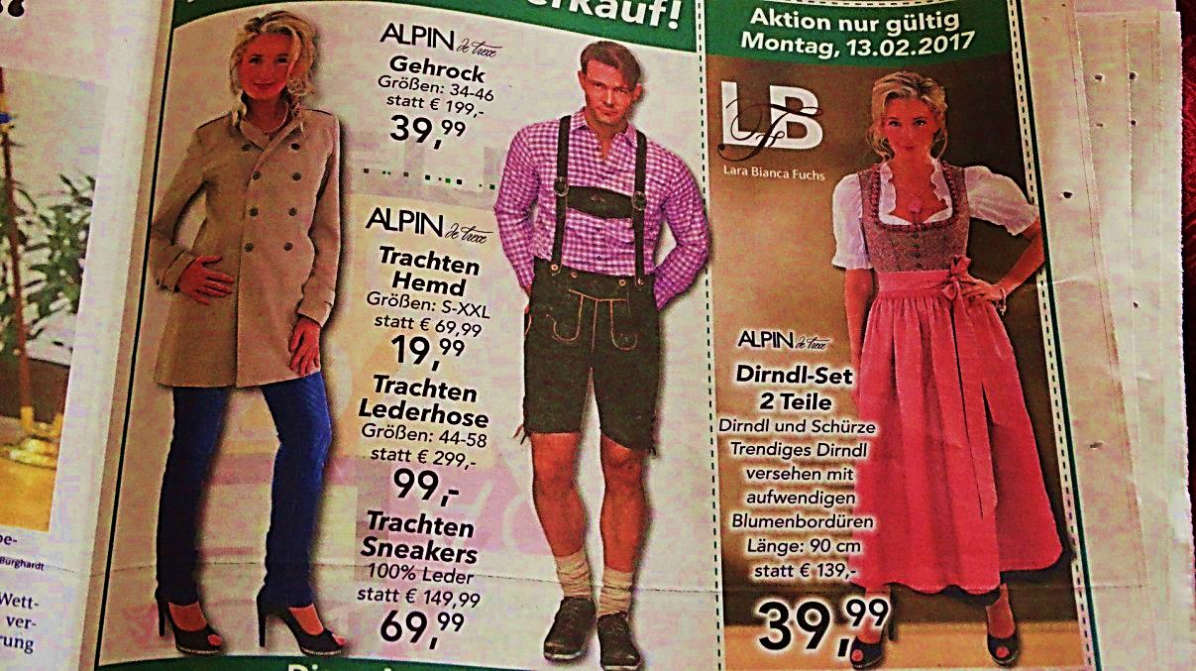
Yes I think they have a high fashion image and are popular. Worldwide this style of fashion is known. And it is popular in Austria and some parts of Germany. I think the advertisement is effective. They use only photography and no artists’ illustrations. Today fashion advertisements are nearly all ways made by photography and not by artists’ illustrations.

3. Visit local designer, evaluate the display techniques, both in windows and interiors. Is lighting used effectively? (Produce a report on your observations).

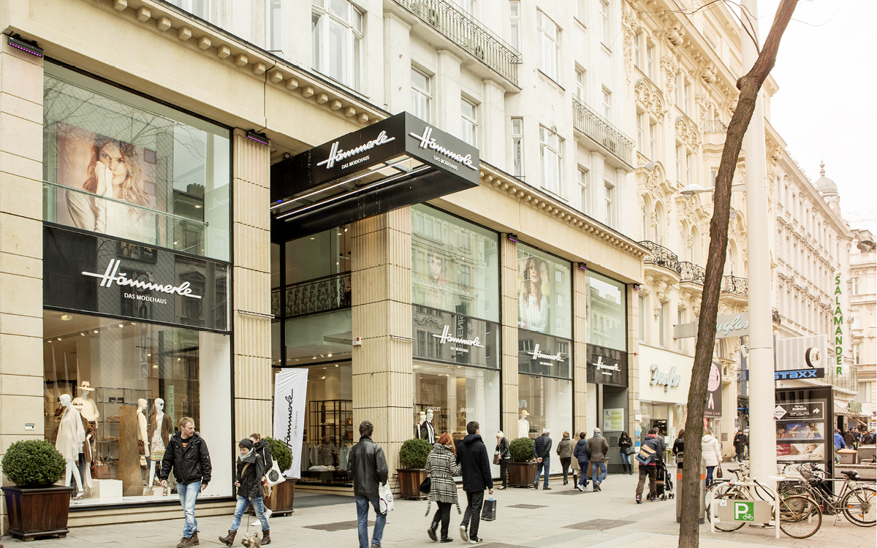

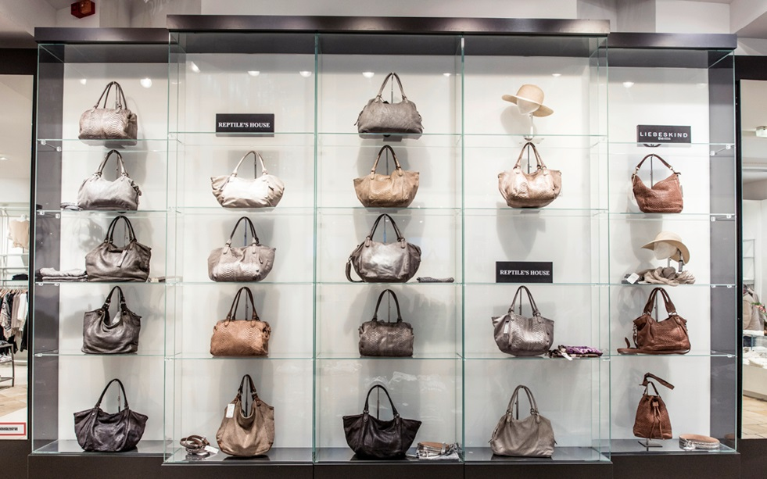
The light was used very effectively. The windows cached the attention of the consumer perfectly. The whole design gave the appearance of cleanness, orderliness, friendliness (especial with the well lightening), freshness, neatness, trustworthiness, elegance, noble, etc.
In the interiors the fashion items was well presented with very good lightening. The facility was very taste fully or with a good style – it was one harmonious style.
There was worked with a lot of glass which gave the noble and clean atmosphere.
It has a very beautiful design!! You can feel “at Home” there and you will not go out on the fastest way as possible like it can happen in some other fashion buildings.

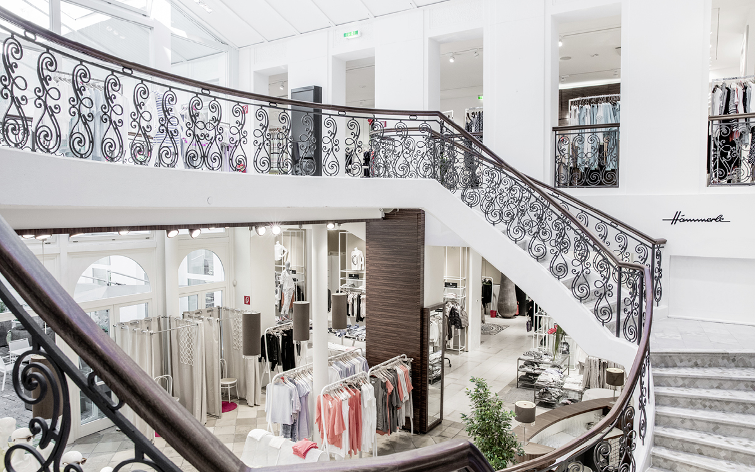

Picture references:
Projects: 3.: www.haemmerle-mode.at (the other pictures are all made by my own)

Student Statement:

By submitting this assignment, I confirm that this is my own work.

Student Signature | Rebekka Annika Schendel | Date | 10.02.2016

For Tutor / Assessor Use Only
Total Marks
Marks Obtained
Percentage / Grade

