
Assignment Cover Sheet

Student Name: | James Keown
Student Number: | 2569
Course: | Diploma in Logistics & Supply Chain Management
Assignment NO: | 5

Marking Criteria:
We expect the learners to write minimum one well expressed point in three lines against each allocated mark. This means one needs to write 15 lines with 5 well expressed points to get high grades for a 5 marks question.
For high grades use examples and illustrations where appropriate.
1. i. Purchasing is the task of acquiring all materials required to enable the business to function effectively. Purchasing controls the flow of products into any business in the supply chain, therefore impacting the flow of finished products out of the business. In most cases, items will be acquired in return for monetary exchange. In some cases, reciprocal trading deals may be set up with product swaps or account credits to reduce tax.

ii. Procurement is more than just the simple purchase of an item. It takes in the broader scope of negotiating: pricing, credit, return policies, delivery and transport terms and any other aspects that relate to the terms and conditions of trade with the vendor. Monitoring processes will also be put in place to monitor the performance of the vendors.

iii. Procurement plays a very important part in the supply chain. As it is responsible for the flow of product into the business, it will have a direct impact on the flow of product out of the business. For example, if product is acquired late from vendors it could impact the production timing of the finished product, potentially compromising delivery commitments to customers. Thus, resulting in poor customer service. There are many variables in the procurement process I.E. product quality, quantity and availability. If they are not monitored correctly customer service will be compromised.

iv. It is extremely important to qualify suppliers to ensure they are capable and competent of delivering on their commitments. The below points should be considered when evaluating and qualifying suppliers:
- Financial Stability– You don’t want your supplier going bankrupt 3 months after you start trading with them. Conduct credit checks.
- Product Quality – Get samples of some of the products to benchmark future supply against. If possible.
- Market Reputation - Check with other customers of theirs on their product quality, service and reputation. How long have they been trading for in the market?
- Site Visit – If possible, visit their manufacturing plant. Get an understanding of their internal processes and what standards they are manufacturing to.

v. E – procurement is the electronic procurement of products primarily from business to customer (B2C), but also from business to business (B2B). This is mostly done via direct trading through the internet. If customers and vendors have compatible systems, they can also choose to interface their systems to allow access to different levels of data and information. This is called Electronic Data Interface (EDI). Orders can be auto-generated by the system when pre-determined minimum stock levels are set and hit. This is commonly used for low cost, fast moving low specification product.

vi. The aim of procurement is to ensure there is constant flow of materials into the business to enable the business to achieve its overall business objectives. These aims include:
- Working with internal stakeholders to understand their requirements.
- Negotiating best prices and terms of trade with suppliers.
- Developing symbiotic partnership relationships with vendors.
- Being awear of price increases, currency fluctuations and other things that may impact the cost of product into the business.
- Monitoring stock levels and product cycles to ensure good rotation.

vii. Manufacturing strategies will change based on what type of product and market the company is targeting. For example, a brick manufacturer may have a common fast moving brick that he makes in large volumes with manufacturing runs planned monthly. This falls in the MTP category (see below). There may also manufacture another more decorative brick that requires more precision manufacturing. This is only made to order in small quantities. This falls in the MTO category (see below)

Make To Plan (MTP) - Can also be defined as Make To Stock (MTS). By manufacturing at a larger volume, economy of scale can be achieved. More product at a lower production cost per unit.

Make To Order (MTO) - Specialist product orders that are generally lower in volume. As product is often shipped direct to the customer less storage is required.

2. The procurement cycle includes many steps that begin with the first step of identifying a need for a product or service, through to the final step of having that product or service delivered and evaluated. The procurement cycle is illustrated in the flow chart below (Fig 1)

Fig 1

IDENTIFY NEED – User department identifies need and ensures departmental purchasing budget supports it. Sends internal purchase request to procurement department with detailed product specifications.

SOURCING OPTIONS – Procurement department confirms requirement with user department. Qualified suppliers are shortlisted and requests for quotation are sent to suppliers.

SUPPLIER CUSTOMER EVALUATION – Supplier checks customers credit history. Checks stocks and or production capacity. Sends quote to customer confirming price, payment terms, and delivery terms and timing.

PROCUREMENT OF MATERIAL – Procurement evaluates quotations from vendors. Confirm with user department the quotation specifications meet their requirements and are within budget. Proceed with issuing purchase order.

SUPPLIER INPUT– Receives and confirms receipt of the purchase order. Organizes required materials and advises delivery timing. Delivers product along with shipping documents and sends invoice.

RECEIVE MATERIAL – Product is received by inwards goods and inspected. If material is correct and in good condition proof of delivery docket is signed. User department gets notification materials have been received.

USER DEPARTMENT FEEDBACK– Inspects material to ensure it meets specifications. Advisers procurement department that product meets specifications so they can advise accounts to proceed with payment. Product is used and relevant feedback given to procurement on product performance.

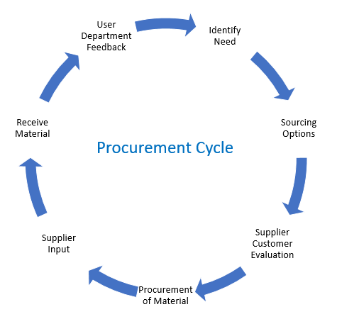

In general, the more expensive and complex the product or service is, the more detailed and complex the procurement cycle needs to be.

3. The performance of suppliers can be monitored by using a check list and feedback can be given through formal or informal discussions. See below list of areas that may be assessed as part of a supplier evaluation.

- Is product quality consistent and meeting specification?
- Are deliveries being received within agreed lead-times and time frames?
- Are orders accurate and in line with what is being ordered?
- Is their price still competitive with other suppliers in the market?
- Is the expected level of customer service and technical support being met?

A lot of time and resource goes into establishing and maintaining a supplier relationship. If any non-conformances are identified as part of a supplier evaluation, it is important to understand the weight of the non-conformance and how it impacts your business. For example, a delivery that is 10 minutes late would have less impact on your business than an order you have received for 1000 chocolate cakes, when you in fact ordered 1000 chocolate biscuits. As such, a different weight should be given to the area of the supplier’s business you are assessing based on its importance to yours. Feedback can be given to the supplier on areas of non-conformance so remedial action can be taken.

References

Author Unknown, Unit 5 – Procurement and Manufacturing Strategies
Author: Mat Lim, http://blog.procurify.com/2014/02/07/what-is-the-difference-between-procurement-and-purchasing/

Student Statement:

By submitting this assignment, I confirm that this is my own work.

Student Signature | James Keown | Date | 28th Jan 2017

For Tutor / Assessor Use Only
Total Marks
Marks Obtained
Percentage / Grade

