
Assignment Cover Sheet

Student Name: | James Weal
Student Number: | 5761
Course: | Construction Management
Assignment NO: | 1

Marking Criteria:
We expect the learners to write minimum one well expressed point in three lines against each allocated mark. This means one needs to write 15 lines with 5 well expressed points to get high grades for a 5 marks question.
For high grades use examples and illustrations where appropriate.
- Construction management is the overall running of any build prosses from the start of the project all the way through to the completion. The Key stages that must be over seen include, the planning, design and then ultimately the performance. Construction management is the link between the owner, the engineering group and the construction group and is necessary to ensure that time scales, costs and the quality of build is all making the specific requirements and delivering the product that the owner requests. One of the key areas of construction management include communication, communication is key in order to make sure instruction is given to the workers necessary to complete each task and also to be able to resolve any potential issues or conflicts that may arise. Safety must be addressed making sure the site is as safe as possible for the workers and any dangers are limited. Thorough and proper planning is also required for costs, time scales and build program to ensure that each target is met and that the project runs as smoothly as possible. This also includes inspecting the build throughout to ensure no problems arise and that the project is meeting the expected standards, if any issues become apparent it is necessary to address these as soon as possible to limit any upset to the cost, time or execution.

- Accident rates in construction tend to be much higher than any other industry due to the nature of the job. Heavy machinery and materials that must all be respected and operated in the correct manner if not injury is easily caused. Other hazards also include that fact that construction is inevitably taking place and therefore structures that are being worked upon may not always be completed and therefore not always be stable as they go through their different stages of erection. Due to this it can also be an issue if scaffolding is attached and as much as danger is limited as much as possible it does still exist. A building site is also in an ever changing environment and unlike working indoors in many other industry’s the elements can play a big part in construction, rain, snow and ice can cause surfaces to become slippery just as wind can cause working from a height to become hazardous. All of these issues are unable to be monitored and therefore can easily lead to Accident or injury.

- The job and duties of Mid-Level management in the construction industry can also be made up of other levels within this level of management. Their duties can include obtaining materials for the job as well as tools and builders as well as other workers to carry out the work. All of this would take place while reporting to top management in order to meet the needs of the build and what is necessary to deliver the product. On site, someone of Mid-Level management may be involved in more specific works and work of a specialised nature as well as talking insuring the First -Line management is up to date on what needs to be done and insuring the time scales are met. On a larger scale project Mid-Level management may be delegated to deal with smaller areas of the build in order to insure the quality of the build is executed.

- What a construction project begins with is essentially the owner of the project, he has a need and the finances for the project. This is then passed on to designers, planners and architects to ensure that the design and scale of what is required by the owner is met. This is then in turn passed to tender with a construction company or contractor that will implement the build. The build is in turn inspected and passed on completion of the build. A construction project can be many different types and could be, Agricultural, Residential, commercial, Industral or environmental. All require financing, strict planning and design, thorough communication and ultimately construction.

Student Statement:

By submitting this assignment, I confirm that this is my own work.

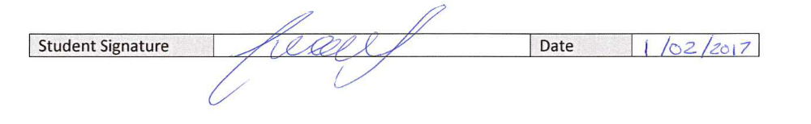

Student Signature |  | Date | 01-02-2017

For Tutor / Assessor Use Only
Total Marks
Marks Obtained
Percentage / Grade

