
Assignment Cover Sheet

Student Name: | Khadija Lahouiri
Student Number: | 3264
Course: | Diploma In Accounting
Assignment NO: | 1

Marking Criteria:
We expect the learners to write minimum one well expressed point in three lines against each allocated mark. This means one needs to write 15 lines with 5 well expressed points to get high grades for a 5 marks question.
For high grades use examples and illustrations where appropriate.
- Answers:
Accounting: Is the art of recording, classifying and summarizing transactions and events and interpreting the result.
Objectives:
- To keep Systematic Records
- To Ascertain the Results of the Operation
- To ascertain the financial position of the business
- To portray the liquidity position
- To protect business properties
- To facilitate rational decision – making
- To satisfy the requirements of law
The limitations of Accounting are:
- Record keeping: events that has non-financial nature do not fall in accounting, hence it influence the financial health of business. Also management skills, variation in consumer preferences, or any other changes in the Human resources may not be recorded in accounting but are, nonetheless, very important factors in running a business.
- Accuracy of information generated by accounting system:
- Value of assets: The true market value of the assets is not normally reflected in balance sheets.
- Window dressing: this action decrease costs and increases profitability.
- Changing price levels: Accounting measures of performance and evaluation of financial position
- may not be accurate
The types of activities are included in data evaluation:
- controls the business activities through budgets and standard costs,
- Evaluating the performance of the business,
- Analyzing financial statements,
- Analyzing cash flows, and choosing alternative courses of action for decision-making process.
- Evaluation of data is one of the most important business activities.
The main functions of accounting considering the following groups;
• Lenders: Creditors are concerned with information about the company’s ability to pay its loans back – both in the short and long term. In other words, they are interested in company’s credit worthiness, liquidity, profitability, etc. Before lending money to the company, the creditors rely on the financial statements to know if the company will be able to pay back its debts in the foreseeable future.
• Employees: Employees are considered important users of the company’s financial information, as their input is required for matters such as settlement of wages, bonuses, output benchmarks, and profit sharing.
• Customers: The information also gives an insight into social responsibility of businesses. By looking at various accounting information, including profits and outputs generated by businesses, the consumers’ organizations can also keep a track of the growth of businesses and find out whether they are in line with the defined national goals.
- The role of accountants in modern business organizations:
a) It assists in keeping and managing record of transactions of a business or a firm.
b) It not only provides useful information about all the financial operations of a business but also highlights net gains or any loss made at the end of a financial year, and thus, it draws an accurate picture of the business.
c) It helps in making important economic decisions by analyzing the past performance.
d) It assists in undertaking a comparative study of profits, losses, and sales, revenues, and expenses indifferent years.
e) It analyses and tells us if an enterprise or a business is utilizing its resources in the most effective possible manner.
f) It interprets information on financial health of a business and facilitates in predicting and
Forecasting its financial future; and
g) It assists the businesses in meeting legal requirements, which include filing of sales-tax returns and income tax. Good accounting and accurate maintenance of all financial transactions helps a lot in assessment of taxes.
3- The accounting cycle.
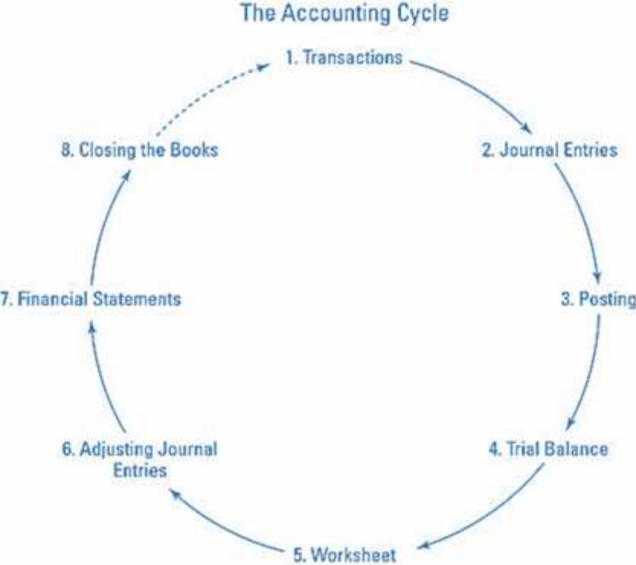

Activity:
The various accounting activities:
- Data creation and collection: Provides the basis for financial statements and accounting records. Historic data refers to the transactions that have already occurred.
- Data evaluation controls the business activities through budgets and standard costs, evaluating the performance of the business, analyzing financial statements, analyzing cash flows, and choosing alternative courses of action for decision-making process. Evaluation of data is one of the most important business activities.
- The analytical and interpretative aspect of accounting has a wide range of internal and external uses, from producing snap answers to elaborate reports based on extensive research. It also includes capital project analysis, budgetary projections, financial forecasts, and research based analysis for reorganization, takeovers, and mergers.
- Audit is the verification of financial transactions as recorded in account books and the authentication of financial statements. Professional accountants and auditors are hired for auditing the financial accounts of businesses to keep track of financial flows and point out any lapses or fraud.
- Data reporting can be internal or external. Internal data reporting is the communication of financial statements, analysis, and evaluation to the management for decision-making. External data reporting communicates the business’s financial position and its earnings to outside parties such as the government, shareholders, regulatory bodies, other businesses, etc.

Student Statement:

By submitting this assignment, I confirm that this is my own work.

Student Signature |  | Date

For Tutor / Assessor Use Only
Total Marks
Marks Obtained
Percentage / Grade

