
Assignment Cover Sheet

Student Name: | Arno Osinga
Student Number: | 3689
Course: | Diploma in Logistics & Supply Chain Management
Assignment NO: | 7

Marking Criteria:
We expect the learners to write minimum one well expressed point in three lines against each allocated mark. This means one needs to write 15 lines with 5 well expressed points to get high grades for a 5 marks question.
For high grades use examples and illustrations where appropriate.
Logistics & Supply Chain Management

Market Distribution in Supply Chain – Unit 7

- Distribution in the supply chain is the movement of product from one sector to the next within that supply chain. Also, the distribution is the method employed for the most efficient path to get a product to its end user, be this via a direct link to a retailer, or by use of a wholesaler who then sells to a retailer, or the possibility of utilising multi marketing methods such as retailers and wholesalers in unison. The ability to opt for an efficient method for this distribution is key to a smooth and continuous supply chain process. Channels of distribution are the avenues used to achieve this. Different products need differing amounts and types of processing, therefore different channels need to be utilised for differing products. In a farm shop for example, honey will need to be processed into jars, then will need labelling. Whereas potatoes need only be washed to be sold.
- Channel participants in a distribution process are manufacturers, wholesalers, distributors, retailers for multi-level distribution, and for the zero-level channel there may be just the manufacturer or producer of a product, for example a hobby beekeeper will sell his own honey from the front room.
- The importance of market coverage in a distribution process is key to a successful marketing strategy. The marketing coverage needs to link well with the distribution channel, it would be pointless to market a product in an area where the distribution network is not available. Marketing can be Intensive, Selective or Exclusive, all dependent upon what product is being marketed and how the organisation wants to portray that product. An exclusive, individual, highly desired product would more likely to be subject to exclusive distribution, possibly a single retail outlet within a large city. Whereas a high turnover, essential to everybody type of product, for example toilet paper, will more likely to be Intensively distributed, sold in as many retail outlets as possible even within local areas.
- Single transaction channels are one-off occurrences such as purchase or property or land, heavy machinery or processing equipment. These do not repeat themselves on a daily or weekly basis.
Conventional channels are purchases/deals made without the need for future or ongoing relationship with that vendor. No thought needs to be made for repeat business or future service requirements. These conventional channels are invariably price/cost dominated, there is no relationship constraints or contracts for ongoing purchases. These channels can be created and ceased, often with the same entities involved, dependent on price/availability/service at that particular time.
- Logistics can affect pricing massively. Who pays for what? if the seller pays for the logistics to bring the goods to the purchaser, known as ‘Delivered Pricing’, this needs to be accounted for, including the responsibility of the goods, insurance is a must for the seller. If the logistics utilised need to cover a large distance, then this can be extremely costly, delivering household goods from a warehouse to a retail shop that is 5 miles away is a massively cheaper cost implication compared to delivering a JCB from the factory in central UK to its distributor in India.
Single Zone pricing is another option, where the seller charges a single fee for delivery to wherever the customer requests. This is normally only an option where the cost of logistics is very low in comparison to the selling price of the product.
Multi-Zone pricing creates set areas within the delivery spectrum and charges accordingly to each of these, Normally, the further and more remote the delivery, the higher the cost attributed to it.
Base Point Pricing is the process of calculating the delivery cost from point to point, on an individual basis. The most complicated method that requires input and calculation on each and every order/delivery.

- Pricing strategy in a supply chain must be carefully considered and monitored. There could be issues with potential discrimination, pricing must be maintained in a fair and equal manner to avoid possible contravention of law. Zone pricing is a particular issue for this discrimination. The most commonly utilised pricing methods are F.O.B. Source pricing and Delivered Pricing. F.O.B. (Free On Board) pricing has variations within itself, dependent on who is liable for what, F.O.B. Origin is where the seller has goods ready and available for the buyer to arrange collection and transport from the goods’ origin. F.O.B. Destination being where the seller assumes responsibility (and bears the cost) of transport to the buyers desired destination.
Another effective method is Menu Pricing, this lists products and services offered at a standard platform price, with the optional addition of value added services, and also incentives given.
Discounts can be applied to encourage bulk buying, or buying in advance of requirement. These discounts can be partially, or even wholly offset by cheaper logistical costs.
Promotions can also be set, giving incentives to purchase, these are normally short term and item specific. These promotions can create headaches for the logistics team, especially where bulk items suddenly increase greatly in turnover. These must therefore be carefully managed and planned to ensure a timely delivery to customer is maintained.

- The channel design process is important in highlighting areas in need of improvement within an existing channel map, and/or in ensuring an efficient channel map is designed and implemented in a new venture. The more detailed and in-depth that a channel map is created the better, it can become a complicated issue to deal with, but information is key to success, therefore it’s well worth making a greater effort to create a full and detailed channel map. There can be several differing areas that may need individual mapping, then amalgamation these individual maps to create one overall channel map, for example there would be a map for the physical logistics of raw materials from source through to end user, whilst there will be a different map for the information required to be sent and received to ensure these raw materials’ logistics. A matrix approach to creating a channel map utilises a concept of separation, each section of a supply chain formulates its own channel map therefore simplifying the amount of information. I have added two very simple examples of channel maps below, normally a channel design would be a lot more informative and contain a lot more information and variables.

Below is a simple channel map, showing the option of removing the Retailers Warehouse to potentially improve efficiency. Highlighting how alternative options are possible
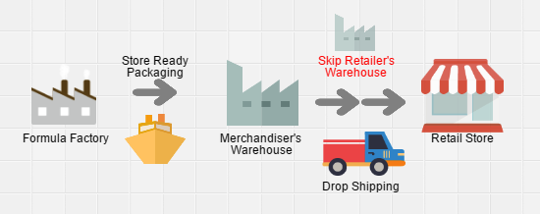

Below is an image example of a simple Channel Map showing ‘Information Flow’
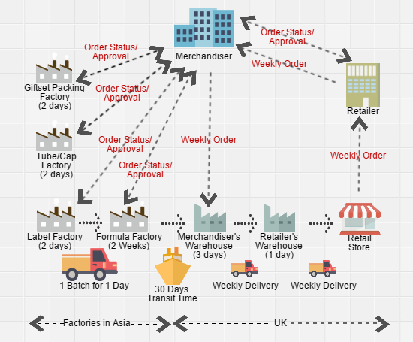

Student Statement:

By submitting this assignment, I confirm that this is my own work.

Student Signature | Arno Osinga | Date | 28/01/2017

For Tutor / Assessor Use Only
Total Marks
Marks Obtained
Percentage / Grade

